**WEEK – 6**

**React**

**1. ReactJS-HOL**

**File Name : App.js**

import React from 'react';

function App() {

return (

<div>

<h1>Welcome to the first session of React</h1>

</div>

);

}

export default App;

**File Name : index.js**

import React from 'react';

import ReactDOM from 'react-dom/client';

import App from './App';

const root = ReactDOM.createRoot(document.getElementById('root'));

root.render(<App />);

File Name :App.css

.App {

text-align: center;

}

.App-logo {

height: 40vmin;

pointer-events: none;

}

@media (prefers-reduced-motion: no-preference) {

.App-logo {

animation: App-logo-spin infinite 20s linear;

}

}

.App-header {

background-color: #282c34;

min-height: 100vh;

display: flex;

flex-direction: column;

align-items: center;

justify-content: center;

font-size: calc(10px + 2vmin);

color: white;

}

.App-link {

color: #61dafb;

}

**File Name : App.test.js**

import { render, screen } from '@testing-library/react';

import App from './App';

test('renders learn react link', () => {

render(<App />);

const linkElement = screen.getByText(/learn react/i);

expect(linkElement).toBeInTheDocument();

});

**File Name : index.css**

body {

margin: 0;

font-family: -apple-system, BlinkMacSystemFont, 'Segoe UI', 'Roboto', 'Oxygen',

'Ubuntu', 'Cantarell', 'Fira Sans', 'Droid Sans', 'Helvetica Neue',

sans-serif;

-webkit-font-smoothing: antialiased;

-moz-osx-font-smoothing: grayscale;

}

code {

font-family: source-code-pro, Menlo, Monaco, Consolas, 'Courier New',

monospace;

}

OUTPUT :

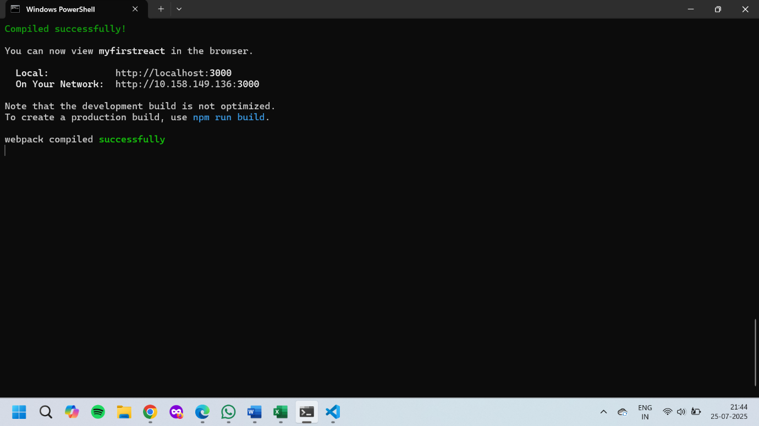

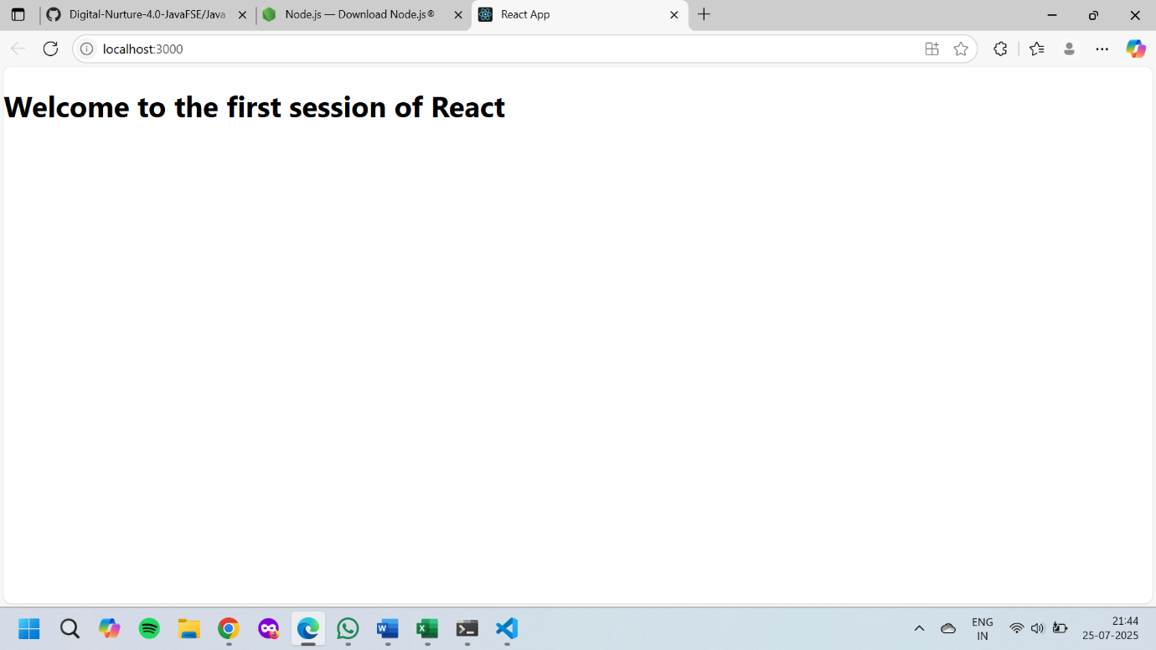

**2. ReactJS-HOL**

**File Name : Home.js**

import React from 'react';

function Home() {

return (

<div>

<h2>Welcome to the Home page of Student Management Portal</h2>

</div>

);

}

export default Home;

**File Name : About.js**

import React from 'react';

function About() {

return (

<div>

<h2>Welcome to the About page of the Student Management Portal</h2>

</div>

);

}

export default About;

**File Name : Contact.js**

import React from 'react';

function Contact() {

return (

<div>

<h2>Welcome to the Contact page of the Student Management Portal</h2>

</div>

);

}

export default Contact;

**File Name : App.js**

import React from 'react';

import Home from './Components/Home';

import About from './Components/About';

import Contact from './Components/Contact';

function App() {

return (

<div>

<h1>Student Management Portal</h1>

<Home />

<About />

<Contact />

</div>

);

}

export default App;

**OUTPUT :**

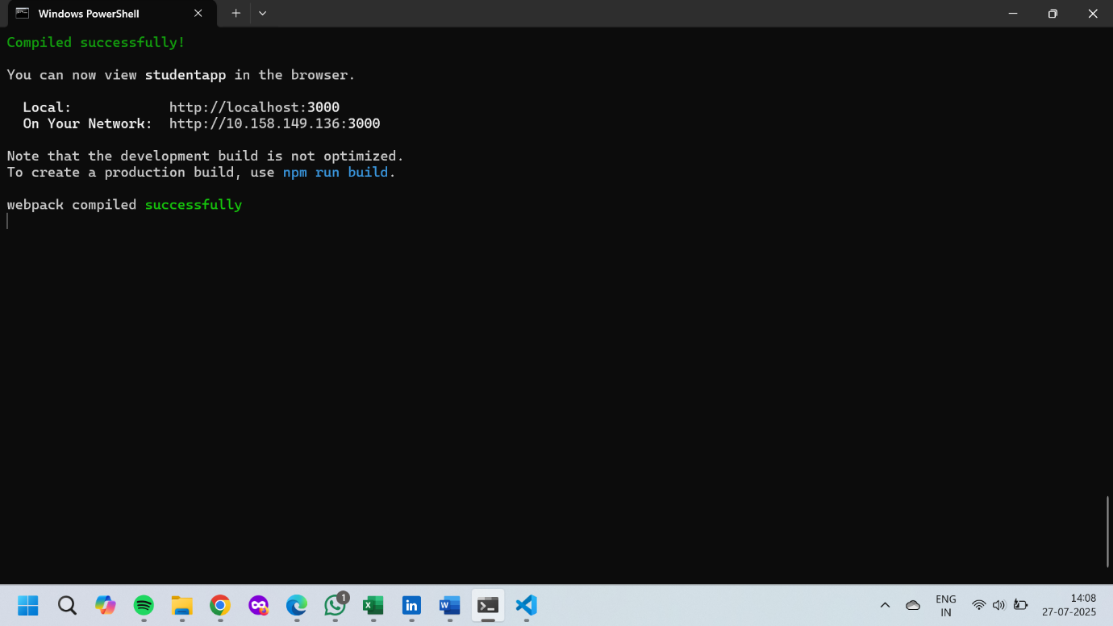

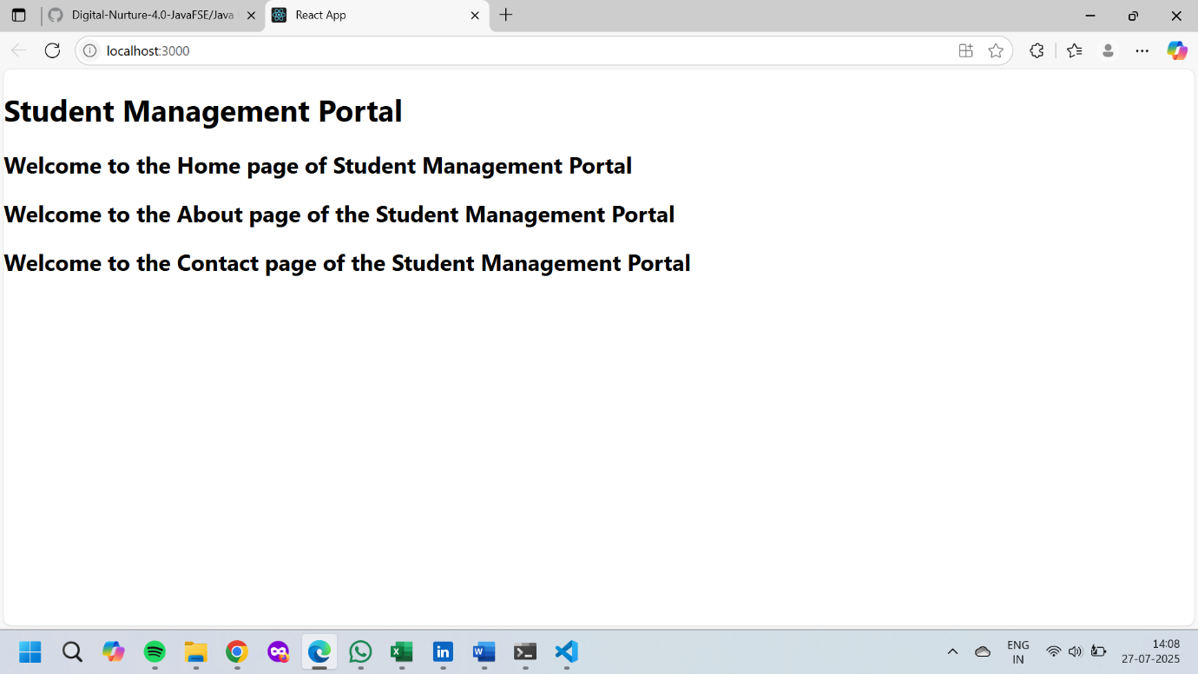

**3. ReactJS-HOL**

**File Name : CalculateScore.js**

import React, { useState } from 'react';

import '../Stylesheets/mystyle.css';

function CalculateScore() {

const [name, setName] = useState('');

const [school, setSchool] = useState('');

const [total, setTotal] = useState('');

const [goal, setGoal] = useState('');

const [average, setAverage] = useState(null);

const calculateAverage = (e) => {

e.preventDefault();

const avg = parseFloat(total) / parseFloat(goal);

setAverage(avg.toFixed(2));

};

return (

<div className="score-card">

<h2>Student Score Calculator</h2>

<form onSubmit={calculateAverage}>

<input type="text" placeholder="Enter Name" value={name} onChange={(e) => setName(e.target.value)} required />

<input type="text" placeholder="Enter School" value={school} onChange={(e) => setSchool(e.target.value)} required />

<input type="number" placeholder="Enter Total Score" value={total} onChange={(e) => setTotal(e.target.value)} required />

<input type="number" placeholder="Enter Goal Score" value={goal} onChange={(e) => setGoal(e.target.value)} required />

<button type="submit">Calculate Average</button>

</form>

{average && (

<div className="result">

<p><strong>Name:</strong> {name}</p>

<p><strong>School:</strong> {school}</p>

<p><strong>Average Score:</strong> {average}</p>

</div>

)}

</div>

);

}

export default CalculateScore;

**File Name : mystyle.css**

.score-card {

background-color: #f4f4f4;

max-width: 400px;

margin: 30px auto;

padding: 20px;

border-radius: 8px;

text-align: center;

font-family: Arial, sans-serif;

box-shadow: 0 0 10px rgba(0, 0, 0, 0.1);

}

.score-card input {

display: block;

width: 90%;

margin: 10px auto;

padding: 8px;

border: 1px solid #ccc;

border-radius: 5px;

}

.score-card button {

padding: 10px 20px;

margin-top: 10px;

background-color: #007bff;

color: white;

border: none;

border-radius: 5px;

cursor: pointer;

}

.score-card button:hover {

background-color: #0056b3;

}

.result {

margin-top: 20px;

font-size: 1rem;

}

**File Name : App.js**

import React from 'react';

import './App.css';

import CalculateScore from './Components/CalculateScore';

function App() {

return (

<div className="App">

<CalculateScore />

</div>

);

}

export default App;

**OUTPUT :**

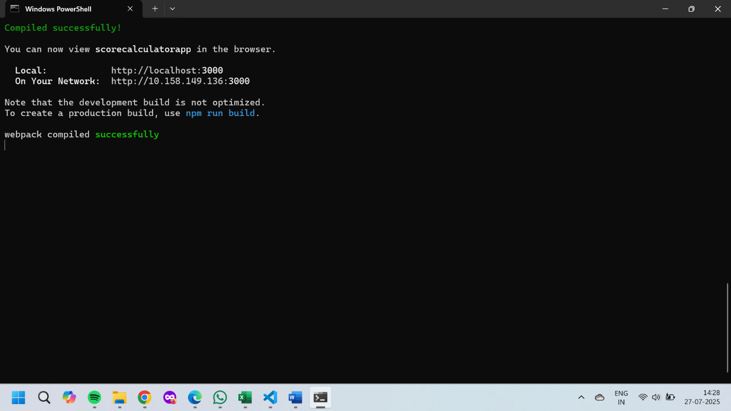

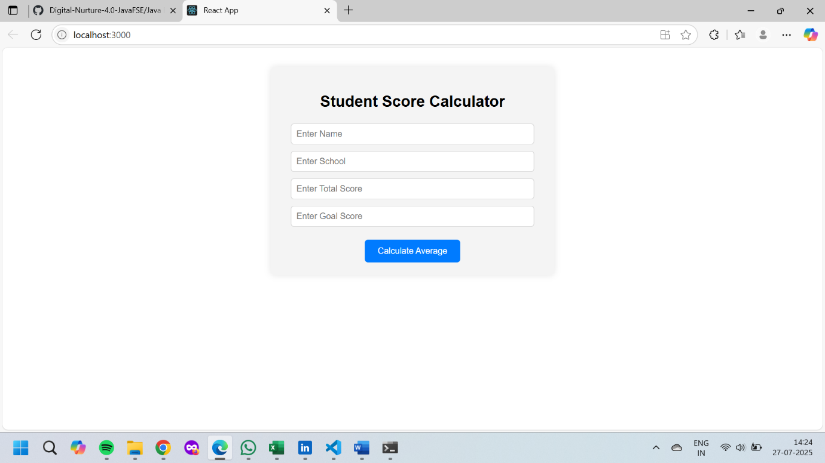

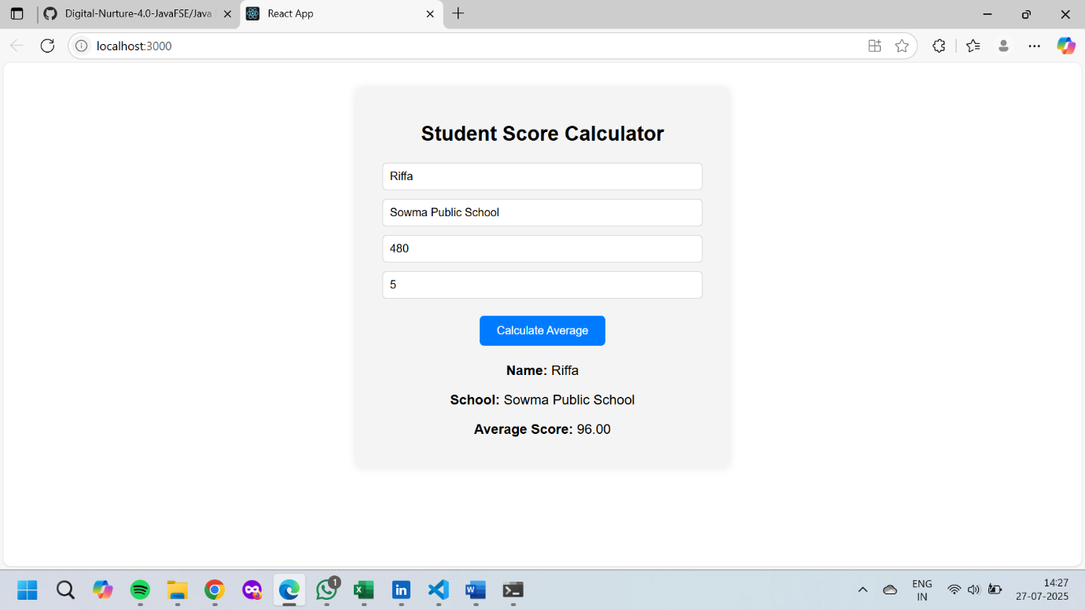

**4. ReactJS-HOL**

**File Name : Post.js**

class Post {

constructor(userId, id, title, body) {

this.userId = userId;

this.id = id;

this.title = title;

this.body = body;

}

}

export default Post;

**File Name : Posts.js**

import React, { Component } from 'react';

import Post from './Post';

class Posts extends Component {

constructor(props) {

super(props);

this.state = {

posts: [],

};

}

loadPosts() {

fetch('https://jsonplaceholder.typicode.com/posts')

.then((response) => {

if (!response.ok) {

throw new Error('Failed to fetch posts');

}

return response.json();

})

.then((data) => {

const posts = data.map(

(item) => new Post(item.userId, item.id, item.title, item.body)

);

this.setState({ posts });

})

.catch((error) => {

this.setState({ hasError: true });

alert(`Error fetching posts: ${error.message}`);

});

}

componentDidMount() {

this.loadPosts();

}

componentDidCatch(error, info) {

alert(`Something went wrong: ${error}`);

}

render() {

return (

<div style={{ padding: '20px' }}>

<h1>Blog Posts</h1>

{this.state.posts.map((post) => (

<div key={post.id} style={{ marginBottom: '20px' }}>

<h3>{post.title}</h3>

<p>{post.body}</p>

</div>

))}

</div>

);

}

}

export default Posts;

**File Name : App.js**

import React from 'react';

import Posts from './Posts';

function App() {

return (

<div className="App">

<Posts />

</div>

);

}

export default App;

**OUTPUT:**

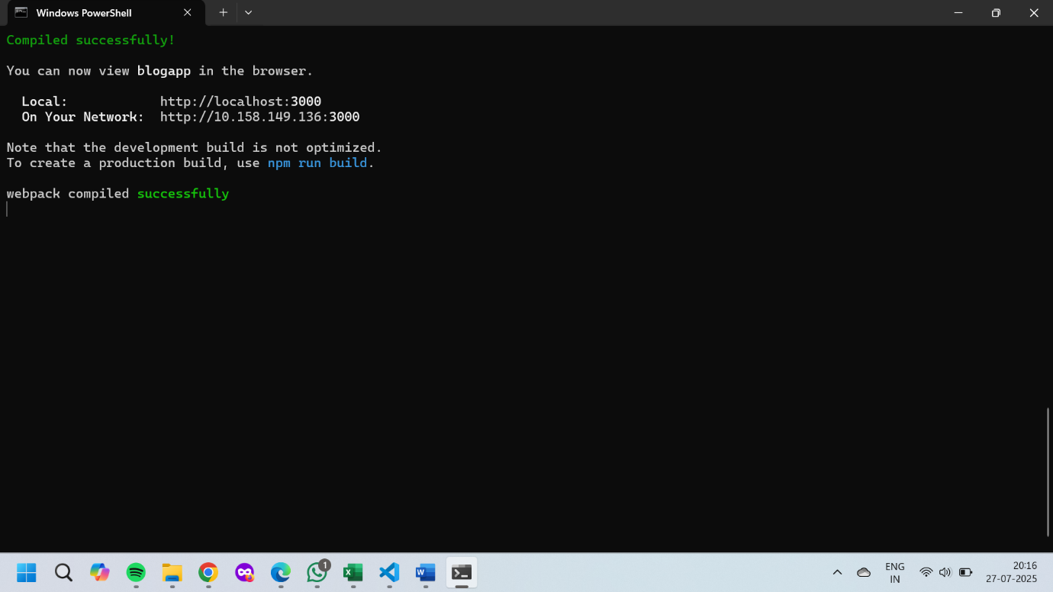

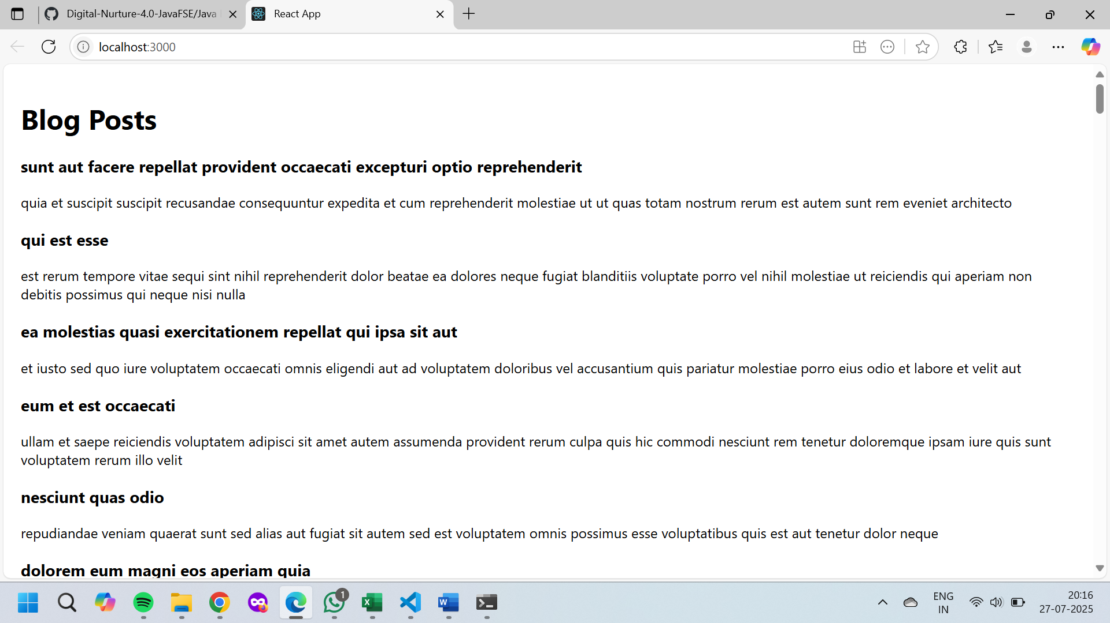

**5. ReactJS-HOL**

**File Name : CohortDetails.module.css**

.box {

width: 300px;

display: inline-block;

margin: 10px;

padding: 10px 20px;

border: 1px solid black;

border-radius: 10px;

}

dt {

font-weight: 500;

}

**File Name : CohortDetails.js**

import React from 'react';

import styles from './CohortDetails.module.css';

function CohortDetails({ cohort }) {

return (

<div className={styles.box}>

<h3 style={{ color: cohort.status === 'ongoing' ? 'green' : 'blue' }}>

{cohort.name}

</h3>

<dl>

<dt>Trainer:</dt>

<dd>{cohort.trainer}</dd>

<dt>Start Date:</dt>

<dd>{cohort.startDate}</dd>

<dt>Status:</dt>

<dd>{cohort.status}</dd>

</dl>

</div>

);

}

export default CohortDetails;

**File Name : App.js**

import React from 'react';

import CohortDetails from './CohortDetails';

function App() {

const cohorts = [

{

name: 'ReactJS Batch 1',

trainer: 'John Doe',

startDate: '2024-06-10',

status: 'ongoing',

},

{

name: 'Java Spring Boot',

trainer: 'Jane Smith',

startDate: '2024-04-01',

status: 'completed',

},

];

return (

<div style={{ textAlign: 'center', marginTop: '20px' }}>

{cohorts.map((cohort, index) => (

<CohortDetails key={index} cohort={cohort} />

))}

</div>

);

}

export default App;

**OUTPUT :**

