**WEEK – 7**

**React**

**9. ReactJS-HOL**

**File Name : ListofPlayers.js**

import React from "react";

const ListofPlayers = () => {

const players = [

{ name: "Virat", score: 95 },

{ name: "Rohit", score: 88 },

{ name: "Gill", score: 67 },

{ name: "Kohli", score: 73 },

{ name: "Hardik", score: 55 },

{ name: "Pant", score: 78 },

{ name: "Rahul", score: 49 },

{ name: "Jadeja", score: 82 },

{ name: "Bumrah", score: 63 },

{ name: "Ashwin", score: 91 },

{ name: "Chahal", score: 74 },

];

const lowScorers = players.filter(player => player.score < 70);

return (

<div>

<h2>All Players</h2>

<ul>

{players.map((player, index) => (

<li key={index}>

{player.name} - {player.score}

</li>

))}

</ul>

<h3>Players with score below 70</h3>

<ul>

{lowScorers.map((player, index) => (

<li key={index}>

{player.name} - {player.score}

</li>

))}

</ul>

</div>

);

};

export default ListofPlayers;

**File Name : IndianPlayers.js**

import React from "react";

const IndianPlayers = () => {

const T20Players = ["Rohit", "Kohli", "Pant", "Hardik"];

const RanjiTrophyPlayers = ["Gambhir", "Rahane", "Pujara"];

// Merge feature of ES6

const allPlayers = [...T20Players, ...RanjiTrophyPlayers];

const oddTeam = allPlayers.filter((_, index) => index % 2 === 0);

const evenTeam = allPlayers.filter((_, index) => index % 2 !== 0);

return (

<div>

<h2>All Indian Players</h2>

<p><strong>Odd Team:</strong> {oddTeam.join(", ")}</p>

<p><strong>Even Team:</strong> {evenTeam.join(", ")}</p>

</div>

);

};

export default IndianPlayers;

**File Name : App.js**

import React from "react";

import ListofPlayers from "./components/ListofPlayers";

import IndianPlayers from "./components/IndianPlayers";

function App() {

const flag = true; // Change to false to display IndianPlayers

return (

<div className="App">

<h1>Cricket App</h1>

{flag ? <ListofPlayers /> : <IndianPlayers />}

</div>

);

}

export default App;

**OUTPUT :**

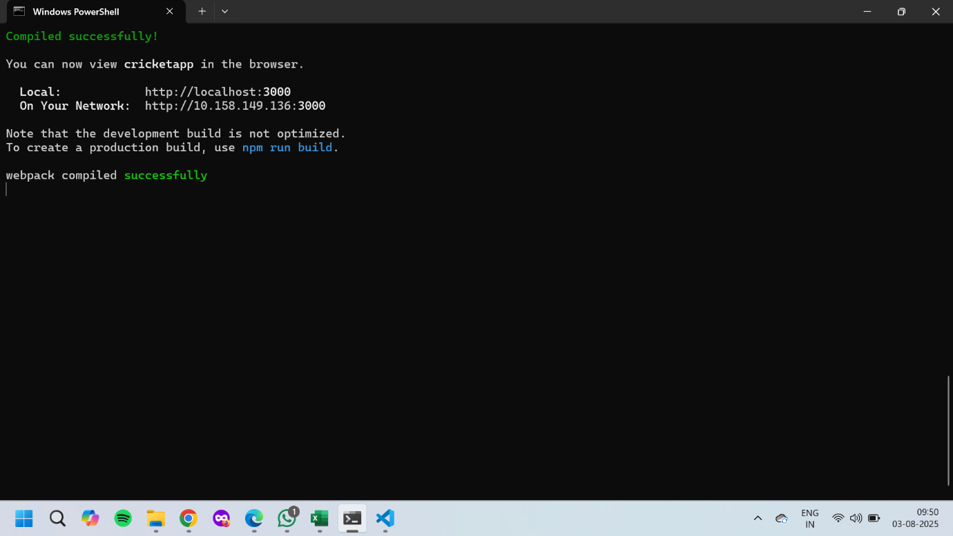

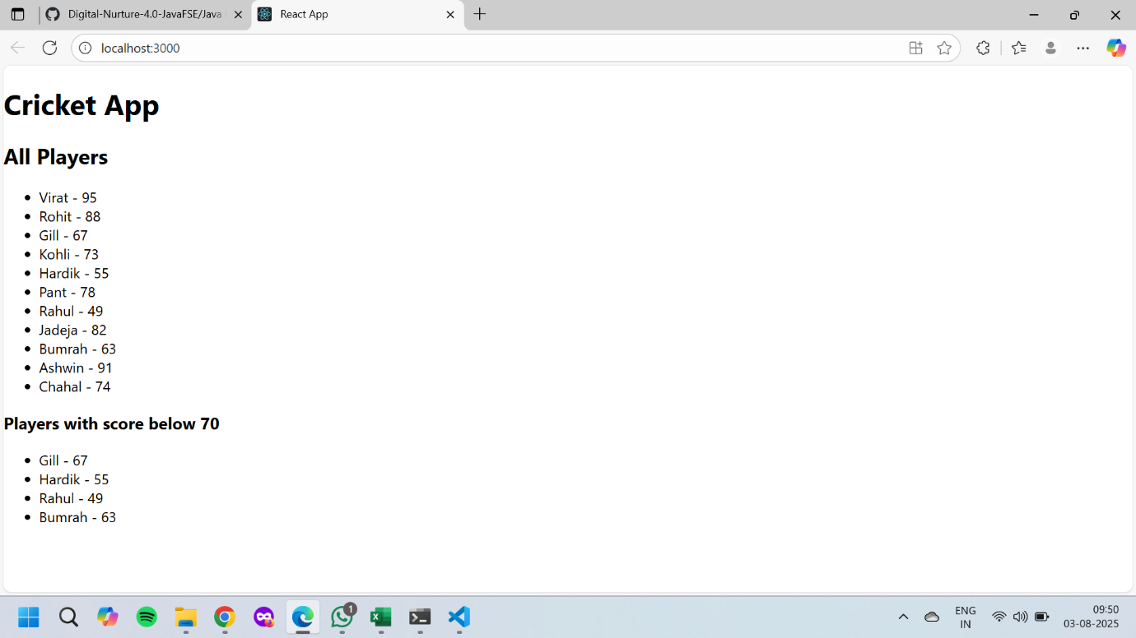

**10. ReactJS-HOL**

**File Name : App.js**

import React from 'react';

import './App.css';

function App() {

const heading = <h1>Office Space Rental Portal</h1>;

const officeImage = "https://via.placeholder.com/400x200.png?text=Office+Space";

const office = {

name: "Tech Park Office",

rent: 55000,

address: "123, Silicon Street, Bangalore"

};

const officeList = [

{ name: "Startup Hub", rent: 45000, address: "HSR Layout" },

{ name: "Corporate Tower", rent: 75000, address: "MG Road" },

{ name: "Eco Space", rent: 60000, address: "Outer Ring Road" },

{ name: "WorkNest", rent: 82000, address: "Koramangala" }

];

return (

<div className="App">

{heading}

<img src={officeImage} alt="Office" style={{ width: "400px", height: "200px" }} />

<h2>Featured Office:</h2>

<p><strong>Name:</strong> {office.name}</p>

<p><strong>Rent:</strong>

<span style={{ color: office.rent < 60000 ? "red" : "green" }}>

₹{office.rent}

</span>

</p>

<p><strong>Address:</strong> {office.address}</p>

<h2>Available Office Spaces</h2>

{officeList.map((o, index) => (

<div key={index} style={{ border: "1px solid #ccc", margin: "10px", padding: "10px" }}>

<p><strong>Name:</strong> {o.name}</p>

<p>

<strong>Rent:</strong>

<span style={{ color: o.rent < 60000 ? "red" : "green" }}> ₹{o.rent} </span>

</p>

<p><strong>Address:</strong> {o.address}</p>

</div>

))}

</div>

);

}

export default App;

**OUTPUT :**

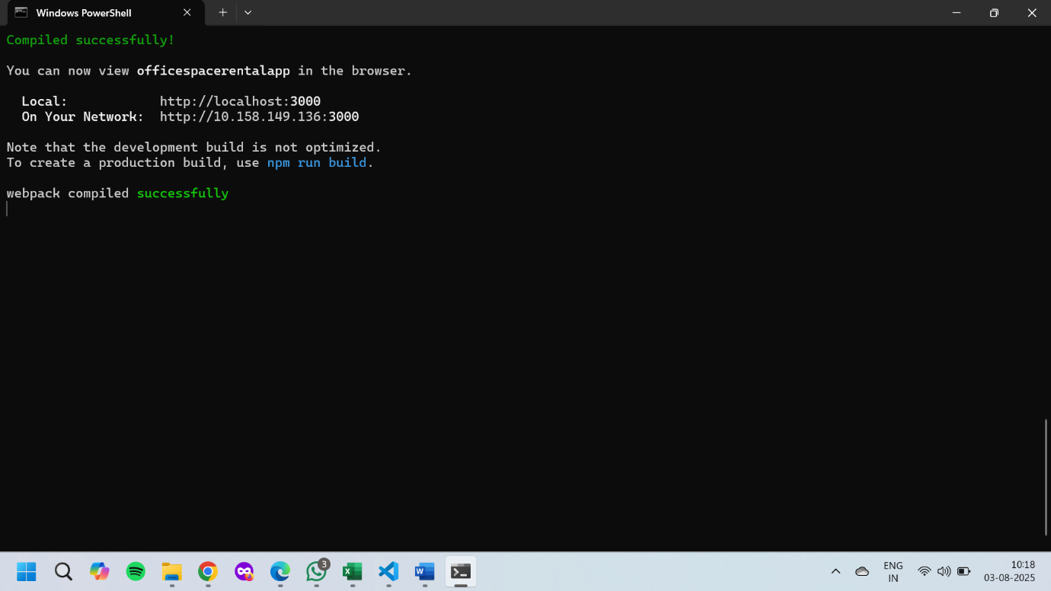

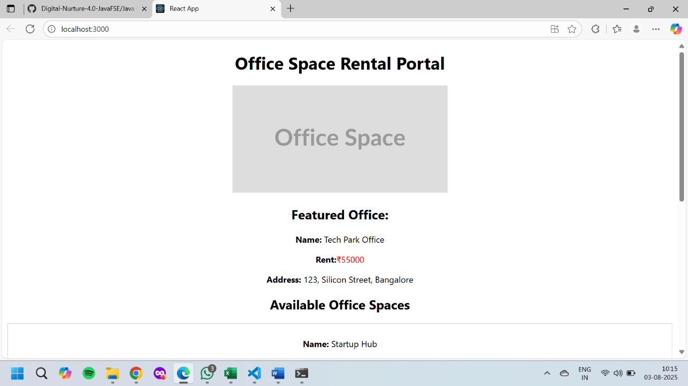

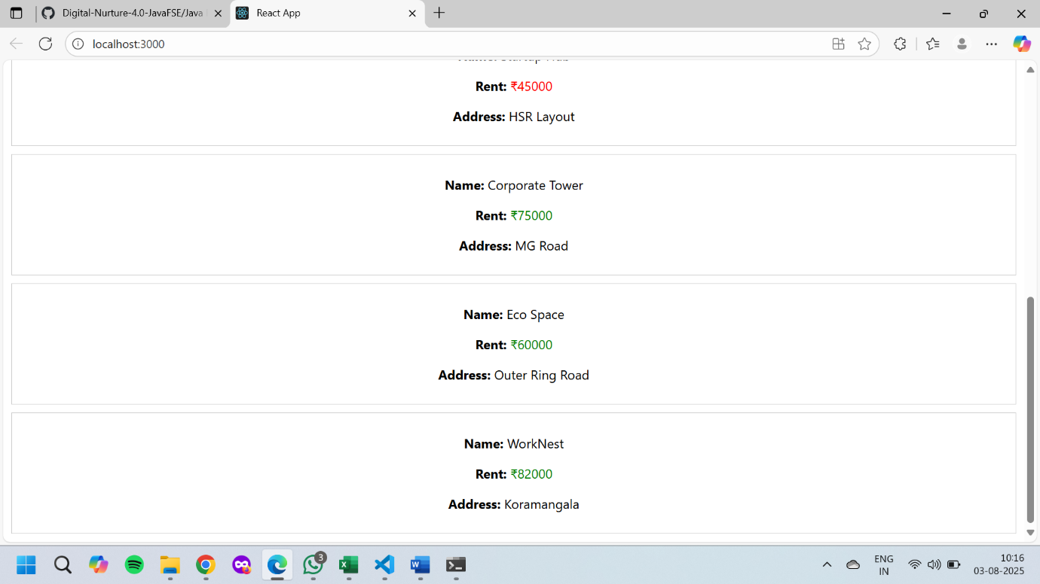

**11. ReactJS-HOL**

**File Name : App.js**

import React, { useState } from "react";

import "./App.css";

function CurrencyConvertor() {

const [rupees, setRupees] = useState("");

const [euro, setEuro] = useState("");

const handleSubmit = (e) => {

e.preventDefault(); // Synthetic event

const converted = parseFloat(rupees) * 0.011; // Example rate

setEuro(converted.toFixed(2));

};

return (

<div>

<h2>Currency Convertor (INR to Euro)</h2>

<form onSubmit={handleSubmit}>

<input

type="number"

placeholder="Enter amount in ₹"

value={rupees}

onChange={(e) => setRupees(e.target.value)}

/>

<button type="submit">Convert</button>

</form>

<p>Converted: €{euro}</p>

</div>

);

}

function App() {

const [count, setCount] = useState(0);

const [message, setMessage] = useState("");

const handleIncrement = () => {

increment();

sayHello();

};

const increment = () => setCount((prev) => prev + 1);

const decrement = () => setCount((prev) => prev - 1);

const sayHello = () => setMessage("Hello from React!");

// Function with argument

const sayWelcome = (msg) => {

setMessage(msg);

};

const handleSyntheticClick = (e) => {

e.preventDefault(); // Synthetic event

setMessage("I was clicked");

};

return (

<div className="App">

<h1>React Event Handling</h1>

<h2>Counter: {count}</h2>

<button onClick={handleIncrement}>Increment</button>

<button onClick={decrement}>Decrement</button>

<br /><br />

<button onClick={() => sayWelcome("Welcome!")}>Say Welcome</button>

<br /><br />

<button onClick={handleSyntheticClick}>Synthetic Event Button</button>

<br /><br />

<p><strong>Message:</strong> {message}</p>

<hr />

<CurrencyConvertor />

</div>

);

}

export default App;

**OUTPUT :**

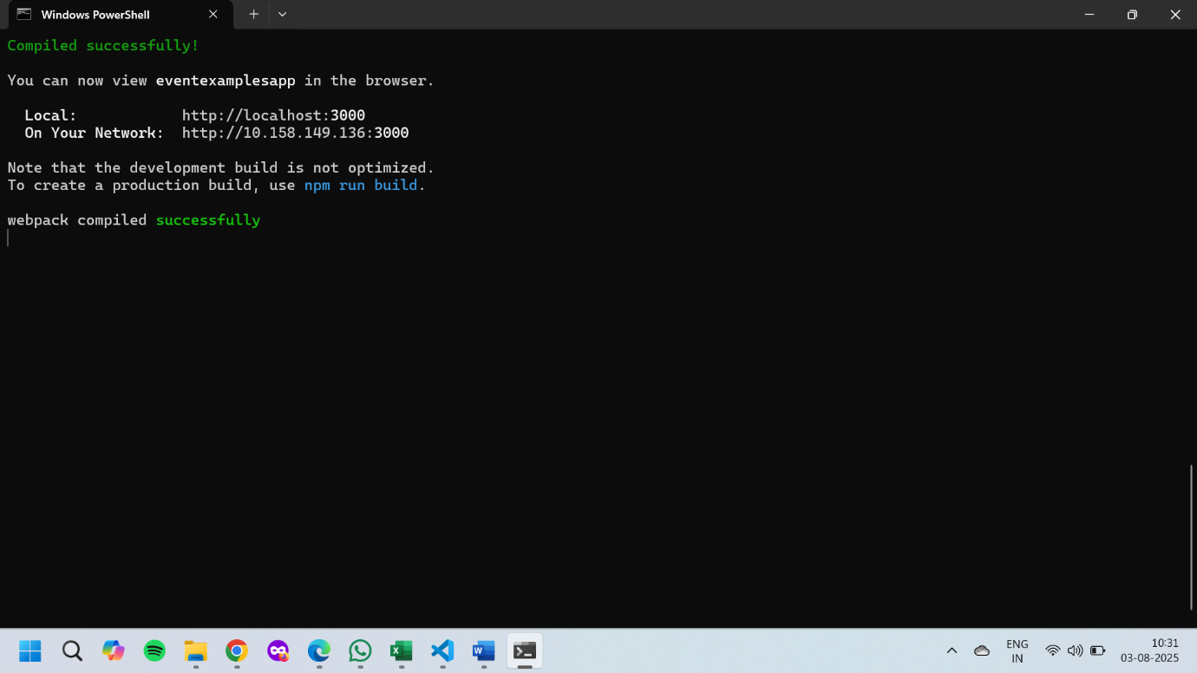

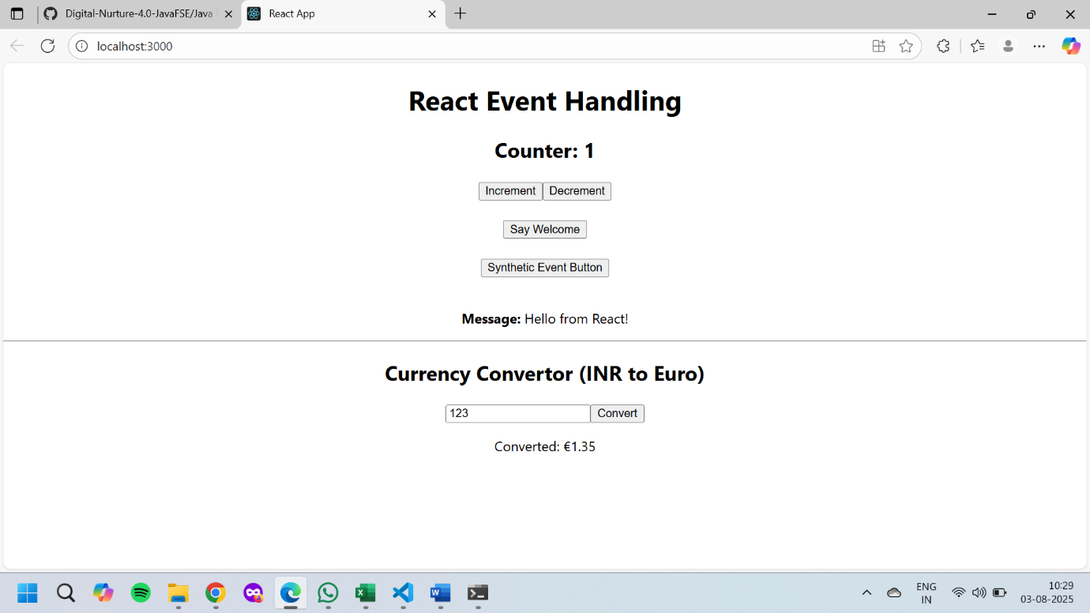

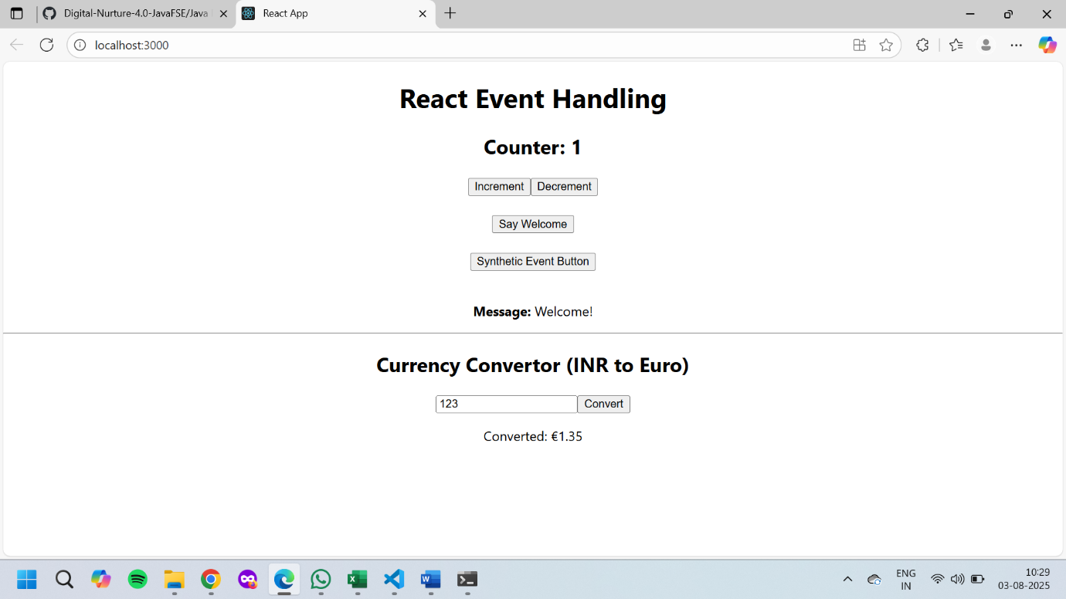

**12. ReactJS-HOL**

**File Name : GuestPage.js**

import React from 'react';

function GuestPage() {

return (

<div>

<h2>Welcome Guest!</h2>

<p>Here are today's available flights:</p>

<ul>

<li>Flight A → ₹5000</li>

<li>Flight B → ₹7000</li>

<li>Flight C → ₹6500</li>

</ul>

</div>

);

}

export default GuestPage;

**File Name : UserPage.js**

import React from 'react';

function UserPage() {

return (

<div>

<h2>Welcome Back, User!</h2>

<p>You can now book your flight tickets:</p>

<ul>

<li>Flight A → <button>Book</button></li>

<li>Flight B → <button>Book</button></li>

<li>Flight C → <button>Book</button></li>

</ul>

</div>

);

}

export default UserPage;

**File Name : App.js**

import React, { useState } from 'react';

import GuestPage from './components/GuestPage';

import UserPage from './components/UserPage';

import './App.css';

function App() {

const [isLoggedIn, setIsLoggedIn] = useState(false);

const handleLogin = () => setIsLoggedIn(true);

const handleLogout = () => setIsLoggedIn(false);

let page;

if (isLoggedIn) {

page = <UserPage />;

} else {

page = <GuestPage />;

}

return (

<div className="App">

<h1>Flight Ticket Booking App</h1>

{isLoggedIn ? (

<button onClick={handleLogout}>Logout</button>

) : (

<button onClick={handleLogin}>Login</button>

)}

<hr />

{page}

</div>

);

}

export default App;

**OUTPUT :**

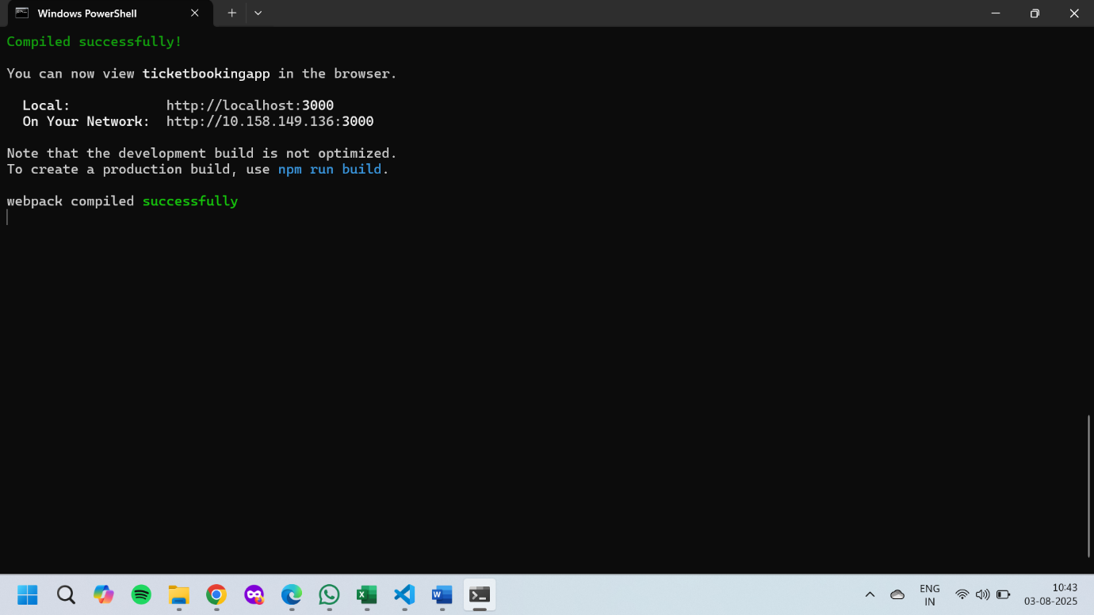

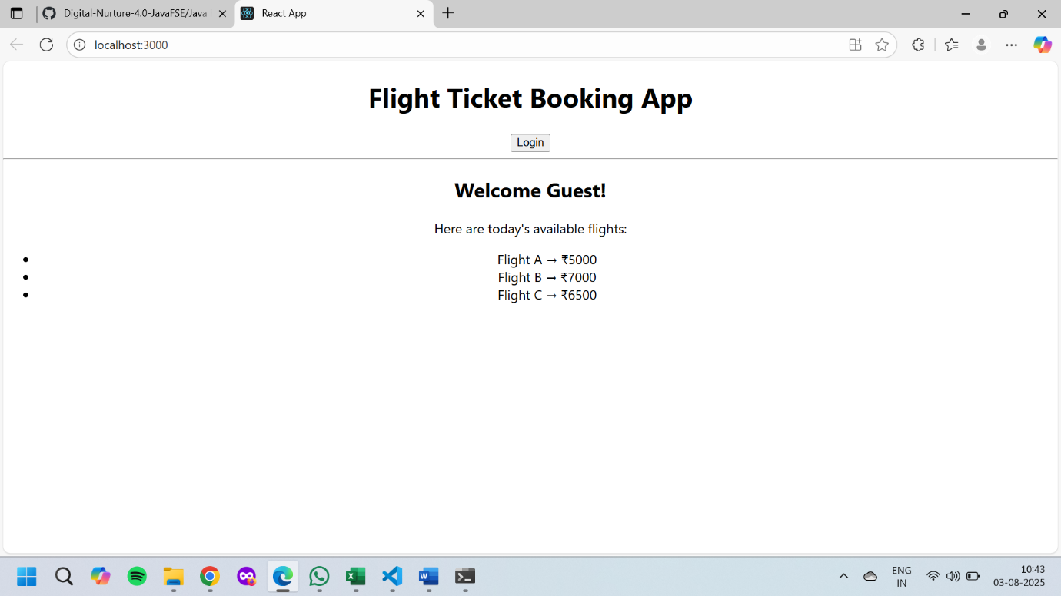

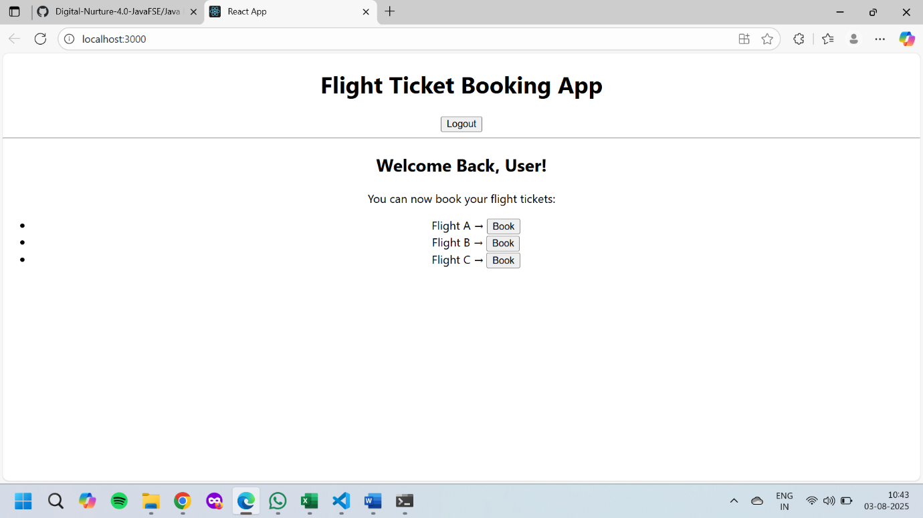

**13. ReactJS-HOL**

**File Name : BookDetails.js**

import React from 'react';

function BookDetails() {

return (

<div>

<h2>📚 Book Details</h2>

<p>Title: React Explained</p>

<p>Author: Zack Jackson</p>

<p>Pages: 250</p>

</div>

);

}

export default BookDetails;

**File Name : BlogDetails.js**

import React from 'react';

function BlogDetails() {

return (

<div>

<h2>Blog Details</h2>

<p>Title: Understanding React Hooks</p>

<p>Author: Jane Doe</p>

<p>Date: Aug 1, 2025</p>

</div>

);

}

export default BlogDetails;

**File Name : CourseDetails.js**

import React from 'react';

function CourseDetails() {

return (

<div>

<h2>Course Details</h2>

<p>Name: React for Beginners</p>

<p>Instructor: John Smith</p>

<p>Duration: 6 weeks</p>

</div>

);

}

export default CourseDetails;

**File Name : App.js**

import React, { useState } from 'react';

import BookDetails from './components/BookDetails';

import BlogDetails from './components/BlogDetails';

import CourseDetails from './components/CourseDetails';

import './App.css';

function App() {

const [selectedComponent, setSelectedComponent] = useState("book");

let componentToRender;

if (selectedComponent === "book") {

componentToRender = <BookDetails />;

} else if (selectedComponent === "blog") {

componentToRender = <BlogDetails />;

} else if (selectedComponent === "course") {

componentToRender = <CourseDetails />;

}

return (

<div className="App">

<h1>Blogger App Dashboard</h1>

{/* 2. Using if-else logic */}

<div>

<button onClick={() => setSelectedComponent("book")}>Show Book</button>

<button onClick={() => setSelectedComponent("blog")}>Show Blog</button>

<button onClick={() => setSelectedComponent("course")}>Show Course</button>

</div>

<hr />

{/* 3. Render selected component using element variable */}

{componentToRender}

<hr />

{/* 4. Using Ternary Operator */}

<div>

{selectedComponent === "book" ? (

<p>You are viewing a Book.</p>

) : selectedComponent === "blog" ? (

<p>You are reading a Blog.</p>

) : (

<p>You are exploring a Course.</p>

)}

</div>

{/* 5. Using Logical AND (&&) operator */}

{selectedComponent === "blog" && (

<div style={{ background: "#eef", padding: "5px" }}>

<strong>Note:</strong> Blogs are updated weekly.

</div>

)}

</div>

);

}

export default App;

**OUTPUT :**

