

Xanitizer's SonarQube Plugin

Last modified: June 24, 2016

Installation
SonarQube (http://www.sonarqube.org) is a tool that aggregates metric values and coding rule violations of different kinds. Xanitizer provides a plugin that feeds Xanitizer findings into SonarQube's database, for SonarQube versions starting with 5.2.
To run the plugin, the following steps must be performed:
- Adapt the build system so that on the machine where SonarQube is running, Xanitizer is run on the projects to be analyzed in headless mode, and creates a findings list report as an XML output file. The plugin does not run Xanitizer, it just reads the results of previous Xanitizer runs.
- Copy the file com.rigsit.xanitizer.sqplugin*.jar to the directory
<SonarQube base directory>/extensions/plugins
Then re-start SonarQube so that the new plugin is used. For example, on a 64 bit linux machine, you can restart SonarQube with the following command line:
<SonarQube base directory>/bin/linux-x86-64/sonar.sh restart
- Tell the plugin about the directory where Xanitizer stores the analysis results of the project that should be displayed in SonarQube. This can be done in SonarQube's GUI:
  - Log in as administrator.
  - Select the project for which you want to specify the Xanitizer project directory.
  - Select the “Administration” menu entry in the project's area (note: do not use the global “Administration” menu item in the top-bar, but the project-specific one beneath the project name).
  - Choose the menu item “General Settings”, and in the page that is shown then, at the left-hand side, click on the category “Xanitizer”.
  - Now specify the XML report file in the edit field labeled “Xanitizer XML Report File”. This is the findings list report output file that was created by the headless execution as described in step 1 above.
  - Press the button labeled “Save Xanitizer Settings” so that the setting is saved in SonarQube.
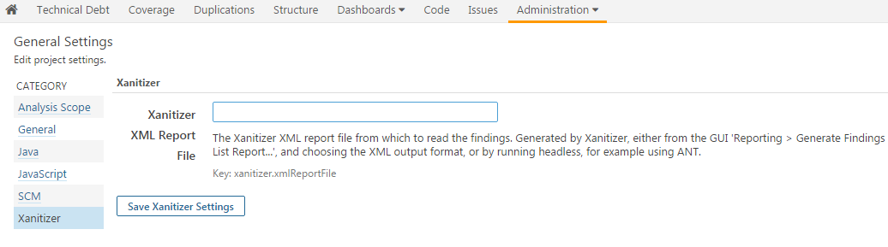
- Activate Xanitizer's rules in the quality profile that you are using:
  - Select the “Rules” menu item in the top-level bar.
  - Enter tag “xanitizer” in the edit text at left-hand side beneath “Tag”. Then, only the Xanitizer rules are displayed in the right-hand area.
  - Click on “Bulk Change” > “Activate In...” in the upper right corner. This allows to assign the displayed Xanitizer rules all at once to some quality profile.
  - In the dialog that opens, select the quality profile that you use for your project.
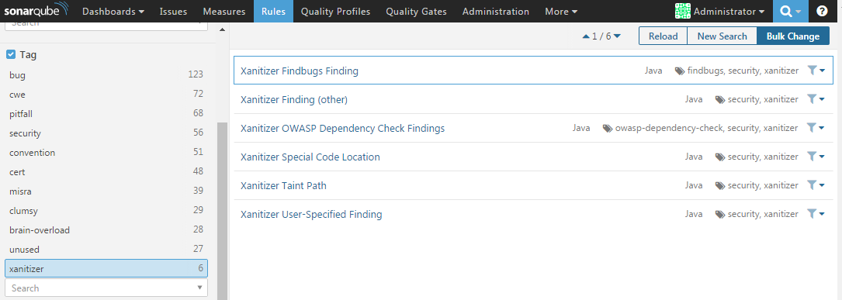
- When SonarQube is run the next time, it will read the Xanitizer results from the project directory and generate SonarQube issues and metrics for them.
- In order to display the Xanitizer issues, a special widget is provided. It is activated in the following way:
  - Select the project for which you want to activate the widget.
  - Click on the “Dashboards” menu item (in the third bar, below the project name), and select the dashboard that you are using (“Custom” by default). This will show your dashboard.
  - Click on “Configure widgets” in the upper right corner.
  - In the yellow area, type “xanitizer” into the search field. Now only the Xanitizer widget can be selected. Click on “Add widget”, and then on “Back to dashboard” in the upper right corner to display the Xanitizer widget.
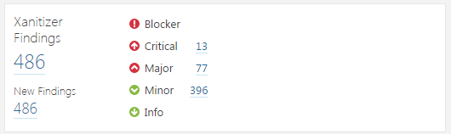
Additionally, the plugin can display the number of Xanitizer issues that have been found for different problem types. This is done via the “Measures” menu item. There are measures for each problem type, for each severity level, and the total number of issues.

Mapping of Xanitizer findings to SonarQube issues
SonarQube issues are computed in the following way from Xanitizer findings:
- For findings that are not associated with a Java class, issues are generated on the project level.
- Only for findings with problem classifications (e. g. “Warning”, “Must fix” etc.), issues are generated.
- Issues for Xanitizer findings with classifications “must fix” and “urgent fix” get severity “blocker”.
- For all other Xanitizer findings, the rating is used instead of the classification for determining the SonarQube severity:
  - Ratings larger than 7 are mapped to severity “critical”.
  - Ratings larger than 4, and up to 7, are mapped to severity “major”.
  - Ratings larger than 1, and up to 4, are mapped to severity “minor”.
  - Smaller ratings are mapped to severity “info”.
This means that for Xanitizer findings that are not classified as “must fix” or “urgent fix”, a rating larger than 7 must be assigned if the SonarQube issue corresponding to that finding should be considered to be “critical” in SonarQube.

