SALESTORM | SYSCRAFTERS 2026
2. System Context

Context Diagram
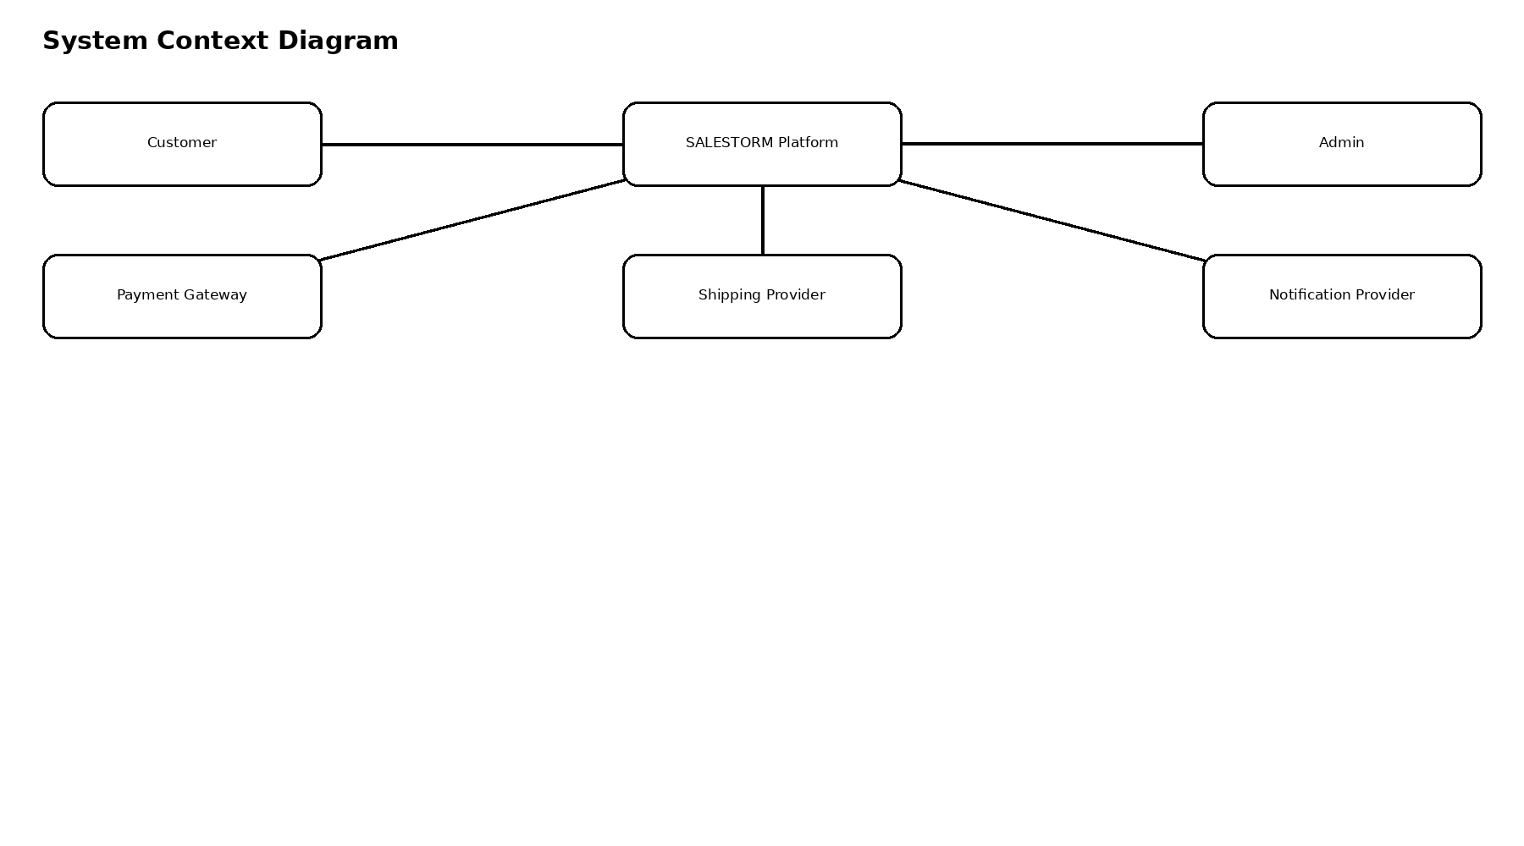
Purpose
The System Context Diagram represents SALESTORM as a central system and identifies external actors and systems interacting with it.

External Actors
Customer
The customer searches products, participates in flash sales, reserves products, makes payments and tracks orders.
Administrator
The administrator manages products, inventory, sale campaigns, promotions and operational monitoring.
Payment Gateway
Processes customer payments and returns success, failure or timeout responses.
Shipment Provider
Handles shipment creation, tracking and delivery status.
Notification Provider
Sends email, SMS or push notifications.
Authentication Provider
Provides authentication or identity verification where applicable.
STG Context
STG sits logically between high-volume purchase requests and inventory reservation.
10,000 Customers
↓
SALESTORM Platform
↓
Scarcity Token Gateway
↓
100 Inventory Tokens
↓
Inventory Reservation
The key design principle is that customers never directly manipulate the scarce inventory record.

