SALESTORM | SYSCRAFTERS 2026
3. HLD Architecture

High-Level Architecture
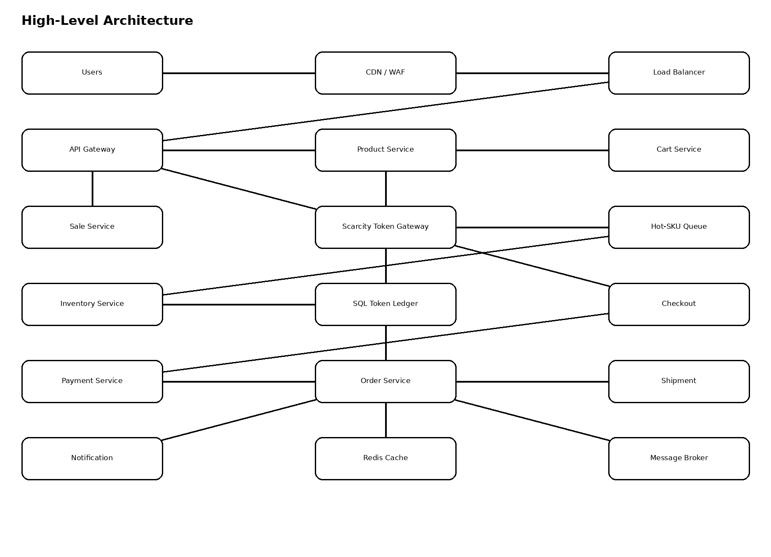

3.1 Critical Design Choice
- Normal reads scale through CDN/cache.
- Buy requests for a hot SKU enter STG instead of directly updating a hot inventory row.
- Only the controlled inventory path allocates scarce tokens.
- SQL is authoritative; Redis and the broker are supporting layers.
- Unrelated SKUs can scale independently.

3.2 Concurrency Strategy Comparison
Strategy | Strength | Weakness | Decision
Atomic direct decrement | Simple | Hot-row contention under flash traffic | Not primary
Optimistic locking | Correct with version checks | Retries can amplify load | Not primary
Pessimistic locking | Deterministic | Lock waits reduce throughput | Not primary
STG + per-SKU queue + token ledger | Controlled contention and deterministic allocation | More moving parts | SELECTED

