SALESTORM | SYSCRAFTERS 2026
4. Container Diagram

Container Diagram

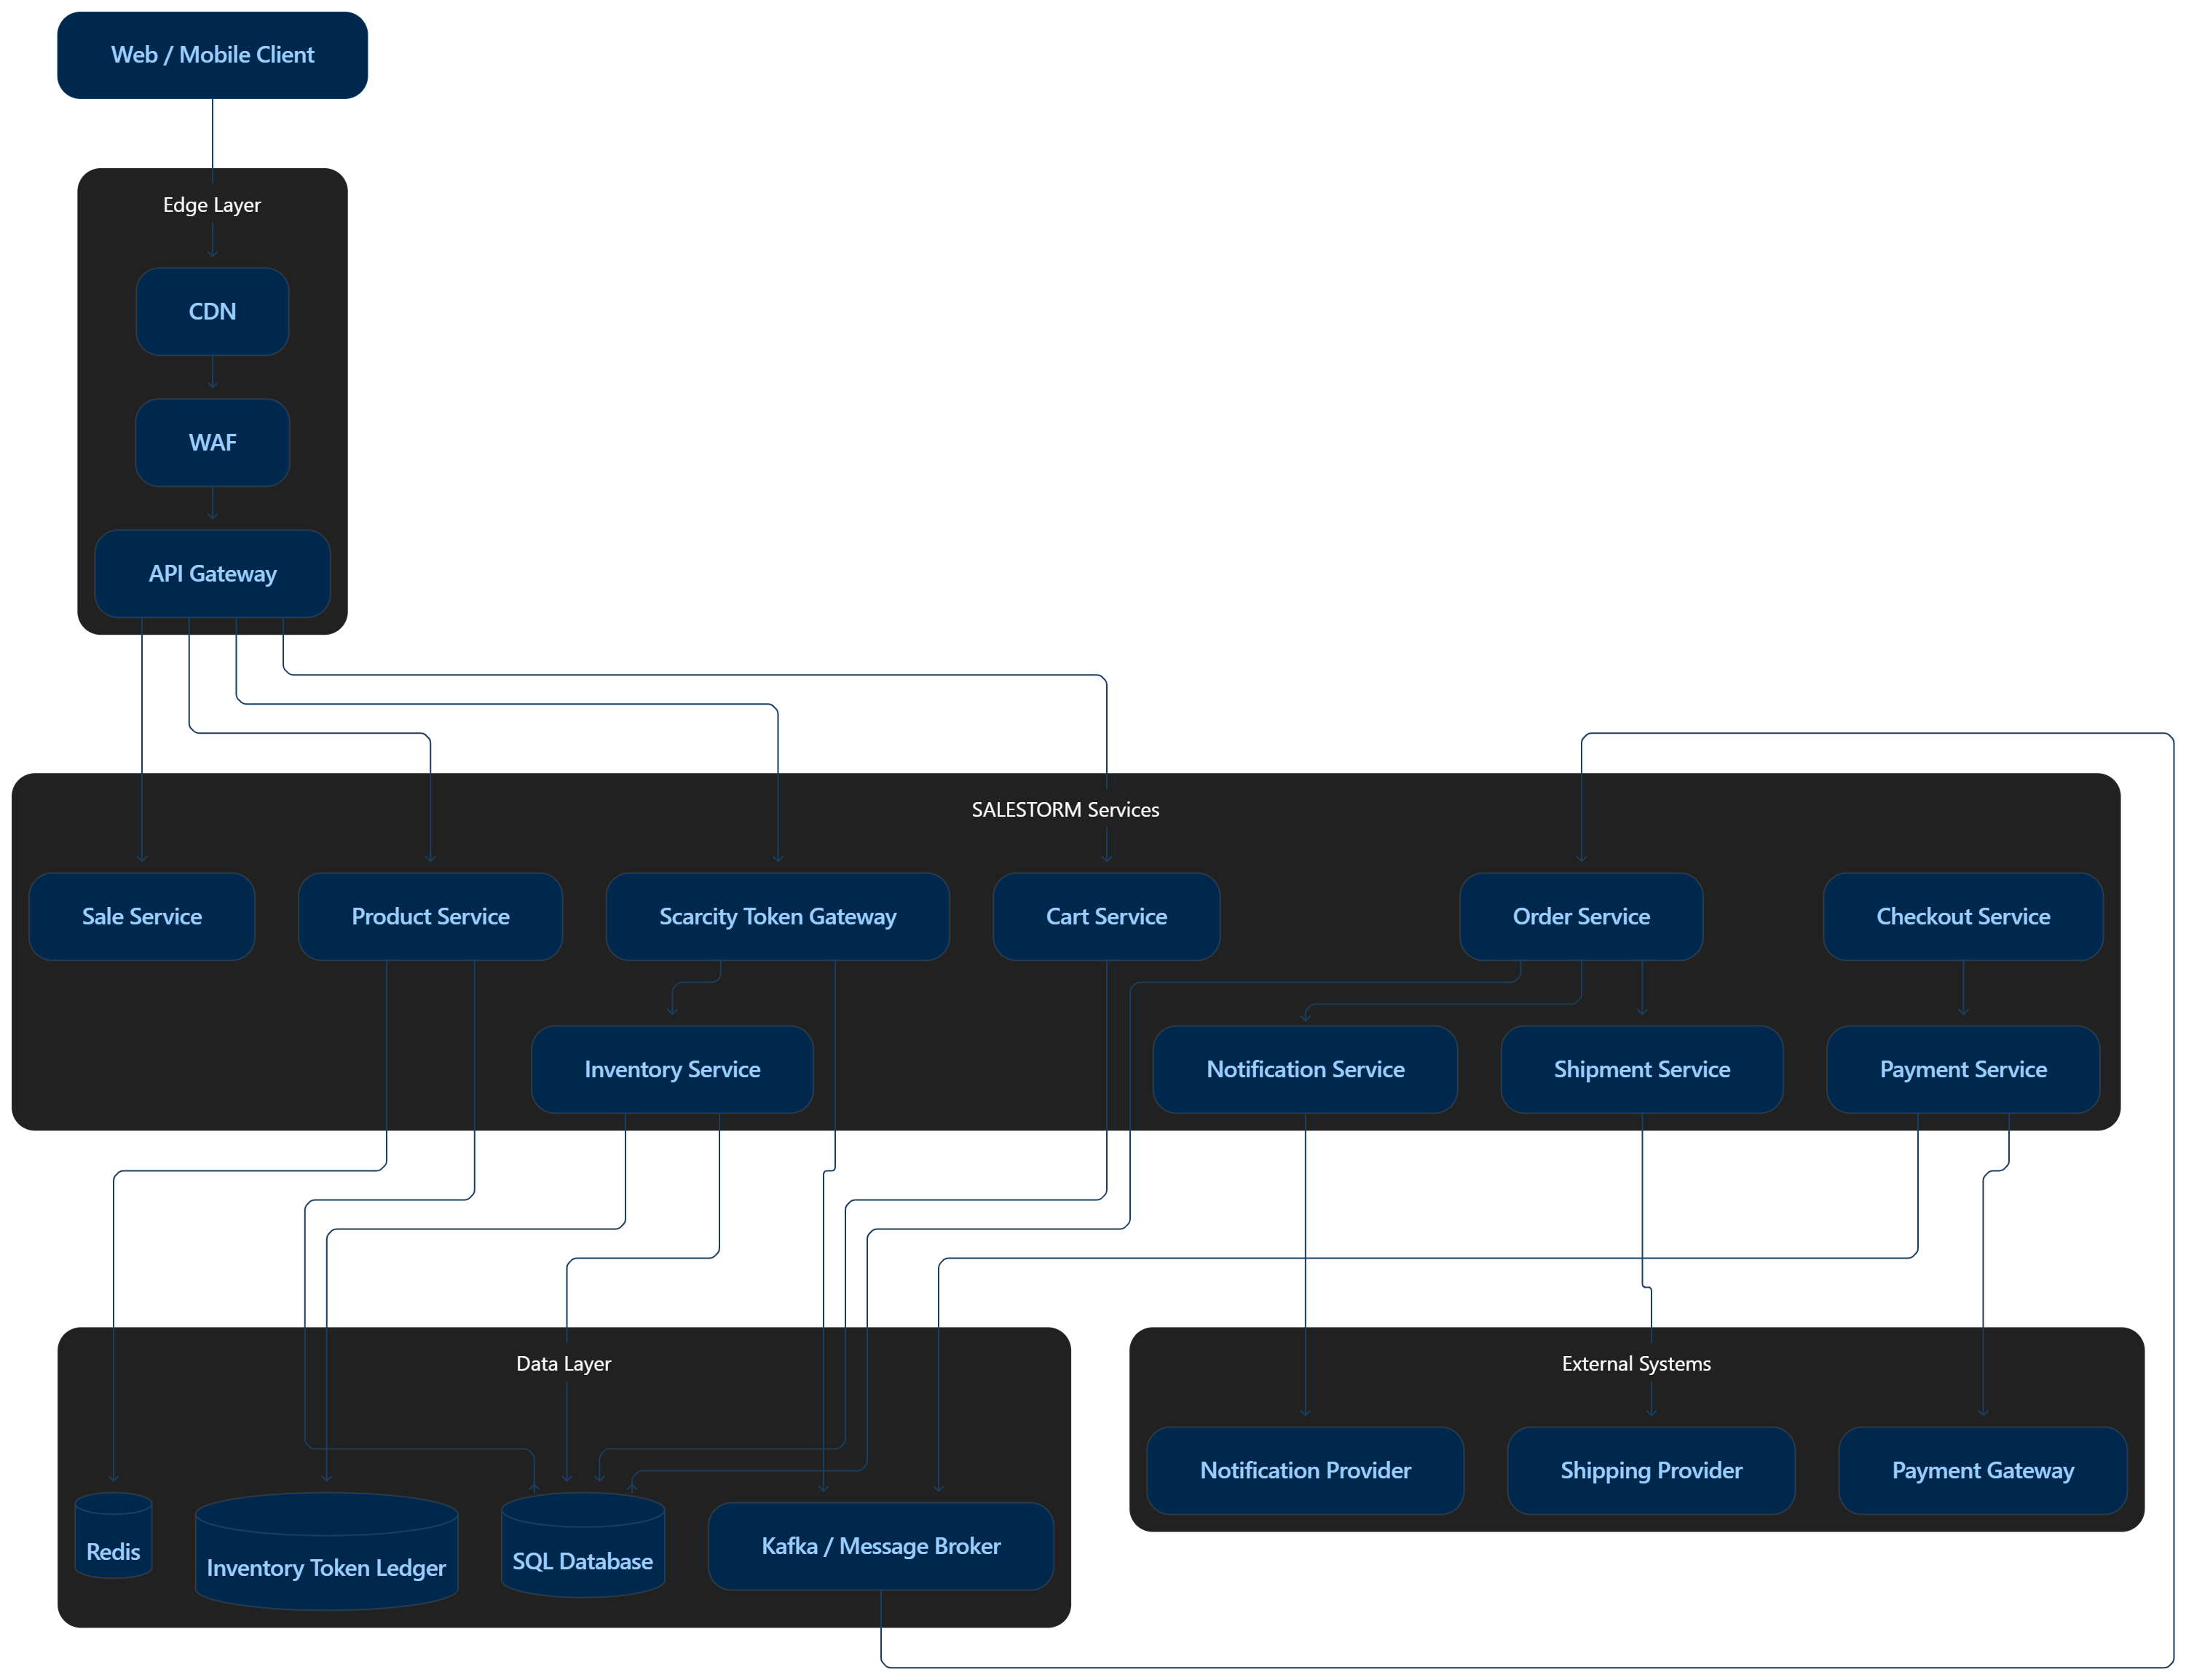

Container | Responsibility
API Gateway | Authentication, routing, rate limiting, admission control
STG | Idempotency + hot-SKU queue admission
Inventory | Token allocation, reservation, release and confirmation
Checkout | Coordinates purchase/payment initiation
Payment | Provider integration and payment state
Order | Idempotent order lifecycle
Shipment/Notification | Asynchronous downstream processing
SQL | Authoritative transactional data
Redis | Cache/non-authoritative acceleration
Broker | Events, buffering, retry

Container Interaction
Client
↓
API Gateway
↓
Sale Service
↓
STG
↓
Reservation Service
↓
Checkout
↓
Payment
↓
Order
↓
Shipment

STG Internal Responsibility
STG performs:
- Request validation.
- Idempotency validation.
- Queue admission.
- Token availability checking.
- Atomic token allocation.
- Reservation creation.
- Token lease assignment.
- Release on timeout.
- Confirmation after payment.

