SALESTORM | SYSCRAFTERS 2026
5. Component Diagram

STG / Inventory Components
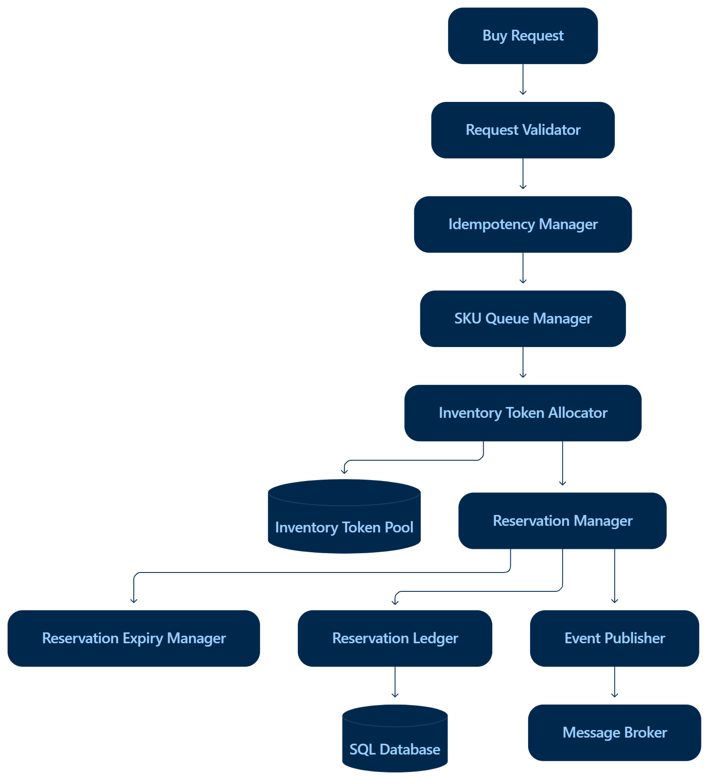

Component | Responsibility
Request Validator | Schema/auth/business input validation
Idempotency Manager | Detect repeated logical requests
SKU Queue Manager | Serialize hot-SKU contention
Token Allocator | Allocate available token(s)
Reservation Manager | Create/confirm/release reservations
TTL Manager | Expire unpaid holds
Ledger Repository | Transactional DB access
Event Publisher | Publish lifecycle events

Token Allocator
Responsible for allocating exactly one available token to an accepted purchase request.
Example:
Request A → TOKEN-001
Request B → TOKEN-002
Request C → TOKEN-003
If no token is available:
Request → OUT_OF_STOCK

Reservation Manager
Creates temporary reservations.
AVAILABLE
↓
RESERVED
↓
PAYMENT_PENDING
Successful payment:
PAYMENT_PENDING → CONFIRMED → SOLD
Failure:
PAYMENT_PENDING → RELEASED

Idempotency Manager
Each purchase request contains an idempotency key.
Example:
Idempotency-Key:
USER123-PRODUCT456-REQUEST789
If the same request arrives multiple times, the system returns the original result instead of creating another reservation.

