SALESTORM | SYSCRAFTERS 2026
6. Deployment Diagram

Multi-AZ Deployment
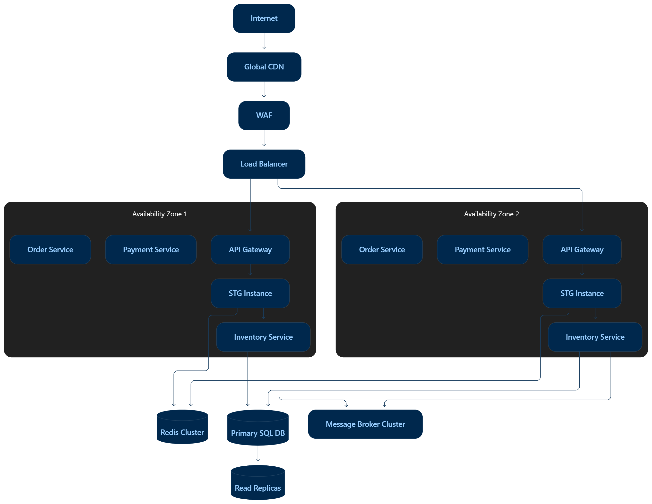

- Stateless services are horizontally scalable.
- Broker and Redis are clustered.
- SQL primary is the write authority; replicas serve safe read-heavy workloads.
- External payment/shipping dependencies are protected by timeout, retry and circuit breaker.
- Monitoring is centralized.

Horizontal Scaling
- Stateless services can be replicated:
- Payment Service × N
- Order Service × N
- Product Service × N
- STG API × N
- The database and token allocation mechanism maintain consistency.

Database Deployment
- Use:
- Primary SQL database.
- Read replicas.
- Automated backup.
- Disaster recovery replica.
- Connection pooling.
- Writes affecting inventory tokens and reservations are directed to the authoritative transactional database.

