SALESTORM | SYSCRAFTERS 2026
7. Database / ER Diagram

ER Diagram
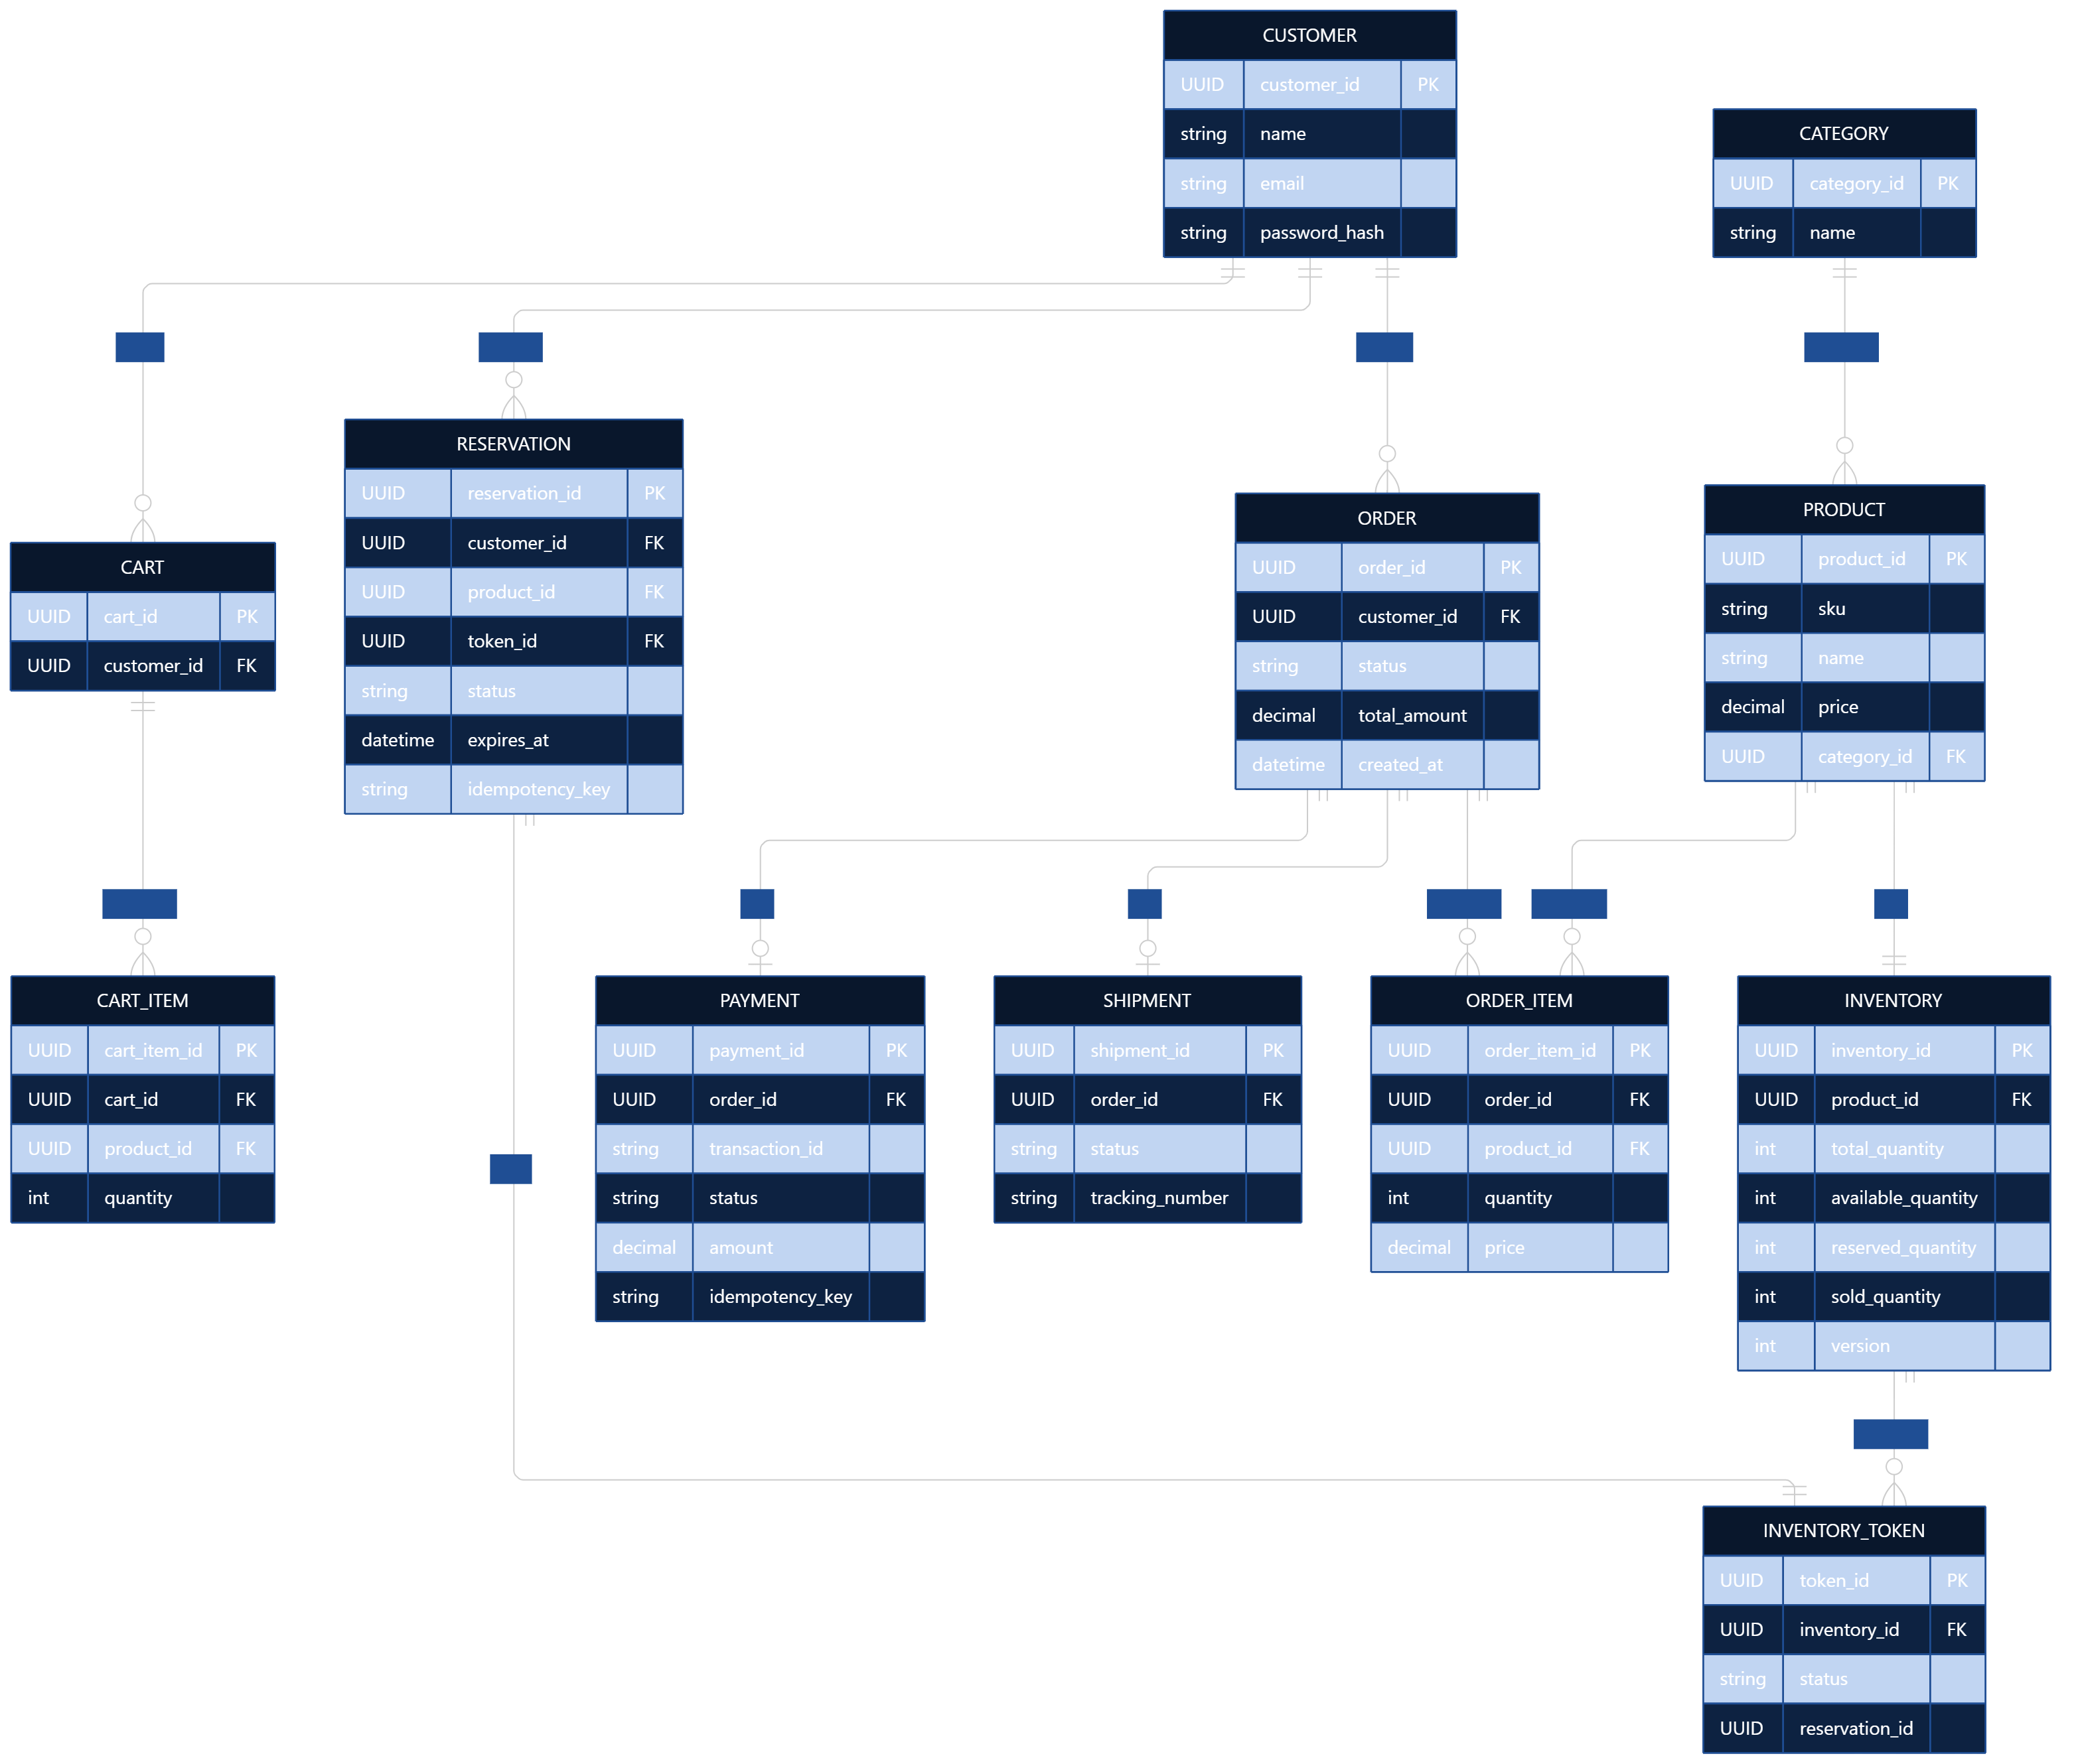

Entity | Important fields / constraints
CUSTOMER | customer_id PK
CATEGORY | category_id PK, unique name
PRODUCT | product_id PK, category_id FK, SKU
INVENTORY | inventory_id PK, product_id FK, quantities, version
INVENTORY_TOKEN | token_id PK, inventory_id FK, status, reservation_id FK
RESERVATION | reservation_id PK, customer_id, inventory_id, status, expires_at, idempotency_key
CART/CART_ITEM | cart and product quantity records
ORDER/ORDER_ITEM | order header and item records
PAYMENT | payment_id, order_id, unique transaction_reference, status
SHIPMENT | shipment_id, order_id, provider/tracking reference

Important uniqueness constraints
payment.transaction_id UNIQUE

reservation.idempotency_key UNIQUE

inventory_token.token_id UNIQUE

product.sku UNIQUE

payment(order_id) UNIQUE
These help prevent duplicates.

