SALESTORM | SYSCRAFTERS 2026
8. Class Diagram

Critical Class Relationships
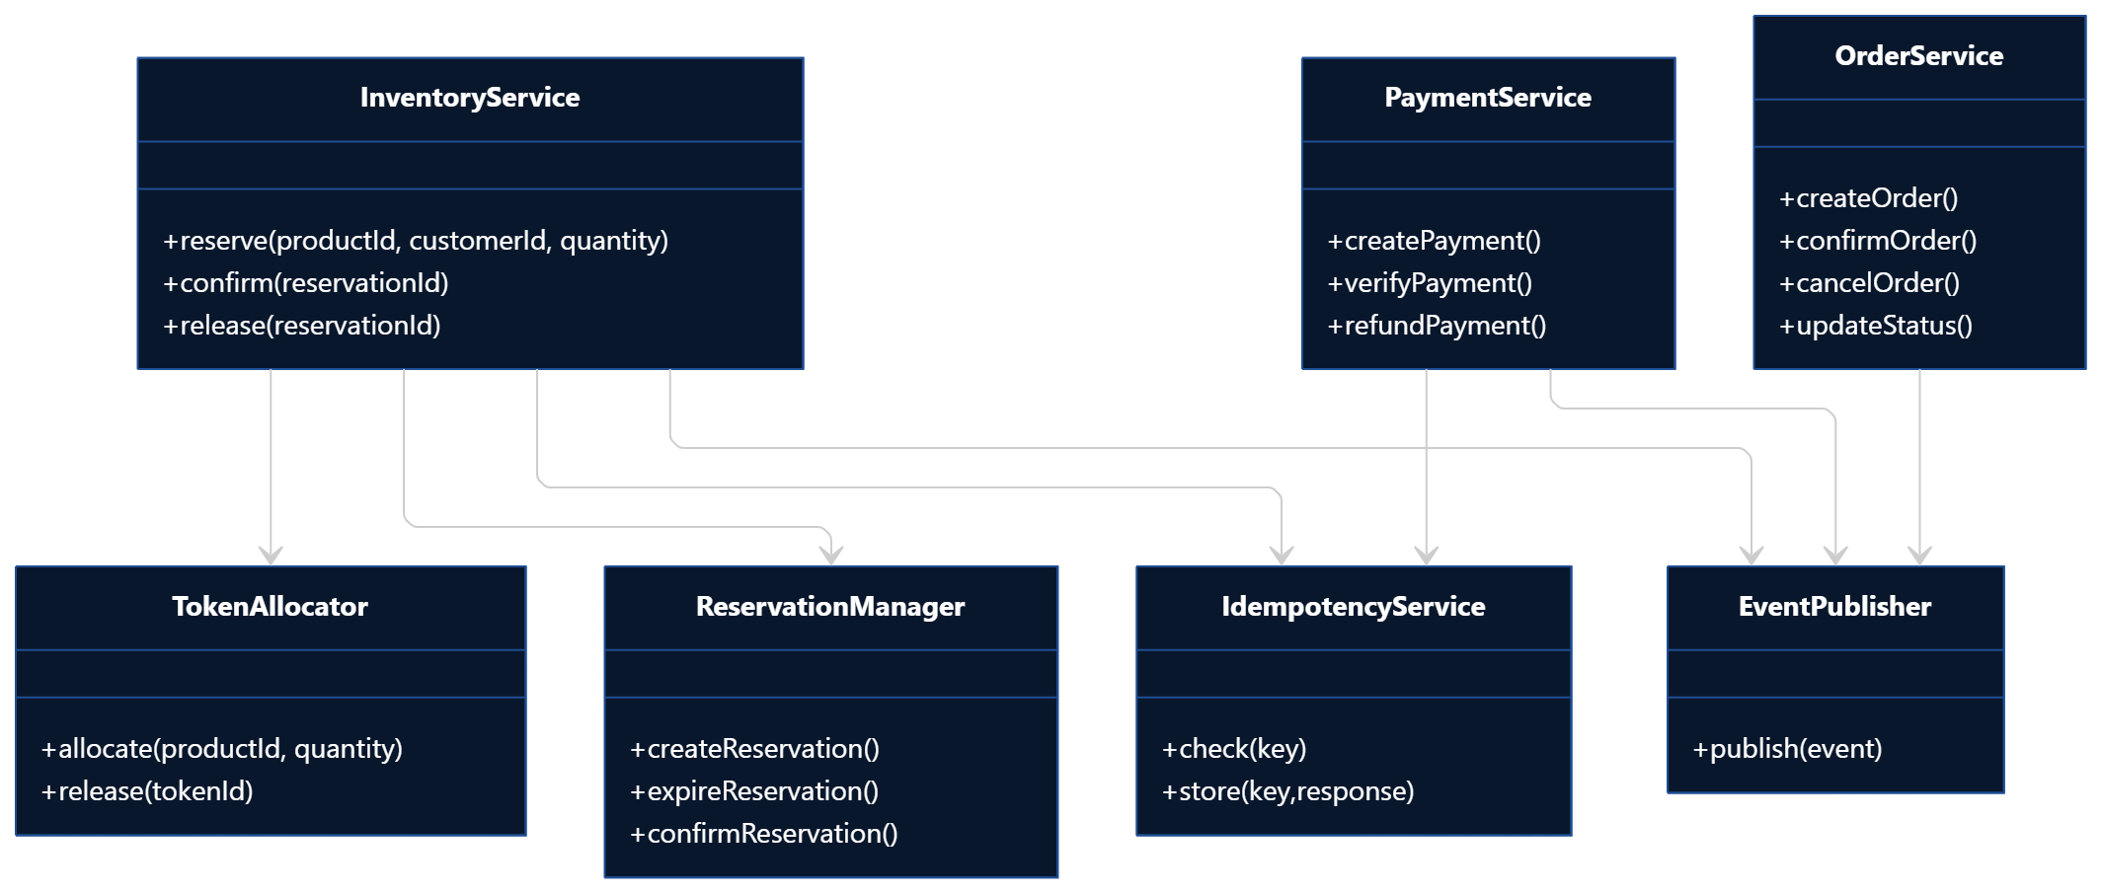
The class design of the SALESTORM system follows a modular and object-oriented architecture in which each class has a clearly defined responsibility. The core classes include InventoryService, TokenAllocator, ReservationManager, IdempotencyService, PaymentService, OrderService, EventPublisher, and repository classes.
The InventoryService acts as the main interface for inventory-related operations. It communicates with the TokenAllocator, which is responsible for selecting available inventory tokens. The ReservationManager controls the lifecycle of reservations, including creation, confirmation, expiration and release.
The IdempotencyService ensures that repeated requests with the same idempotency key do not create duplicate reservations or payments. The PaymentService manages communication with the payment provider and handles success, failure and timeout conditions. The OrderService creates and manages orders after successful payment.
Repository classes such as TokenRepository, ReservationRepository, PaymentRepository, and OrderRepository isolate database operations from business logic.
This separation makes the system easier to maintain, test and scale.
Main classes
- InventoryService – manages inventory operations.
- TokenAllocator – allocates available scarcity tokens.
- ReservationManager – manages reservation lifecycle.
- IdempotencyService – prevents duplicate operations.
- PaymentService – handles payment processing.
- OrderService – manages order creation and lifecycle.
- EventPublisher – publishes system events.
- TokenRepository – accesses token data.
- PaymentGateway – abstraction for external payment providers.

