SALESTORM | SYSCRAFTERS 2026
9. Purchase / Reservation Sequence Diagram

Purchase Sequence
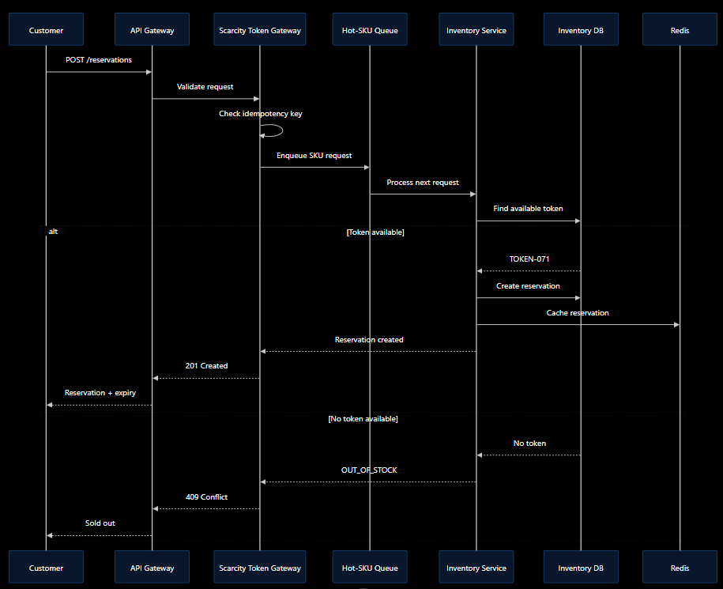
9.1 Low-Level Design
The Low-Level Design explains how the major components of the SALESTORM system internally work.
The critical modules are:
- Inventory Service
- Scarcity Token Gateway
- Reservation Manager
- Payment Service
- Order Service
- Notification Service
The LLD should contain:
- Class Diagram
- Interface-based design
- Purchase/Reservation Sequence Diagram
- Payment Sequence Diagram
- Order Creation and Recovery Sequence Diagram
- Order/Reservation State Diagram
Our LLD approach
The Scarcity Token Gateway (STG) is the central concurrency-control component.
Instead of allowing thousands of customers to directly update the same inventory record, STG places requests for a high-demand SKU into a controlled queue.
For 100 available units:
100 units
↓
100 logical inventory tokens
↓
STG
↓
Hot-SKU Queue
↓
Controlled Token Allocation
↓
Reservation
Each token can exist in:
AVAILABLE
HELD
SOLD
This provides a deterministic mechanism for handling the final available units.
9.2 — SOLID PRINCIPLES
The design should demonstrate all five SOLID principles.
S — Single Responsibility Principle
Separate responsibilities:
- TokenAllocator → allocates inventory tokens
- ReservationManager → manages reservation lifecycle
- PaymentService → handles payment
- OrderService → manages orders
- NotificationService → handles notifications
O — Open/Closed Principle
The system should allow new payment or pricing strategies without modifying the existing core workflow.
Example:
PaymentStrategy
├── CardPayment
├── UPI
└── WalletPayment
L — Liskov Substitution Principle
Any implementation of a common interface should be replaceable without breaking the system.
I — Interface Segregation Principle
Instead of one huge interface, use smaller interfaces:
PaymentGateway
ShippingProvider
NotificationProvider
InventoryRepository
D — Dependency Inversion Principle
High-level services should depend on abstractions rather than concrete implementations.

