SALESTORM | SYSCRAFTERS 2026
10. Payment Sequence Diagram

Payment Sequence
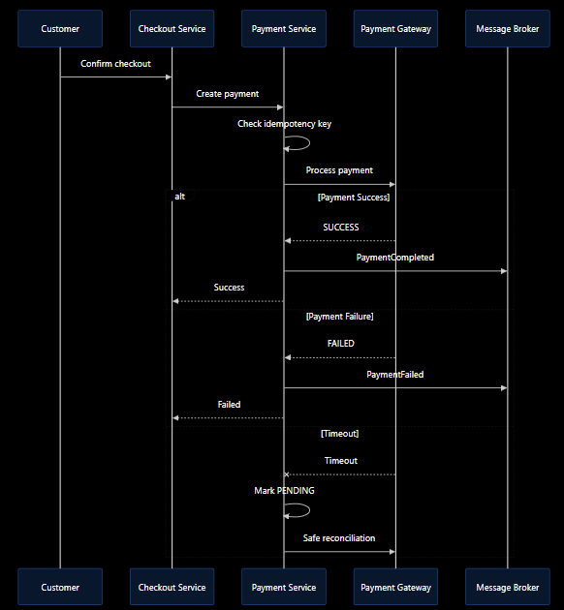

Case | Behavior
Success | Persist payment; confirm reservation; publish OrderConfirmed.
Failure | Persist failure; release token/reservation.
Timeout | Reconcile provider state before compensation.
Duplicate | Return original result using idempotency.
Order outage | Keep durable payment result and retry OrderConfirmed.
Provider outage | Timeout + circuit breaker + bounded retry.

