SALESTORM | SYSCRAFTERS 2026
11. Order Sequence Diagram

Order Recovery Sequence
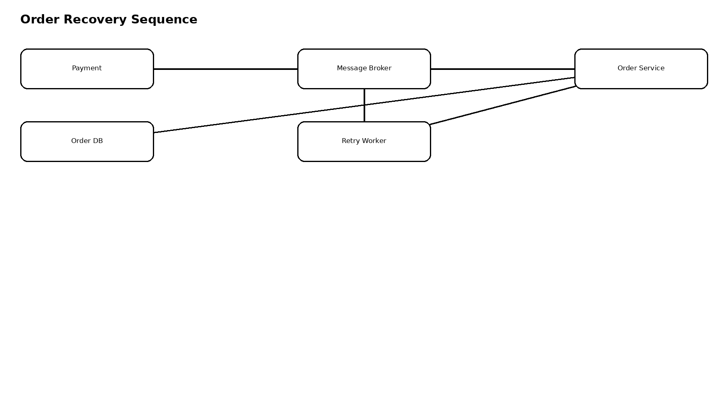
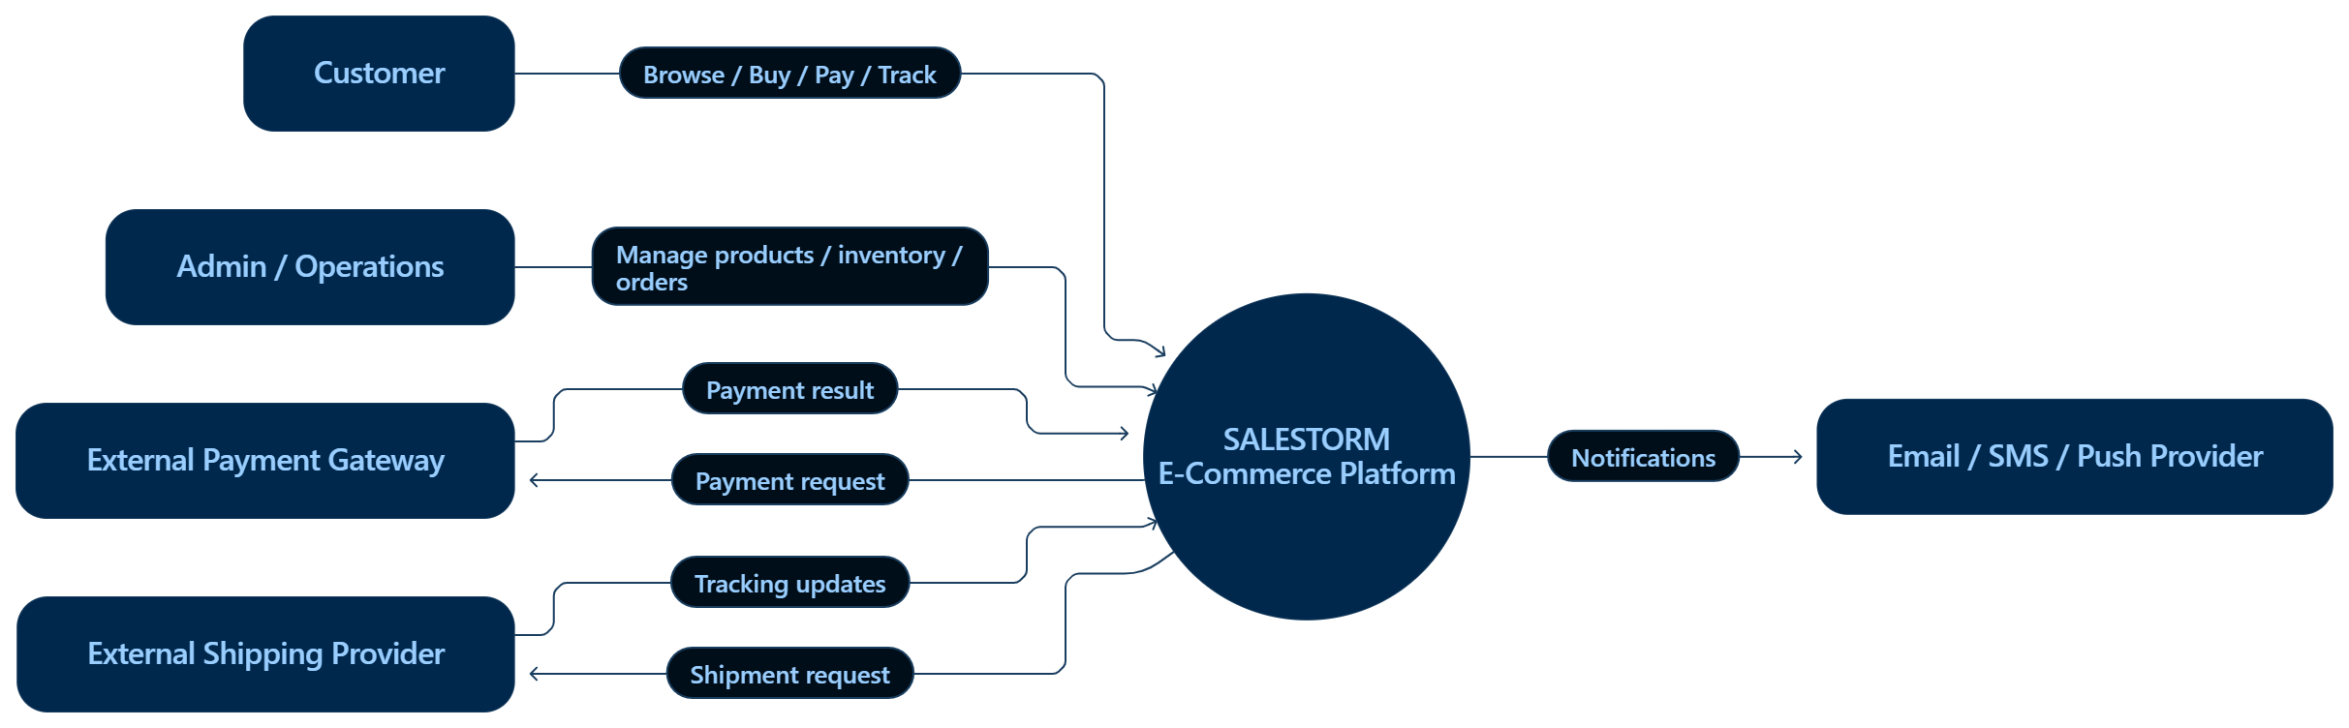
The order consumer uses a unique business reference such as payment_id/order_reference so reprocessing cannot create a second order.

