SALESTORM | SYSCRAFTERS 2026
12. Order / Reservation State Diagram

RESERVATION STATE:

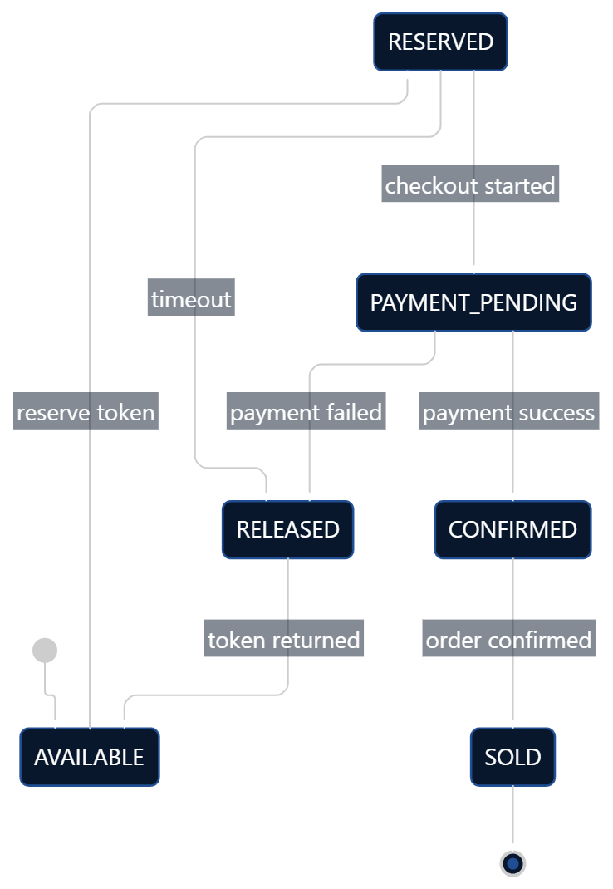

ORDER STATE:
