

AIC SOLUTIONS

A PERSONALIZED SOFTWARE FOR AGARWAL’S INVEST CARE

|  |  |  |
| --- | --- | --- |
| Name | Reg. No. | Signature |
| **Ritik Agarwal (Team Leader)** | 202243900348 | ------------------------- |
| **Sahitya Jiya** | 202243900370 | ------------------------- |
| **Aditya Prakash** | 202243900196 | ------------------------- |
| **Sachin Karn** | 202243900362 | ------------------------- |







**Arya Kumar Road, Rajendra Nagar, Patna – 800016**

SYNOPSIS

**(Paper : Hons. VIII)**

**Session: 2022 - 2025**

***for***

**Title of the Project**

**AIC SOLUTIONS**

**……………….……………………………………………**

**PRJ2432N**

**SubmittedBy:**

|  |  |  |  |
| --- | --- | --- | --- |
| **Coll. Roll No.** | Registration No. | **Name** | **Signature** |
| 22085 | 202243900348 | **Ritik Agarwal** |  |
| 22079 | 202243900370 | **Sahitya Jiya** |  |
| 22119 | 202243900196 | **Aditya Prakash** |  |
| 22090 | 202243900362 | **Sachin Karn** |  |

**Group ID : …………………………**

**Remarks:**



AIC SOLUTIONS

A PERSONALIZED SOFTWARE FOR AGARWAL’S INVEST CARE

**ACKNOWLEDGEMENT**

We are truly grateful and proud to present our project, **AIC Solution**, created for **Agarwal Invest Care**. This journey has been full of learning, growth, and teamwork, made possible with the help and support of many wonderful people.

we are very grateful to **Agarwal Invest Care** for giving us the chance to work on this project. Their trust and encouragement inspired us to create the best solution we could.

We sincerely thank **Anupam Singh**, Head of Department, for his constant guidance, encouragement, and valuable advice throughout this project. His support has motivated us to work hard and achieve our goals.

We would like to convey our gratitude to **Md. Khurshid Alam**, in our Faculty for the good of during the class period of our course Coordinator and All our course faculty members. His knowledge, feedback, and belief in us have been key to completing this project successfully.

A special thanks to our team members, whose hard work, creativity, and cooperation made this project possible. Everyone’s contributions have been important in making this experience unforgettable.

We would like to thank all the faculty members and our lab teachers for sharing their knowledge and helping us with practical skills. Their support and patience have been invaluable during this journey.



**DECLARATION**

We hereby declare that the project titled “AIC Solution”, submitted as part of the curriculum for the 6th semester of the Bachelor of Computer Applications program at Arcade Business College, Patna, is a genuine and original work carried out by us.

This project has been completed under the expert guidance of Anupam Singh, Head of Department, Arcade Business College, Patna.



|  |  |  |
| --- | --- | --- |
| Name | Reg. No. | Signature |
| **Ritik Agarwal (Team Leader)** | 202243900348 | ------------------------- |
| **Sahitya Jiya** | 202243900370 | ------------------------- |
| **Aditya Prakash** | 202243900196 | ------------------------- |
| **Sachin Karn** | 202243900362 | ------------------------- |

**Co-Supervised By:**

**-------------------------**

**Md Khurshid Alam**

Faculty

Arcade Business College

**Supervised By:**

**-------------------------**

**Anupam Singh**

H.O.D

Arcade Business College

Table of Contents

1. INTRODUCTION: AGARWAL’S INVEST CARE 1

Team Size 1

The company has a team of three dedicated employees: 1

Our Services 1

Agarwal's Invest Care offers a diverse portfolio of financial products, including: 1

Benefits of a Financial Consultant 2

A financial consultant can provide numerous benefits to individuals, including: 2

Company’s Mission 2

1. LIMITATION OF THE EXISTING SYSTEM 3

1.Storage and Space: 3

2.Accessibility and Retrieval: 3

3.Security and Privacy 3

4.Data Integrity and Accuracy 3

5.Cost and Efficiency 3

1. OBJECTIVE OF THE PROJECT 4

1.Storage and Space: 4

2.Accessibility and Retrieval 4

3.Security and Privacy 4

4.Data Integrity and Accuracy 4

5.Cost and Efficiency 4

1. H/W AND S/W REQUIREMENTS 5

➢ Hardware Requirements 5

1. INTRODUCTION TO VB 6.O 6

Key Features of VB6.O: 6

VB6 is versatile and supports the creation of various Types of applications, including: 7

Desktop Applications: 7

Data-driven Applications: 7

Games: 7

Utility Tools: 7

Web-Enabled Applications: 7

Automation Applications: 7

The VB6 IDE is where you design, code, and test your applications. Its components include: 8

1. INTRODUCTION TO ORACLE 10G 9

Oracle 10g for Desktop-Based Applications 9

Key Uses in Desktop Applications 9

Benefits of Using Oracle 10g for Desktop-Based Applications 10

Examples of Desktop-Based Applications Using Oracle10g 10

1. MODULE DESCRIPTION 11

Department Management Module: 12

Employee Management Module: 13

Attendance and Leave Management Module 13

Payroll Management Module 14

Bonus and Incentives Module 14

Advance Management Module 14

Retirement and Benefits Module 14

Taxation and Compliance Module 14

Pay Slip Generation Module 15

Salary Calculation Module 15

Reports and Analytics Module 16

User Roles and Security Module 16

Integration Module (Optional) 16

1. E-R DIAGRAM 17
2. TABLE DESCRIPTION 18

1.DEPARTMENT TABLE 18

2.POSITION TABLE 19

3.EMPLOYEE TABLE 20

4.BANK TABLE 22

6.ATTENDANCE TABLE 24

7. PAYROLL TABLE 25

8. COMPLIANCE TABLE 26

9.ADVANCE TABLE 27

10.BONUS TABLE 28

11.SALARY_SLIP 29

12.SALARY TABLE 30

1. PROJECT PLANNING 31
2. GANTT CHART 32

Key Features of a Gantt Chart 32

Why Use a Gantt Chart? 32

1. FUTURE SCOPE OF PROJECT 33

Future Scope for Desktop-Based Applications Using VB6.0 33

# INTRODUCTION: AGARWAL’S INVEST CARE

Agarwal's Invest Care, established in 2007, is a premier service sector company dedicated to providing a wide range of intangible financial products. Owned by Narendra Mohan Agarwal.

The company prides itself on its personalized and professional services. The ownership status of the company is sole proprietorship.

Currently, Agarwal's Invest Care is managing Assets Under Management (AUM) worth 109 Crores. Located at M/S Agarwal's Invest Care, in front of Axis Bank, Arya Kumar Road, Rajendra Nagar, Patna, Bihar, India 800016.

## Team Size

### The company has a team of three dedicated employees:

1. Ajay Kumar

2. Janardan Kumar

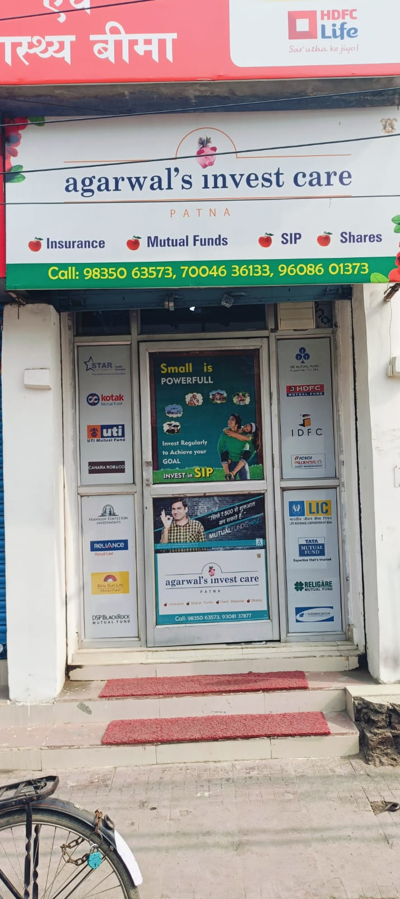3. Dada

## Our Services

### Agarwal's Invest Care offers a diverse portfolio of financial products, including:

1.Equity & Derivatives

2.Commodity Market

3.Mutual Funds

4.Fixed Deposits (FD) & Recurring Deposits (RD)

5.Life Insurance

6.General Insurance

7.Motor Insurance

8.Government Bonds

## Benefits of a Financial Consultant

### A financial consultant can provide numerous benefits to individuals, including:

Expert Advice: Financial consultants offer expert advice tailored to your specific financial situation and goals. They help you make informed decisions about investments, savings, and insurance.

Personalized Financial Planning: They create personalized financial plans that align with your short-term and long-term objectives, ensuring that your financial resources are managed effectively.

Risk Management: Consultants help you identify and manage financial risks, providing strategies to protect your assets and investments.

Tax Efficiency: They offer guidance on tax-efficient investment strategies, helping you minimize tax liabilities and maximize returns.

Time Savings: Managing finances can be time-consuming. A financial consultant handles the complexities, allowing you to focus on other important aspects of your life.

Peace of Mind: Knowing that a professional is managing your finances can provide peace of mind, reducing stress and uncertainty about your financial future.

## Company’s Mission

Agarwal's Invest Care is currently managing assets under management (AUM) worth 109 crores rupees, demonstrating its expertise and trustworthiness in the financial services industry.

The company's mission is to provide our clients with the best financial solutions tailored to their individual needs, ensuring their investments are secure and profitable. With a commitment to excellence and a customer-centric approach, Agarwal's Invest Care continues to be a trusted name in the financial services industry.

# LIMITATION OF THE EXISTING SYSTEM

### 1.Storage and Space:

Physical Space: Paper documents require physical storage space, which can become cumbersome and expensive as the volume of documents grows.

Organization: Managing and organizing large volumes of paper documents can be challenging and time-consuming.

### 2.Accessibility and Retrieval:

Limited Access: Accessing paper documents often requires physical presence, making it difficult for remote access.

Slow Retrieval: Finding specific information in a large stack of paper documents can be slow and inefficient.

3.Security and Privacy:

Vulnerability: Paper documents are susceptible to damage from fire, water, and other environmental factors.

Unauthorized Access: Ensuring the security and privacy of paper documents can be difficult, as they can be easily misplaced or accessed by unauthorized individuals.

4.Data Integrity and Accuracy:

Human Error: Manual data entry and processing are prone to human errors, which can affect the accuracy and integrity of the data.

Duplication: Managing duplicates and ensuring data consistency can be challenging with paper documents.

5.Cost and Efficiency:

Operational Costs: The cost of paper, printing, storage, and maintenance can add up over time.

Time-Consuming: Manual processes are often slower and less efficient compared to automated software solutions.

# OBJECTIVE OF THE PROJECT

### 1.Storage and Space:

Digital Storage: Software systems store data digitally, reducing the need for physical storage space.

Scalability: Digital storage can be easily scaled to accommodate growing data volumes.

2.Accessibility and Retrieval:

Remote Access: Software systems allow for remote access, enabling users to access information from anywhere with an internet connection.

Quick Retrieval: Advanced search functionalities enable quick and efficient retrieval of specific information.

3.Security and Privacy:

Data Protection: Software systems can implement robust security measures, such as encryption and access controls, to protect data.

Audit Trails: Software systems can maintain audit trails to track access and modifications to data.

4.Data Integrity and Accuracy:

Automation: Automated data entry and processing reduce the risk of human errors and improve data accuracy.

Consistency: Software systems can enforce data validation rules to ensure consistency and integrity.

5.Cost and Efficiency:

Reduced Operational Costs: Digital systems reduce the need for paper, printing, and physical storage, leading to cost savings.

Increased Efficiency: Automated processes are faster and more efficient, improving overall productivity.

# H/W AND S/W REQUIREMENTS

➢ Software Requirements

• Technology: Desktop Application.

• Front end: Visual Basic 6.0

• Back end: Oracle 10g.

• Operating System: Microsoft windows XP or above

### ➢ Hardware Requirements

• Processor : Intel Pentium or more

• Motherboard : Intel Chipset Motherboard.

• RAM: 128 MB or more

• Cache: 512 KB

• Hard disk: 16 GB hard disk recommended

# INTRODUCTION TO VB 6.O

Visual Basic 6.0 (VB6) is a programming language developed by Microsoft, which became popular in the late 1990s. It is a high-level programming language that allows developers to create applications with a Graphical User Interface (GUI) through its drag-and-drop functionality. VB6 is part of the Visual Basic family and focuses on simplicity and rapid application development (RAD), making it ideal for beginners and experienced programmers alike.

### Key Features of VB6.O:

* 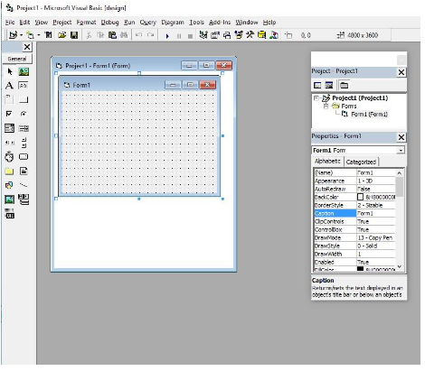Event-driven programming: Code is executed based on user interactions like clicks, inputs, or other events.
* Integrated Development Environment (IDE**)**: VB6 provides a powerful IDE to design GUIs, write code, and debug applications.
* Object-based: While not fully object-oriented, it supports features like encapsulation and modular programming.
* Database support: Built-in support for database access through ADO, DAO, and RDO technologies.
* Component-based: Allows integration with ActiveX controls and DLLs

### VB6 is versatile and supports the creation of various Types of applications, including:

### Desktop Applications:

* Inventory management systems
* Employee or payroll management systems
* Hotel or restaurant management systems

### Data-driven Applications:

* Database management tools
* Reporting applications using Crystal Reports or Microsoft Access integration

### Games:

* Basic 2D games using VB6's graphics capabilities

### Utility Tools:

* File management utilities (e.g., file Renamer, batch processing tools)
* Custom calculators

### Web-Enabled Applications:

* With additional tools, you can build simple web applications or integrate VB6 applications with web technologies.

### Automation Applications:

* Automating repetitive tasks in Windows using VBScript.

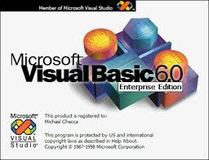

### The VB6 IDE is where you design, code, and test your applications. Its components include:

Menu Bar:

Contains standard menus like *File*, *Edit*, *View*, *Project*, and more for managing your project.

Toolbox:

Provides controls like buttons, text boxes, labels, and combo boxes that you can drag onto forms to design the user interface.

Form Designer:

A graphical workspace where you design the application's interface.

Project Explorer:

Displays all the files in your project, such as forms, modules, and class modules, in a tree view.

Properties Window:

Used to set properties of the selected object (e.g., font, color, size) at design time.

Code Editor:

Where you write the application's logic in VB6's syntax.

Debugging Tools:

Tools to help find and fix errors in your code, such as the Immediate window and breakpoints.

Object Browser:

Allows you to explore objects, methods, and properties available in your project.

# INTRODUCTION TO ORACLE 10G

### ****Oracle 10g for Desktop-Based Applications****

Oracle 10g can be used as a backend database for **desktop-based applications**, enabling them to store, retrieve, and manage data efficiently. Desktop applications often rely on robust database systems like Oracle 10g to handle their data needs, ensuring high performance and reliability.

### ****Key Uses in Desktop Applications****

Standalone Applications: Applications such as inventory management systems, payroll software, or accounting tools use Oracle 10g to store and process large volumes of data locally or on a network.

Data Storage and Retrieval: Oracle 10g serves as the central database where the desktop application can execute SQL queries to handle CRUD operations (Create, Read, Update, Delete).

Rich Features for Desktop Integration:

**PL/SQL Programming**: Allows the embedding of business logic in the database, reducing the need for extensive application-side coding.

**Data Integrity**: Provides strong data consistency and integrity through constraints and triggers.

Connectivity: Oracle 10g can connect with desktop applications written in languages like Java, C#, VB.NET, or even VB6 through technologies such as:

**ODBC** (Open Database Connectivity)

**JDBC** (Java Database Connectivity)

**Oracle Data Provider for .NET (ODP.NET)**

Report Generation: Applications can use Oracle 10g with reporting tools (e.g., Crystal Reports or Oracle Reports) to generate detailed and interactive reports.

Security: Ensures secure data access through user roles, privileges, and encryption, making it ideal for desktop systems that require confidentiality.

### ****Benefits of Using Oracle 10g for Desktop-Based Applications****

Scalability: Can handle small-scale applications while being scalable to enterprise levels if needed.

High Availability: Supports continuous operations with minimal downtime.

Performance Optimization: Features like indexing, partitioning, and query optimization improve desktop application performance.

### ****Examples of Desktop-Based Applications Using Oracle10g****

Library Management Systems: Manages books, members, and transactions.

Point-of-Sale Systems: Handles billing, inventory, and sales data.

Healthcare Management Systems: Tracks patient records, appointments, and prescriptions.

Educational Management Systems: Maintains student records, grades, and fees.



# MODULE DESCRIPTION

1. **Department Management Module**
2. **Employee Management Module**
3. **Attendance and Leave Management Module**
4. **Bonus and Incentives Module**
5. **Advance Management Module**
6. **Retirement and Benefits Module**
7. **Taxation and Compliance Module**
8. **Salary Calculation Module**
9. **Reports and Analytics Module**
10. **User Roles and Security Module**
11. **Integration Module (Optional)**

### 1.Department Management Module:

* **DEPARTMENT MODULE**

A department can have multiple positions, but a position belongs to only one department.  
A department can have many employees, but each employee is associated with only one department.

* + Input File Name:-
  + Output File Name:- DEPARTMENT
* **POSITION MODULE**

**Benefits of Adding Position**

* **Clear Hierarchy**: Positions help define organizational roles explicitly.
* **Dynamic Salary Calculation**: Payroll can dynamically compute salaries based on the employee's position.
* **Ease of Updates**: Changes in salary structure or allowances at the position level automatically apply to all employees in that position.

Input File Name:- DEPARTMENT

Output File Name:- POSITION

### 2.Employee Management Module:

1. Emp personal information (name, address, contact, etc.).
2. Emp details (department, job role, joining date, etc.).
3. Salary structure assignment.

* **EMPLOYEE CREATION MODULE**
  + Input File Name:- DEPARTMENT, POSITION
  + Output File Name:- EMPLOYEE
* **BANK_DETAILS MODULE**
  + Input File Name:- EMPLOYEE
  + Output File Name:- BANK

### 3.Attendance and Leave Management Module

1. Daily, weekly, or monthly attendance tracking.
2. Leave approval and balance management.
3. Integration of attendance data into salary calculations (e.g., deductions for absences).

* **LEAVE MODULE**
  + Input File Name:- EMPLOYEE
  + Output File Name:-LEAVE
* **ATTENDANCE MODULE**
  + Input File Name:- EMPLOYEE, LEAVE
  + Output File Name:-ATTENDANCE
* **Payroll Management Module**

Input File Name:- EMPLOYEE

Output File Name:- PAYROLL

### 4.Bonus and Incentives Module

1. Based on Cultural Events
2. Performing Sales and New Leads Creation
3. Maintaining good Customer Relationship

Input File Name:- EMPLOYEE, PAYROLL

Output File Name:- BONUS

### 5.Advance Management Module

1. Advance Approval
2. EMI setting
3. Outstanding Loan Status Accounting

Input File Name:- EMPLOYEE, PAYROLL

Output File Name:- ADVANCE

### 6.Retirement and Benefits Module

For managing gratuity, pensions, and other end-of-service benefits.

Input File Name:- EMPLOYEE, PAYROLL

Output File Name:- BENEFIT

### 7.Taxation and Compliance Module

1. Calculation of income tax, social security, and other statutory deductions.
2. Submission of compliance reports.

Input File Name:- EMPLOYEE, PAYROLL

Output File Name:- COMPLIANCE

### 8.Salary Calculation Module

**1.Pay Slip Generation Module**

1. Itemized breakdown of salary components (gross pay, net pay, deductions).
2. Printable and digital pay slip formats.

Input File Name:- EMPLOYEE, PAYROLL, BONUS,

COMPLIANCE, ADVANCE, BENEFIT

Output File Name:- SALARY_SLIP

**2.SALARY Management Module**

1. Basic pay, allowances, and deductions calculation.
2. Overtime and bonuses integration.
3. Deduction of taxes, provident fund (PF), and other contributions.

Input File Name:- EMPLOYEE, SALARY_SLIP,PAYROLL

Output File Name:- SALARY

### 9.Reports and Analytics Module

1. Generation of reports (salary summaries, tax deductions)
2. Historical data tracking for audits.
3. Analytics for financial planning and decision-making

Input File Name:- EMPLOYEE

Output File Name:- SALARY_SLIP, ATTENDANCE, COMPLIANCE,

BONUS, BENEFIT

### 10.User Roles and Security Module

1. Role-based access control (e.g., admin, HR, accountant).
2. Secure login and encryption of data.
3. Protects sensitive payroll information and defines access rights.

### 11.Integration Module (Optional)

1. Integration with accounting systems for seamless financial management.
2. Exporting data to external systems (e.g., Excel, ERP)

# E-R DIAGRAM

**SKELETON ERD**

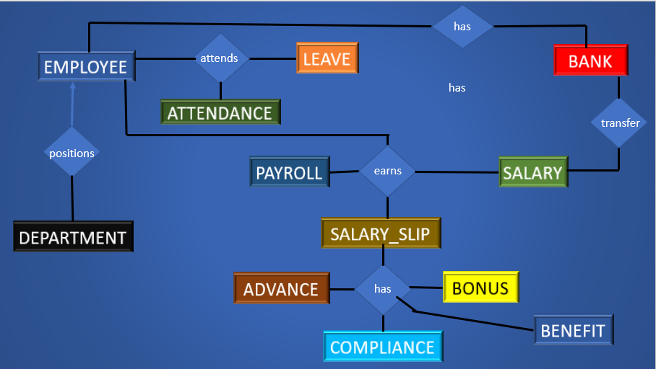ERD

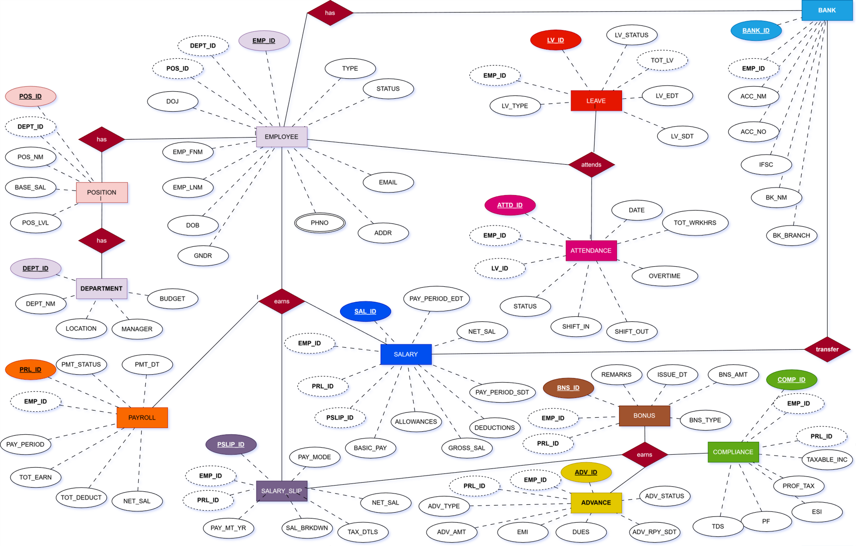

# TABLE DESCRIPTION

### 1.DEPARTMENT TABLE

|  |  |  |  |  |  |
| --- | --- | --- | --- | --- | --- |
| **SNO** | **Column Name** | **Data Type** | **Size** | **Constraints** | **Description** |
| 1 | **DEPT_ID** | VARCHAR2 | 6 | Primary Key | Unique identifier for each department record. |
| 2 | **DEPT_NM** | VARCHAR2 | 15 | NOT NULL | Name of department |
| 3 | **LOCATION** | VARCHAR2 | 6 | NULLABLE | Location of department |
| 4 | **MANAGER** | CHAR | 6 | NULLABLE | Manager who is controlling the department. |
| 5 | **BUDGET** | DECIMAL | 8,2 | NULLABLE | Fixes how much budget is allocated |

### 2.POSITION TABLE

|  |  |  |  |  |  |
| --- | --- | --- | --- | --- | --- |
| **SNO** | **Column NM** | **Data Type** | **Size** | **Constraints** | **Description** |
| 1 | **POS_ID** | VARCHAR2 | 6 | Primary Key | Unique identifier for each position record |
| 2 | **DEPT_ID** | VARCHAR2 | 6 | Foreign Key, NOT NULL | References the **DEPT_ID** in the department entity. |
| 3 | **POS_NM** | VARCHAR2 | 15 | NOT NULL | Name of the position |
| 4 | **BASE_SAL** | DECIMAL | 7,2 | DEFAULT 500  CHECK BASE_SAL BETWEEN 499 AND 35000) | Base salary of the worker |
| 5 | **POS_LVL** | CHAR | 1 | DEFAULT ‘E’ CHECK (POS_LVL IN ‘E’,’M’,’V’) | ‘E’=entry level  ‘M’=mid level  ‘V’=veteran level |

### 3.EMPLOYEE TABLE

|  |  |  |  |  |  |
| --- | --- | --- | --- | --- | --- |
| **SrNO.** | **Column Name** | **Data Type** | **Size** | **Constraints** | **Description** |
| 1 | EMP_ID | VARCHAR2 | 6 | Primary Key | Unique identifier for each employee. |
| 2 | DEPT_ID | VARCHAR2 | 6 | Foreign Key | References the **DEPT_ID** in the department entity. |
| 3 | POS_ID | VARCHAR2 | 6 | Foreign Key | References the **POS_ID** in the POSITION entity. |
| 4 | EMP_FNM | VARCHAR2 | 50 | NOT NULL | Employee’s first name. |
| 5 | EMP_LNM | VARCHAR2 | 50 | NULLABLE | Employee’s last name (optional). |
| 6 | DOB | DATE | - | NULLABLE | Employee’s date of birth. |
| 7 | GNDR | CHAR | 1 | CHECK (Gender IN M,F,T,O) | Gender of the employee.(M='Male', F='Female', T=TRANSGENDER O= 'Other') |
| 8 | LN1 | VARCHAR2 | 20 | NOT NULL | ADDRESS |
| 9 | LN2 | VARCHAR2 | 20 | NULL | ADDRESS |
| 10 | LN3 | VARCHAR2 | 20 | NULL | ADDRESS |
| 11 | LANDMARK | VARCHAR2 | 20 | NULL | ADDRESS |
| 12 | DISTRICT | VARCHAR2 | 15 | NOT NULL | ADDRESS |
| 13 | STATE | VARCHAR2 | 15 | NOT NULL | ADDRESS |
| 14 | COUNTRY | VARCHAR2 | 15 | NOT NULL | ADDRESS |
| 15 | PINCODE | CHAR | 6 | NOT NULL | ADDRESS |
| 16 | PHNO | CHAR | 10 | NOT NULL | Employee’s contact number. |
| 17 | WPHNO | CHAR | 10 | NULL | Employee’s WHATSAPP contact number. |
| 18 | EPHNO | CHAR | 10 | NULL | Employee’s EMERGENCY contact number. |
| 19 | EMAIL | VARCHAR2 | 100 | VALID EMAIL FORMAT | Employee’s email address. |
| 20 | DOJ | DATE | - | NOT NULL | The date when the employee joined the organization. |
| 21 | TYPE | CHAR | 1 | CHECK (TYPE IN( 'F','C','P')) | Type of employment.(F= 'FULLTIME','C'= 'Contractual', 'P'=Part-time')) |
| 22 | STATUS | CHAR | 1 | CHECK (Status IN ('A', 'I')) | Indicates the current employment status.'A'='Active', I='Inactive')) |

### 

### 4.BANK TABLE

|  |  |  |  |  |  |
| --- | --- | --- | --- | --- | --- |
| **SrNO** | **Column Name** | **Data Type** | **Size** | **Constraints** | **Description** |
| 1 | **BANK_ID** | VARCHAR2 | 6 | Primary Key | Unique identifier for each bank record. |
| 2 | **EMP_ID** | VARCHAR2 | 6 | Foreign Key, NOT NULL | References the **EMP_ID** in the Employee entity. |
| 3 | **ACC_NM** | VARCHAR2 | 40 | NOT NULL | Name of the account holder as per bank records. |
| 4 | **BK_NM** | VARCHAR2 | 40 | NOT NULL | Name of the bank where the account is held. |
| 5 | **ACC_NO** | VARCHAR | 17 | UNIQUE, NOT NULL | Unique account number of the employee. |
| 6 | **IFSC** | VARCHAR2 | 11 | NOT NULL, VALID FORMAT (e.g., ^[A-Z]{4}0[A-Z0-9]{6}$) | Indian Financial System Code for identifying the bank branch. |
| 7 | **BK_BRANCH** | VARCHAR2 | 25 | NULL | Name of the branch where the account is maintained. |

**5.LEAVE TABLE**

|  |  |  |  |  |  |
| --- | --- | --- | --- | --- | --- |
| **SNO** | **Column Name** | **Data Type** | **Size** | **Constraints** | **Description** |
| 1 | **LV_ID** | VARCHAR2 | 10 | Primary Key | Unique identifier for each leave record. |
| 2 | **EMP_ID** | VARCHAR2 | 6 | Foreign Key, NOT NULL | References the **EMP_ID** in the Employee entity. |
| 3 | **LV_TYPE** | CHAR | 1 | DEFAULT ‘O’  CHECK ( LV_TYPE IN ('S','C','P','O')), | Type of leave requested S='Sick',C= 'Casual',P= 'Paid', O='Other' |
| 4 | **LV_SDT** | DATE | - | NOT NULL | The start date of the leave period. |
| 5 | **LV_EDT** | DATE | - | NOT NULL, CHECK (LV_EDT >= LV_SDT) | The end date of the leave period. |
| 6 | **TOT_LV** | DECIMAL | 5,1 | NOT NULL, CHECK (TOT_LV >= 0) | Total number of days of leave, calculated or entered manually. |
| 7 | **LV_STATUS** | CHAR | 1 | CHECK (LV_STATUS IN ('A', 'R', 'P')), DEFAULT 'P', NOT NULL | Current approval status of the leave request. L= LEAVE,P= PENDING,A=APPROVED |

### 6.ATTENDANCE TABLE

|  |  |  |  |  |  |
| --- | --- | --- | --- | --- | --- |
| **SrNO** | **COL** | **Data Type** | **Size** | **Constraints** | **Description** |
| 1 | ATTD_ID | VARCHAR2 | 10 | Primary Key | Unique identifier for each attendance record. |
| 2 | EMP_ID | VARCHAR2 | 6 | Foreign Key, NOT NULL | References the **EMP_ID** in the Employee entity. |
| 3. | LV_ID | VARCHAR2 | 10 | Foreign Key, NULLABLE | References the LV_ID in the LEAVE entity. |
| 4 | DATE | DATE | - | NOT NULL, UNIQUE WITH EMP_ID | The date of the attendance entry. |
| 5 | STATUS | CHAR | 1 | CHECK (Status IN ('P', 'A', 'L')), NOT NULL | Indicates whether the employee was present, absent, or on leave.(P ='Present', A='Absent', L='Leave') |
| 6 | SHIFT_IN | TIME | - | NULLABLE | The time the employee started their shift. |
| 7 | SHIFT_OUT | TIME | - | NULLABLE | The time the employee ended their shift. |
| 8 | OVERTIME | DECIMAL | 5,2 | DEFAULT 0, CHECK (OVERTIME >= 0) | Number of hours worked beyond the standard shift. |
| 9 | TOT_WRKHRS | DECIMAL | 5,2 | DEFAULT 0, CHECK (TOT_WRKHRS >= 0) | Total number of hours worked during the shift,including overtime |

### 7. PAYROLL TABLE

|  |  |  |  |  |  |
| --- | --- | --- | --- | --- | --- |
| **SNO** | **Column NM** | **Data Type** | **Size** | **Constraints** | **Description** |
| 1 | **PRL_ID** | VARCHAR2 | 6 | Primary Key | Unique identifier for each payroll record. |
| 2 | **EMP_ID** | VARCHAR2 | 6 | Foreign Key, NOT NULL | References the **EMP_ID** in the Employee entity. |
| 3 | **PAY_PERIOD** | DATE | 7 | NOT NULL, CHECK (FORMAT MM/YYYY) | The month and year of the payroll, formatted as MM/YYYY. |
| 4 | **TOT_EARN** | DECIMAL | 7,2 | DEFAULT 0 | Total earnings for the payroll period, including allowances. |
| 5 | **TOT_DEDUCT** | DECIMAL | 7,2 | DEFAULT 0 | Total deductions for the payroll period, including TDS, PF, etc. |
| 6 | **NET_SAL** | DECIMAL | 7,2 | CHECK (NET_SAL=TOT_EARN - TOT_DEDUCT) DEFAULT 0 | Final salary after deductions. Calculated automatically. |
| 7 | **PMT_DT** | DATE | - | NULLABLE | The date on which the payment was made. |
| 8 | **PMT_STATUS** | VARCHAR2 | 6 | CHECK (PMT_STATUS IN ('PAID','UNPAID')), DEFAULT 'UNPAID' | Indicates whether the salary has been paid OR 'Unpaid' |

### 8. COMPLIANCE TABLE

|  |  |  |  |  |  |
| --- | --- | --- | --- | --- | --- |
| **SrNO** | **Column** | **DATATYPE** | **SIZE** | **CONSTRAINTS** | **DESCRIPTION** |
| 1 | **COMP_ID** | VARCHAR2 | 7 | Primary Key | Unique identifier for each compliance record. |
| 2 | **EMP_ID** | VARCHAR2 | 6 | Foreign Key, NOT NULL | References the **EMP_ID** in the Employee entity. |
| 3 | **PRL_ID** | VARCHAR2 | 7 | FOREIGN KEY,NOT NULL | References the **PRL_ID** in the PAYROLL entity. |
| 4 | **TDS** | DECIMAL | 6,2 | DEFAULT 0, CHECK (TDS >= 0) | Amount deducted as Tax Deducted at Source (TDS). |
| 5 | **PF** | DECIMAL | 6,2 | DEFAULT 0, CHECK (PF >= 0) | Employee’s contribution towards the Provident Fund. |
| 6 | **ESI** | DECIMAL | 6,2 | DEFAULT 0, CHECK (ESI >= 0) | Employee State Insurance contribution by the employee. |
| 7 | **PROF_TAX** | DECIMAL | 6,2 | DEFAULT 0, CHECK (PROF_Tax >= 0) | Tax deducted as professional tax from the employee. |
| 8 | **TAXABLE_INC** | DECIMAL | 6,2 | DEFAULT 0 CHECK (TAXABLE_INC >= 0) | Income subject to taxation after applicable deductions |

### 9.ADVANCE TABLE

|  |  |  |  |  |  |
| --- | --- | --- | --- | --- | --- |
| **SNO** | **Column Name** | **Data Type** | **Size** | **Constraints** | **Description** |
| 1 | **ADV_ID** | VARCHAR2 | 7 | Primary Key | Unique identifier for each loan record. |
| 2 | **EMP_ID** | VARCHAR2 | 6 | Foreign Key, NOT NULL | References the **EMP_ID** in the Employee entity. |
| 3 | **PRL_ID** | VARCHAR2 | 7 | FOREIGN KEY,NOT NULL | References the **PRL_ID** in the PAYROLL entity. |
| 4 | **ADV_TYPE** | VARCHAR2 | 15 | NOT NULL | Type of advance (e.g. EMERGENCY,  ELECTRONIC_BUY,  EVENT,  FINANCIAL_LOSS). |
| 5 | **ADV_AMT** | DECIMAL | 8,2 | DEFAULT 0 CHECK (LN_AMT >= 0) | Total sanctioned loan or advance amount. |
| 6 | **EMI** | DECIMAL | 7,2 | NOT NULL, CHECK (EMI >= 0) | Monthly Equated Installment amount for repayment. |
| 7 | **DUES** | DECIMAL | 8,2 | NOT NULL, CHECK (DUES >= 0) | Remaining amount to be repaid for the loan. |
| 8 | **ADV_RPY_SDT** | DATE | - | NOT NULL | Date when loan repayment starts. |
| 9 | **ADV_STATUS** | CHAR | 1 | CHECK (Status IN ('A','C')), DEFAULT 'Active', NOT NULL | Current status of the loan (A=Active or C=Closed). |

### 10.BONUS TABLE

|  |  |  |  |  |  |
| --- | --- | --- | --- | --- | --- |
| **SNO** | **Column Name** | **Data Type** | **Size** | **Constraints** | **Description** |
| 1 | **BNS_ID** | VARCHAR2 | 7 | Primary Key | Unique identifier for each bonus or incentive record. |
| 2 | **EMP_ID** | VARCHAR2 | 6 | Foreign Key, NOT NULL | References the **EMP_ID** in the Employee entity. |
| 3 | **PRL_ID** | VARCHAR2 | 7 | FOREIGN KEY,NOT NULL | References the **PRL_ID** in the PAYROLL entity. |
| 4 | **BNS_TYPE** | VARCHAR2 | 15 | NOT NULL | Type of bonus or incentive (e.g., Performance, Annual). |
| 5 | **BNS_AMT** | DECIMAL | 6,2 | NOT NULL, CHECK ( BNS_AMT>= 0) | The monetary amount of the bonus or incentive. |
| 6 | **ISSUE_DT** | DATE | - | NOT NULL | The date when the bonus or incentive was issued. |
| 7 | **REMARKS** | VARCHAR2 | 255 | NULLABLE | Optional remarks or reason for the bonus issuance. |

### 11.SALARY_SLIP

|  |  |  |  |  |  |
| --- | --- | --- | --- | --- | --- |
| **SNO.** | **Column Name** | **Data Type** | **Size** | **Constraints** | **Description** |
| 1 | **SAL_ID** | VARCHAR2 | 7 | Primary Key | Unique identifier for each payslip record. |
| 2 | **PRL_ID** | VARCHAR2 | 7 | Foreign Key, NOT NULL | References the **PRL_ID** in the Payroll entity. |
| 3 | **EMP_ID** | VARCHAR2 | 6 | Foreign Key, NOT NULL | References the **EMP_ID** in the Employee entity. |
| 4 | **BNS_ID** | VARCHAR2 | 7 | FOREIGN KEY,NULLABLE | References the **BNS_ID** in the BONUS entity |
| 5 | **ADV_ID** | VARCHAR2 | 7 | FOREIGN KEY,NULLABLE | References the **ADV_ID** in the ADVANCE entity |
| 6 | **COMP_ID** | VARCHAR2 | 7 | FOREIGN KEY,NULLABLE | References the **COMP_ID** in the COMPLIANCE entity |
| 4 | **PAYM_MT_YR** | VARCHAR | 7 | NOT NULL, CHECK (FORMAT MM/YYYY) | Month and year of the payslip, formatted as MM/YYYY. |
| 5 | **SAL_BRKDWN** | TEXT | - | NOT NULL | A detailed breakdown of earnings and deductions (e.g., Basic Pay, HRA, Deductions). |
| 6 | **TAX_DTLS** | TEXT | - | NULLABLE | Additional tax-related details such as TDS, exemptions, etc. |
| 7 | **NET_SAL** | DECIMAL | 10,2 | NOT NULL, CHECK (NET_SAL >= 0) | Final net salary after earnings and deductions. |
| 8 | **PAY_MODE** | CHAR | 20 | NOT NULL, CHECK (PAY_MODE IN 'C','B','O' ) | Mode of payment for the salary (C='Cash', B='TO_BANK', O='Other'). |
| 9 | TRANS_ID | VARCHAR2 | 30 | NULLABLE | IF ONLINE PAY_MODE |

### 12.SALARY TABLE

|  |  |  |  |  |  |
| --- | --- | --- | --- | --- | --- |
| SrNO | **Column Name** | **Data Type** | **Size** | **Constraints** | **Description** |
| 1 | **SAL_ID** | VARCHAR2 | 6 | Primary Key | Unique identifier for each salary record. |
| 2 | **EMP_ID** | VARCHAR2 | 6 | Foreign Key, NOT NULL | References the **EMP_ID** in the Employee entity. |
| 3 | **SAL_SLIP** | VARCHAR2 | 7 | FOREIGN KEY,NULLABLE | References the **SAL_SLIP** in the SALARY_SLIP entity. |
| 3 | **BASIC_PAY** | DECIMAL | 7,2 | NOT NULL, CHECK (BasicPay >= 0) | Basic salary of the employee before any additions or deductions. |
| 4 | **ALLOWANCES** | DECIMAL | 7,2 | NULLABLE, CHECK (Allowances >= 0) | Total allowances provided to the employee (HRA, DA, etc.). |
| 5 | **DEDUCTIONS** | DECIMAL | 7,2 | NULLABLE, CHECK (Deductions >= 0) | Total deductions from the salary (PF, TDS, loans, etc.). |
| 6 | **GROSS_SAL** | DECIMAL | 7,2 | NOT NULL, GENERATED ALWAYS AS (BasicPay + Allowances) STORED | Total salary before deductions. Calculated as BasicPay + Allowances. |
| 7 | **NET_SAL** | DECIMAL | 7,2 | NOT NULL, GENERATED ALWAYS AS (GrossSalary - Deductions) STORED | Final salary after deductions. Calculated as GrossSalary - Deductions. |
| 8 | **PAY_PERIOD_SDT** | DATE | - | NOT NULL | Start date of the salary payment period. |
| 9 | **PayPeriodEndDate** | DATE | - | NOT NULL | End date of the salary payment period. |

# PROJECT PLANNING

|  |  |  |
| --- | --- | --- |
| PHASES | MEMBERS | TOTAL DAYS: 75 |
| **ANALYSIS**   * DATA GATHERING * FEASIBILITY STUDY * COSTBENEFIT ANALYSIS * PROJECT PROPOSAL | RITIK AGARWAL  SAHITYA JIYA  ADITYA PRAKASH  SACHIN KARN | **30 DAYS** |
| **DESIGN** | ADITYA PRAKASH  SACHIN KARN  RITIK AGARWAL  SAHITYA JIYA | **7 DAYS** |
| **CODING** | RITIK AGARWAL | **19 DAYS** |
| **TESTING** | RITIK AGARWAL  SAHITYA JIYA  ADITYA PRAKASH  SACHIN KARN | **15 DAYS** |
| **IMPLEMENTATION** | RITIK AGARWAL | **4 DAYS** |
| **DOCUMENTATION** | RITIK AGARWAL  SAHITYA JIYA  ADITYA PRAKASH  SACHIN KARN | **75 DAYS** |

# GANTT CHART

**15**

**75**

**30**

**4**

**19**

**7**

**FEB**

**JAN**

**DEC**

**NOV**

**OCT**

### ****Key Features of a Gantt Chart****

1. **Tasks**: Listed on the left side of the chart.
2. **Timeline**: Shown at the top, divided into days, weeks, or months.
3. **Bars**: Horizontal bars on the chart represent each task and show its start and end dates.
4. **Dependencies**: Lines connecting tasks show the relationships between them (e.g., one task must finish before another starts).

### ****Why Use a Gantt Chart?****

* **Simple Visualization**: Easily see which tasks happen when and how they overlap.
* **Track Progress**: Monitor completed, ongoing, and upcoming tasks.
* **Manage Resources**: Assign tasks to team members and avoid conflicts.
* **Identify Dependencies**: Understand which tasks depend on others.

# FUTURE SCOPE OF PROJECT

### ****Future Scope for Desktop-Based Applications Using VB6.0****

1. **Visitor Register**:
2. **To-Do List Application**:
3. **SIP Calculator**:
4. **Employee Target Management Tool**:
5. **Task Organizer**:
6. **Event Management (Workshop Organizer)**:
7. **Finance Planner**

