Mininet and Open vSwitch

Platform: Ubuntu Linux in VirtualBox
Tools: Open vSwitch, Mininet, Python virtual environments
Evidence: 13 supplied terminal screenshots arranged chronologically

Step 1: Refresh Ubuntu package information
Run sudo apt update. This downloads the latest package lists from the configured Ubuntu repositories.
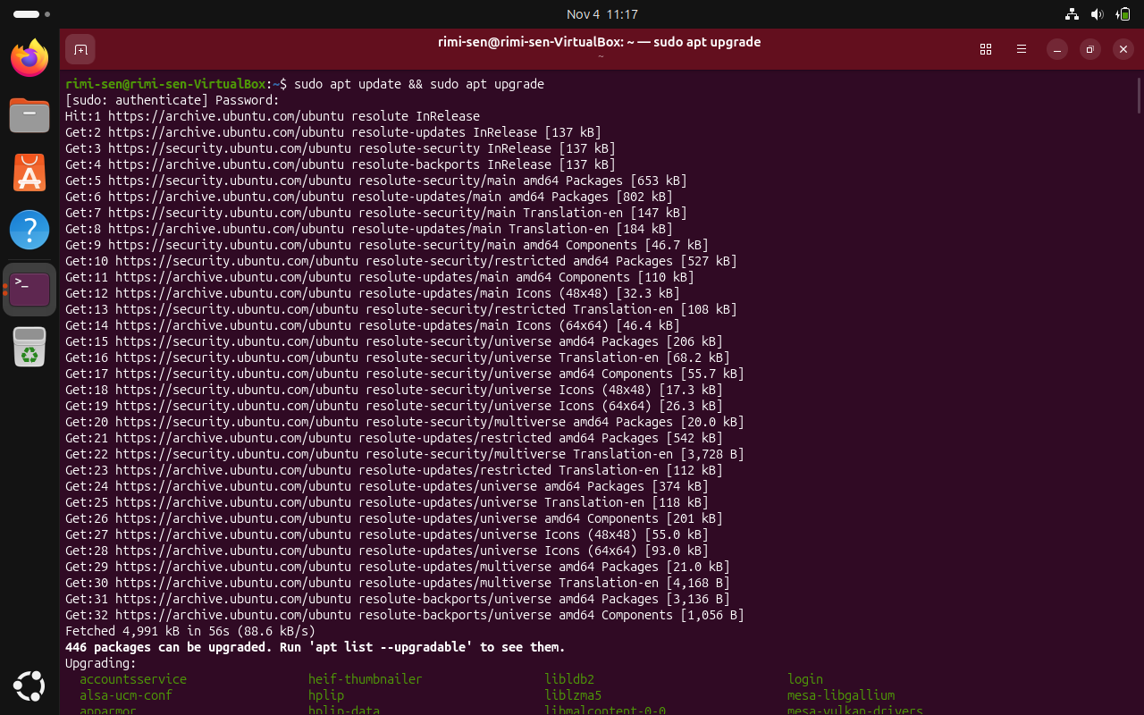
Screenshot 1

Step 2: Upgrade installed Ubuntu packages
Run sudo apt upgrade after the update completes. Enter your password when prompted and review the packages that will be upgraded.

Step 3: Allow the package upgrade to finish
Wait while Ubuntu downloads and installs the available updates. Do not close the terminal during this process.
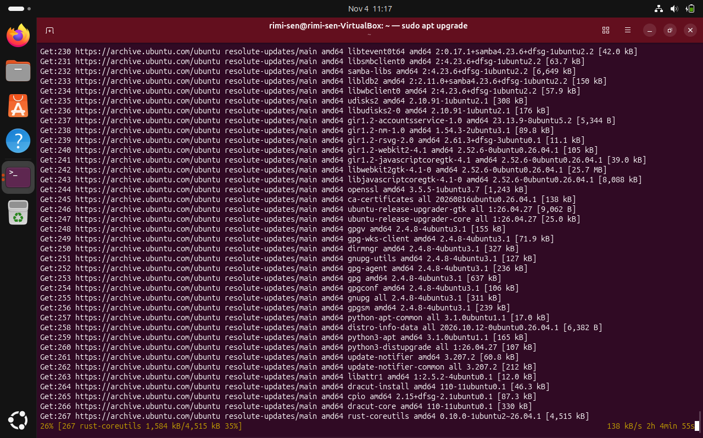
Screenshot 2

Step 4: Install Open vSwitch
Run sudo apt install openvswitch-switch -y. The output confirms that Open vSwitch is already at the newest available version.
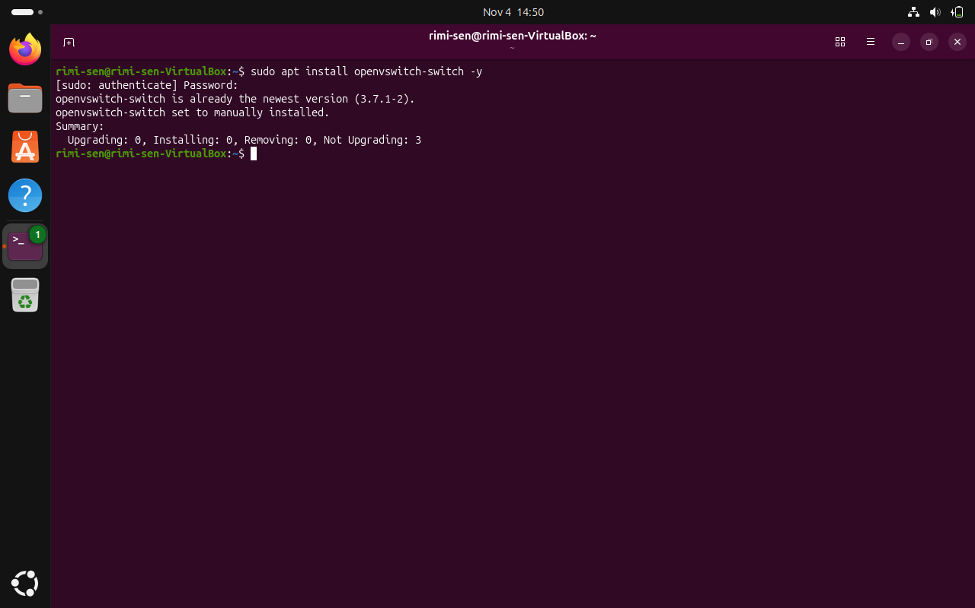
Screenshot 3

Step 5: Verify the Open vSwitch service
Run sudo systemctl status openvswitch-switch. The screenshot shows the service as enabled and active (exited).
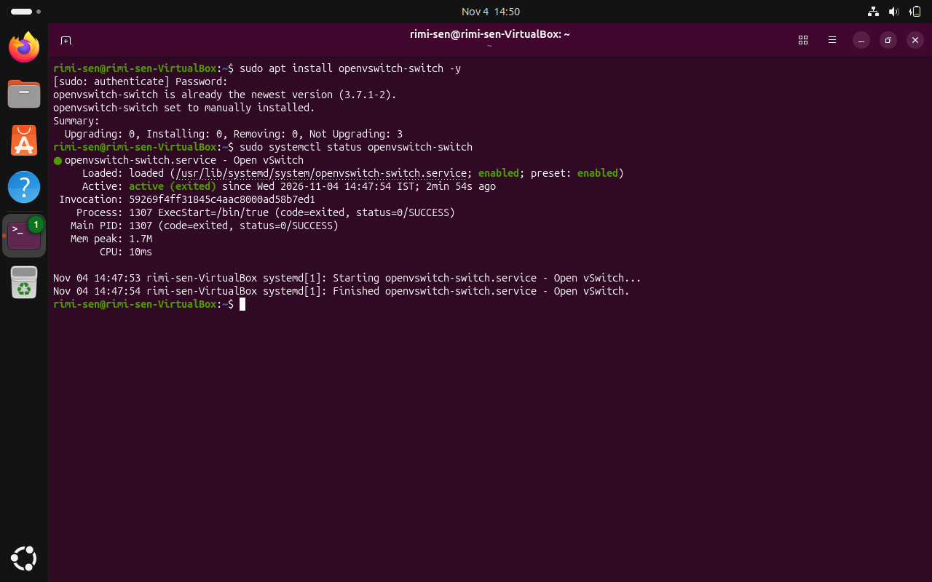
Screenshot 4

Step 6: Launch Mininet's default topology
Run sudo mn. Mininet creates its default topology with two hosts (h1 and h2), one switch (s1), and their links.
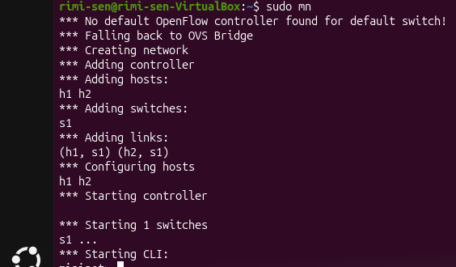
Screenshot 5

Step 7: List the Mininet nodes
At the mininet> prompt, enter nodes. This displays the hosts and switch created in the topology.

Step 8: Test connectivity between all hosts
At the Mininet prompt, enter pingall. The displayed result shows 0% packet loss (2/2 received), indicating successful connectivity.
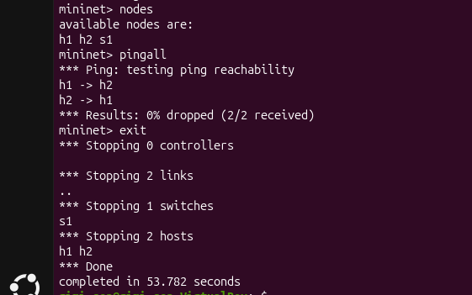
Screenshot 6

Step 9: Exit the Mininet CLI
Enter exit at the mininet> prompt to return to the normal Ubuntu terminal.

Step 10: Install Python pip and venv
Run sudo apt install python3-pip python3-venv -y. These packages provide pip and Python virtual-environment support.
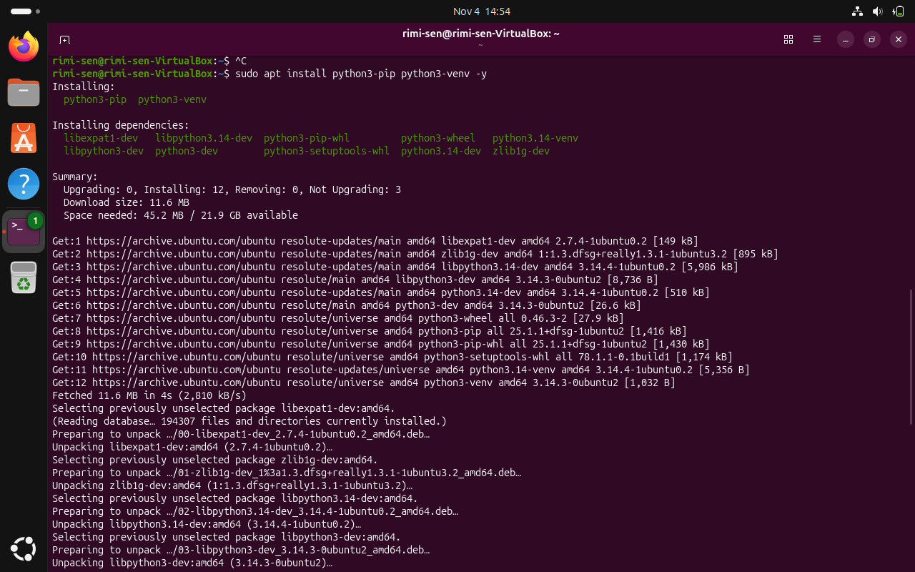
Screenshot 7

Step 11: Create a virtual environment for the first Ryu attempt
Run python3 -m venv ryu-env. This creates an isolated environment named ryu-env using the default Python version shown in the terminal (Python 3.14).
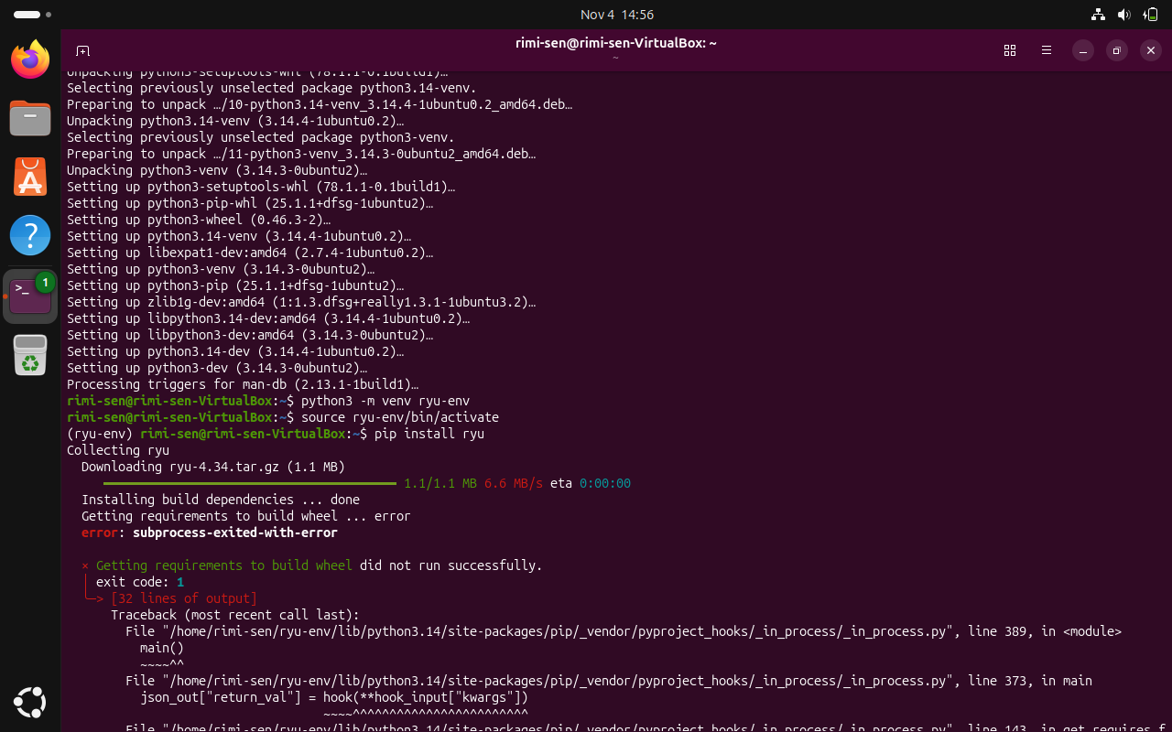
Screenshot 8

Step 12: Activate the first virtual environment
Run source ryu-env/bin/activate. The (ryu-env) prefix in the prompt indicates that the environment is active.

Step 13: Attempt to install Ryu
Run pip install ryu. The installation fails while pip is preparing the package's build requirements in the Python 3.14 environment.

Step 14: Review the Ryu installation error
The traceback shows that the package build step exited with an error. This is an installation/build compatibility issue; it does not indicate that the earlier Mininet ping test failed.
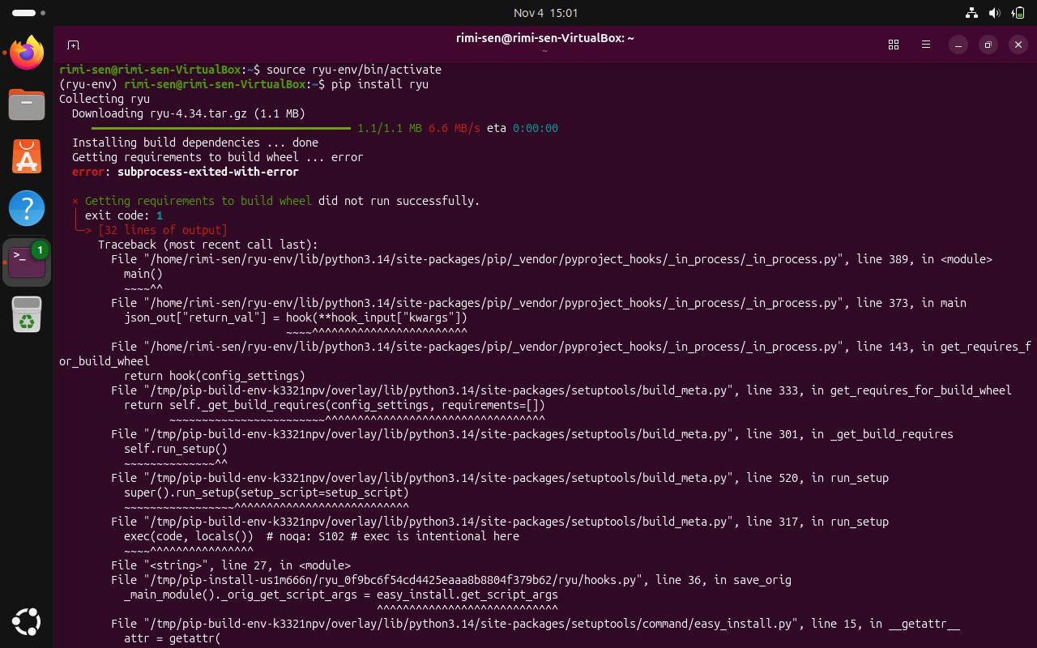
Screenshot 9

Step 15: Create a separate Python 3.10 virtual environment
After preparing Python 3.10, run python3.10 -m venv ryu-env-310. This creates a separate environment for a Ryu installation attempt using Python 3.10.
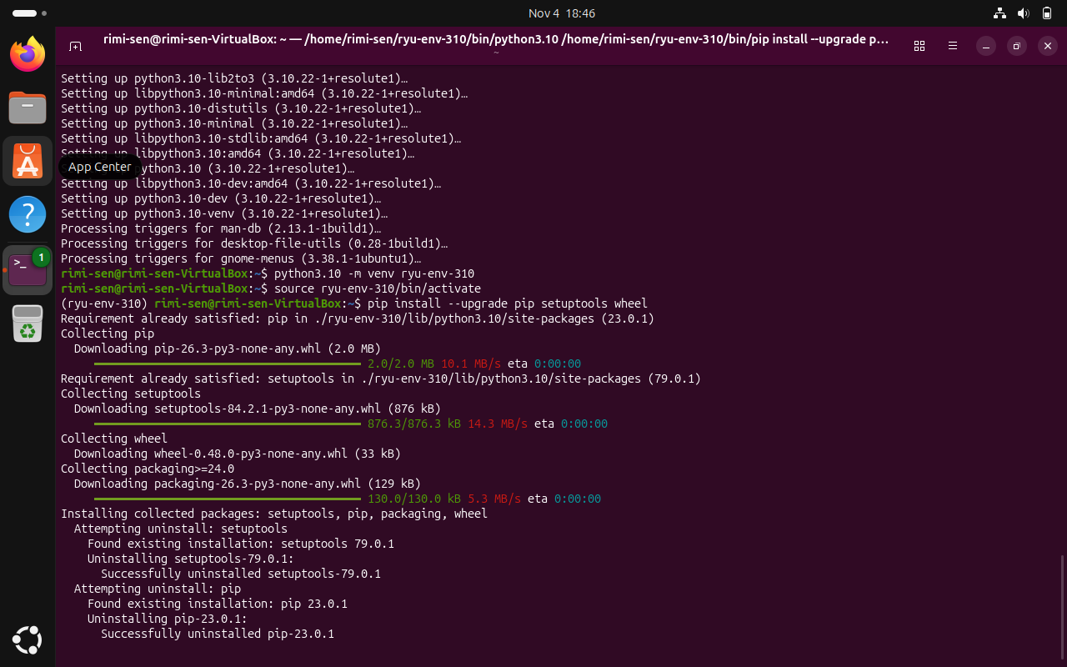
Screenshot 10

Step 16: Activate Python 3.10 environment and update build tools
Run source ryu-env-310/bin/activate, then pip install --upgrade pip setuptools wheel. The screenshot shows the package tools being upgraded. It does not show a successful Ryu installation.

Step 17: Start a three-host Mininet topology using Open vSwitch
Run sudo mn --topo single,3 --mac --switch ovsk --controller remote. This creates three hosts connected to one Open vSwitch switch and configures a remote controller endpoint at 127.0.0.1:6653.
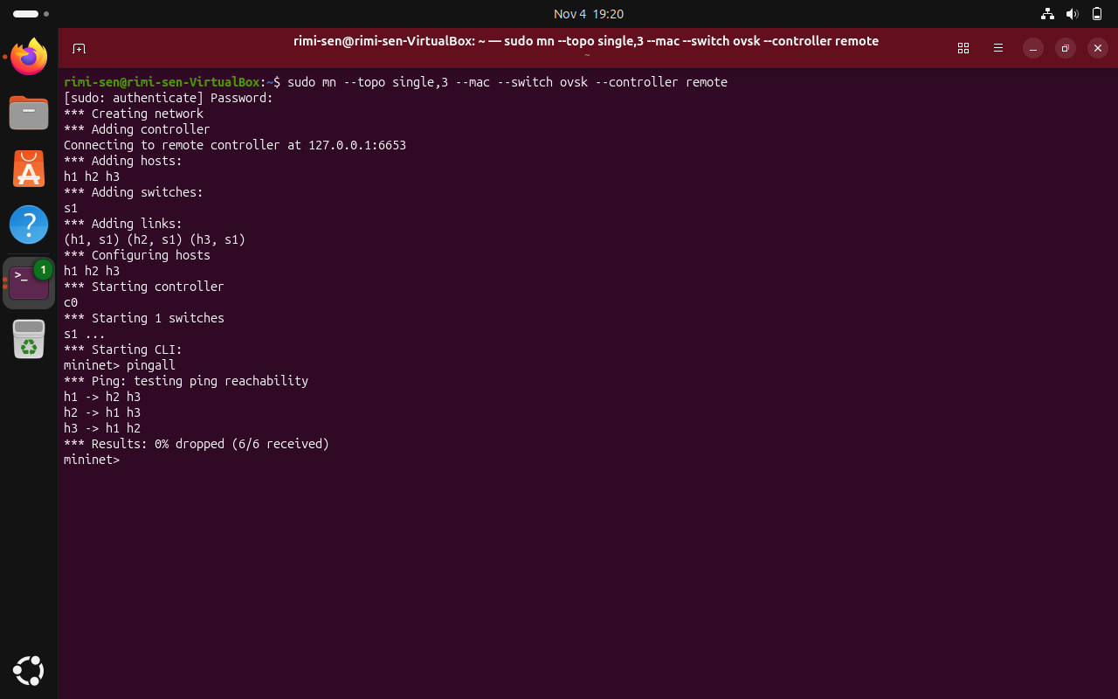
Screenshot 11

Step 18: Inspect links and ping from h1 to h2
At the Mininet prompt, run net to inspect the host-to-switch links. Then run h1 ping h2. The screenshot shows successful ICMP replies from 10.0.0.2.
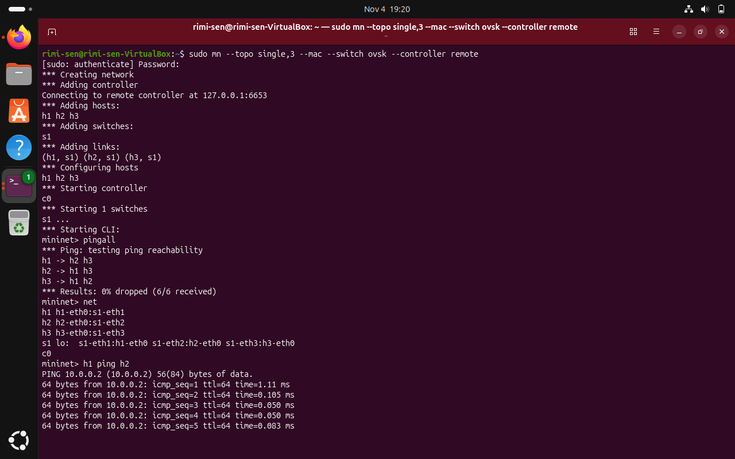
Screenshot 12

Step 19: Check ping statistics and clean up Mininet correctly
The ping summary shows 51 packets transmitted, 51 received, and 0% packet loss. The screenshot also shows sudo mn -c entered inside the Mininet CLI, where it is not a valid command. Correct procedure: enter exit first, then run sudo mn -c from the normal Ubuntu shell.
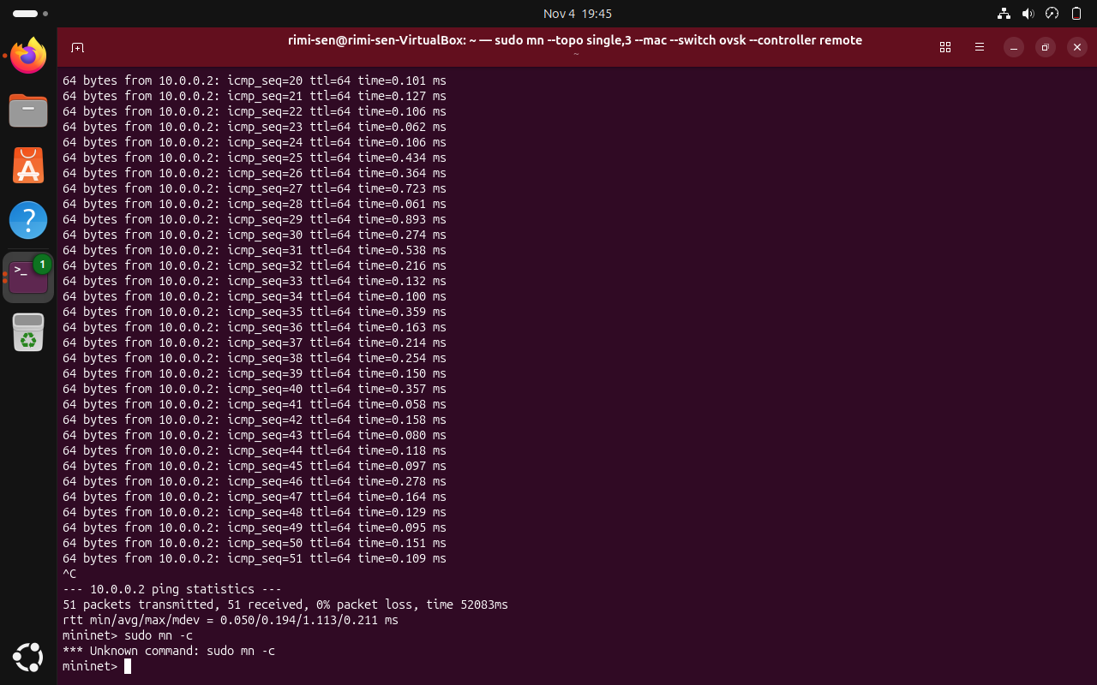
Screenshot 13

Final Verification and Command Summary
Results visible in the screenshots:
- The default two-host topology passed pingall with 0% packet loss.
- The three-host topology was created with one Open vSwitch switch.
- The net command displayed the host-to-switch connections.
- The h1-to-h2 ping received replies; the final statistics showed 0% packet loss.

