CLOUD SCHEDULING LAB
Step-by-Step Setup, Build and Execution Guide
Ubuntu Linux • Java 17 • Apache Maven • CloudSim Plus

This editable guide follows the terminal screenshots and the supplied execution recording.

Overview
This practical demonstrates how to prepare an Ubuntu environment, create a Maven-based Java project, add a CloudSim Plus simulation class, compile the project, and execute a cloud scheduling experiment. The screenshots are inserted in the order supplied.

Requirements
- Ubuntu Linux terminal (the supplied demonstration uses Ubuntu in VirtualBox).
- Internet connection for downloading Ubuntu packages and Maven dependencies.
- OpenJDK 17, Apache Maven and Git.
- A Maven project named CloudSchedulingLab with CloudSim Plus dependencies.

Important note
The screenshots show the commands and successful build/runtime output, but they do not expose the full contents of pom.xml or the complete Java source file. Therefore, this guide explains the actions shown without inventing missing code or dependency versions. Keep the pom.xml and SchedulingExperiment.java contents that you prepared in your project.

Procedure

Step 1: Open the Ubuntu terminal
Start the Ubuntu virtual machine and open Terminal. Confirm that the shell prompt is visible before entering commands.

Step 2: Refresh the package list
Update Ubuntu's local package index so the system checks the latest package information from the configured repositories.
sudo apt update
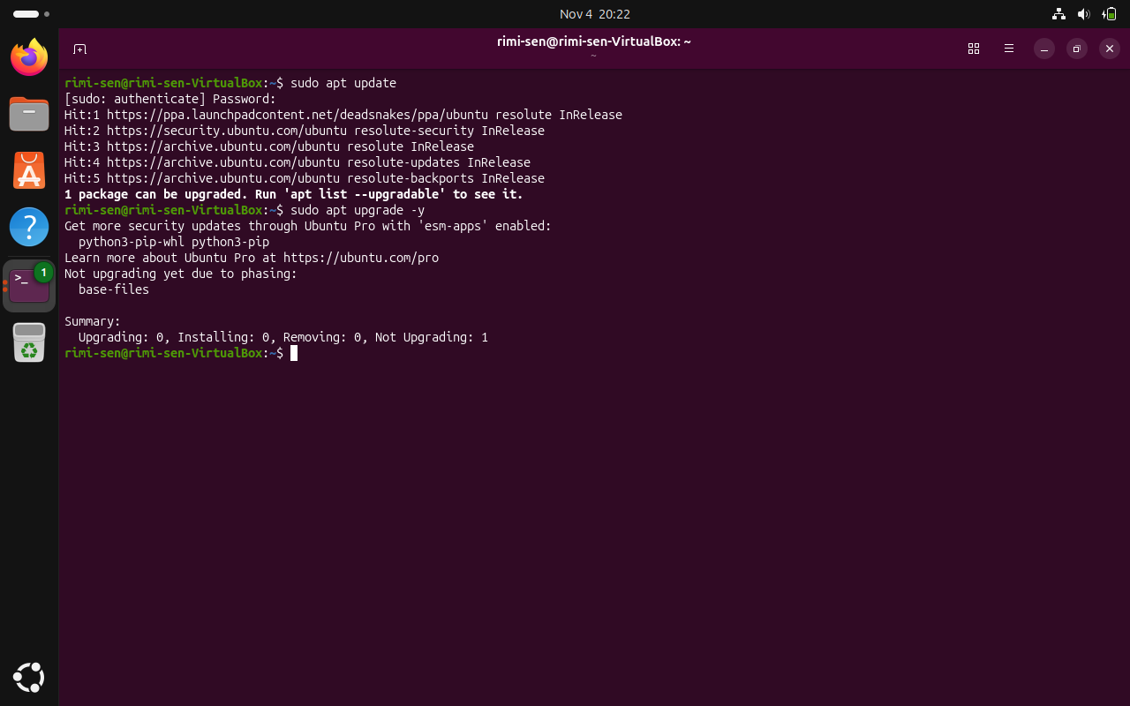
Figure — evidence for Step 2

Step 3: Upgrade available packages
Run the package upgrade command. In the supplied terminal output, one package is held back and no packages are upgraded; this is not a failure of the later Java setup.
sudo apt upgrade -y
Note: The output reports one package as 'Not upgraded'.

Step 4: Install Java, Maven and Git
Install OpenJDK 17, Apache Maven and Git using APT. The installation output may take some time because Ubuntu downloads and configures several Java packages.
sudo apt install openjdk-17-jdk maven git -y
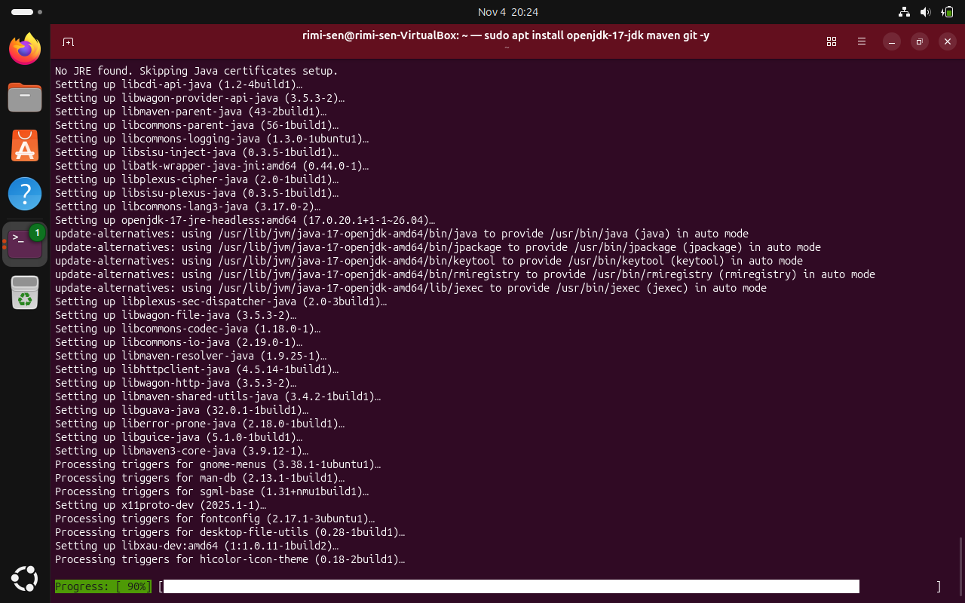
Figure — evidence for Step 4

Step 5: Verify the Java runtime
Check the installed Java runtime version. The supplied system reports OpenJDK 17.0.20.1.
java -version

Step 6: Verify the Java compiler
Check that the Java compiler is installed and available from the terminal.
javac -version

Step 7: Verify Maven and Git
Check the Maven and Git versions. The supplied output shows Apache Maven 3.9.12 and Git 2.53.0.
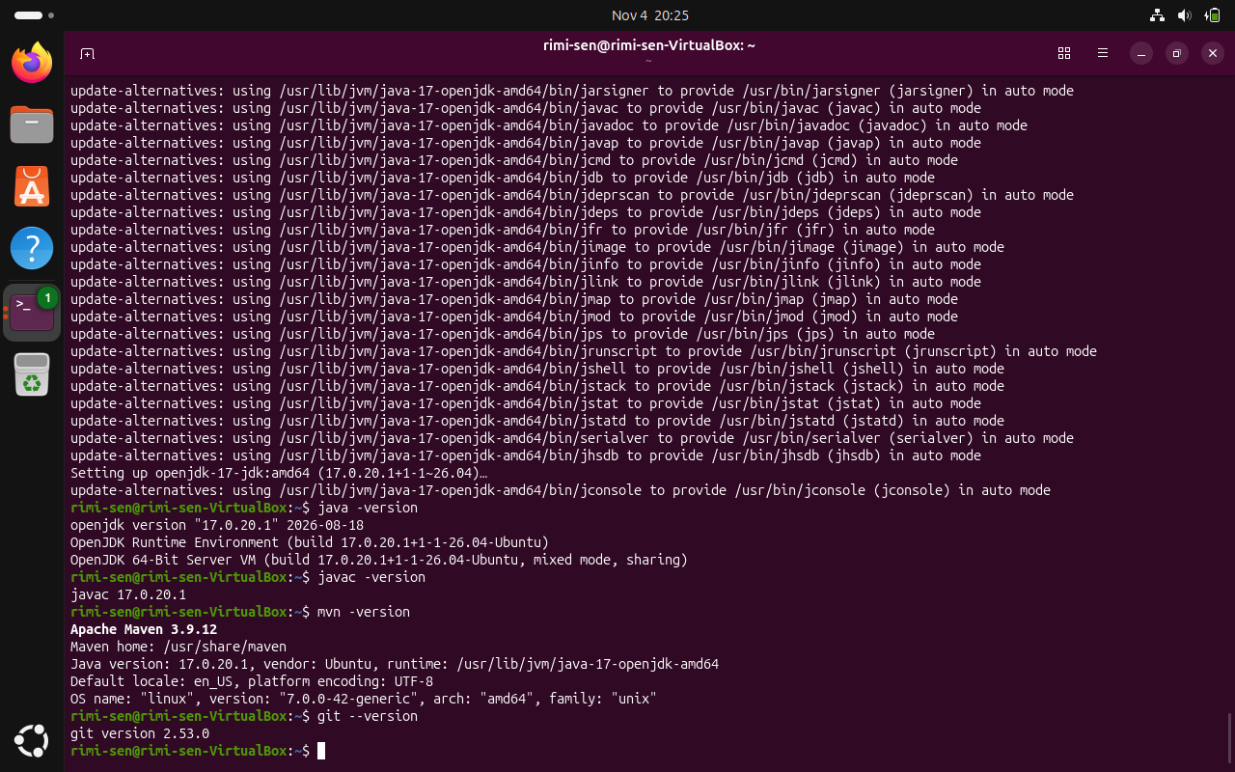
Figure — Java, Maven and Git version verification
mvn -version
git --version

Step 8: Create the Maven source directory
Create the standard Maven package directory for Java source files. The -p option creates any missing parent folders.
mkdir -p ~/CloudSchedulingLab/src/main/java/lab
Figure — evidence for Step 8

Step 9: Move into the project folder
Change the current directory to the project root. Maven commands should be run from the folder containing pom.xml.
cd ~/CloudSchedulingLab

Step 10: Create the Maven project descriptor
Open a new pom.xml file in the project root. This file describes the project, Java build settings, dependencies (including CloudSim Plus), and the execution configuration used by Maven.
nano pom.xml
Note: Save in nano with Ctrl+O, press Enter, then exit with Ctrl+X. The exact pom.xml contents are not fully visible in the supplied screenshots.

Step 11: Resolve Maven dependencies
Ask Maven to read pom.xml and download/resolve the project's dependencies from Maven Central. Wait for the command to finish.
mvn dependency:resolve
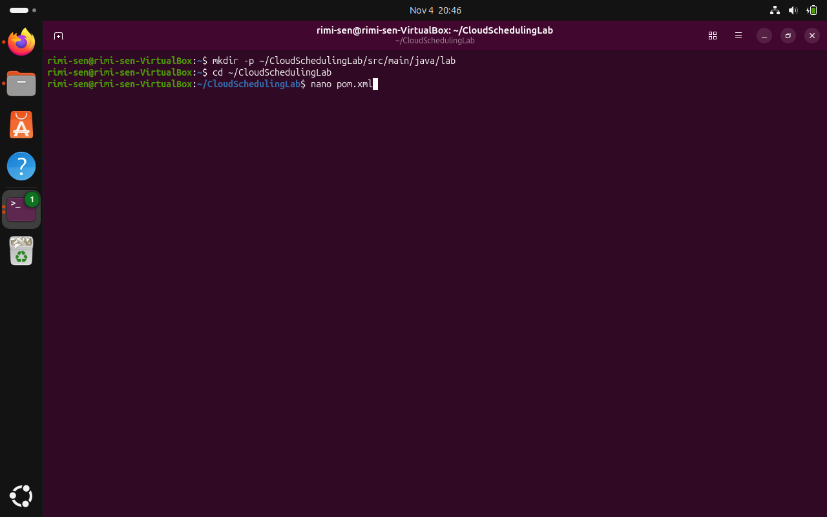
Figure — evidence for Step 11

Step 12: Confirm the initial Maven build
Run the Maven package lifecycle to compile the project and package it. The supplied output ends with BUILD SUCCESS.
mvn package
Note: The screenshot shows a successful build of cloud-scheduling-lab 1.0-SNAPSHOT.
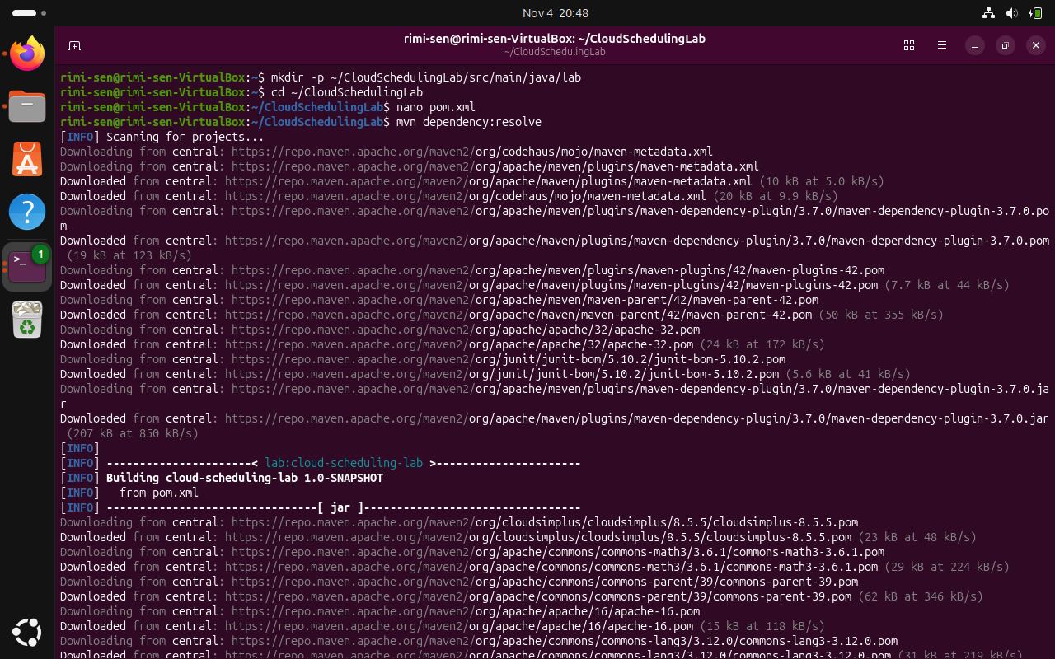
Figure — evidence for Step 12

Step 13: Clean previous build output
Remove the previous target directory so the next compilation starts from a clean build state.
mvn clean
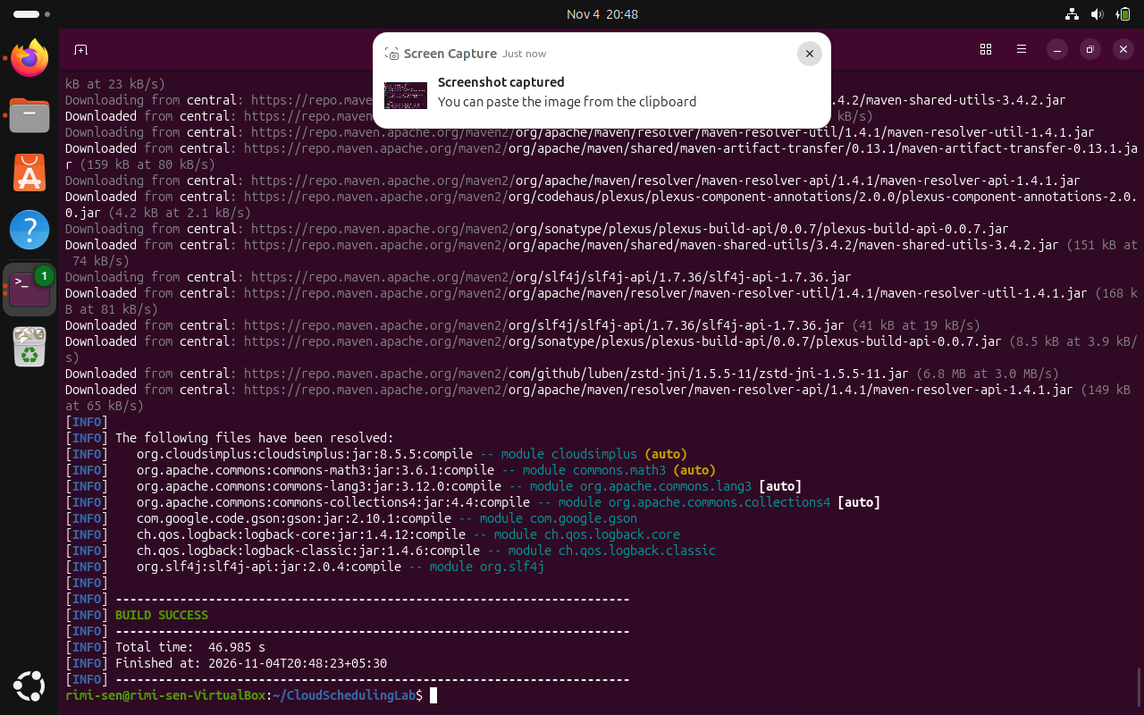
Figure — evidence for Step 13

Step 14: Create the Java experiment class
Open the Java source file in the lab package. Its package declaration should be package lab; and the public class name should match the filename SchedulingExperiment.java.
nano src/main/java/lab/SchedulingExperiment.java
Note: The screenshot shows imports for CloudSim Plus classes and constants for hosts, VMs, cloudlets and simulation length.
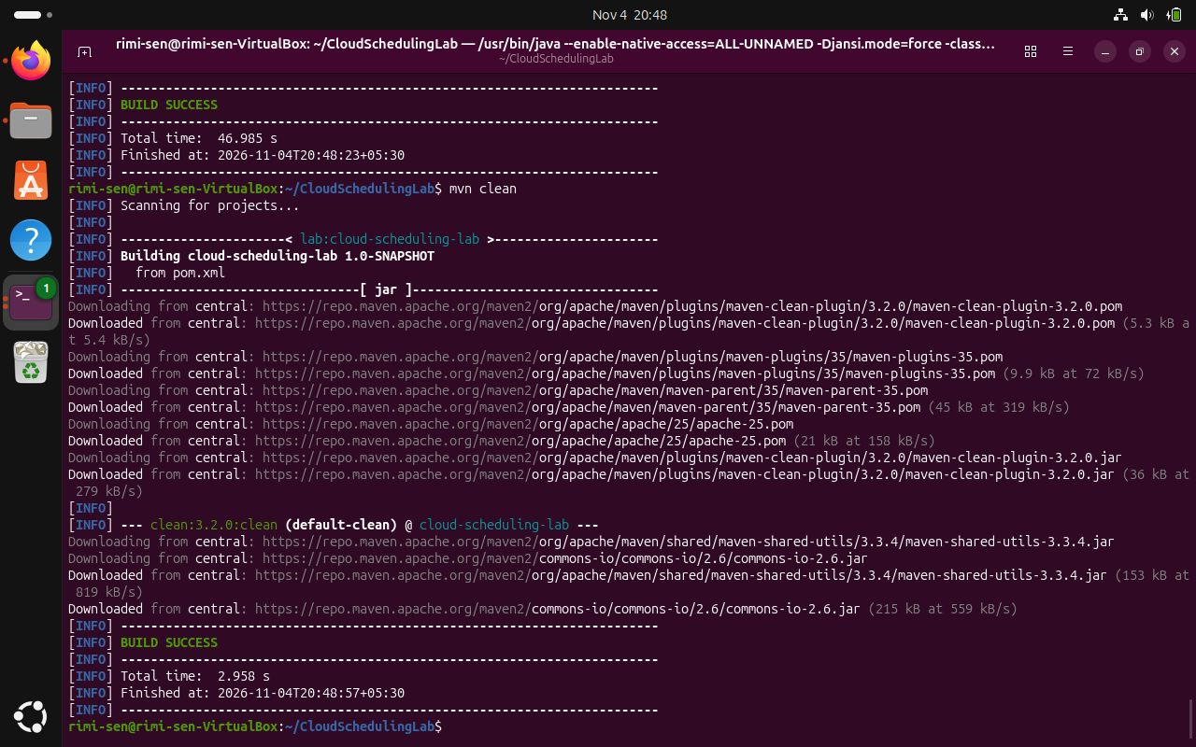
Figure — evidence for Step 14

Step 15: Add the scheduling simulation code
Enter or retain the SchedulingExperiment Java implementation. The visible source imports CloudSim, datacenters, brokers, cloudlets, hosts, processing elements, schedulers, utilization models, VMs and a VM allocation policy. Save the file before leaving nano.
Note: The complete source code is not visible in the screenshot, so this guide does not recreate unseen lines.

Step 16: Compile the Java source
Run Maven clean compile to remove old build output and compile the Java source against the dependencies in pom.xml.
mvn clean compile
Note: The supplied output reports BUILD SUCCESS and compilation of one source file.
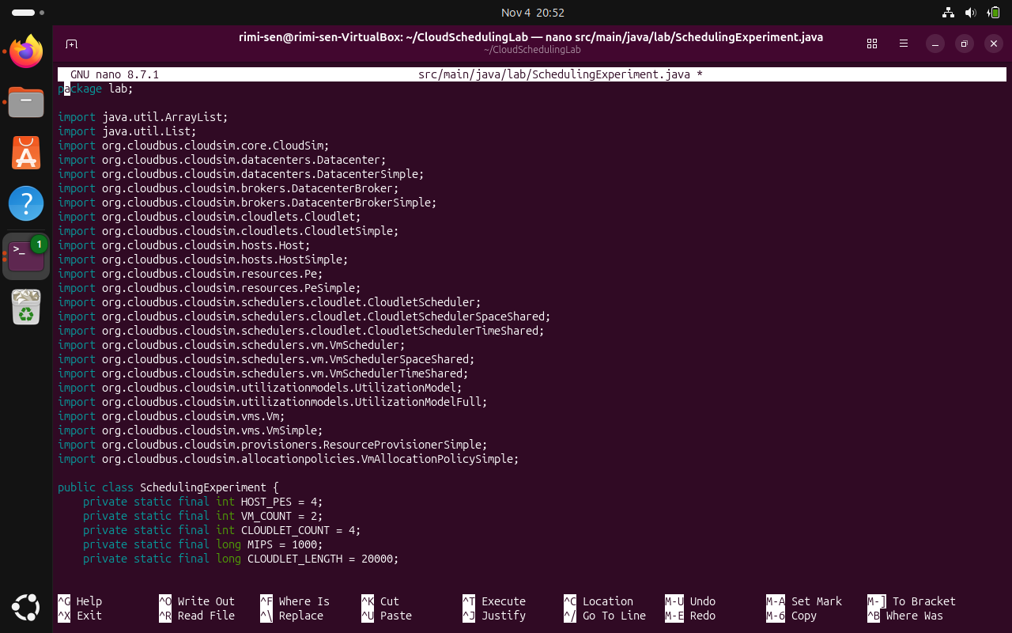
Figure — evidence for Step 16

Step 17: Execute the experiment through Maven
Run the configured main class using the Maven exec plugin. This starts the CloudSim Plus simulation.
mvn exec:java -Dexec.mainClass="lab.SchedulingExperiment"
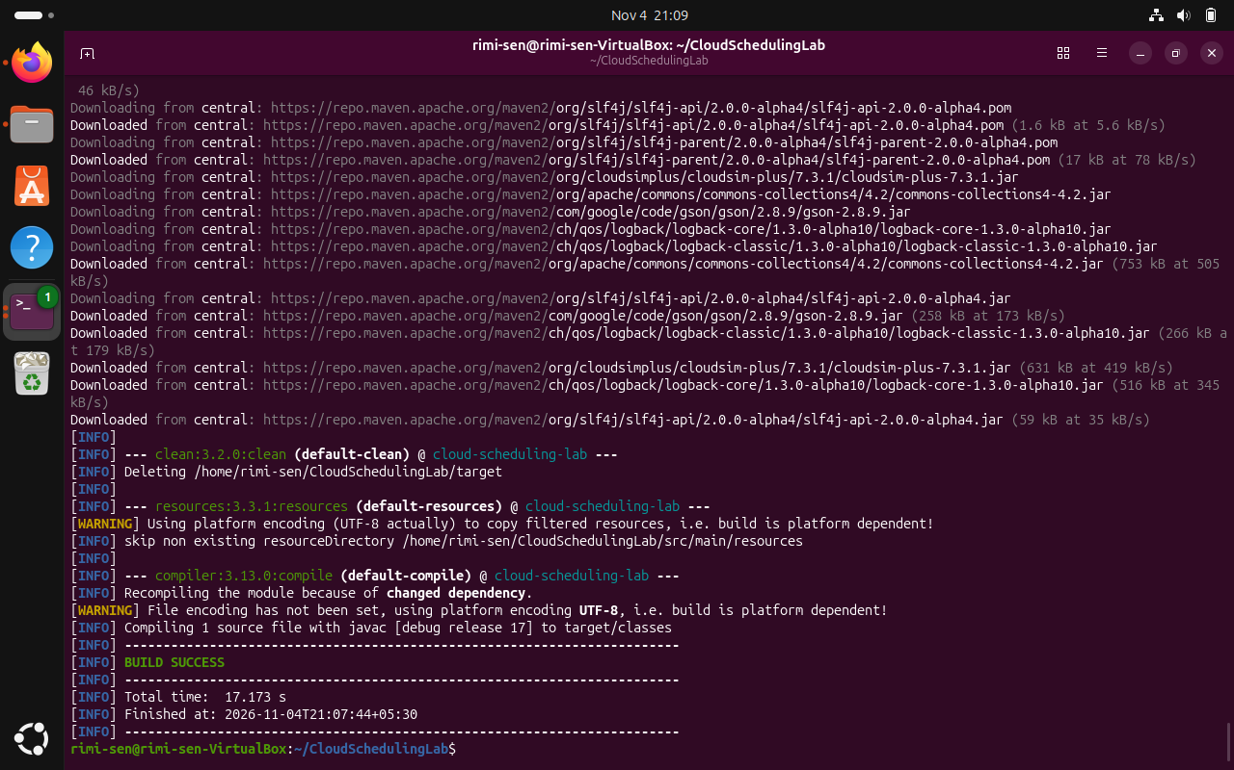
Figure — evidence for Step 17

Step 18: Review and correct runtime issues if shown
If execution prints a stack trace or reports a source-level issue, inspect the complete error message, correct the indicated Java line, save the file, and compile again. The supplied recording shows a command-line source edit followed by another clean compile and execution attempt.
Note: The recording contains a short error/retry segment. The exact correction should be based on the full error text in your terminal, not copied blindly.
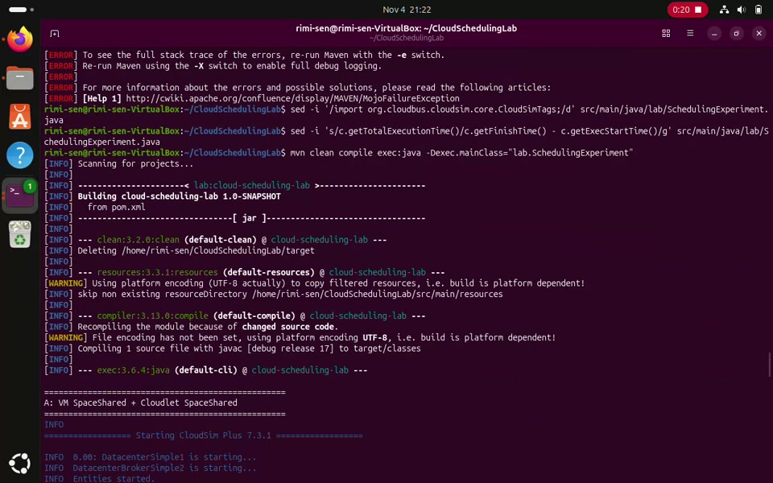
Figure — evidence for Step 18

Step 19: Check the simulation results
After the simulation completes, review the console output. The supplied recording shows CloudSim Plus starting, processing cloudlets, shutting down the entities, and printing a results table with cloudlet status, VM, start time, finish time and execution time. Confirm that the expected cloudlets report SUCCESS.
Note: The recording also shows the simulation summary and a second run/configuration. Your values may differ if you change the number of hosts, VMs, cloudlets or scheduling settings.
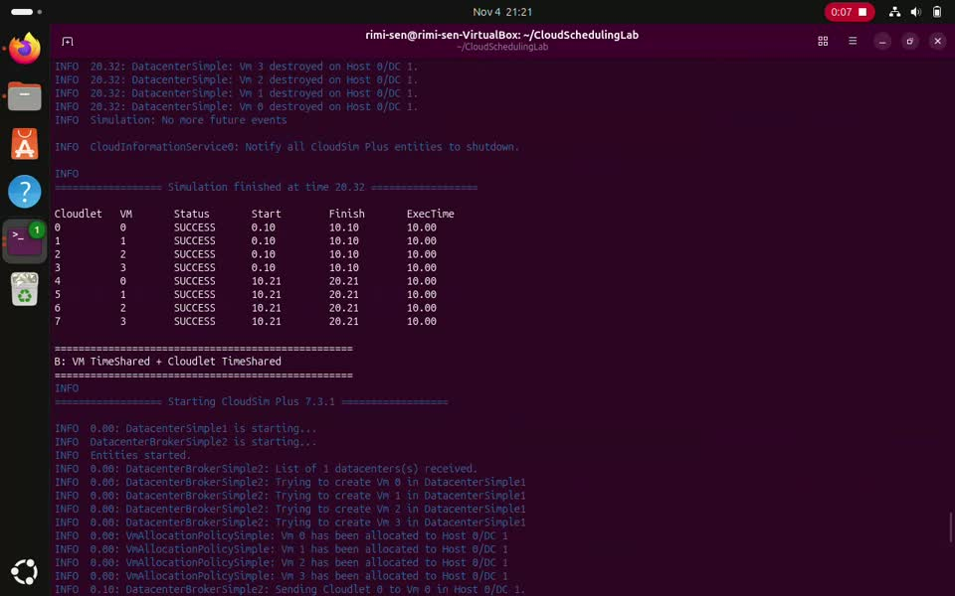
Figure — evidence for Step 19

Useful commands at a glance
- sudo apt update
- sudo apt upgrade -y
- sudo apt install openjdk-17-jdk maven git -y
- java -version
- javac -version
- mvn -version
- git --version
- mkdir -p ~/CloudSchedulingLab/src/main/java/lab
- cd ~/CloudSchedulingLab
- mvn dependency:resolve
- mvn package
- mvn clean
- mvn clean compile
- mvn exec:java -Dexec.mainClass="lab.SchedulingExperiment"

Final checklist
- OpenJDK 17 is installed and java / javac commands work.
- Maven and Git are installed.
- CloudSchedulingLab contains pom.xml.
- The Java source is saved at src/main/java/lab/SchedulingExperiment.java.
- mvn clean compile completes with BUILD SUCCESS.
- The Maven exec command starts the simulation.
- The final console output shows the expected cloudlet results.

