**The**

**Flower**

**World**

|  |  |  |
| --- | --- | --- |
| **Supervisor:** | **Syed Murtaza Saeed.** | |
| **Batch :** | **2409d.** | |
| **Group:** | **The Florita.** | |
| **Serial No :** | **Enrollment No.** | **Student Name** |
| **1** | **1613388** | **Rimsha Sajid** |
| **2** | **1613459** | **Hafsa Ayub** |
| **3** | **1612939** | **Muhammad Sufiyan Siddiqui** |
| **4** | **1612963** | **Muhammad Affan Siddiqui** |

**Acknowledgment**

First, we would like to express our special thanks to my teacher SIR SYED MURTAZA SAEED who helped us a lot in finalizing this project within the limited time frame, valuable counseling and assistance for the accomplishment of this project.

Secondly, we would also like to thanks the e-project team at Aptech Head office, Who gave us the opportunity to do this interesting and wonderful project about The Flower World.

Following are the benefits of this project.

* Re-enforcement of Skills happens in the experimental learning process.
* A mentor, ensuring that we do not get drifted, constantly guide us.
* It gave us a lot of confidence to face an interview as we have worked on a project. We can explain virtually everything on the subject we have learned.

**Synopsis**

**Flower World** – Adorning every moment with joy, The Flower World is a premium online flower delivery service that brings your emotions to life with fragrances and colors. On our website, you’ll find a wide range of exquisite floral arrangements, perfect for any occasion. Whether you're looking to surprise your loved ones on their birthday, anniversary, or any special event, our fresh, handpicked flowers will convey your messages in the best possible way.

* **Fresh & Handpicked Flowers:** We offer a wide selection of the freshest flowers, handpicked daily to ensure the best quality.
* **Customized Floral Arrangements:** Personalize your bouquet or floral arrangement to match your occasion and preferences.
* **Timely & Hassle-Free Delivery:** We guarantee prompt delivery, ensuring your flowers reach their destination on time.
* **Special Occasions & Events:** Perfect for birthdays, anniversaries, weddings, and more. Let us help make your celebrations even more special.
* **Eco-Friendly Packaging:** We care about the environment and use sustainable packaging materials for every order.
* **24/7 Customer Support:** Our friendly support team is always available to assist you with orders, queries, and customizations.

With hassle-free delivery, customization options, and timely service, The Flower World makes every moment memorable. Send happiness to your loved ones today, and visit our website to order your perfect bouquet!

**Scope Of the work**

The name of project is The Flower World the software provides the customer various facilities. In this project Create an intuitive, easy-to-navigate interface for a smooth customer experience. Develop a secure and easy-to-use online ordering system for customers to select flowers, customize their bouquets, and place orders.

Implement a powerful search feature to help users easily find products based on their needs. Enable customers to personalize their floral arrangements with different flowers, colors, and sizes.

This **Scope of Work** outlines the key features, functionalities, and tasks involved in creating and maintaining a flower website. It ensures clarity on all technical and operational aspects of the website development process.

1. **TOP LAYOUT**

This the Top of the page.

* User can know about website by clicking on About us button.
* User can get touch to the admin through contact info



**2.HOME PAGE.**

* This page contains our Flowers, where every bloom tells a story.

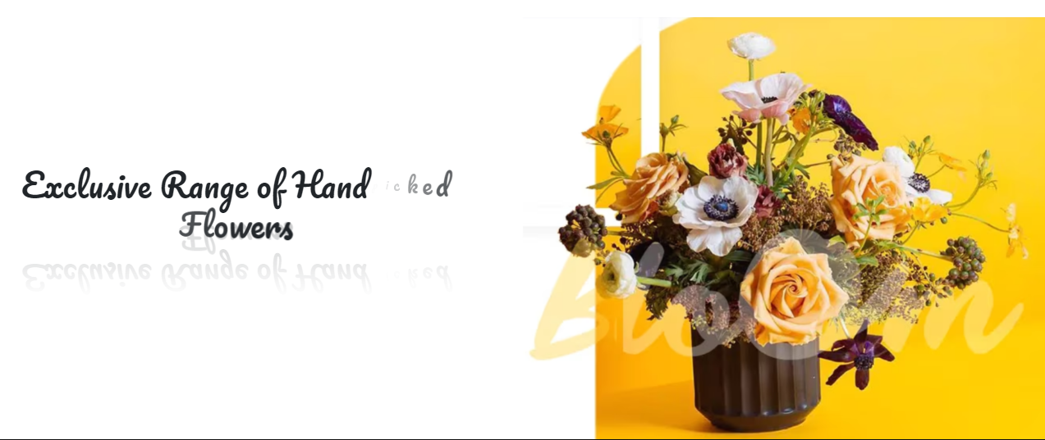

**3.PRODUCT PAGE.**

* In this page you can discover our vibrant collection of fresh, handpicked flowers, perfect for every occasion. Add a touch of beauty and elegance to your moments today!

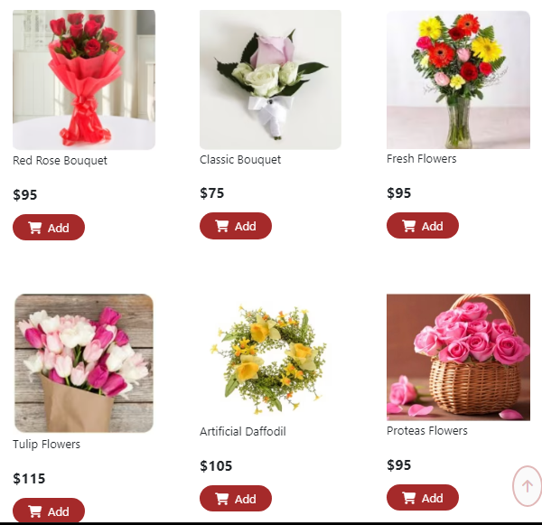

**4.Contact PAGE.**

* You can contact us easily by our id’s and number and you can send your feedback about our website and our work.

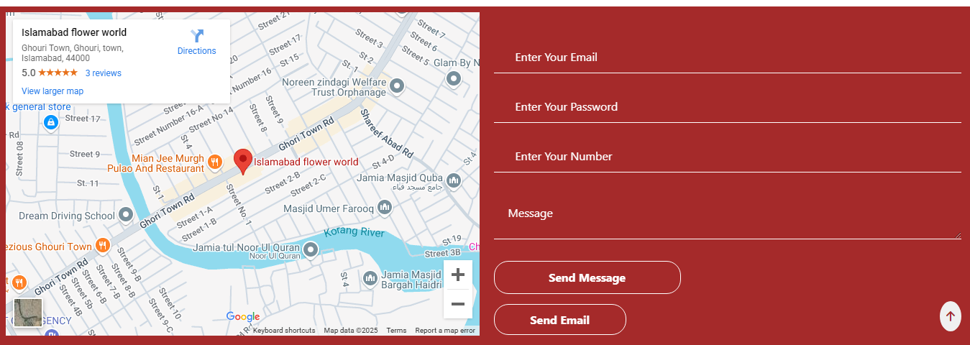

**Thank You**