**Car rental**

RANACHRITA - Car Service

Table of Contents

1. Introduction 2
   1. History ……………………………………………………………………………………………. 2
   2. What the Problem is 2
   3. Goals for the Project 2 - 3
   4. Stakeholders 3 - 4
   5. Motivation for the Project 5
   6. Process Flow Preview 5 - 6
2. Analysis and Design 7
   1. Plan for Requirements Engineering 7 - 9
   2. Functional Requirements 10 - 13
   3. Non-Functional Requirements 13 - 17
   4. Use Cases 17 - 20
   5. Model 21 - 22
3. Project Plan 23
4. Develop 33
5. Testing 28
6. **Release 33**
7. **Feedback 33**
8. **User Manual 33**

**Introduction**

*1.*

# History

We are a group of four students who wants to create a car rental web application with new

Features. Our group members are: Nazanin Binesh who is graduated in IT and studying Computer at

Douglas college has been working as a front-end developer and will play a programmer and Analyzer in

this company. Taban Nikdel who is studying computer at Douglas college as well is a programmer in this

project. The next programmer is Rafael Olivares, who is a Douglas College student, he has a couple years experience working as a full stack developer.

# What the Problem is

More than a problem, we are looking for helping people to make money with extra resources they got at home, in this case an extra car. And it will provide of more option when people will want to rent a car. For example, someone who has more than 3 cars at home, and usually use one of the at the time, it could register one of them to be rented during the time this person is not using it. Also, give more optiones for insurens and paiments methods.

# Goals for the Project

This software, called ‘Ranachrita’,….

Both registered and non-registered users will be able to search car rentals by price, model, seating and any other potential searches. They will also be able to select and pay for the service. The consumer would choose on checkout if they will come to pick up the car of if they

# Stakeholders

# Process Flow Preview

For our process flow, we plan on taking the iterative route, as we find communication essential throughout the development process. In order to plan all aspects of the project in detail, we feel that contacting the car rental service and having those in charge be in the same room when

the planning is taking place. It is our way of discussing requirements and develop important notes that will help in constructing the overall feel and idea. The modeling process in its own right we feel is not a start to finish process. There will be times that we may have to go back to certain portions within the modeling activity to ensure a sufficient model. We wish to make sure that if we miss anything, we do not figure that out in the construction stage.

Lastly, we find the construction framework activity to require communication with the car rental service as well. It would allow for us to get small tweaks out of the way as well as have a kind of testing process on the interaction between the constructed elements and those that will use the software directly. We feel that allowing for the users to view how the software is made will ease the transition during the deployment stage.

**Analysis and Design**

# Functional Requirements

**Host**

* Host should be able to create a profile
* Host should be able to define car(s) details (picture /technical information/)
* Host should be able to define a schedule for car(s) availability
* Host should be able see a list of request for a car
* Host should be able to confirm who can rent his car.
* Host should be able to edit the details of the car
* Host should be able to define if insurance is mandatory
* Host should be able to define if adding more drivers are possible
* Host should be able to define Pickup & return location
* Host should be able to define if free delivery is the option

**Customer**

* Customer should be able to Register a profile
* Customer should be able to list products
* Customer should be able to search and filter
* Customer should be able to look at details of cars
* Customer should be able to select a car with or without a driver
* Customer should be able to select insurance option
* Customer should be able to select having more than one driver in a trip
* Customer should be able to cancel a booked car
* Customer should be able to pay by card
* Customer should be able to select Pickup & return location
* Customer should be able to send feedback and rate

# Non Functional Requirements

* The Site should be able to serve a huge number of customers at the same time without problems.
* The site should be secure enough because there will be sensitive data.

# Use Cases ???????????????????

# Model

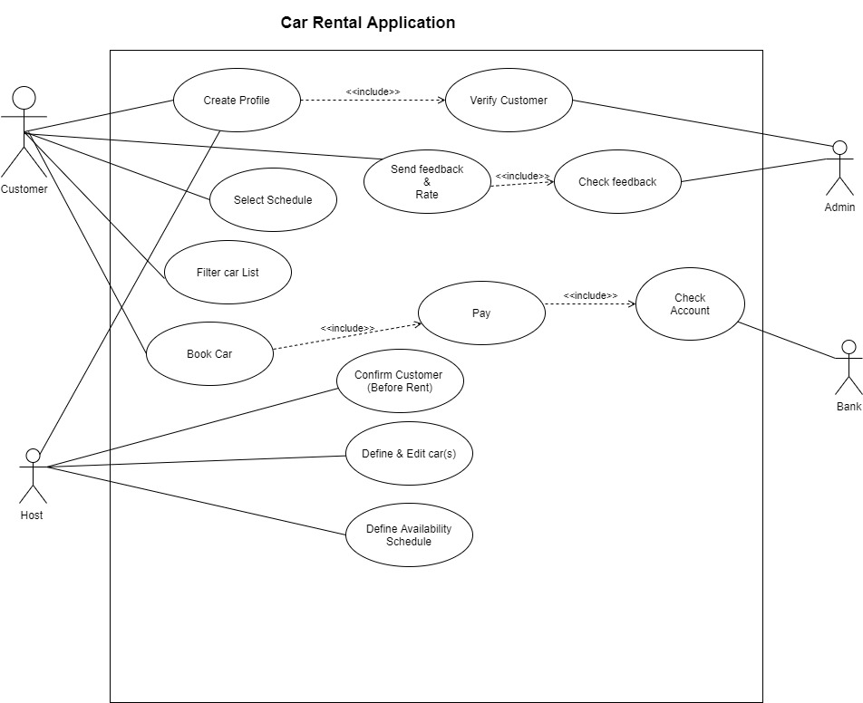

**Project Plan**

*3.*

**Develop**

*4.*

**Testing**

*5.*

**Release**

*6.*

**Feedback**

*7.*

**User Manual**

*8.*