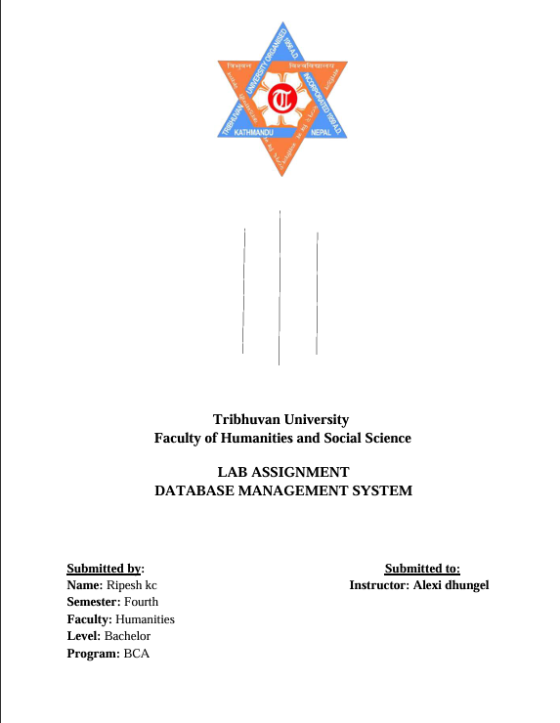

**Tribhuvan University  
Faculty of Humanities and Social Science**

**LAB ASSIGNMENT**

**DATABASE MANAGEMENT SYSTEM**

**Submitted by:**Name: Ripesh KC  
Semester: Fourth  
Faculty: Humanities  
Level: Bachelor  
Program: BCA

**Submitted to:**Instructor: Alexi Dhungel