**Computing Basics – Open On Demand on RIS Scientific Compute Platform**

**Demos**

In this workshop you will learn how to:

- Connect to RIS Scientific compute platform on the command line

- Connect to RIS Open on Demand on the web

- Browse RIS OOD menus

- Launch Interactive Apps and submit jobs that use RStudio and Jupyter Notebook

--------------------------------------------------------------------------------------------------------------------

**Activity 1: Launch RIS OOD**

Step 1: Connect to RIS Scientific compute

Make sure your personal computer has command line interface shell (terminal) and the ssh protocol.

Linux and Mac computers have built-in terminal and ssh. Windows computers with Windows PowerShell would work fine. Windows computers can also get a terminal from a Windows Subsystem for Linux (WSL) installation or from other 3rd party software such as MobaXterm or Putty.

Connect to the RIS compute with the ssh command using your wustl key as shown below.

**ssh wustlkey@compute1-client-1.ris.wustl.edu**

VPN connection is needed for off campus access: <https://it.wustl.edu/items/connect/>.

Here’s the ssh command that connects Maze to RIS scientific compute platform:

ssh ndukummaze@compute1-client-1.ris.wustl.edu

Password: Maze’s wustlkey password

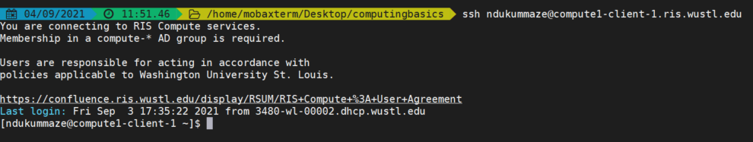

Step 2: Connect to RIS OOD

Open On Demand is web based, use this url: [http://ood.ris.wustl.edu](http://ood.ris.wustl.edu/) to open RIS OOD in a web browser such as Google Chrome or Mozilla Firefox (currently, OOD doesn’t work on safari). You need to connect to RIS compute using command line at least once before you can connect to RIS OOD.

After connecting to RIS scientific compute using ssh on command line at least once, you can connect to RIS OOD using single sign on with your wustl key credentials. Since you only need a web browser, you can connect from on or off campus, on different types of devices (computer, tablet, cell phone), and don’t have to be on WashU network.

url: [http://ood.ris.wustl.edu](http://ood.ris.wustl.edu/)

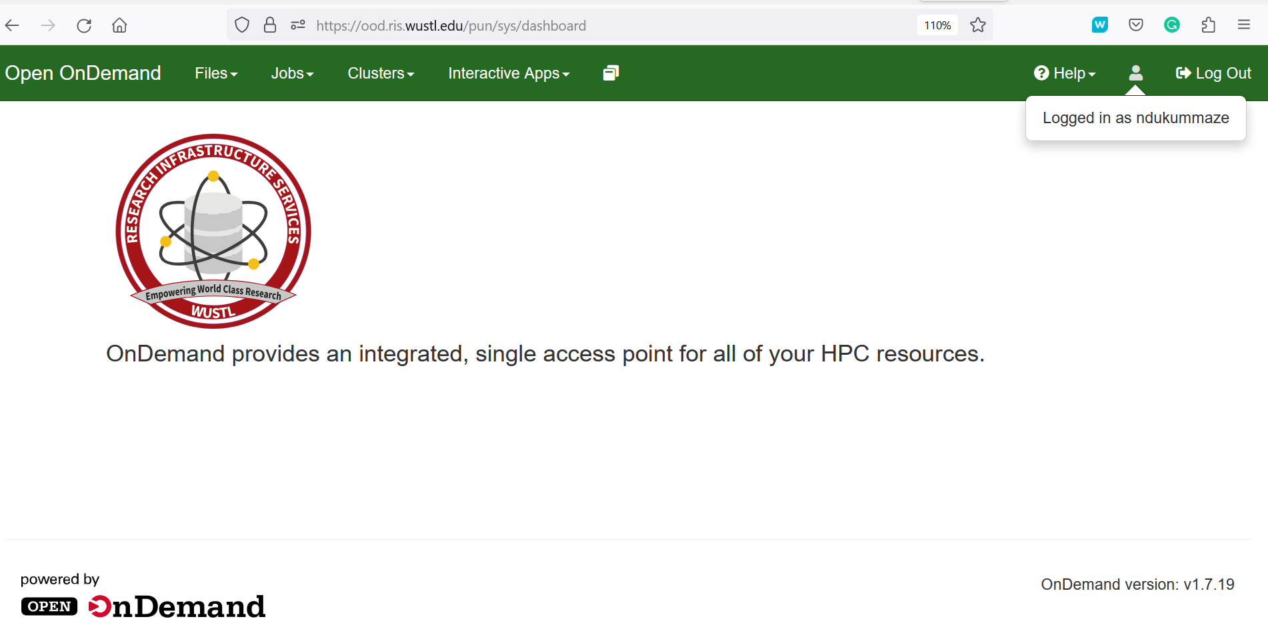

--------------------------------------------------------------------------------------------------------------------

**Activity 2: Browse RIS OOD menus**

https://docs.ris.wustl.edu/doc/compute/compute-ood.html

Files:

* Display files and directories in your RIS Home directory. Users can manage files and directories, create new files, delete files, upload files

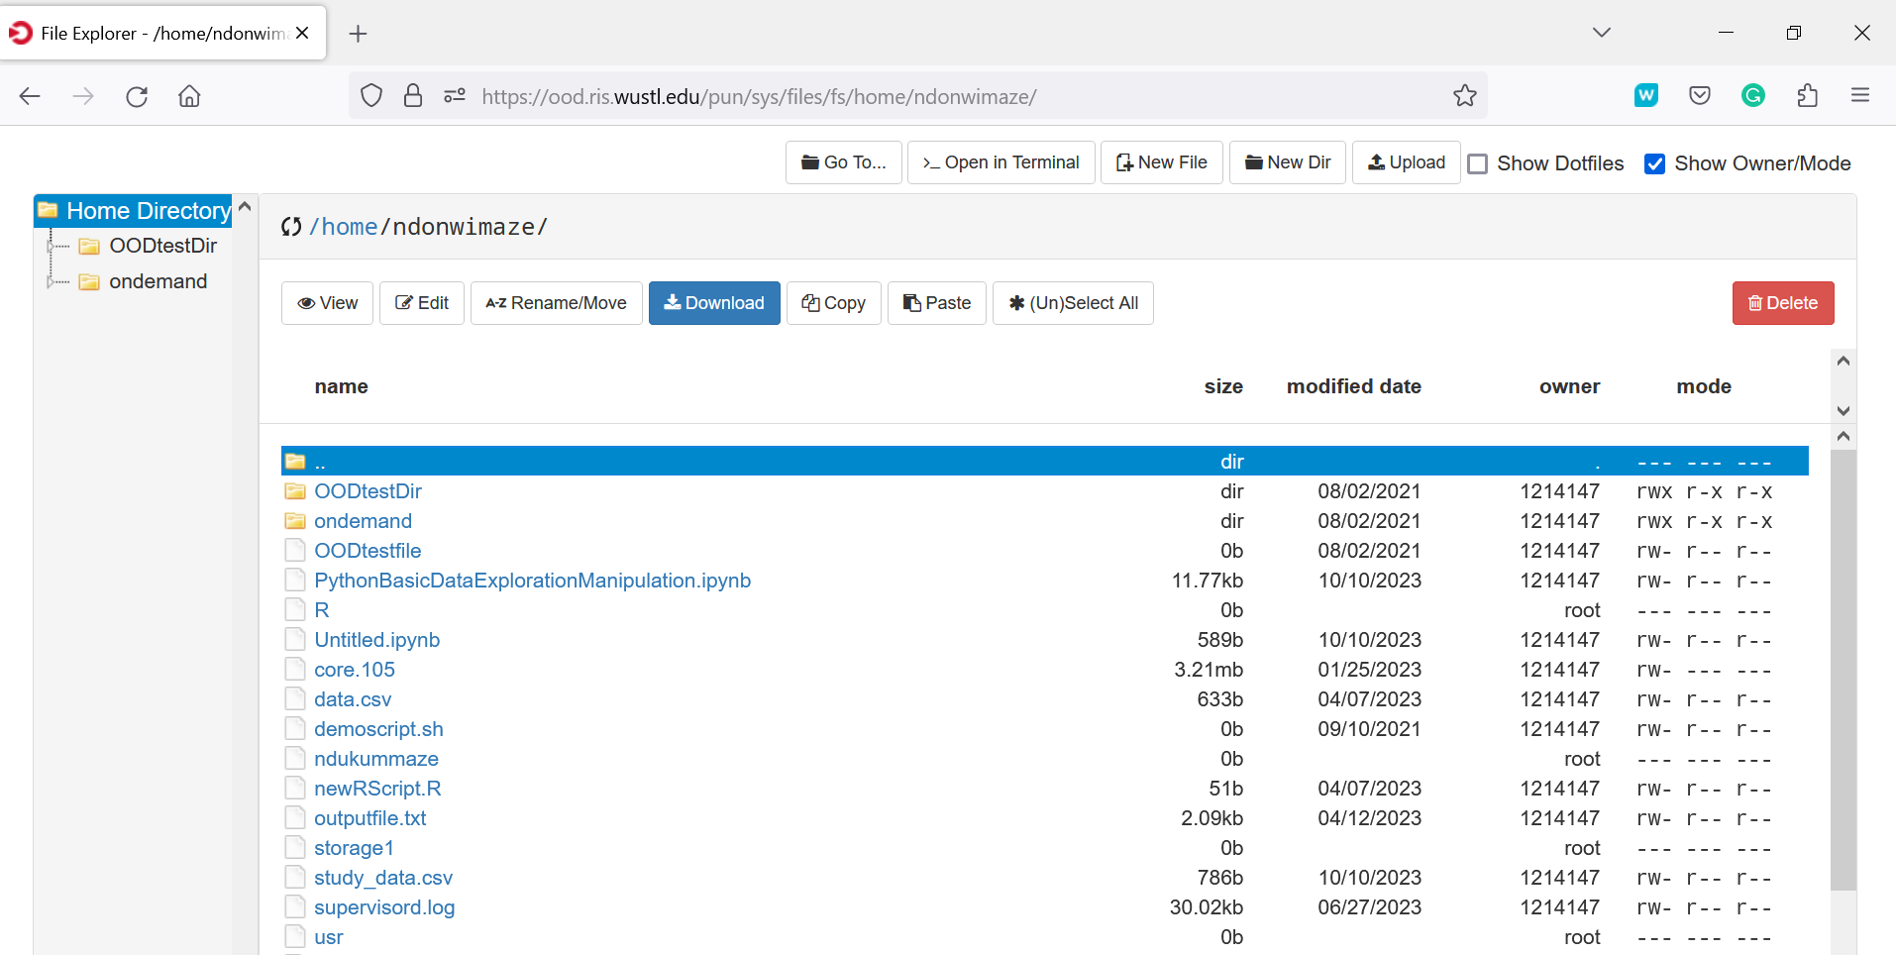

Jobs:

The Active Jobs window lists any pending or running jobs and the *trash can* icon can be used to delete a job if needed

The Job Composer allows users to create and launch batch jobs. Jobs can be created from a default template, a specified path or an existing job

Clusters:

RIS Compute1 Shell Access provides access to command line terminal and RIS compute1 resources. Users can also click the _*open in terminal* tab in the Files menu to open a terminal.

At the terminal prompt, type in the ssh command using your wustl key and wustl key password to connect to RIS compute.

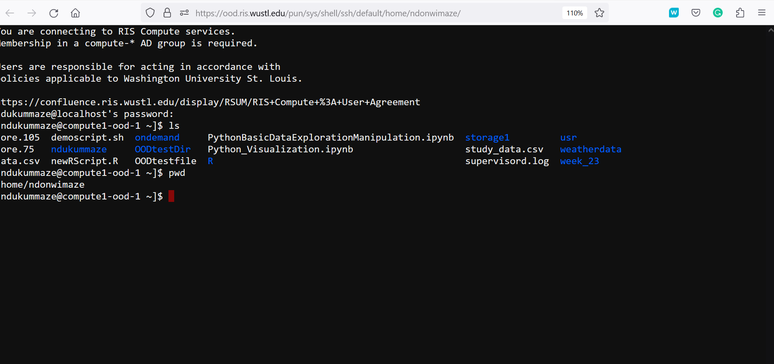

This is a command line interface you can use for submitting jobs if you’d like. Run the groups and bqueues commands.

Interactive apps:

When users need to use software on RIS compute, the RIS OOD is a great option. To run jobs with software, choose from the Interactve Apps drop-down menu and click on a software. Complete the job submission form and click Launch.

Let’s demonstrate how to launch the RIS OOD interactive apps using basic and default job resource options

1. Launch RStudio and run some R code to analyze a small spreadsheet data located in storage1.

Complete the job submission form following the instructions on the slides or the detailed instructions found here - <https://docs.ris.wustl.edu/doc/compute/compute-quick-start.html>

The RStudio software launches and opens from the Home directory (the default location). To access files in another location such as storage1, users need to click the three dots on the right of the RStudio Files Window and provide the path to that location as shown below.

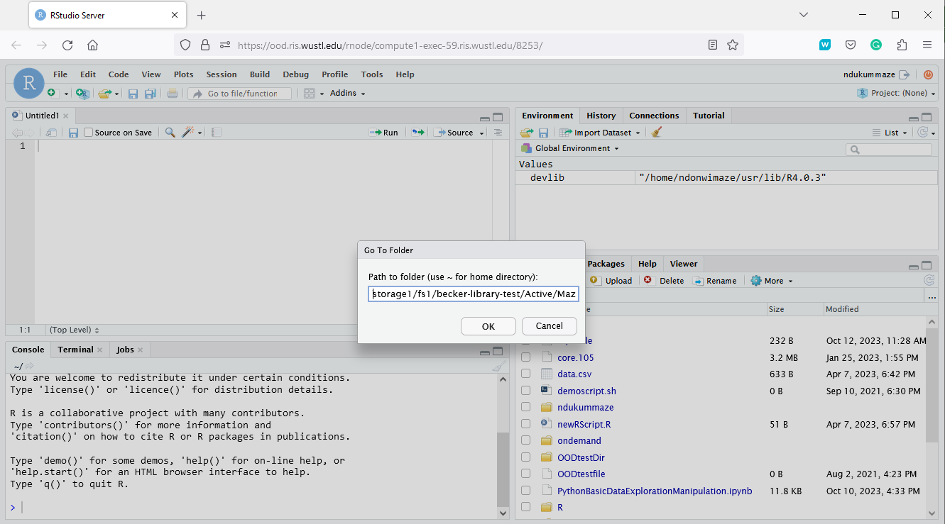

1. Launch Jupyter Notebook: Similar to the RStudio example above, we’ll open a Jupyter Notebook to run some Python code. To access storage1 files, make sure to input a single file path in the “Custom Jupyter Notebook Directory” box to change from the default Home folder to your storage1 directory.

For example, this path opens in Maze’s storage1 allocation: /storage1/fs1/becker-library-test/Active/Maze

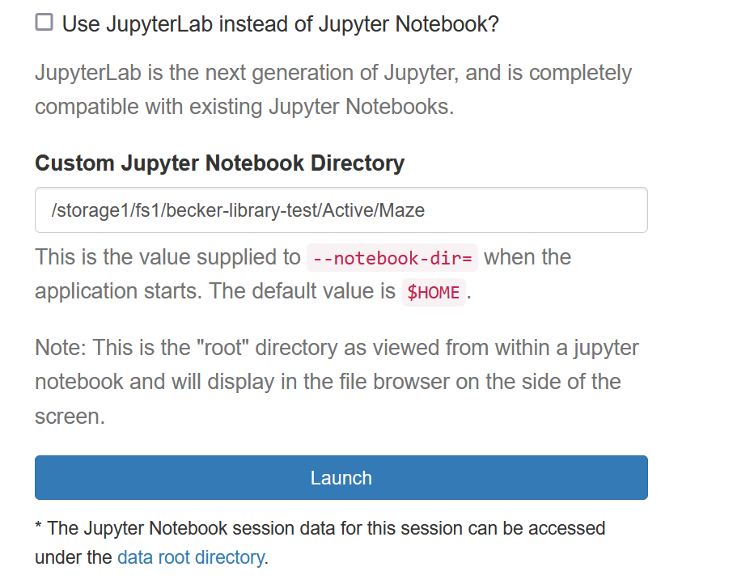

1. Compute RIS Desktop: is a way to run jobs using the command line module load system to load software, this provides a more traditional HPC option
2. Custom noVNC Image: with this option, users can run jobs using the RIS vetted noVNC images listed here: <https://docs.ris.wustl.edu/doc/compute/recipes/tools/novnc-dockerimage.html#novnc-dockerimage>.

To make use of the Custom noVNC Image app, when filling the job submission form, users need to input Environment Variables and a Docker Image as shown below.

For example, RStudio can be launched via the Custom noVNC app using this RIS Docker image: ghcr.io/washu-it-ris/rstudio:4.3.0

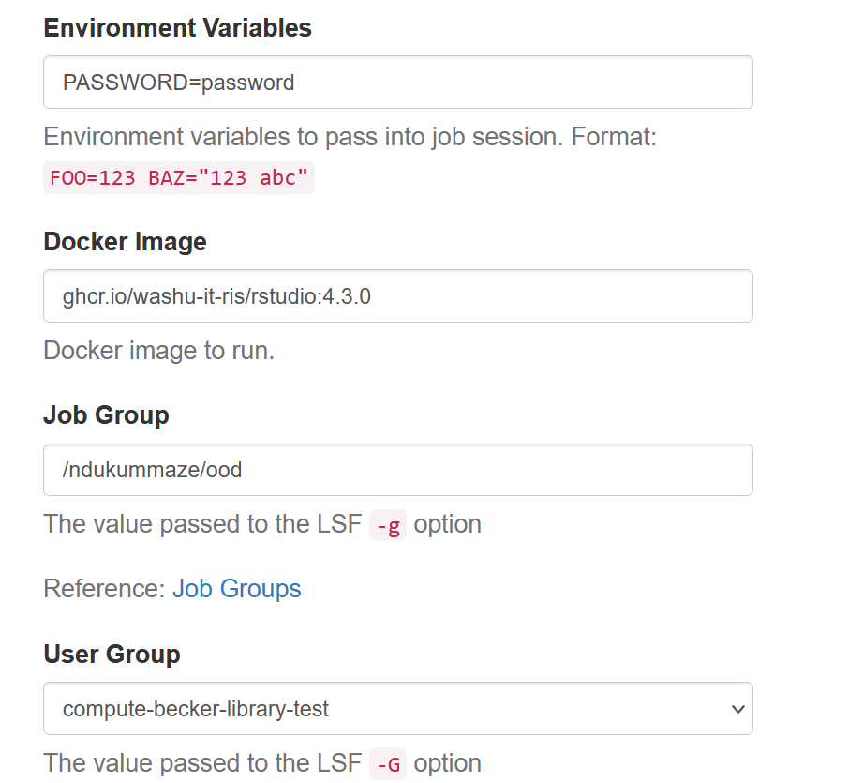

--------------------------------------------------------------------------------------------------------------------

**Learn more:**

* Compute Quick Start:<https://docs.ris.wustl.edu/doc/compute/compute-quick-start.html#compute-quick-start>
* RIS OOD:<https://docs.ris.wustl.edu/doc/compute/compute-ood.html>

* [Bioinformatics training on campus:](https://becker.wustl.edu/news/free-bioinformatics-training/) Lectures are recorded and participants can join anytime throughout the year. For details, visit the bfx workshop webpage <https://github.com/genome/bfx-workshop>

--------------------------------------------------------------------------------------------------------------------