# RISC-V Community

**Contents**

RISC-V Community 1

Chapter overview 3

Learning objectives 3

Exploring the RISC-V Community 4

Culture of Community Engagement 4

Collaboration and Contribution 4

Intellectual Property Policy 4

Code of Conduct and Privacy 5

Technical Working Group Organization 5

RISC-V’s Technical Organization 5

Terminology 6

Technical Steering Committee (TSC) 6

Chief Technology Office (CTO) 6

ISA Committees (IC) 6

Horizontal Committees (HC) 6

Task Groups (TG) 6

Special Interest Groups (SIG) 6

Chair & Vice-Chair 7

Technical Leadership & Governance 7

Technical Steering Committee 7

ISA and Horizontal Committees 8

Task Groups 9

Technical Staff 9

Chief Technical Officer 9

Technical Program Managers 10

Other Technical Staff 10

Administrative & Executive Groups 10

Additional Roles 10

Board of Directors 10

Marketing & Visibility 10

Operations & Program Management 11

Tools of the Trade 11

Communication Channels 11

Member Portal 11

Meetings 11

Slack 12

GitHub 12

Совместное хранилище и RISC-V Wiki 12

Technical Policies 12

Public Discussion Groups 12

Public Conferences, Workshops, and Local Events 12

The RISC-V Exchange 13

## Chapter overview

This chapter explores the RISC-V community of developers and our culture of community engagement. We will explore the technical working groups and their policies, practices, and communication methods.

## Learning objectives

By the end of this chapter, you should be able to:

* Understand how the technical organization works in RISC-V.
* Know where to go for information as well as communication.
* Completely understand the RISC-V Code of Conduct and how it applies to all forms of communication within the organization.

## Exploring the RISC-V Community

## Culture of Community Engagement

RISC-V is, at its heart, a community organization, meaning that it operates primarily as a group of motivated organizations and individuals pursuing a common goal by working in concert rather than as adversaries, even if those organizations compete with each other in other areas. This arrangement has proven dramatically successful in many software projects, including the Linux operating system that is by far the most successful software project in history. The open-source methodology works.

RISC-V is bringing this methodology to the hardware world by creating a culture of community engagement and participation around the RISC-V ISA and related specifications, testing and debugging frameworks, development software, and more. As of this writing (February 2021), there are well over 2,000 people working on RISC-V, representing over 230 organizations, and with many people representing themselves. RISC-V employs a few people as staff to help shepherd this process in a neutral capacity, but the vast bulk of effort on RISC-V comes from its community.

RISC-V provides the tools and methods to collaborate, but it also creates some guardrails around intellectual property as well as personal conduct, setting expectations for the community to get along.

## Collaboration and Contribution

As you will find in this chapter, RISC-V has a robust technical organization with a hierarchy of working groups and committees, along with many communication and collaboration tools to support them. The real point, though, is that contribution is a key function to the success of RISC-V, as it literally would not exist or prosper without the effort of its members.

## Intellectual Property Policy

At the core of RISC-V membership is the membership agreement[1] , a contract that all members sign. It includes the RISC-V Intellectual Property policy set forth in Appendix A of the Internal Regulations[2]. The goal of this policy is to protect RISC-V members as well as the RISC-V IP itself.

In essence, this policy creates a framework of protection around artifacts created by (or contributed to) RISC-V International in order to maximize the benefits of collaboration and to minimize the risks on behalf of every member. The policy assigns the rights of those artifacts to RISC-V International, who then provides them to the public under an open license (see section 6). In particular, section 7 provides protection from lawsuits related to the IP created in the collaborative processes outlined and managed by RISC-V.

## Code of Conduct and Privacy

As a community organization, RISC-V is made up of people, not all of whom hold the same ideas about conduct and privacy. RISC-V, along with nearly all community organizations, has instituted a Code of Conduct[3], that is applicable to the entire community. In essence, this Code of Conduct sets out the standards of behavior that are acceptable to the community, as well as indications of what could happen if they are not followed, and a reporting mechanism so that people can feel comfortable reporting issues knowing that their privacy will be respected. Note that this is also true for in-person and virtual events, which have their own, more detailed policy.

RISC-V also follows the Linux Foundation’s privacy policy[4] , which outlines the information collected by RISC-V related to personal identity, and how we treat this information. RISC-V does not sell personal information to anyone. Individuals in leadership positions and those who participate actively may become known through the transparent collaborative working processes of the organization, particularly if they also engage in public speaking at events. However, in all cases we treat your personal information as we treat our own, with respect and privacy topmost in mind.

# Technical Working Group Organization

## RISC-V’s Technical Organization

RISC-V’s technical organization is organized in a hierarchy, with a number of leadership roles at each level.

The RISC-V founders continue to be deeply involved in the development and implementation of RISC-V. Krste Asanović, Yunsup Lee, and Andrew Waterman all participate daily as technical task group and committee chairs as well as mentors to other technical leaders. David Patterson and Krste Asanović represent member organizations on the Board of Directors, providing business and industry guidance as well as technical leadership.

## Terminology

These terms describe the various types of groups in the technical organization, along with their chartered responsibilities. These groups are described in detail later in this section.

### ****Technical Steering Committee (TSC)****

Primary decision-making body within the technical organization.

### Chief Technology Office(CTO)

Runs TSC voting process, Leadership Strategy Meeting (LSM) and Chairs meetings, strategy, organization, IT, roadmap, resources, escalations.

### ISA Committees (IC)

Approve and oversee packages for TSC votes for the creation of ISA Extension TGs, as well as filling the chair and vice-chair vacancies for its TGs. Develop strategy for the groups under it and complete coverage of areas of responsibility under it including gaps.

### Horizontal Committees (HC)

Approve and oversee TGs working on activities other than ISA extensions. Has responsibilities to make sure that all ISA TGs cover the area overseen by the HC before ratification. Responsible for developing a holistic strategy and reaching out to the external ecosystem and community groups.

### Task Groups (TG)

Must have a charter that defines deliverable work products: extension specifications, standards, requirements, best practices, etc. TGs under the unpriv and priv SC can have ISA extension work products. TGs under HCs should not have ISA extension work products.

### Special Interest Groups (SIG)

Topic discussion. No work product. Can be created by the TSC, ICs or HCs with TSC approval not required.

### Chair & Vice-Chair

Leadership positions for a committee, task group, or SIG. These positions are generally elected on an annual basis. Chairs are always from member organizations, while vice-chairs may be either Individual members or representing organizations. Chairs and vice-chairs meet weekly to collaborate and discuss organizational details.

## Technical Leadership & Governance

Technical direction and decision-making happens within the governance committees - the Technical Steering Committee (TSC) as well as a host of committees and special interest groups (SIGs). Direct work on the specifications is driven by individual task groups working on specific specifications, software initiatives, testing or compliance frameworks, and many other ongoing projects. This work is organized and directed by technical leadership, and enabled and tracked by RISC-V’s neutral technical staff.

## Technical Steering Committee

The Technical Steering Committee (TSC) provides leadership to our technical initiatives. They are assisted by the Standing Committees, Technical Task Groups, and Special Interest Groups, all of which report to the TSC.

The TSC delegates responsibilities to organizational components below it in the hierarchy of groups. In addition, it discusses and decides on strategy, escalations, group and chair and preliminary charter approvals, and extension ratification.

The TSC has voting members as well as non-voting attendees who participate in a regular Leadership Strategy Meeting (LSM). Voting members include representatives from premier members as well as HC and IC chairs, although a single member organization may only be represented once in the group. Non-voting members include RISC-V staff, invited guests, and advisors. Next, we will describe each level of the technical organization underneath the authority of the TSC. Note that the details change from time to time, so be sure to check out the RISC-V website for the most up to date information about the technical organization. These images show the organization as of August 2022:

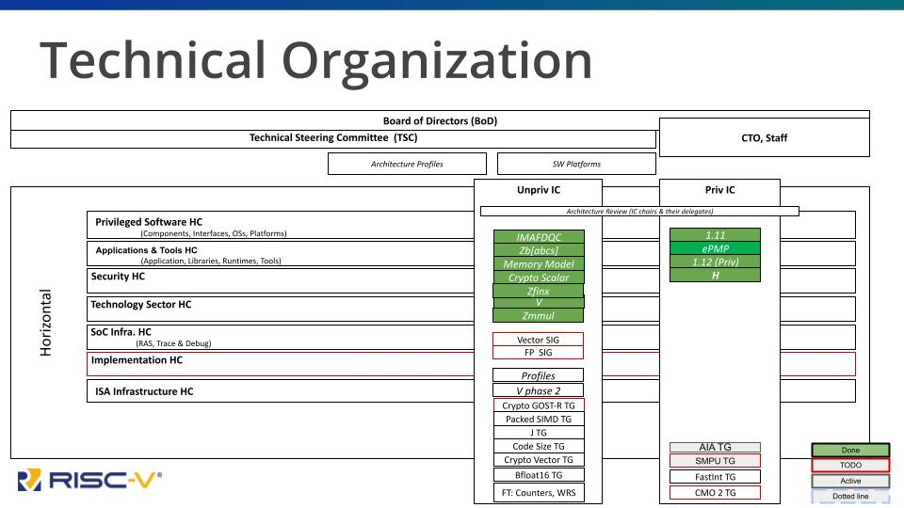

Picture 1. Structure of the technical organization.

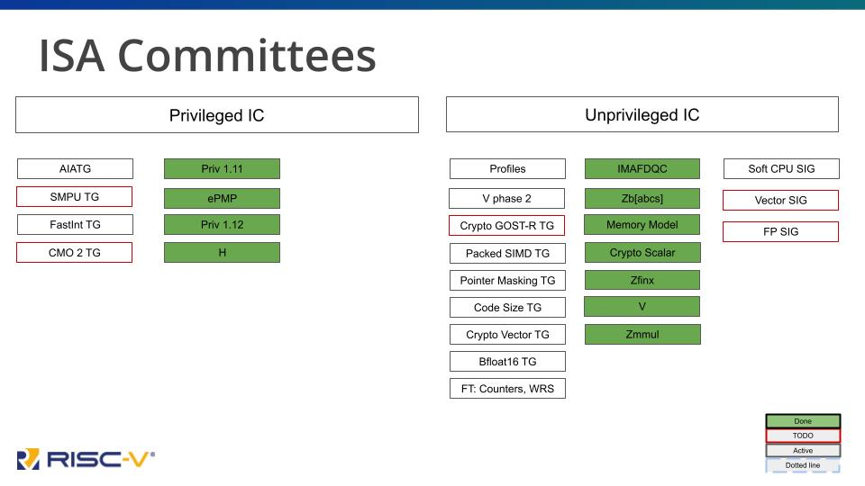

Picture 2. ISA committee structure.

## ISA and Horizontal Committees

Committees are responsible for directing work within the scope of their charter. ISA committees - “priv” and “unpriv”, referring to the Privileged and Unprivileged RISC-V specification volumes - direct the creation of specific extensions. Horizontal committees - including Software, Security, ISA Infrastructure, SOC Infrastructure, Implementation, and others - are responsible for directing specification work in their areas other than ISA extensions. All ISA extensions must be signed off by each of the Horizontal committees prior to ratification.

## Task Groups

This is where the actual work is done on specifications, software, test frameworks, and other concrete deliverables. Task groups are usually started for a specific purpose, which is then written into their charter and approved by the committee responsible for them. Some task groups finish their work relatively quickly (within 3-6 months) while others work for much longer to make sure the final product is worthy of inclusion.

Task group products go through an approval process called ratification that we will cover in Chapter 4.

The chair for each group is responsible for directing the activities, overseeing the creation of the deliverable work product (spec, software, etc.), reporting back to the Committee and the technical organization on status, and attending a weekly chairs meeting. Vice-chairs share the responsibilities and the effort, but chairs hold the final responsibility for the group. Chairs and vice-chairs are elected by the community and serve 1-year terms between election cycles, although there are no term limits and existing chairs may reapply.

## Technical Staff

As we have said, RISC-V International is a member-driven organization, but there are some specific roles that are best filled by a neutral party - someone without a stake in any specific member’s interests. In addition, there are many administrative tasks that have to be done to keep the organization running smoothly. These are the roles filled by RISC-V staff, who are hired into RISC-V through their agreement with the Linux Foundation and who work directly for RISC-V.

### Chief Technical Officer

The CTO role is vital, as it provides a neutral leadership function that can’t be filled by a member. The CTO takes all members’ needs into account to both instigate and drive organization and initiatives within the technical hierarchy, and to facilitate negotiation at all levels within working groups, committees, and governance groups. The CTO also creates and seeks approval for organizational policies, and reports technical progress up to the Board of Directors and functions as the neutral voice of the technical community in workshops and public events.

### Technical Program Managers

This is a catch-all term for experienced individuals who perform all of the operational activities within the project, including everything from running meetings to setting up calendar entries and conference calls to organizing technical information and even writing detailed technical policies.

### Other Technical Staff

While the above roles are the only permanent staff in the technical organization, RISC-V occasionally hires contractors for specific tasks, including test development and documentation.

# Administrative & Executive Groups

## Additional Roles

Even highly technical organizations like RISC-V can’t operate in a vacuum. RISC-V has an active Board of Directors, a vibrant Marketing/Visibility organization, and a trained operations staff, along with management services provided by the Linux Foundation. These are just some of the groups within the administration that keep RISC-V on track.

Board of Directors  
 The Board is the primary decision-making body for RISC-V. As such, it has representation from all members. Premier members each have a seat at the table, while Strategic, Community Organization, and even Community Individual level members elect representatives each year.

Marketing & Visibility  
 RISC-V has a Director of Marketing who is responsible for driving the visibility of RISC-V worldwide. Working with the Marketing Committee, a member group that provides feedback and resources, the Director of Marketing manages all visibility activities, including the main Marketing Committee, Events, Content (including written, video, and in-person content), social media and PR (supported by an outside firm), and developer advocacy activities including online learning, RISC-V Ambassadors, Regional and Industry Alliances, and the quickly-growing RISC-V user community.

Operations & Program Management  
 Operations include the day-to-day management of member activities - joining RISC-V, onboarding, paying dues, becoming part of the Member Portal, and other member activities - as well as support for all other business functions within RISC-V International.

# Tools of the Trade

## Communication Channels

Communication is the most critical part of community-based development, whether in open source software, open specifications, open standards or any other type of shared resource development. RISC-V uses best practices drawn from decades of experience in open source and academia.

While we won’t go through every communication point here, as they can sometimes change and evolve, we will go over the most important types of communication points and how to access them.

## Member Portal

The RISC-V mailing lists consist of moderated, members-only discussions related to the development of the RISC-V ISA, other specifications, testing frameworks, and software. Mailing lists are a valuable tool for asynchronous communication, as they preserve the entire conversation with date stamps in a searchable form.

Most technical groups (committees, task groups, and SIGs) within RISC-V operate with public visibility[5] – active participation is limited to members, but anyone can read the archives. Administrative and executive groups within RISC-V are visible to RISC-V members only.

## Meetings

Mailing lists are great, but often the efficiency of communication can be greatly enhanced with meetings. Most RISC-V working groups meet on a regular basis using Zoom, with minutes recorded so nothing is lost.

## Slack

In addition to mailing lists, many RISC-V developers use synchronous online communications, particularly during events. RISC-V provides a Slack space with many channels on various topics. Activity on these channels is not preserved, but the channels are a great way to have a live discussion without the overhead of a meeting or phone call.

## GitHub

Most work on deliverables is done using GitHub, which provides a working model that is well suited to technical development. GitHub provides version control, continuous integration and building for both software and documentation, issue tracking, and a well-documented approval chain.

## Совместное хранилище и RISC-V Wiki

Like most open-source projects RISC-V has a wiki[6] that contains a wealth of information. All of the information in our wiki is open to the public, however some of the links may lead to areas available only to RISC-V members.

## Technical Policies

The technical organization operates on a group of policies which are often updated to include best practices. These policies form the basis for the development processes within RISC-V and enable more than 2,000 developers to work together.

## Public Discussion Groups

There is also a set of public discussion lists that does not require membership. You can join these discussions and others using links from the technical page [7] on the website.

## Public Conferences, Workshops, and Local Events

RISC-V International hosts a number of events each year, culminating in our annual RISC-V Summit in December. In addition, RISC-V sponsors and participates in many industry events, and RISC-V Affiliates also host events around the world. In particular, the local events serve as a great opportunity to learn about RISC-V and to meet people in specific areas. Events are tracked on the RISC-V website[8] and discussed often on the Marketing Events Committee calls.

## The RISC-V Exchange

The RISC-V Exchange provides a window into work that people have accomplished around the world in the RISC-V community, including physical hardware, IP cores, and a great deal of software. This section of our website will grow as hardware and software continue to be created.

The Exchange contains:

* **Available Boards**

RISC-V based single board computers (SBCs) both open source hardware and proprietary designs. These range from simple microcontroller boards to complex System on Chip (SoC) designs.

* **Available Cores & SoCs**

These hardware designs might be open source or proprietary, and may be available for free or for purchase.

* **Available Software**

Software is available in binary form and in source code form. Licenses stretch across the spectrum from permissive open source to restrictive proprietary licenses.

* **Available Services**

Many organizations provide services relevant to RISC-V product development, including design, verification, software tooling, and more.

* **Available Learning**

Books, online courses, curricula and academic materials, and anything else related to learning about RISC-V.

1. https://riscv.org/wp-content/uploads/2020/03/RISC-V_Membership_Agreement_NFS.pdf
2. https://riscv.org/wp-content/uploads/2020/03/RISC-V-International-Regulations-03-11-2020.pdf
3. https://riscv.org/community/community-code-of-conduct/
4. https://www.linuxfoundation.org/legal/privacy-policy
5. https://lists.riscv.org/g/main
6. https://wiki.riscv.org/
7. https://riscv.org/technical/technical-forums/
8. https://riscv.org/events/