# Learning platform

**Contents**

Learning platform 1

Introduction 2

Makerchip IDE and Resources 3

Course Resources 3

Makerchip IDE 3

Lab: Introduction to Makerchip 3

Demo: Introduction to Makerchip 4

List of sources 5

## Introduction

This mini-workshop is a crash course in digital logic design and basic CPU microarchitecture. Using the Makerchip online integrated development environment (IDE), you will implement everything from logic gates to a simple, but complete, RISC-V CPU core. You will be amazed by what you can do using freely-available online tools for open-source development. You will walk away with fundamental skills for a career in logic design, and you will position yourself on the forefront by learning to use the emerging Transaction-Level Verilog language extension (even if you don’t already know Verilog).

In this chapter, you will be introduced to the course and its learning platform. You will:

* understand the resources available to you for completing this course;
* familiarize yourself with the learning platform: Makerchip.com;
* familiarize yourself with the structure of the course.

## Makerchip IDE and Resources

## Course Resources

Before getting started, open this GitHub repository [1], containing external resources for this course, and read the “Welcome” section. Any relevant changes to the technology you will use in this course will be described there. You should bookmark this page or keep it open throughout the course.

## Makerchip IDE

This section is presented in the video [2].

## Lab: Introduction to Makerchip

This first lab simply gives you a chance to play with the features of the Makerchip IDE. Your challenge is simply to reproduce the screenshot below (or close to it) following the steps below.

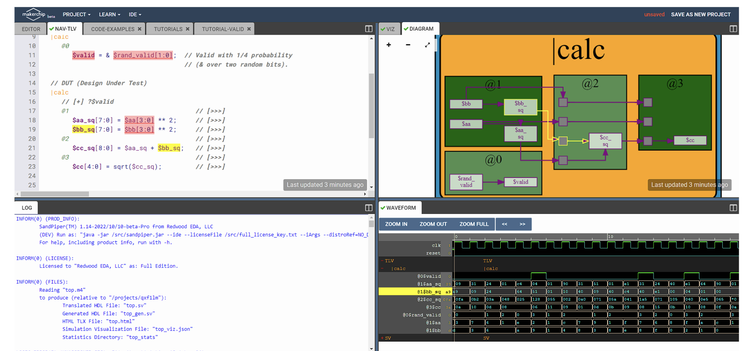

Picture 1 – Makerchip IDE

As you go through the labs of this course, for your own convenience, you can use the checkboxes to keep track of your completion of each step. Note that boxes will be reset to unchecked if you revisit the page, and this is fine as long as you have completed the steps.

To reproduce the above screenshot, complete the following steps. (Or, if the features of Makerchip have changed, find similar steps to follow by exploring on your own.):

Выполните следующие действия (или, если возможности Makerchip изменились, найдите альтернативные пути выполнения задачи самостоятельно):

1. Open the "Validity Tutorial".
2. Click "Load Pythagorean Example".
3. Split panes and move tabs between panes.
4. Zoom/pan in Diagram with the mouse wheel and drag.
5. Zoom Waveform with the "Zoom In" button.
6. Click $bbsq to highlight.

## Demo: Introduction to Makerchip

In case you had trouble with the first lab, here [4] is a screen capture of the steps you had to perform.

# List of sources

1. LF – Building a RISC-V CPU Core. URL: <https://github.com/stevehoover/LF-Building-a-RISC-V-CPU-Core>.
2. Makerchip IDE video material. URL: <https://git.miem.hse.ru/mtomarov/RISC-V_courses/-/blob/master/RISC-V_CPU_core_building/Chapter_1.Learning_Platform/Makerchip_IDE_%26_Resources/Makerchip_IDE.mp4.zip>
3. Makerchip. URL: <https://makerchip.com/>.
4. Demonstration material of Makership IDE lab. URL: <https://git.miem.hse.ru/mtomarov/RISC-V_courses/-/blob/master/RISC-V_CPU_core_building/Chapter_1.Learning_Platform/Makerchip_IDE_%26_Resources/Demo_Introduction_to_Makerchip.mp4.zip>.