Sum of 1st 9 natural numbers: expected output 45

**Task 1: using C code below to achieve functionality & compiled using RISCV compiler**

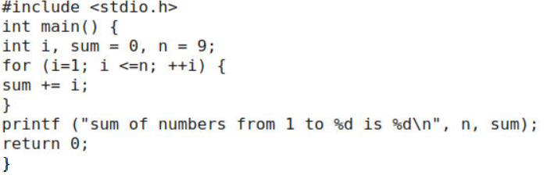

Commands used to compile is:

1. riscv64-unknown-elf-gcc –Ofast -mabi=lp64 –marchi=rv64i –o sumofnum.o sumofnum.c:

This command gives us bunch of assembly language codes

1. riscv64-unknown-elf-objdump –d sumofnum.o | less

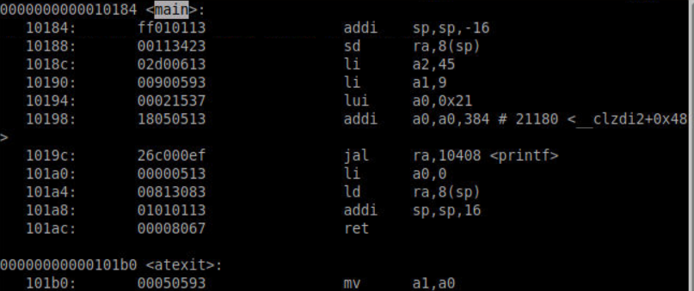

The instructions required by main program are:

(Address till which main program occupies–Address of starting location)/sizeoccupied by each instruction

= (101b0 – 10184)/4indecimal

11 instructions are needed here

1. spike pk sumofnum.o //[to get the output out of riscv]

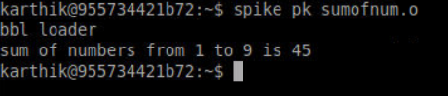

**TASK2: Introduction of concept of Application Binary Interface [a means by which programmer can access the registers directly]:**

Modified C code looks like:

Main program customofsum.c:

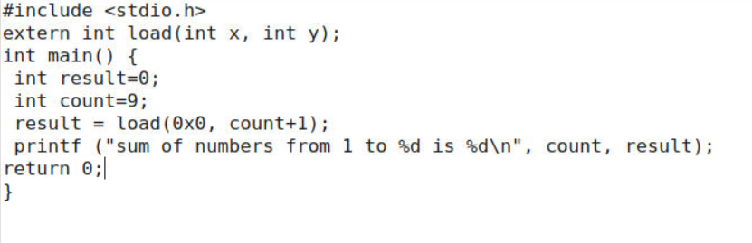

Subroutine (or) function load.S:

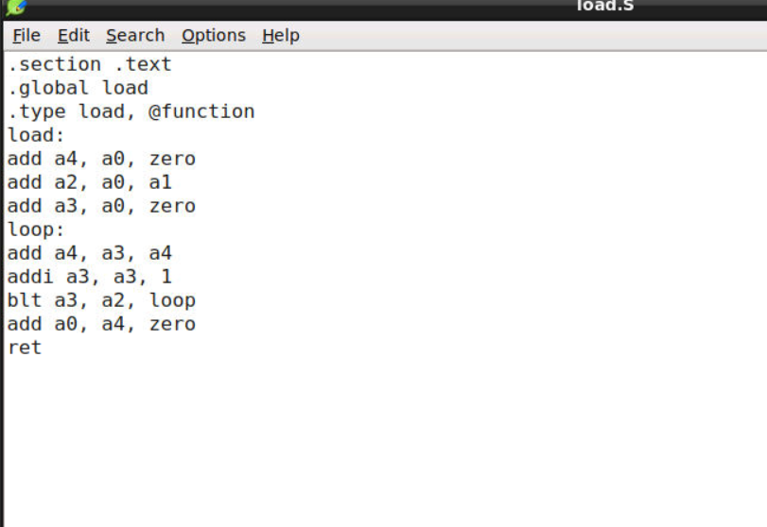

After using riscv compiler and spike simulator same like above task we see some output like:

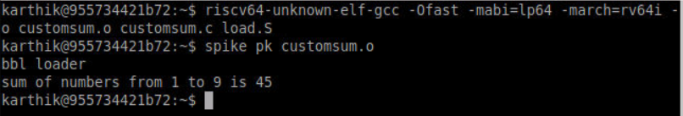

1. To findout instructions occupied by main program:

riscv64-unknown-elf-objdump –d customsum.o | less

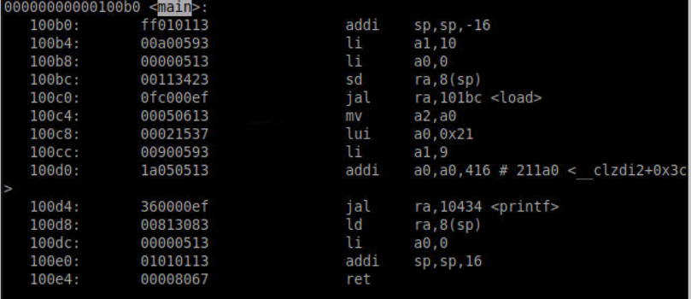

Gives us 11 instructions

Instructions consumed by loop and load labels can also be debugged from the above report:

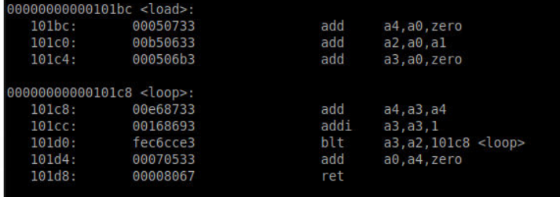

**Task 3: Running the process on RISCV CPU**

Generate hex file and load it in cpu and run it.

Output is verified as 45 [sum of numbers]