Rare Book Inventory & Sales Ecosystem (RISE)
Product Description 1

Daniel Rhoads
02-18-26

Table of Contents
1. Project Vision and Description 3
2. Team Roles 3
3. Collaboration Methodology 4
4. The Definition of “Done” 5
5. Product Design 7
5.3 Design System & Style Guide 8
6. Sprint 1 Retrospective Summary Report 15
7. Sprint 2 Retrospective Summary Report 16
8. References 18

Project Vision and Description

The Rare Book Inventory & Sales Ecosystem (RISE) is a digital transformation project designed to modernize the operations of a traditional rare bookstore. Currently operating on a manual, paper-based workflow, the client requires a centralized automated system to handle the unique complexities of rare book retail. RISE will integrate four core business pillars—accounting, inventory management, manufacturer ordering, and customer sales—into a single, high-performance computer-based platform. By digitizing these processes, the system will significantly reduce the time required to catalog unique items and provide real-time visibility into the store’s financial health and stock levels.

Team Roles

Detailed Oriented Tester - Lyiondra Bradley
Logic Architect (Backend Developer) - Midori (Alyssa Brown)
UX/UI Specialist (Frontend Developer) - Daniel Rhoads *me
Collaborater (SCRUM Master) - Pablo Gomez
Business Analyst (Documentation Lead) - Gustavo Rosas

Collaboration Methodology

The RISE team will utilize an Agile-inspired methodology to ensure steady progress:
- Communication: Primary communication will occur via GitHub and or Microsoft360 for daily updates, with one synchronized meeting per week.

- Version Control: Project documentation and code will be maintained in a shared repository to ensure all members have access to the latest versions.

- Task Management: We will use a Kanban-style approach, breaking down weekly requirements into specific tasks assigned to individual members.

- Conflict Resolution: Decisions will be made by a simple majority vote, with technical leads providing final recommendations for their respective areas.

The Definition of “Done”

A task or feature is considered "Done" when it meets the following criteria:
- Requirement Alignment: The feature fully addresses the specific criteria outlined in the instructor’s grading rubric.
- Peer Review: All individual contributions must be reviewed by at least one other team member for clarity and logic before final submission.
- Functional Integrity: Technical components must execute without errors and integrate successfully with the existing system.
- Documentation: Any new functionality is properly documented within the master Project Document.
- Visual Alignment: Features must adhere to the Design System (Section 5.3) to ensure a cohesive user experience.
- Responsiveness: The UI must be functional across multiple screen sizes (Mobile/Tablet/Desktop).
- Usability: Critical workflows (Sale/Inventory) must be completed within the 3-click architecture defined in the Site Map.

Product Design

5.1 User Personas
To ensure the RISE system meets the needs of its users, the following personas were developed to guide the interface design:
- Primary Persona: Arthur, the Bookstore Owner
  - Background: Owns a legacy bookstore; comfortable with books but overwhelmed by manual paper ledgers.
  - Goal: Quickly catalog a new "find," check if a rare edition is in stock, and see if he made a profit today.
  - UI Need: High-contrast text, large buttons, and a "no-clutter" dashboard that works on a tablet.

- Secondary Persona: Sarah, the Rare Book Collector
  - Background: Tech-savvy, looking for specific first editions.
  - Goal: Browse the catalog remotely and place a "Request to Buy" without needing to call the shop.
  - UI Need: High-quality imagery placeholders, clear pricing, and a mobile-friendly checkout/request flow.

5.2 Information Architecture (Site Map)

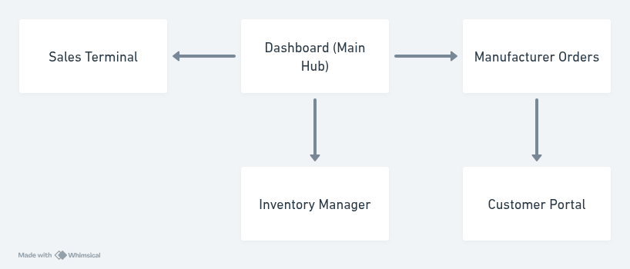
The system is organized into a three-tier hierarchy to minimize "clicks-to-action" and reduce cognitive load:
- Dashboard: High-level summary of sales and inventory alerts.
- Management Modules: Deep-dive tables for Inventory, Sales Records, and Manufacturer Orders.
- Action Layers: Pop-up Modals for data entry (e.g., Adding a Book) to keep the user in their current context.

5.3 Design System & Style Guide
This style guide ensures visual consistency across all modules of the RISE platform, reducing cognitive load for the user through predictable interface patterns.

A. Color Palette

We have selected a professional palette that balances the "traditional" feel of a rare bookstore with "modern" digital clarity.

Primary (Midnight Blue): #2C3E50 — Used for the sidebar, headers, and primary navigation. Represents stability and trust.
Secondary (Cloud White): #ECF0F1 — Used for page backgrounds to ensure text readability.
Success (Emerald Green): #27AE60 — Used for "In Stock" indicators, "Sale Completed" buttons, and positive profit margins.

Accent (Carrot Orange): # — Used for "Rare" item tags and urgent inventory alerts to draw immediate attention

B. Typography
- Primary Font: Segoe UI or Helvetica (Sans-serif).

- Rationale: While rare books use "Serif" fonts (like Times New Roman), digital interfaces are easier to read on screens using "Sans-serif" fonts. This modernization improves speed for Arthur when scanning inventory.

- Hierarchy: * H1: 24px Bold (Page Titles)
  - Body: 16px Regular (Table Data)
  - Captions: 12px Italic (Metadata like SKU numbers)

C. UI Components (Bootstrap 5)
The system utilizes Bootstrap 5 for its responsive grid and pre-built components.
- Buttons: Rounded corners (Border-radius: 4px) for a modern feel.
- Modals: Used for all "Add/Edit" actions to keep the user focused on the current screen without page reloads.
- Cards: Used on the Dashboard to display high-level "Quick Stats"

By using the Bootstrap 5 framework, the UI will be fully responsive, ensuring that Arthur (the owner) can access the inventory system on his tablet while working on the sales floor, as well as on a desktop in the back office's Total Sales

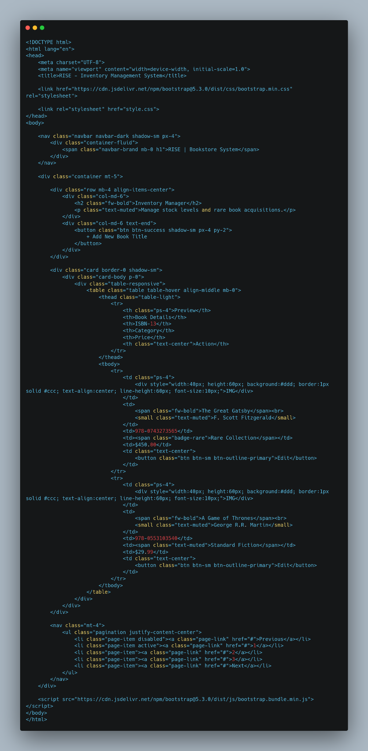

.

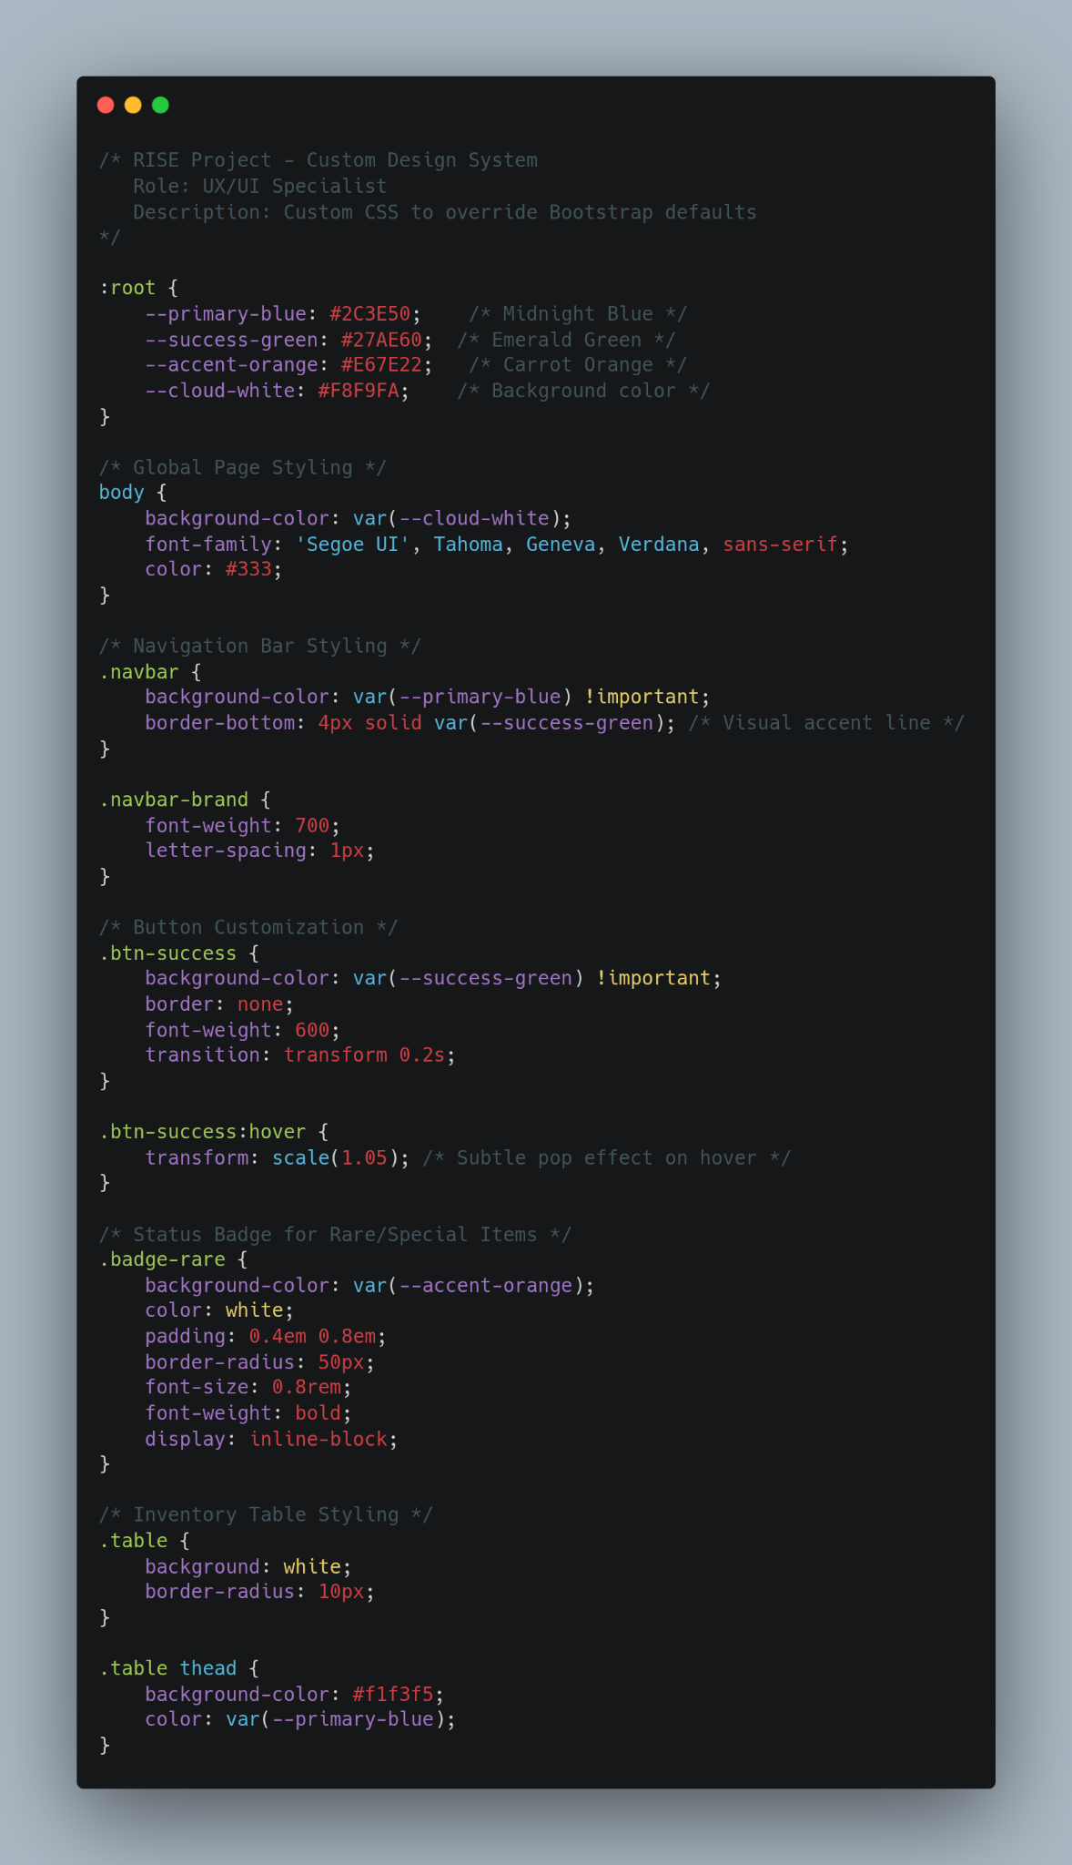
CSS variables and custom classes used to maintain brand consistency across the RISE platform

Section 5.4 Prototype Mockup
Initial functional mockup of the Inventory Dashboard

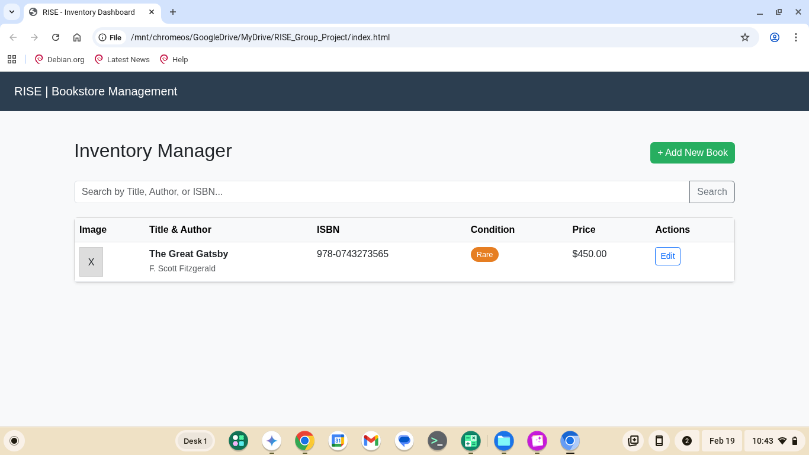

Section 5.4 Prototype Mockup & Feasibility
To validate the design system and logic architecture, a functional technical prototype was developed (hosted on GitHub). This mockup focuses on the Inventory Management module, proving that the Bootstrap 5 UI integrates correctly with the localized data structures.
Key Validations:
- Responsive Layout: Confirmed that the inventory table adjusts for mobile and desktop views.

- Data Rendering: Validated that book metadata (ISBN, Price, Rare Tags) displays correctly from the script logic.

- Interactivity: Confirmed that 'Add Book' modals trigger without page reloads, maintaining a modern user experience."

Section 5.5 Product Backlog Alignment
While the prototype in Section 5.4 demonstrates technical success, the official implementation of the full system will follow the Product Backlog (see attached Excel). This backlog ensures that high-priority items, such as Security Sanitization and User Authentication, are built with full testing coverage during Sprints 1 and 2. The following retrospective reports (Sections 6 and 7) summarize our team’s collaborative process during this planning and envisioning phase.

Sprint 1 Retrospective Summary Report
Things That Went Well
Things That Could Have Gone Better
Things That Surprised Us
Lessons Learned

Sprint 2 Retrospective Summary Report
Things That Went Well
Things That Could Have Gone Better
Things That Surprised Us
Lessons Learned

References

Agile Alliance. (n.d.). Glossary of Agile Terms: User Stories and Product Backlog. Retrieved from https://www.agilealliance.org/agile101/
Bootstrap Core Team. (2024). Bootstrap v5.3 Documentation: Layout and Components. Retrieved from https://getbootstrap.com/docs/5.3/getting-started/introduction/

