DBIM Information Architecture Test Report
Target Website: https://www.stqc.gov.in/
Generated: 2026-05-29 11:28:12

Test Case 1: Mandatory Global Navigation (Figure 45)
Test Case ID | Target Section | Status | Reason / Finding
TC-L1-01 | Home | PASS | 'Home' found in global navigation.
TC-L1-02 | Ministry / Department | FAIL | Missing mandatory Level 1 section: 'Ministry / Department'.
TC-L1-03 | Offerings | FAIL | Missing mandatory Level 1 section: 'Offerings'.
TC-L1-04 | Documents | FAIL | Missing mandatory Level 1 section: 'Documents'.
TC-L1-05 | Media / Resources | FAIL | Missing mandatory Level 1 section: 'Media / Resources'.
TC-L1-06 | Connect | FAIL | Missing mandatory Level 1 section: 'Connect'.

Test Evidence (Navigation Visual Capture):
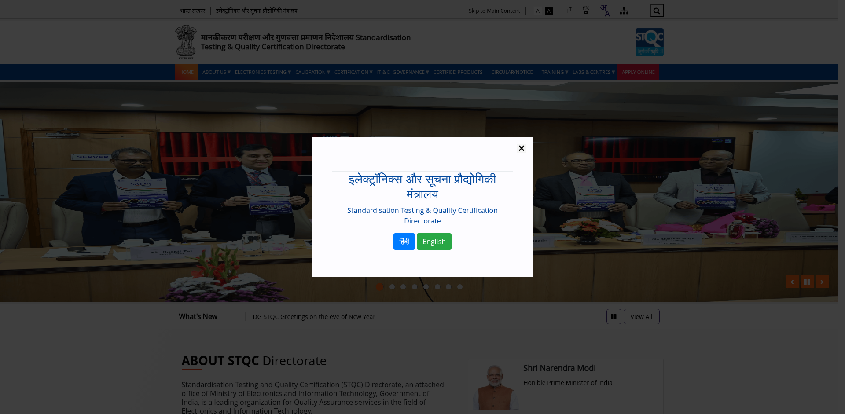

Test Case 2: Content Grouping Validation (Table 11)
Test Case ID | Parent Category | Status | Reason / Finding
TC-L2-01 | Ministry Department | WARN | Found 1 items. Missing suggested L2 items: Our Team, Our Organizations, Our Groups, Our Performance, Directory.
TC-L2-02 | Offerings | WARN | Found 0 items. Missing suggested L2 items: Schemes, Services, Competitions, Awards, International Collaborations, Careers, Tenders.
TC-L2-03 | Documents | WARN | Found 0 items. Missing suggested L2 items: Reports, Acts, Policies, Orders, Notices, Publications, Press Release, Gazette Notifications.
TC-L2-04 | Resources Media | WARN | Found 0 items. Missing suggested L2 items: Photos, Videos, Brochures, Presentations, Podcasts.
TC-L2-05 | Connect | WARN | Found 1 items. Missing suggested L2 items: Contact Us, Directory, Visitor'S Pass, Visitor Pass, Grievance, Citizen Engagement, Parliament Questions.

Test Evidence (Navigation Visual Capture):


Test Case 3: Subjective UX Objectives Evidence
Objective: Gather visual evidence to manually assess DBIM heuristics for Simplification, Consistency, and Engagement. Automation cannot assign pass/fail metrics to subjective design principles.

Evidence Type: Homepage Baseline
URL: https://www.stqc.gov.in/
Review Instruction: Review for: Simplification (cognitive load) and Engagement.


Evidence Type: Interior Template
URL: https://www.stqc.gov.in/en
Review Instruction: Review for: Consistency. Check if layout, fonts, and headers match the Homepage baseline.


