Information Architecture Compliance Report
Target Website : https://webel.in
Generated : 2026-05-26 14:14:20
Pages Crawled : 80
Overall Status : FAIL

Executive Summary
This report presents the findings of an automated Information Architecture compliance audit. Each section includes test cases with individual pass/fail results and embedded screenshot evidence captured during the scan.
Check | Status | Key Finding
1+2 - Main Menu & Submenus | WARN | 20 broken menu links found
3 - Page Hierarchy | PASS | No issues found
4 - Breadcrumb Validation | WARN | 11 breadcrumb label mismatches detected
5 - 3-Click Rule | PASS | No issues found
6 - Orphan Pages | PASS | No issues found
7 - URL Structure | WARN | 45 URLs failed canonical naming conventions
8 - Search Validation | WARN | No global search field found on the homepage
9 - Footer Validation | WARN | Missing footer elements: ['contact us', 'privacy policy', 'terms', 'sitemap', 'accessibility', 'rti', 'help', 'disclaime
10 - Responsive Design | WARN | No hamburger/mobile menu toggle detected on Tablet
11 - Accessibility | FAIL | Heading structure issues: ['Multiple H1 tags found (13)', 'Heading hierarchy skip: H1 → H4', 'Heading hierarchy skip: H1
12 - Broken Links | FAIL | 60 broken links detected
13 - Performance | PASS | No issues found
14 - Sitemap & Robots | WARN | No sitemap.xml found at standard paths
15 - Internal Link Graph | PASS | No issues found
+ - Duplicate Content | WARN | 3 pages with identical content detected

Detailed Findings

1+2 - Main Menu & Submenus
Status: WARN
Findings:
- 20 broken menu links found
Recommendation:
- Review and fix all broken navigation links. Ensure menu labels are unique and all items are accessible.
Metrics:
Metric | Value
items | [{"label": "Home", "href": "https://webel.in/", "visible": true, "clickable": true}, {"label": "About", "href": "https://webel.in/#", "visible": true, "clickable": true}, {"label": "Services", "href": "https://webel.in/#", "visible": true, "clickable": true}, {"label": "Online Services", "href": "ht
duplicates | []
broken | [{"url": "https://webel.in/board-of-directors", "status": -3}, {"url": "https://webel.in/intranet", "status": -3}, {"url": "https://webel.in/md-desk", "status": -3}, {"url": "https://webel.in/chairmans-desk", "status": -3}, {"url": "https://webel.in/", "status": -3}, {"url": "https://webel.in/RTI",
submenu_items | [{"parent": "About", "label": "About Webel", "href": "https://webel.in/about"}, {"parent": "About", "label": "Backdrop", "href": "https://webel.in/backdrop"}, {"parent": "About", "label": "Organisation Chart", "href": "https://webel.in/organisation-chart"}, {"parent": "About", "label": "Strategic Pa
hidden_items | []

Test Cases:
TC ID | Test Case | Description | Expected Result | Result
TC-MN-01 | Navigation element present | Check that a <nav> or equivalent element exists on the homepage. | At least one navigation container is found and visible. | PASS
TC-MN-02 | Menu items extractable | Verify that anchor tags inside the navigation can be read. | One or more menu items with labels are extracted. | PASS
TC-MN-03 | No duplicate menu labels | Scan all top-level menu labels for duplicates. | Each menu label appears exactly once. | PASS
TC-MN-04 | No hidden menu items | Identify menu links that are present in DOM but not visible. | All menu items are visible to the end user. | PASS
TC-MN-05 | Submenu hover detection | Hover over top-level items and detect any dropdown submenus. | Submenu items are accessible via hover interaction. | PASS
TC-MN-06 | No broken menu links | Send HTTP HEAD requests to all menu and submenu URLs. | All menu URLs return HTTP 200 (no 404 / 500 / timeout). | FAIL

Screenshot Evidence:
Menu Broken Links
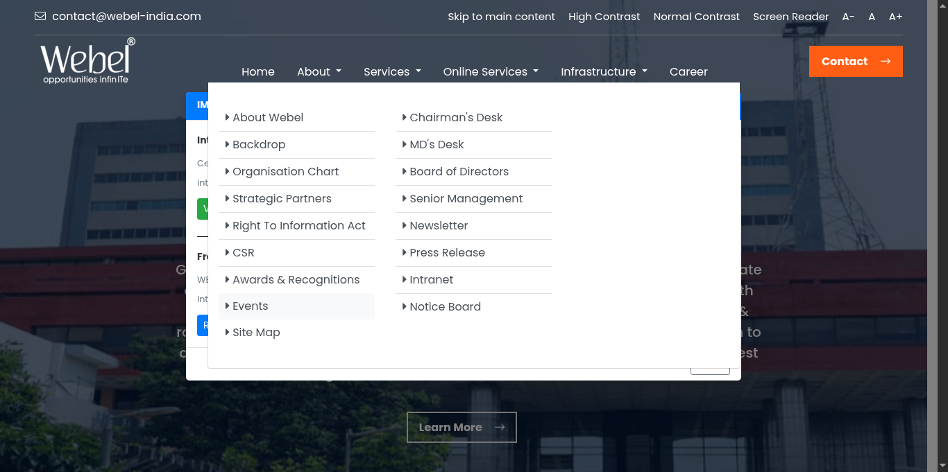

3 - Page Hierarchy
Status: PASS
No issues detected.
Metrics:
Metric | Value
pages | [{"url": "https://webel.in", "depth": 0, "title": "West Bengal Electronics Industry Development Corporation Limited (WEBEL)", "load_time": 0.81, "parent": null}, {"url": "https://webel.in/screen-reader", "depth": 1, "title": "Webel", "load_time": 0.3, "parent": "https://webel.in"}, {"url": "https://
tree | {"https://webel.in": ["https://webel.in/screen-reader", "https://webel.in/index", "https://webel.in/", "https://webel.in/about", "https://webel.in/backdrop", "https://webel.in/organisation-chart", "https://webel.in/strategic-partners", "https://webel.in/RTI", "https://webel.in/Corporate-Social-Respo
parent_child | [{"parent": "https://webel.in", "child": "https://webel.in/screen-reader"}, {"parent": "https://webel.in", "child": "https://webel.in/index"}, {"parent": "https://webel.in", "child": "https://webel.in/"}, {"parent": "https://webel.in", "child": "https://webel.in/about"}, {"parent": "https://webel.in
total | 80

Test Cases:
TC ID | Test Case | Description | Expected Result | Result
TC-CR-01 | Homepage loads successfully | Load the base URL and confirm the page responds. | Homepage returns a valid page with a <body> element. | PASS
TC-CR-02 | Internal links discovered | Parse anchor tags on each crawled page for same-domain URLs. | At least one internal link is found per crawled page. | PASS
TC-CR-03 | Crawl depth respected | Verify the crawler does not exceed the configured depth limit. | No page is crawled beyond the set depth threshold. | PASS
TC-CR-04 | Max pages cap enforced | Confirm crawling stops after reaching the MAX_PAGES limit. | Total pages crawled does not exceed MAX_PAGES. | PASS
TC-CR-05 | No infinite loop or duplicate visits | Ensure each URL is visited at most once. | The visited set prevents re-crawling any URL. | PASS
TC-CR-06 | Page titles captured | Record the <title> of every crawled page. | Each crawled page entry contains a non-empty title string. | PASS

4 - Breadcrumb Validation
Status: WARN
Findings:
- 11 breadcrumb label mismatches detected
Recommendation:
- Add breadcrumb navigation to all interior pages (depth > 1). Ensure breadcrumb labels match the page URL segments.
Metrics:
Metric | Value
pages_checked | 15
found | 11
missing | []
mismatches | [{"url": "https://webel.in/screen-reader", "crumb": "home", "segment": "screen reader"}, {"url": "https://webel.in/about", "crumb": "home", "segment": "about"}, {"url": "https://webel.in/backdrop", "crumb": "about", "segment": "backdrop"}, {"url": "https://webel.in/organisation-chart", "crumb": "abo

Test Cases:
TC ID | Test Case | Description | Expected Result | Result
TC-BC-01 | Breadcrumb present on interior pages | Check for breadcrumb widget on pages at depth > 1. | Every interior page exposes a breadcrumb navigation trail. | PASS
TC-BC-02 | Breadcrumb label matches URL segment | Compare the last crumb label against the URL path segment. | Last breadcrumb label corresponds to the current page segment. | WARN
TC-BC-03 | Breadcrumb is visible | Verify the breadcrumb container is displayed (not hidden via CSS). | Breadcrumb element reports is_displayed() == True. | PASS

5 - 3-Click Rule
Status: PASS
No issues detected.
Metrics:
Metric | Value
reachable_in_3 | ["https://webel.in", "https://webel.in/screen-reader", "https://webel.in/index", "https://webel.in/", "https://webel.in/about", "https://webel.in/backdrop", "https://webel.in/organisation-chart", "https://webel.in/strategic-partners", "https://webel.in/RTI", "https://webel.in/Corporate-Social-Respon
exceeds_3 | []

Test Cases:
TC ID | Test Case | Description | Expected Result | Result
TC-3C-01 | Key pages reachable within 3 clicks | Measure crawl depth for all discovered pages. | All important pages are reachable within 3 navigation steps. | PASS
TC-3C-02 | No pages beyond depth 3 | Identify pages discovered at depth > 3. | Zero pages exceed the 3-click rule threshold. | PASS

6 - Orphan Pages
Status: PASS
No issues detected.
Metrics:
Metric | Value
sitemap_urls | []
nav_urls | ["https://webel.in/hardware", "https://webel.in/contact", "https://webel.in/WEBEL-Education-and-Training-Initiative", "https://webel.in/WEBEL-Animation-Academy", "https://webel.in/", "https://webel.in/WEBEL-Learning-Services", "https://webel.in/telemedicine", "https://webel.in/strategic-partners", "
orphans | []

Test Cases:
TC ID | Test Case | Description | Expected Result | Result
TC-OP-01 | Sitemap.xml accessible | Fetch /sitemap.xml and verify HTTP 200 response. | Sitemap returns valid XML with <loc> entries. | WARN
TC-OP-02 | All sitemap URLs reachable via navigation | Cross-reference sitemap URLs against crawled URL set. | Every URL listed in sitemap is reachable through normal navigation. | PASS
TC-OP-03 | No orphan pages detected | Identify sitemap URLs absent from the navigation crawl. | Count of orphan pages is zero. | PASS

7 - URL Structure
Status: WARN
Findings:
- 45 URLs failed canonical naming conventions
Recommendation:
- Use lowercase, hyphen-separated URL slugs. Remove tracking parameters from internal links.
Metrics:
Metric | Value
total | 80
bad_urls | [{"url": "https://webel.in/RTI", "issues": ["uppercase-path", "non-readable-segment"]}, {"url": "https://webel.in/Corporate-Social-Responsibility", "issues": ["uppercase-path", "non-readable-segment"]}, {"url": "https://webel.in/WEBEL-IT-Parks-WBEIDC", "issues": ["uppercase-path", "non-readable-segm

Test Cases:
TC ID | Test Case | Description | Expected Result | Result
TC-UR-01 | URLs are lowercase | Check each crawled URL path for uppercase characters. | All URL path segments are fully lowercase. | WARN
TC-UR-02 | No tracking or noise parameters | Scan URLs for utm_, sessionid, PHPSESSID, token parameters. | No internal URLs contain tracking query parameters. | PASS
TC-UR-03 | URL segments are human-readable | Verify path segments contain only a-z, 0-9, hyphens, underscores. | All URL segments pass the readable-slug pattern check. | WARN

8 - Search Validation
Status: WARN
Findings:
- No global search field found on the homepage
Recommendation:
- Ensure the site-wide search is prominently placed and returns relevant results for common queries.
Metrics:
Metric | Value
found | False
queries_tested | []

Test Cases:
TC ID | Test Case | Description | Expected Result | Result
TC-SR-01 | Search input field present | Locate a search <input> element on the homepage. | A visible search box is found on the homepage. | WARN
TC-SR-02 | Search returns results for education | Submit 'education' query and inspect result page body. | Result page contains result-indicating keywords. | N/A
TC-SR-03 | Search returns results for minister | Submit 'minister' query and inspect result page body. | Result page contains result-indicating keywords. | N/A
TC-SR-04 | Search returns results for contact | Submit 'contact' query and inspect result page body. | Result page contains result-indicating keywords. | N/A

9 - Footer Validation
Status: WARN
Findings:
- Missing footer elements: ['contact us', 'privacy policy', 'terms', 'sitemap', 'accessibility', 'rti', 'help', 'disclaimer']
Recommendation:
- Add all required footer links: Contact Us, Privacy Policy, Terms, Sitemap, Accessibility, RTI, Help, and Disclaimer.
Metrics:
Metric | Value
found_items | []
missing_items | ["contact us", "privacy policy", "terms", "sitemap", "accessibility", "rti", "help", "disclaimer"]

Test Cases:
TC ID | Test Case | Description | Expected Result | Result
TC-FT-01 | Footer contains Contact Us | Inspect footer text for contact link. | 'contact us' text found in footer region. | WARN
TC-FT-02 | Footer contains Privacy Policy | Inspect footer text for privacy policy link. | 'privacy policy' text found in footer region. | WARN
TC-FT-03 | Footer contains Terms | Inspect footer text for terms link. | 'terms' text found in footer region. | WARN
TC-FT-04 | Footer contains Sitemap | Inspect footer text for sitemap link. | 'sitemap' text found in footer region. | WARN
TC-FT-05 | Footer contains Accessibility | Inspect footer text for accessibility statement. | 'accessibility' text found in footer region. | WARN
TC-FT-06 | Footer contains RTI | Inspect footer for Right to Information link. | 'rti' text found in footer region. | WARN
TC-FT-07 | Footer contains Help | Inspect footer for help or FAQ link. | 'help' text found in footer region. | WARN
TC-FT-08 | Footer contains Disclaimer | Inspect footer for disclaimer link. | 'disclaimer' text found in footer region. | WARN

10 - Responsive Design
Status: WARN
Findings:
- No hamburger/mobile menu toggle detected on Tablet
- No hamburger/mobile menu toggle detected on Mobile
Recommendation:
- Implement a responsive layout with a hamburger menu for mobile viewports. Test all breakpoints thoroughly.
Metrics:
Metric | Value
viewports | [{"viewport": "Desktop", "width": 1366, "height": 768, "nav_visible": true, "hamburger": false, "screenshot": "screenshots/responsive_Desktop_1779785015.png", "issues": []}, {"viewport": "Tablet", "width": 768, "height": 1024, "nav_visible": false, "hamburger": false, "screenshot": "screenshots/resp

Test Cases:
TC ID | Test Case | Description | Expected Result | Result
TC-RD-01 | Desktop navigation visible at 1366x768 | Load homepage at 1366x768 and check nav visibility. | Navigation bar is visible and not collapsed at desktop width. | PASS
TC-RD-02 | Tablet layout renders at 768x1024 | Load homepage at 768x1024 viewport. | Page renders without horizontal overflow at tablet width. | WARN
TC-RD-03 | Mobile hamburger menu present at 375x812 | Load homepage at 375x812 and detect toggle button. | A hamburger or menu-toggle button is visible at mobile width. | WARN
TC-RD-04 | No layout breakage at any viewport | Capture screenshots at each viewport and check nav element. | No JavaScript errors or missing nav elements at any breakpoint. | WARN

Screenshot Evidence:
Responsive Desktop


Responsive Tablet
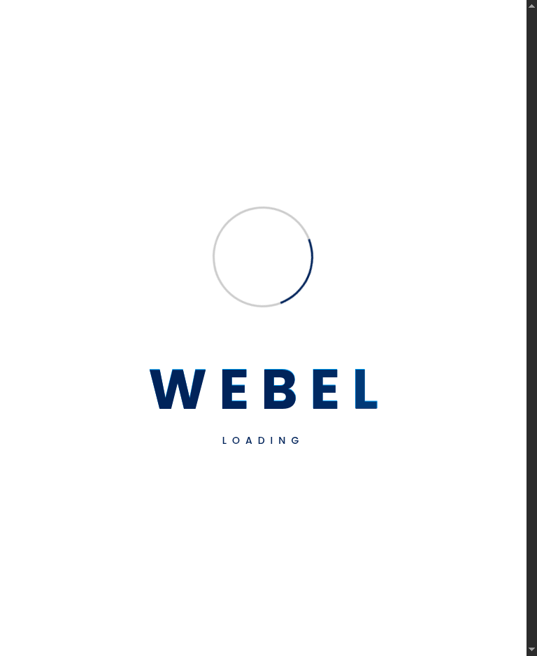

Responsive Mobile


11 - Accessibility
Status: FAIL
Findings:
- Heading structure issues: ['Multiple H1 tags found (13)', 'Heading hierarchy skip: H1 → H4', 'Heading hierarchy skip: H1 → H4', 'Heading hierarchy skip: H1 → H4', 'Heading hierarchy skip: H1 → H4', 'Heading hierarchy skip: H1 → H4', 'Heading hierarchy skip: H1 → H4', 'Heading hierarchy skip: H1 → H4', 'Heading hierarchy skip: H1 → H4', 'Heading hierarchy skip: H1 → H3', 'Heading hierarchy skip: H3 → H5', 'Heading hierarchy skip: H1 → H3', 'Heading hierarchy skip: H1 → H4', 'Heading hierarchy skip: H1 → H5']
- ARIA issues: ['Button element found without aria-label or text content']
Recommendation:
- Add descriptive alt text to all images. Fix heading hierarchy to follow H1 → H2 → H3 order. Add aria-labels to icon-only buttons.
Metrics:
Metric | Value
img_missing_alt | []
heading_issues | ["Multiple H1 tags found (13)", "Heading hierarchy skip: H1 \u2192 H4", "Heading hierarchy skip: H1 \u2192 H4", "Heading hierarchy skip: H1 \u2192 H4", "Heading hierarchy skip: H1 \u2192 H4", "Heading hierarchy skip: H1 \u2192 H4", "Heading hierarchy skip: H1 \u2192 H4", "Heading hierarchy skip: H1
aria_landmarks | {"banner": 1, "main": 0, "navigation": 3, "contentinfo": 1, "search": 0}
aria_issues | ["Button element found without aria-label or text content"]

Test Cases:
TC ID | Test Case | Description | Expected Result | Result
TC-A11-01 | All images have alt text | Parse <img> tags and check for non-empty alt attributes. | Zero images are missing alt text. | PASS
TC-A11-02 | Exactly one H1 tag present | Count H1 elements on the homepage. | Exactly one H1 heading exists on the page. | WARN
TC-A11-03 | Heading hierarchy is sequential | Check for skipped heading levels such as H1 to H3. | No heading level is skipped in the document outline. | WARN
TC-A11-04 | ARIA landmark banner present | Detect <header> or role=banner element. | Page has at least one banner landmark. | PASS
TC-A11-05 | ARIA landmark main content present | Detect <main> or role=main element. | Page has at least one main landmark. | WARN
TC-A11-06 | ARIA landmark navigation present | Detect <nav> or role=navigation element. | Page has at least one navigation landmark. | PASS
TC-A11-07 | Buttons have accessible labels | Check all <button> elements for aria-label or text content. | No button is missing both aria-label and visible text. | WARN

Screenshot Evidence:
Accessibility Issues


12 - Broken Links
Status: FAIL
Findings:
- 60 broken links detected
Recommendation:
- Fix or remove all broken links (404/500). Set up automated link monitoring to catch regressions.
Metrics:
Metric | Value
broken | [{"url": "https://webel.in/assets/img/hardware-park/Electronic-Manufacturing-Cluster-Falta.jpg", "status": -3}, {"url": "https://webel.in/archive-tenders", "status": -3}, {"url": "https://webel.in/assets/img/Webel-IT-park/Kalimpong-IT-Park.jpg", "status": -3}, {"url": "https://webel.in/assets/notice
redirects | []
timeouts | []

Test Cases:
TC ID | Test Case | Description | Expected Result | Result
TC-BL-01 | No 404 responses | Send HEAD requests to all discovered URLs and log 404s. | Zero URLs return HTTP 404. | PASS
TC-BL-02 | No 500 server errors | Send HEAD requests and log 500 responses. | Zero URLs return HTTP 500. | PASS
TC-BL-03 | No DNS or connection failures | Detect URLs that fail DNS resolution or connection. | Zero URLs result in connection error (status -3). | FAIL
TC-BL-04 | Redirect chains documented | Record all 301 / 302 / 307 / 308 redirects. | All redirects are intentional; no redirect loops. | PASS
TC-BL-05 | Timeout count within acceptable range | Record URLs that time out during HEAD request. | Timeout count is zero or negligible. | PASS

Screenshot Evidence:
Broken Links Evidence
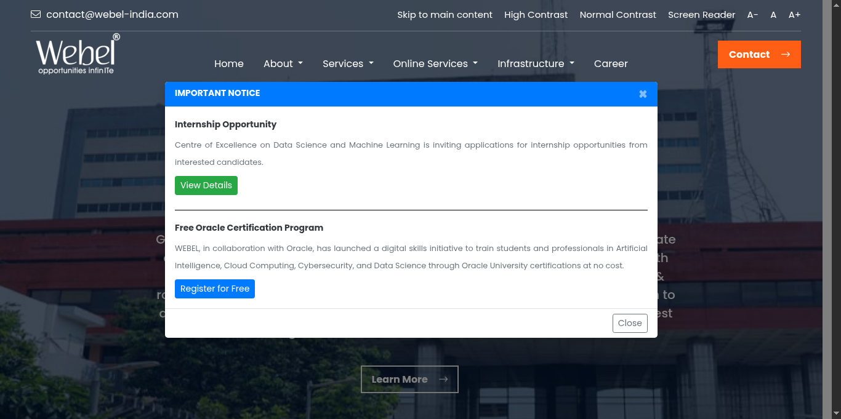

13 - Performance
Status: PASS
No issues detected.
Metrics:
Metric | Value
page_load_times | [{"url": "https://webel.in", "load_time_s": 1.36}, {"url": "https://webel.in/screen-reader", "load_time_s": 1.35}, {"url": "https://webel.in/index", "load_time_s": 1.71}, {"url": "https://webel.in/", "load_time_s": 1.46}, {"url": "https://webel.in/about", "load_time_s": 1.33}, {"url": "https://webel
avg_load | 1.08
slow_pages | []

Test Cases:
TC ID | Test Case | Description | Expected Result | Result
TC-PF-01 | Homepage loads within 5 seconds | Measure wall-clock load time for the homepage. | Homepage load time is under 5 seconds. | PASS
TC-PF-02 | All sampled pages load within 5 seconds | Measure load time for up to 10 sampled interior pages. | No sampled page exceeds the 5-second threshold. | PASS
TC-PF-03 | Average page load under 3 seconds | Calculate mean load time across all sampled pages. | Average load time is below 3 seconds. | PASS

14 - Sitemap & Robots
Status: WARN
Findings:
- No sitemap.xml found at standard paths
Recommendation:
- Create and maintain a valid sitemap.xml. Ensure robots.txt is present and correctly configured.
Metrics:
Metric | Value
sitemap | {"found": false, "url_count": 0, "issues": ["No sitemap.xml found"]}
robots | {"found": false, "disallows": [], "issues": ["No robots.txt found"]}

Test Cases:
TC ID | Test Case | Description | Expected Result | Result
TC-SM-01 | sitemap.xml accessible at standard path | Fetch /sitemap.xml or /sitemap_index.xml. | Sitemap returns HTTP 200 with valid XML content. | WARN
TC-SM-02 | Sitemap contains URL entries | Count <loc> elements in the sitemap. | At least one URL entry exists in the sitemap. | WARN
TC-SM-03 | robots.txt accessible | Fetch /robots.txt and verify HTTP 200. | robots.txt is present and returns a valid plain-text response. | WARN
TC-SM-04 | robots.txt Disallow rules documented | Parse Disallow directives from robots.txt. | All Disallow rules are intentional and do not block key paths. | PASS

15 - Internal Link Graph
Status: PASS
No issues detected.
Metrics:
Metric | Value
nodes | 54
edges | 1436
edge_list | [{"from": "https://webel.in", "to": "https://webel.in/board-of-directors"}, {"from": "https://webel.in", "to": "https://webel.in/index"}, {"from": "https://webel.in", "to": "https://webel.in/Sound-Limiter"}, {"from": "https://webel.in", "to": "https://webel.in/Webel-Fujisoft-Vara-CoE-Industry-4"}, {
avg_degree | 8.5

Test Cases:
TC ID | Test Case | Description | Expected Result | Result
TC-LG-01 | Internal link graph built | Verify the crawler populated the link graph with nodes and edges. | Link graph contains at least one node and one edge. | PASS
TC-LG-02 | Average in-degree calculated | Use NetworkX to compute mean in-degree across all nodes. | Average in-degree value is computed without errors. | PASS

+ - Duplicate Content
Status: WARN
Findings:
- 3 pages with identical content detected
Recommendation:
- Investigate pages with identical content. Use canonical tags or merge/redirect duplicate pages.
Metrics:
Metric | Value
duplicate_groups | [["https://webel.in", "https://webel.in/index", "https://webel.in/", "https://webel.in/Webel-Fujisoft-Vara-CoE-Industry-4"], ["https://webel.in/assets/img/video/BGBS-2023.mp4", "https://webel.in/assets/img/video/webel-49Year.mp4", "https://webel.in/assets/notice/WBEIDCL_Circular_25-05-2026.pdf", "ht
count | 3

Test Cases:
TC ID | Test Case | Description | Expected Result | Result
TC-DC-01 | No pages with identical content hashes | Compare MD5 hashes of page body text across all crawled pages. | Zero duplicate content groups are detected. | WARN
TC-DC-02 | Duplicate groups documented if found | List all URL groups that share the same content hash. | Each duplicate group is reported with its member URLs. | PASS

