Typeface and Alignment Compliance Report
Government of India – Digital Presence Guidelines Audit
URL: https://www.mea.gov.in/
Date: 2026-05-26 15:15:50
Tool: GIGW Auditor v2.6

Executive Summary
Overall Result: FAIL
The site returned an Access Denied / bot-protection page. All subsequent checks would be meaningless. Try auditing in visible (non-headless) mode or use a whitelisted IP.

Summary
Metric | Count
PASS | 0
FAIL | 1
SKIP | 0
INFO | 0

Detailed Test Results

BLOCK-01: Bot Protection Detected
Test Case | BLOCK-01
Description | Pre-audit check: confirm site is accessible to automated scanner.
Result | FAIL
Reason | The site returned an Access Denied / bot-protection page. All subsequent checks would be meaningless. Try auditing in visible (non-headless) mode or use a whitelisted IP.

Screenshot Evidence:
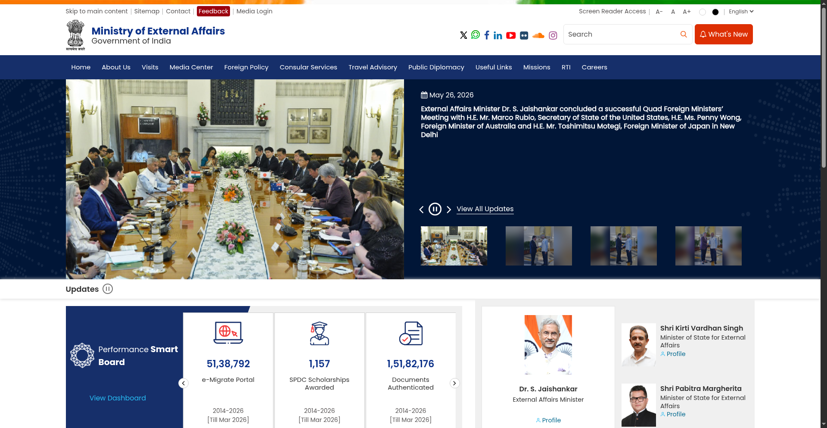

Methodology
This audit uses Selenium WebDriver to load the target URL in a headless Chromium browser. For each HTML element type, the tool reads the computed font-family via window.getComputedStyle() and checks whether any Noto Sans variant is present. It also inspects <link> tags, @font-face rules, @import rules, and inline style attributes for references to Noto Sans. Screenshots are captured as evidence for each test case. Furthermore, it verifies text and table alignment using JavaScript to inspect computed styles. Content parsing evaluates paragraphs to ensure standard casing and prevents phonetic Hinglish terms. Finally, layout scripts confirm proportional descending header scales (Type Scale validation) and mathematically calculate precise RGB relative luminance algorithms to enforce GIGW 3.0 / WCAG 2.1 color contrast minimums.

Compliance Criteria
As per the Government of India digital presence guidelines, Noto Sans must be selected as the main typeface. Furthermore, body text must be left-aligned, and tables must have left-aligned text, right-aligned numbers, and center-aligned column names. Long text blocks and paragraphs must not be fully capitalized, and content should avoid casual Hinglish transliteration. Type sizes must also remain visibly proportional descending from H1, and element background-to-text color contrast ratio must score at least 4.5:1 across the user interface.

