Typeface and Alignment Compliance Report
Government of India – Digital Presence Guidelines Audit
URL: https://www.meity.gov.in/
Date: 2026-05-25 13:08:05
Tool: GIGW Auditor v2.6

Executive Summary
Overall Result: FAIL
Audit complete. Checked 25 rule definitions. Total failures: 3.

Summary
Metric | Count
PASS | 10
FAIL | 4
SKIP | 12
INFO | 1

Detailed Test Results

TC-01: Font Resource Loading
Test Case | TC-01
Description | Verify that Noto Sans font files are loaded via CSS.
Result | PASS
Reason | Noto Sans font resources detected. Native browser layout stack active verification confirmation.

Screenshot Evidence:
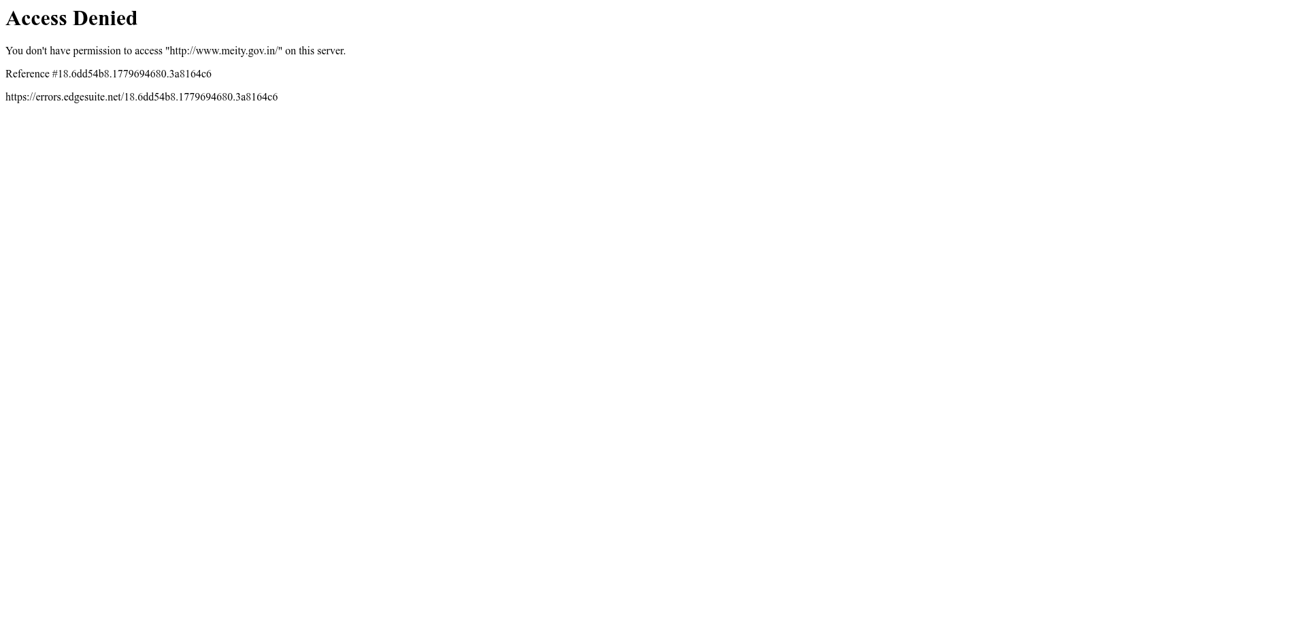

TC-02: Inline Style Noto Sans Reference
Test Case | TC-02
Description | Check whether any element uses Noto Sans via inline style.
Result | INFO
Reason | No inline style attribute references Noto Sans.

Screenshot Evidence:


TC-03: Computed Font – Body / Global (<body>)
Test Case | TC-03
Description | Verify the <body> element uses Noto Sans.
Result | FAIL
Reason | Computed font-family: ""Times New Roman"". Noto Sans NOT detected — NON-COMPLIANT.

Screenshot Evidence:
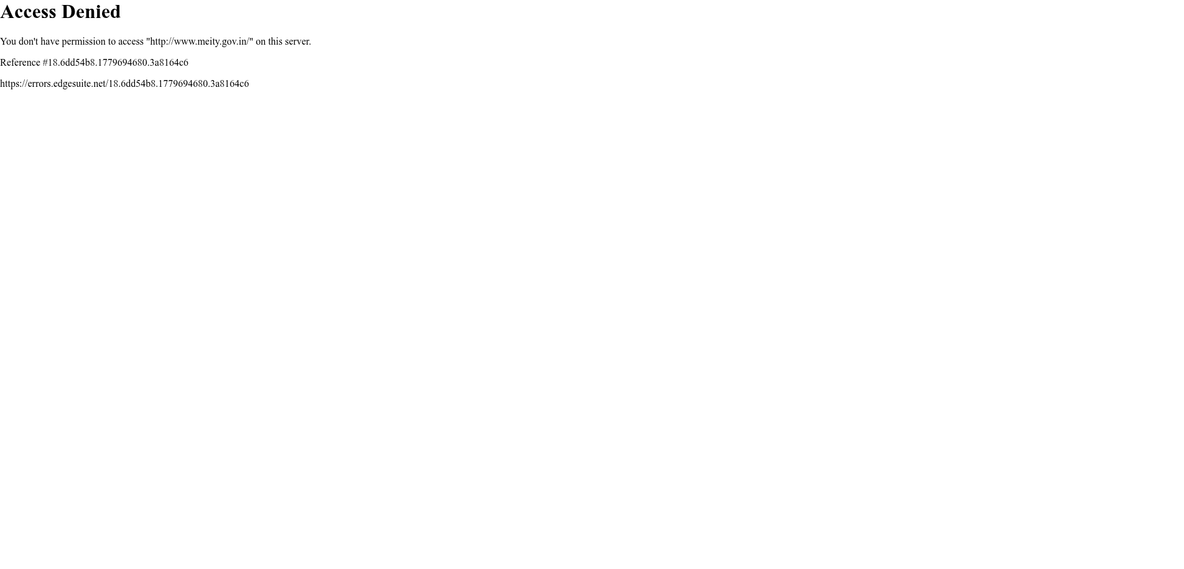

TC-04: Computed Font – Heading 1 (<h1>)
Test Case | TC-04
Description | Verify the <h1> element uses Noto Sans.
Result | FAIL
Reason | Computed font-family: ""Times New Roman"". Noto Sans NOT detected — NON-COMPLIANT.

Screenshot Evidence:

TC-05: Computed Font – Heading 2 (<h2>)
Test Case | TC-05
Description | Verify the <h2> element uses Noto Sans.
Result | SKIP
Reason | No <h2> element found on the page.

TC-06: Computed Font – Heading 3 (<h3>)
Test Case | TC-06
Description | Verify the <h3> element uses Noto Sans.
Result | SKIP
Reason | No <h3> element found on the page.

TC-07: Computed Font – Paragraph (<p>)
Test Case | TC-07
Description | Verify the <p> element uses Noto Sans.
Result | FAIL
Reason | Computed font-family: ""Times New Roman"". Noto Sans NOT detected — NON-COMPLIANT.

Screenshot Evidence:

TC-08: Computed Font – Anchor / Link (<a>)
Test Case | TC-08
Description | Verify the <a> element uses Noto Sans.
Result | SKIP
Reason | No <a> element found on the page.

TC-09: Computed Font – List Item (<li>)
Test Case | TC-09
Description | Verify the <li> element uses Noto Sans.
Result | SKIP
Reason | No <li> element found on the page.

TC-10: Computed Font – Span (<span>)
Test Case | TC-10
Description | Verify the <span> element uses Noto Sans.
Result | SKIP
Reason | No <span> element found on the page.

TC-11: Computed Font – Button (<button>)
Test Case | TC-11
Description | Verify the <button> element uses Noto Sans.
Result | SKIP
Reason | No <button> element found on the page.

TC-12: Computed Font – Input Field (<input>)
Test Case | TC-12
Description | Verify the <input> element uses Noto Sans.
Result | SKIP
Reason | No <input> element found on the page.

TC-13: Computed Font – Navigation (<nav>)
Test Case | TC-13
Description | Verify the <nav> element uses Noto Sans.
Result | SKIP
Reason | No <nav> element found on the page.

TC-14: Computed Font – Footer (<footer>)
Test Case | TC-14
Description | Verify the <footer> element uses Noto Sans.
Result | SKIP
Reason | No <footer> element found on the page.

TC-15: Computed Font – Header (<header>)
Test Case | TC-15
Description | Verify the <header> element uses Noto Sans.
Result | SKIP
Reason | No <header> element found on the page.

TC-16: Computed Font – Table (<table>)
Test Case | TC-16
Description | Verify the <table> element uses Noto Sans.
Result | SKIP
Reason | No <table> element found on the page.

TC-17: Computed Font – Label (<label>)
Test Case | TC-17
Description | Verify the <label> element uses Noto Sans.
Result | SKIP
Reason | No <label> element found on the page.

ALIGN-01: Body Text Alignment Check
Test Case | ALIGN-01
Description | Verify that standard page body text layers render strictly left-aligned.
Result | PASS
Reason | Body text is left-aligned (found: start).

Screenshot Evidence:


ALIGN-02: Table Data Structure Alignment
Test Case | ALIGN-02
Description | Verify tables enforce left-aligned text, right-aligned numbers, and center headers.
Result | PASS
Reason | No tables found on the page.

Screenshot Evidence:


CONTENT-01: Content Casing & Language Purity Check
Test Case | CONTENT-01
Description | Verify that paragraphs do not use full capital case or contain basic Hinglish.
Result | PASS
Reason | No capitalized long sentences or explicit Hinglish content detected.

Screenshot Evidence:


SCALE-01: Typographic Hierarchy Scale (Desktop)
Test Case | SCALE-01
Description | Verify that font sizes maintain a logical hierarchy (H1 > H2 > H3 > P) at 1920x1080.
Result | PASS
Reason | Heading scale hierarchy (H1 > H2 > H3 > P) is maintained properly.

Screenshot Evidence:


CONTRAST-01: Accessible Color Pairing & Contrast
Test Case | CONTRAST-01
Description | Verify text and background combinations meet WCAG 2.1 minimum (4.5:1) standards.
Result | PASS
Reason | Checked 3 elements. All met 4.5:1 standard.

Screenshot Evidence:


SCALE-02: Typographic Hierarchy Scale (Mobile)
Test Case | SCALE-02
Description | Verify that font sizes maintain a logical hierarchy (H1 > H2 > H3 > P) at 375x812.
Result | PASS
Reason | Heading scale hierarchy (H1 > H2 > H3 > P) is maintained properly.

Screenshot Evidence:
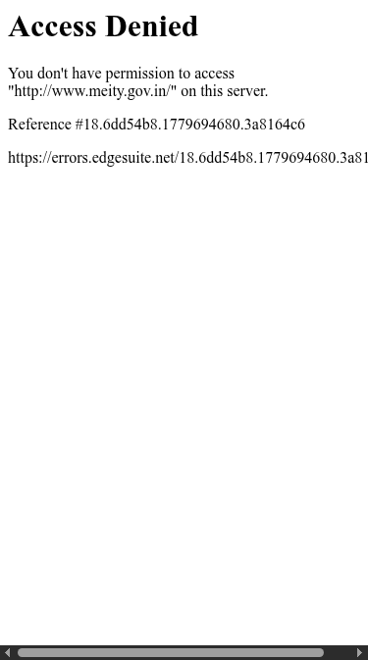

BTN-01: Button Padding Consistency
Test Case | BTN-01
Description | Verify button sizes are consistent with uniform padding used throughout (DBIM 4.5).
Result | PASS
Reason | No buttons found on page.

Screenshot Evidence:


BTN-02: Button State Style Differentiation
Test Case | BTN-02
Description | Verify distinct styles for enabled, hover, focus and disabled button states (DBIM 4.5).
Result | PASS
Reason | No enabled buttons found.

Screenshot Evidence:


BTN-03: Mouse Hover Feedback on Clickable Items
Test Case | BTN-03
Description | Verify mouse hover prompts a noticeable visual change on all clickable items (DBIM 4.5).
Result | PASS
Reason | No clickable elements found.

Screenshot Evidence:


SUMMARY: Overall Compliance Verdict
Test Case | SUMMARY
Description | Aggregate summary across all typographic, structural, and content rules.
Result | FAIL
Reason | Audit complete. Checked 25 rule definitions. Total failures: 3.

Screenshot Evidence:


Methodology
This audit uses Selenium WebDriver to load the target URL in a headless Chromium browser. For each HTML element type, the tool reads the computed font-family via window.getComputedStyle() and checks whether any Noto Sans variant is present. It also inspects <link> tags, @font-face rules, @import rules, and inline style attributes for references to Noto Sans. Screenshots are captured as evidence for each test case. Furthermore, it verifies text and table alignment using JavaScript to inspect computed styles. Content parsing evaluates paragraphs to ensure standard casing and prevents phonetic Hinglish terms. Finally, layout scripts confirm proportional descending header scales (Type Scale validation) and mathematically calculate precise RGB relative luminance algorithms to enforce GIGW 3.0 / WCAG 2.1 color contrast minimums.

Compliance Criteria
As per the Government of India digital presence guidelines, Noto Sans must be selected as the main typeface. Furthermore, body text must be left-aligned, and tables must have left-aligned text, right-aligned numbers, and center-aligned column names. Long text blocks and paragraphs must not be fully capitalized, and content should avoid casual Hinglish transliteration. Type sizes must also remain visibly proportional descending from H1, and element background-to-text color contrast ratio must score at least 4.5:1 across the user interface.

