DBIM Website Compliance Report
Government of India – Digital Brand Identity Manual Audit
URL: https://www.stqc.gov.in/
Date: 2026-05-25 15:35:38
Tool: DBIM Compliance Checker v1.0

Executive Summary
Overall Result: FAIL
11 passed, 6 failed out of 17 checks.

Summary Counts
PASS | 11
FAIL | 7
SKIP | 0

Content & Language

CL-01: Language Attribute
Test ID | CL-01
Description | HTML <html lang> must be 'en' or 'en-GB'.
Result | PASS
Reason | lang attribute is 'en' — correct.

Screenshot Evidence:
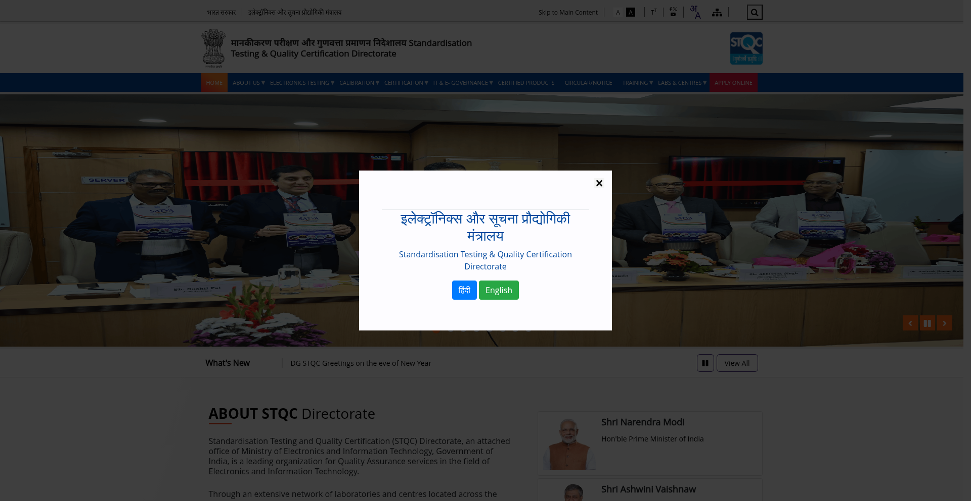

CL-02: British English
Test ID | CL-02
Description | No common American spellings in visible text.
Result | PASS
Reason | No common American spellings found in visible text.

Screenshot Evidence:


CL-03: No Hinglish
Test ID | CL-03
Description | Paragraph content must not contain Hinglish words.
Result | PASS
Reason | No Hinglish words found in paragraph content.

Screenshot Evidence:


CL-04: Acronym Expansion
Test ID | CL-04
Description | All uncommon acronyms must have their full form on first occurrence.
Result | FAIL
Reason | Acronyms without expansion: TT, HOME, ABOUT, US, STQC, ELECTRONICS, TESTING, CALIBRATION

Screenshot Evidence:


CL-05: Accessible Downloads (PDF only)
Test ID | CL-05
Description | Downloadable documents must be PDFs, not editable formats.
Result | PASS
Reason | All downloadable files appear to be PDFs.

Screenshot Evidence:


CL-06: Secure Hyperlinks (HTTPS only)
Test ID | CL-06
Description | All links must use HTTPS, not HTTP.
Result | PASS
Reason | All links use HTTPS.

Screenshot Evidence:
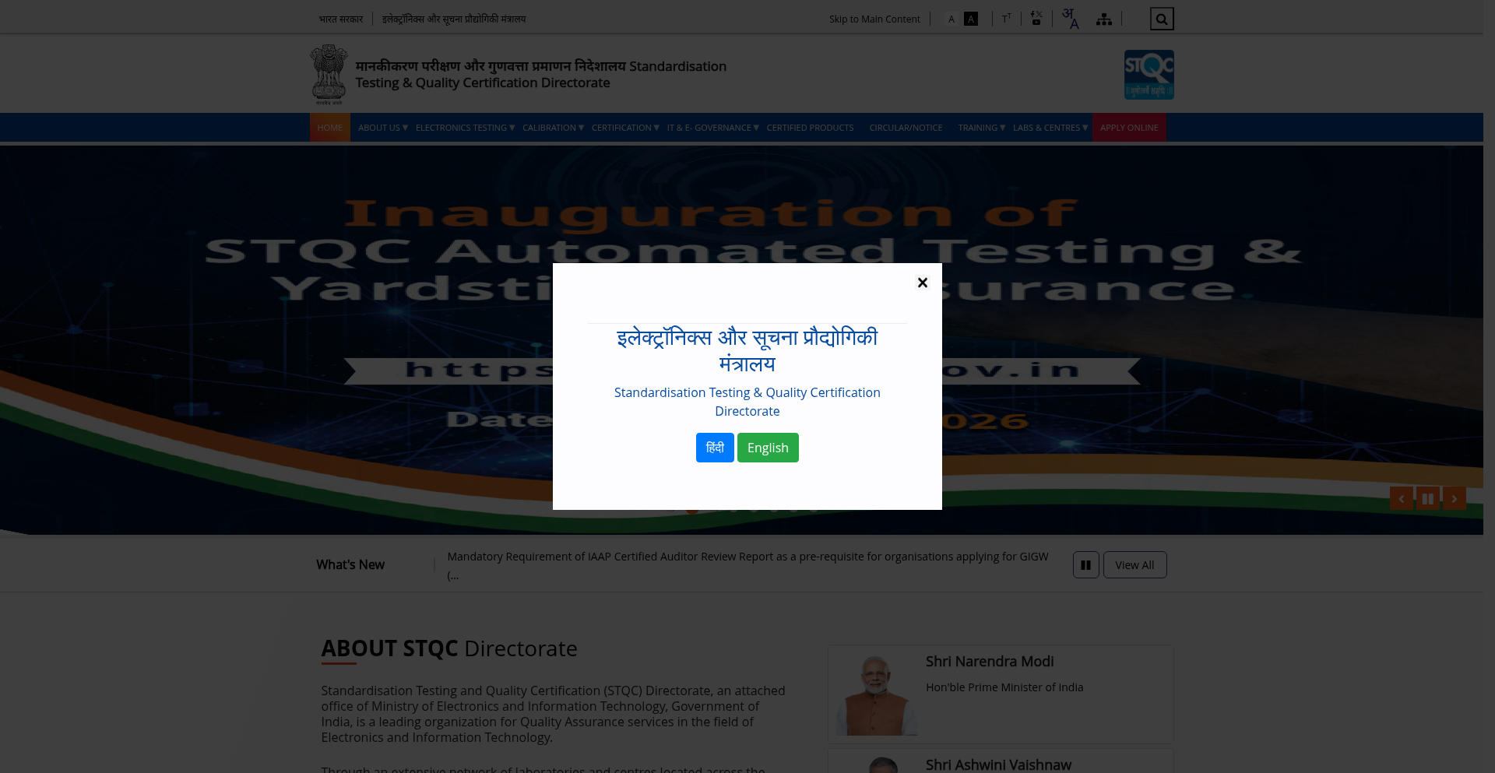

Multilingual

ML-01: Language Switcher in Header
Test ID | ML-01
Description | Language selection must be visible in the page header.
Result | PASS
Reason | Language switcher detected in page header.

Screenshot Evidence:


ML-02: HTML lang Attribute (Multilingual)
Test ID | ML-02
Description | The <html> tag must declare content language.
Result | PASS
Reason | lang attribute is 'en' — correct.

Screenshot Evidence:


ML-03: hreflang Tags
Test ID | ML-03
Description | Multilingual pages must include <link rel=alternate hreflang>.
Result | FAIL
Reason | No <link rel='alternate' hreflang='...'> tags found.

Screenshot Evidence:


ML-04: Multilingual URL Structure
Test ID | ML-04
Description | Language URLs must follow /hi/, /en/ or IDN conventions.
Result | PASS
Reason | Language URL patterns found (92 links). Example: https://www.stqc.gov.in/en/about-stqc

Screenshot Evidence:


CCPS

CC-01: CCPS API Subscription
Test ID | CC-01
Description | Page source must reference CCPS or api.india.gov.in.
Result | FAIL
Reason | No CCPS API references detected in page source.

Screenshot Evidence:
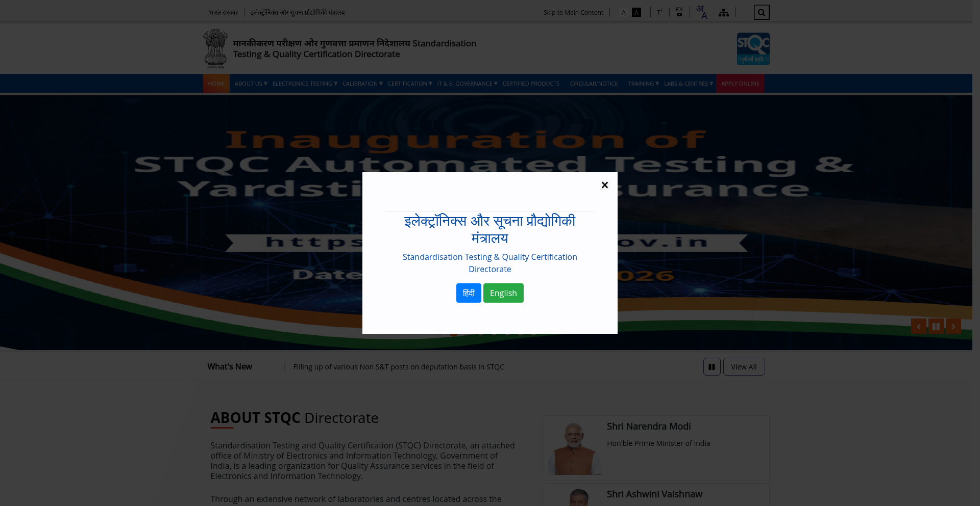

CC-02: First Banner Full-Width
Test ID | CC-02
Description | First homepage banner must be full-width (>=1800px).
Result | PASS
Reason | First large banner is 6016x3384 — qualifies as full-width.

Screenshot Evidence:


CC-03: Banner Pixel Dimensions
Test ID | CC-03
Description | Banners must match CCPS sizes: 1800x338/500/600 or 960x245.
Result | PASS
Reason | CCPS-compliant banner dimensions found: 1800x600, 1800x600, 1800x600, 1800x600, 1800x600, 1800x600

Screenshot Evidence:


Cookie & Personalization

CK-01: Cookie Consent Banner
Test ID | CK-01
Description | A visible cookie consent banner must be present.
Result | FAIL
Reason | No visible cookie consent banner found on the page.

Screenshot Evidence:


CK-02: Consent Options
Test ID | CK-02
Description | Banner must include Accept, Reject, and Customize options.
Result | FAIL
Reason | Cookie consent missing options: reject

Screenshot Evidence:


CK-03: Privacy Policy Link
Test ID | CK-03
Description | A privacy policy link must be accessible from the page.
Result | FAIL
Reason | No privacy policy link found on the page.

Screenshot Evidence:
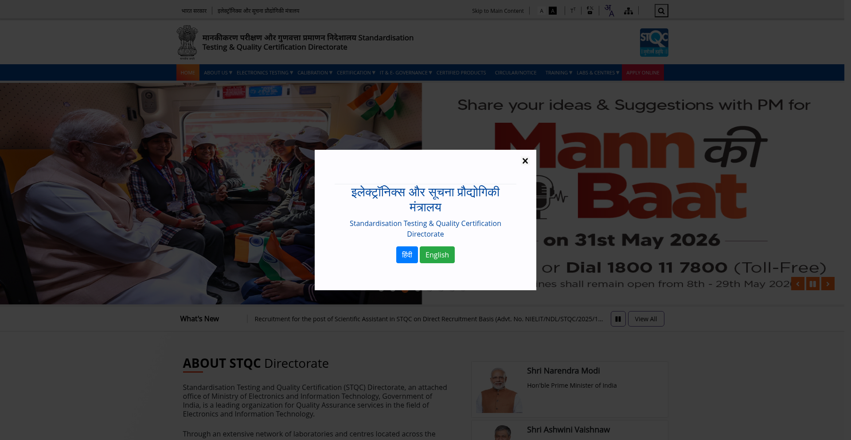

CK-04: Secure & HttpOnly Cookie Flags
Test ID | CK-04
Description | Session cookies must carry Secure and HttpOnly flags.
Result | PASS
Reason | No Set-Cookie header in initial response (cookies may be set dynamically).

Screenshot Evidence:
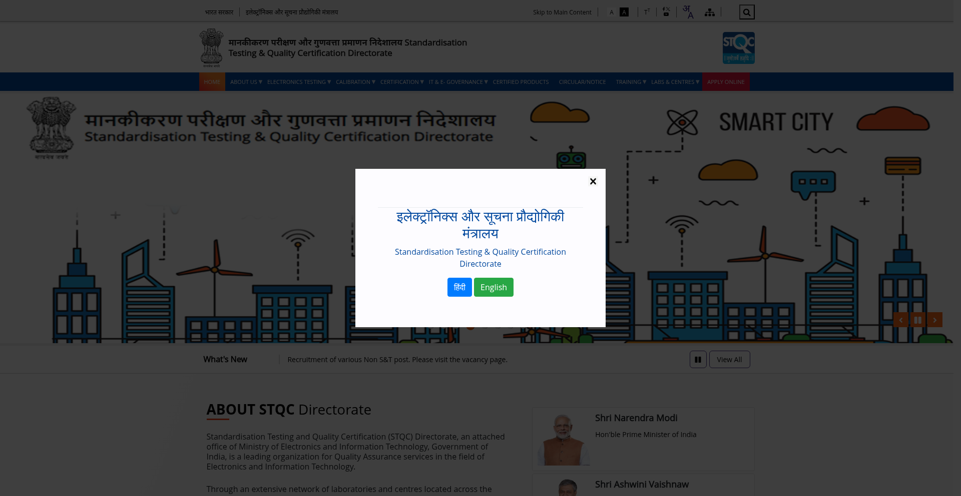

Summary

SUMMARY: Overall Compliance Verdict
Test ID | SUMMARY
Description | Aggregate result across all DBIM checklists.
Result | FAIL
Reason | 11 passed, 6 failed out of 17 checks.

Screenshot Evidence:


