DBIM Homepage Compliance Report

Homepage Screenshot
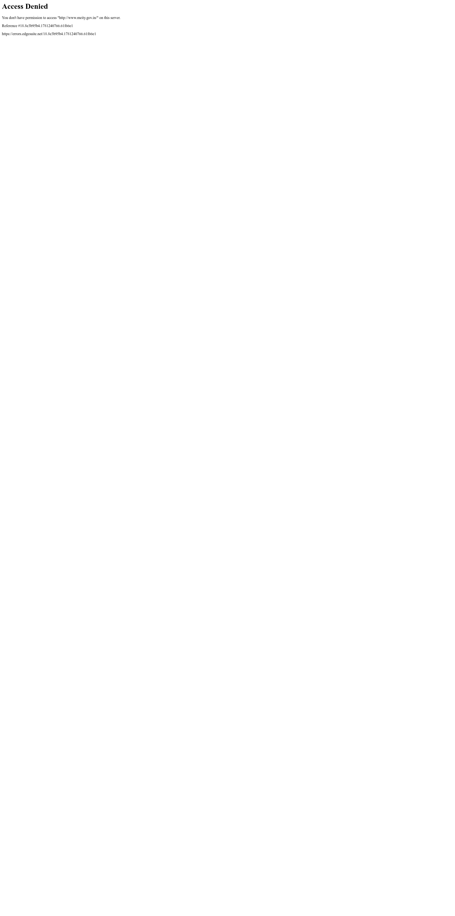

DBIM-A4-06: Integration with Social Media Handles
Status: FAIL
Reason: Missing platforms: Twitter/X, Instagram, Facebook, LinkedIn, YouTube


DBIM-A4-07: PM Image Transparent Background
Status: FAIL
Reason: PM section not found.


DBIM-A4-08: Authorized PM Sources
Status: FAIL
Reason: PM section not found.


DBIM-A4-09: PM Quote Relevance
Status: FAIL
Reason: PM quote section not found.


DBIM-A4-10: PM Quote DBIM Format
Status: FAIL
Reason: PM quote section missing.


Summary
Test ID | Test | Status | Reason
DBIM-A4-06 | Integration with Social Media Handles | FAIL | Missing platforms: Twitter/X, Instagram, Facebook, LinkedIn, YouTube
DBIM-A4-07 | PM Image Transparent Background | FAIL | PM section not found.
DBIM-A4-08 | Authorized PM Sources | FAIL | PM section not found.
DBIM-A4-09 | PM Quote Relevance | FAIL | PM quote section not found.
DBIM-A4-10 | PM Quote DBIM Format | FAIL | PM quote section missing.

