DBIM Homepage Compliance Report
Generated: 2026-06-12 10:51:24

Homepage Screenshot
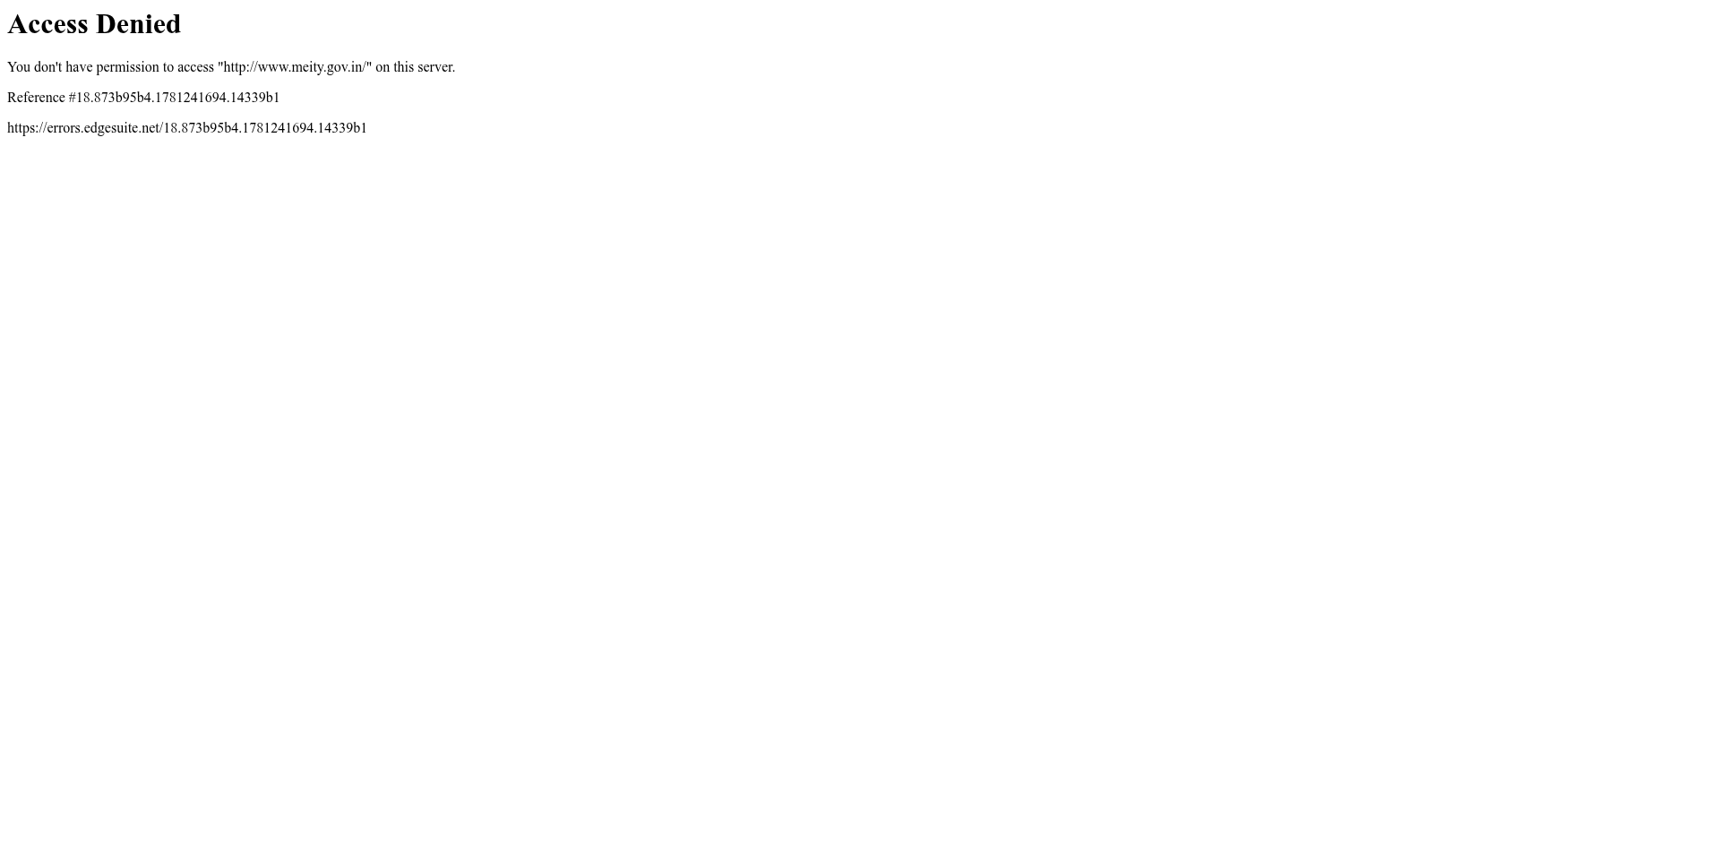

DBIM-A4-06: Integration with Social Media Handles
Status: FAIL
Reason: Missing platforms: Twitter/X, Instagram, Facebook, LinkedIn, YouTube

Evidence Screenshot:


DBIM-A4-07: PM Image Transparent Background
Status: FAIL
Reason: PM section not found on homepage. Please verify the PM section exists.

Evidence Screenshot:


DBIM-A4-08: Authorized PM Sources
Status: FAIL
Reason: PM section not found.

Evidence Screenshot:


DBIM-A4-09: PM Quote Relevance
Status: FAIL
Reason: PM quote section not found.

Evidence Screenshot:


DBIM-A4-10: PM Quote DBIM Format
Status: FAIL
Reason: PM quote section missing.

Evidence Screenshot:


Summary
Total Tests: 5
Passed: 0
Failed: 5

Test ID | Test | Status | Reason
DBIM-A4-06 | Integration with Social Media Handles | FAIL | Missing platforms: Twitter/X, Instagram, Facebook, LinkedIn, YouTube
DBIM-A4-07 | PM Image Transparent Background | FAIL | PM section not found on homepage. Please verify the PM section exists.
DBIM-A4-08 | Authorized PM Sources | FAIL | PM section not found.
DBIM-A4-09 | PM Quote Relevance | FAIL | PM quote section not found.
DBIM-A4-10 | PM Quote DBIM Format | FAIL | PM quote section missing.

