CUSTOMER SHOPPING BEHAVIOR
Data Analytics Project Report
Python • PostgreSQL • Power BI

PROJECT PURPOSE
Analyze customer shopping behavior, purchasing patterns, product performance, discounts/promotions, subscription behavior, seasonal trends, profitability, and returns, then communicate the findings through an interactive Power BI dashboard.

Project Information | Details
Dataset | Customer Shopping Behavior dataset
Rows | 4,000
Columns | 24
Analysis Notebook | Shopping_analysis.ipynb
Primary Tools | Python, Pandas, NumPy, Matplotlib, Seaborn, PostgreSQL, Power BI
Database Table | customer (loaded to PostgreSQL)
Report Status | Editable project report prepared for GitHub / portfolio use

Prepared for portfolio / academic project documentation

1. Executive Summary
This project applies an end-to-end data analytics workflow to a 4,000-record customer shopping behavior dataset. The analysis begins with Python-based data inspection and exploratory data analysis (EDA), continues with PostgreSQL for structured business analysis, and is designed to culminate in an interactive Power BI dashboard.
The analytical focus is on understanding who the customers are, how they purchase, which products and categories perform well, how discounts and promotional codes relate to purchase behavior, how subscriptions relate to spending, how sales vary over time and seasons, and how returns and profitability can be monitored.

Project Outcomes
- Validated the structure and completeness of the dataset using Pandas.
- Standardized column names for easier analysis and SQL/Power BI integration.
- Performed univariate, behavioral, correlation, and time-trend EDA.
- Calculated age-group spending, subscription spending, seasonal revenue, and monthly sales trends.
- Loaded the cleaned DataFrame into PostgreSQL for business-oriented SQL analysis.
- Designed a multi-page Power BI dashboard covering executive, customer, product, sales/returns, and optional customer-detail analysis.
- Defined reusable DAX measures for revenue, profit, orders, customers, average purchase, return rate, subscription rate, product ranking, and promotional usage.
IMPORTANT INTERPRETATION NOTE
The notebook contains exploratory analysis and visualizations, but it does not establish causal relationships. For example, differences between discount users and non-discount users should be interpreted as observed associations rather than proof that discounts caused higher or lower spending.

2. Dataset Overview
The supplied notebook loads a CSV named customer_shopping_behavior_4000_rows_updated.csv and converts Purchase Date to a datetime field. The resulting DataFrame contains 4,000 rows and 24 columns.
Area | Observed in Notebook
Rows | 4,000
Columns | 24
Age range | 18–70
Purchase amount range | USD 20–100
Previous purchases range | 1–50
Review rating | Numeric; 4,000 non-null values
Date range | 2024-01-02 to 2026-09-14
Missing values | 0 across all 24 columns
Unique products | 25
Categories | 4
Locations | 50
Seasons | 4
Customer segments | 3
Age groups | 5
Return status | 2 values

2.1 Data Dictionary
Field | Business Meaning | Type
Customer ID | Customer identifier | Identifier
Age | Customer age | Numeric
Gender | Customer gender | Categorical
Item Purchased | Purchased product | Categorical
Category | Product category | Categorical
Purchase Amount (USD) | Transaction purchase value | Numeric
Location | Customer location | Categorical
Size | Purchased product size | Categorical
Color | Product color | Categorical
Season | Season associated with purchase | Categorical
Review Rating | Customer review score | Numeric
Subscription Status | Subscription indicator | Categorical
Shipping Type | Shipping method | Categorical
Discount Applied | Discount indicator | Categorical
Promo Code Used | Promotion-code indicator | Categorical
Previous Purchases | Historical purchase count | Numeric
Payment Method | Payment method used | Categorical
Frequency of Purchases | Purchase-frequency category | Categorical
Purchase Date | Transaction date | DateTime
Order ID | Order identifier | Identifier
Profit (USD) | Profit generated by transaction | Numeric
Customer Segment | Customer segment | Categorical
Age Group | Predefined age band | Categorical
Return Status | Returned / not returned status | Categorical

3. Python Data Preparation & EDA
The supplied notebook uses Pandas, NumPy, Matplotlib, and Seaborn. The workflow is primarily exploratory: load the data, inspect structure, check missingness, standardize column names, rename selected measures, and visualize customer and purchasing behavior.

3.1 Environment and Data Loading
import pandas as pd
import numpy as np
import matplotlib.pyplot as plt
import seaborn as sns
df=pd.read_csv(r"C:\Users\dell\Downloads\customer_shopping_behavior_4000_rows_updated.csv")
df["Purchase Date"] = pd.to_datetime(df["Purchase Date"], format="%Y-%m-%d")
The notebook converts Purchase Date using the format %Y-%m-%d. It then works with the resulting DataFrame, df.

3.2 Initial Data Inspection
df.head()
df.tail()
df.info()
df.describe(include='all')
df.isnull().sum()
The notebook confirms 4,000 records, 24 columns, and zero missing values in every column. The data types include integer, floating-point, string, and datetime fields.

3.3 Column Standardization
df.columns=df.columns.str.lower()
df.columns=df.columns.str.replace(" ","_")
df = df.rename(columns={"purchase_amount_(usd)": "purchase_amount"})
df = df.rename(columns={"profit_(usd)": "profit"})
df.columns
Column names are converted to lowercase and spaces are replaced with underscores. The fields purchase_amount_(usd) and profit_(usd) are then simplified to purchase_amount and profit.

3.4 Univariate Analysis
- Customer age distribution.
- Gender distribution.
- Customer segment distribution.
- Purchases by category.
- Average purchase amount by age group.
#Age distribution
plt.figure(figsize=(8,5))
sns.histplot(df["age"], bins=20, kde=True)
plt.title("Customer Age Distribution")
plt.xlabel("Age")
plt.ylabel("Number of Customers")
plt.show()
#Gender distribution
plt.figure(figsize=(6,5))
sns.countplot(data=df, x="gender")
plt.title("Customer Gender Distribution")
plt.xlabel("Gender")
plt.ylabel("Number of Customers")
plt.show()
#Customer segment distribution
plt.figure(figsize=(7,5))
sns.countplot(data=df, x="customer_segment")
plt.title("Customer Segment Distribution")
plt.xlabel("Customer Segment")
plt.ylabel("Number of Customers")
plt.xticks(rotation=30)
plt.show()
#Category-wise purchases
plt.figure(figsize=(8,5))
sns.countplot(
data=df,
x="category"
)
plt.title("Purchases by Category")
plt.xlabel("Category")
plt.ylabel("Number of Purchases")
plt.show()

3.5 Age-Group Spending
#Average purchase amount
age_spending = df.groupby("age_group")["purchase_amount"].mean()
print(age_spending)
plt.figure(figsize=(8,5))
sns.barplot(
x=age_spending.index,
y=age_spending.values
)
plt.title("Average Spending by Age Group")
plt.xlabel("Age Group")
plt.ylabel("Average Purchase Amount (USD)")
plt.show()
Age Group | Average Purchase (USD)
18-25 | 60.1908
26-35 | 58.8262
36-50 | 59.8145
51-65 | 59.5503
66+ | 60.7963

Within this dataset, average purchase amounts are relatively close across age groups. The highest observed average is for the 66+ group (about USD 60.80), while the lowest is for ages 26–35 (about USD 58.83).

3.6 Business-Relationship Analysis
The notebook explores discount behavior, subscription status, and numerical correlations.
#Discount vs purchase amount
plt.figure(figsize=(7,5))
sns.boxplot(
data=df,
x="discount_applied",
y="purchase_amount"
)
plt.title("Purchase Amount by Discount Status")
plt.xlabel("Discount Applied")
plt.ylabel("Purchase Amount (USD)")
plt.show()
#Subscription vs spending
subscription_spending = (
df.groupby("subscription_status")["purchase_amount"]
.mean()
.reset_index()
)
print(subscription_spending)
plt.figure(figsize=(7, 5))
sns.barplot(
data=subscription_spending,
x="subscription_status",
y="purchase_amount"
)
plt.title("Average Purchase Amount by Subscription Status")
plt.xlabel("Subscription Status")
plt.ylabel("Average Purchase Amount (USD)")
plt.show()
#Correlation
sns.heatmap(df.select_dtypes("number").corr(), annot=True)
plt.show()
Subscription Status | Average Purchase (USD)
No | 59.7541
Yes | 59.5434

The notebook output shows very similar average purchase values for subscribers and non-subscribers. This is an observed descriptive result and should not be treated as evidence that subscription status has no broader business effect.

3.7 Time-Trend Analysis
#Monthly sales
print(df["purchase_date"].min())
print(df["purchase_date"].max())
monthly_sales = df.groupby(
df["purchase_date"].dt.to_period("M")
)["purchase_amount"].sum()
monthly_sales.index = monthly_sales.index.astype(str)
plt.figure(figsize=(12,5))
plt.plot(
monthly_sales.index,
monthly_sales.values,
marker="o"
)
plt.title("Monthly Sales Trend")
plt.xlabel("Month")
plt.ylabel("Total Sales (USD)")
plt.xticks(rotation=45)
plt.show()
The purchase dates in the notebook span from 2024-01-02 through 2026-09-14. Monthly sales are aggregated using the purchase month and visualized as a line chart.

3.8 Seasonal Purchasing Behavior
#Seasonal purchasing behavior
season_revenue = (
df.groupby("season")["purchase_amount"]
.sum()
.reset_index()
)
print(season_revenue)
plt.figure(figsize=(7, 5))
sns.barplot(
data=season_revenue,
x="season",
y="purchase_amount"
)
plt.title("Total Revenue by Season")
plt.xlabel("Season")
plt.ylabel("Total Revenue (USD)")
plt.show()
Season | Total Purchase Amount (USD) | Share of Total
Spring | 61,655 | 26.17%
Winter | 60,655 | 25.75%
Fall | 59,137 | 25.10%
Summer | 57,341 | 24.34%

The notebook's seasonal aggregation indicates Spring has the largest total purchase amount and Summer the smallest. The differences are relatively modest, so seasonality should be interpreted alongside month, category, product, and customer-segment views.

4. Dataset Profile & Descriptive Findings
The following values are directly supported by the notebook's descriptive output. They are useful as a baseline profile for the project and can be expanded after the final Power BI model is refreshed.
Metric / Attribute | Observed Value
Average age | 44.09 years
Median age | 44 years
Age range | 18–70 years
Average purchase amount | USD 59.697
Median purchase amount | USD 59
Purchase amount range | USD 20–100
Average profit | USD 11.419
Profit range | USD 1.64–29.77
Average previous purchases | 25.408
Median previous purchases | 25
Most frequent category | Clothing (1,725 records)
Most frequent product | Pants (187 records)
Most frequent gender | Male (2,738 records)
Most frequent season | Spring (1,045 records)
Most frequent size | M (1,867 records)
Most frequent customer segment | Loyal (2,780 records)
Most frequent age group | 51–65 (1,154 records)
Most frequent return status | Not Returned (3,542 records)
Most frequent promo-code status | No (2,251 records)
Most frequent payment method | Debit Card (700 records)
Most frequent purchase frequency | Every 3 Months (621 records)

DESCRIPTIVE INSIGHT
The dataset is dominated by the Loyal customer segment in the supplied sample, while average transaction value remains close to USD 60. The customer base and purchasing behavior should therefore be analyzed using both volume and value metrics rather than relying on a single KPI.

5.1 Business Questions
- What are the overall business performance KPIs?
  - Orders, customers, revenue, average order value, profit.
- Which product categories generate the highest revenue?
  - Orders, revenue, and average purchase by category.
- How does customer purchasing behavior vary across seasons?
  - Orders, revenue, and average purchase by season.
- Which customer segments contribute the most revenue and profit?
  - Customers, revenue, average purchase, and profit by segment.
- How does subscription status relate to customer purchasing behavior?
  - Spending, revenue, profit, and previous purchases of subscribers vs. non-subscribers.
- Which product categories have the highest return rates?
  - Total orders, returned orders, and return percentage.
- How do revenue and profit change over time?
  - Monthly orders, revenue, and profit.
- What are the top 5 most purchased products within each category?
  - Uses RANK() and PARTITION BY to rank products within categories.
- Which products generate the highest total profit?
  - Top 10 products based on total profit.
- How does subscription rate differ based on previous purchase history?
- Compares customers with more than 5 previous purchases against those with 5 or fewer.

5.2 Core SQL Queries

Overall KPIs
SELECT
COUNT(*) AS total_orders,
COUNT(DISTINCT customer_id) AS total_customers,
ROUND(SUM(purchase_amount), 2) AS total_revenue,
ROUND(AVG(purchase_amount), 2) AS average_order_value,
ROUND(SUM(profit)::NUMERIC, 2) AS total_profit,
ROUND(AVG(profit)::NUMERIC, 2) AS average_profit
FROM customer;

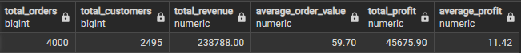

Revenue by Category
SELECT
category,
COUNT(*) AS total_orders,
ROUND(SUM(purchase_amount), 2) AS total_revenue,
ROUND(AVG(purchase_amount), 2) AS average_purchase
FROM customer
GROUP BY category
ORDER BY total_revenue DESC;

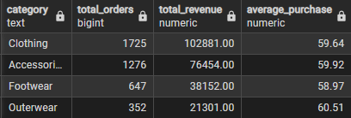

Seasonal Performance
SELECT
season,
COUNT(*) AS total_orders,
ROUND(SUM(purchase_amount), 2) AS total_revenue,
ROUND(AVG(purchase_amount), 2) AS average_purchase
FROM customer
GROUP BY season
ORDER BY total_revenue DESC;

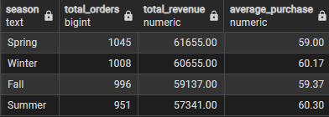

Customer Segment
SELECT
customer_segment,
COUNT(*) AS customers,
ROUND(AVG(purchase_amount), 2) AS average_purchase,
ROUND(SUM(purchase_amount), 2) AS total_revenue,
ROUND(AVG(profit)::NUMERIC, 2) AS average_profit
FROM customer
GROUP BY customer_segment
ORDER BY total_revenue DESC;

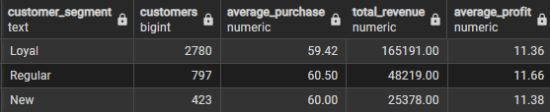

Subscription Analysis
SELECT
subscription_status,
COUNT(*) AS customers,
ROUND(AVG(purchase_amount), 2) AS average_purchase,
ROUND(SUM(purchase_amount), 2) AS total_revenue,
ROUND(AVG(profit)::NUMERIC, 2) AS average_profit,
ROUND(AVG(previous_purchases), 2) AS average_previous_purchases
FROM customer
GROUP BY subscription_status
ORDER BY average_purchase DESC;

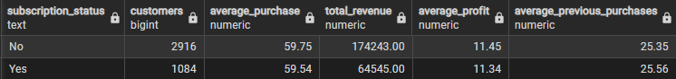

Return Rate
SELECT
category,
COUNT(*) AS total_orders,
COUNT(*) FILTER (WHERE return_status = 'Returned') AS returned_orders,
ROUND(
100.0 * COUNT(*) FILTER (WHERE return_status = 'Returned')
/ COUNT(*),
2
) AS return_rate_percentage
FROM customer
GROUP BY category
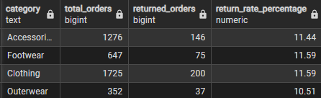

Revenue and profit change over time
SELECT
DATE_TRUNC('month', purchase_date) AS month,
COUNT(*) AS orders,
ROUND(SUM(purchase_amount), 2) AS revenue,
ROUND(SUM(profit)::NUMERIC, 2) AS profit
FROM customer
GROUP BY DATE_TRUNC('month', purchase_date)
ORDER BY month;
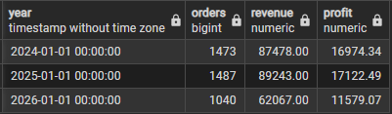

Top 5 products from each category
SELECT
category,
item_purchased,
purchase_count,
product_rank
FROM (
SELECT
category,
item_purchased,
COUNT(*) AS purchase_count,
RANK() OVER (
PARTITION BY category
ORDER BY COUNT(*) DESC
) AS product_rank
FROM customer
GROUP BY category, item_purchased
) ranked_products
WHERE product_rank <= 5

Most profitable products
SELECT
item_purchased,
COUNT(*) AS orders,
ROUND(SUM(profit)::NUMERIC, 2) AS total_profit
FROM customer
GROUP BY item_purchased
ORDER BY total_profit DESC
LIMIT 10;
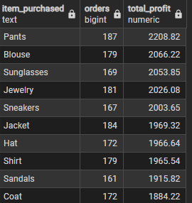

Is customer which have more than 5 previous purchases are likely to subscribe?
SELECT
CASE
WHEN previous_purchases > 5 THEN 'More than 5'
ELSE '5 or fewer'
END AS purchase_group,
COUNT(*) AS total_customers,
COUNT(*) FILTER (
WHERE subscription_status = 'Yes'
) AS subscribed_customers,
ROUND(
100.0 * COUNT(*) FILTER (
WHERE subscription_status = 'Yes'
) / COUNT(*), 2
) AS subscription_rate
FROM customer
GROUP BY
CASE
WHEN previous_purchases > 5 THEN 'More than 5'
ELSE '5 or fewer'
END
ORDER BY subscription_rate DESC;
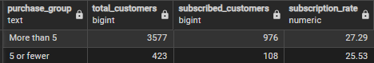

6. Power BI Dashboard Design
The dashboard was planned as a professional four-page analytical report. The visual language uses a dark futuristic background with cyan, blue, purple, yellow, and pink accents. The supplied background images are intended to act as layout guides/backgrounds while native Power BI visuals are placed over the empty chart areas.

6.1 Page 1 — Executive Overview
Business question: How is the business performing?
Component | Recommended Content
Filters | Month | Category | Gender | Season | Customer Segment | Location
KPIs | Total Revenue | Total Profit | Total Orders | Average Purchase | Return Rate
Visual 1 | Revenue & Profit Trend — line chart
Visual 2 | Revenue by Category — bar chart
Visual 3 | Revenue by Season — column/bar chart
Visual 4 | Profit by Category — bar chart
Bottom section | 4–5 concise business insights

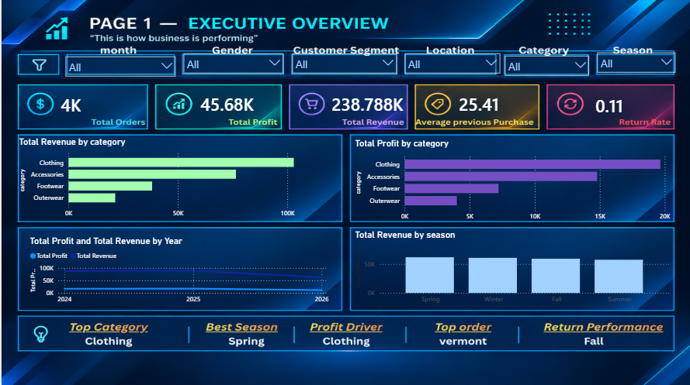

6.2 Page 2 — Customer Analytics
Business question: Who are our customers and how do they behave?
Component | Recommended Content
Filters | Segment | Gender | Age Group | Subscription | Location
KPIs | Customers | Repeat % | Subscription Rate | Average Order | Avg Previous Purchases
Visual 1 | Customer Segment Analysis
Visual 2 | Customer Demographics
Visual 3 | Subscription Analysis
Visual 4 | Previous Purchases vs Subscription
Bottom section | Customer Insight Matrix

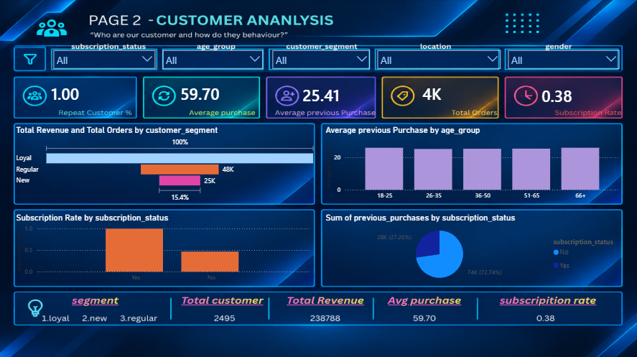
6.3 Page 3 — Product Analytics
Business question: Which products drive sales, profit and customer satisfaction?
Component | Recommended Content
Filters | Category | Season | Rating | Payment | Discount | Return | Gender (optional)
KPIs | Total Products | Top Item | Average Rating | Total Revenue | Return Rate
Visual 1 | Top Products
Visual 2 | Category Performance
Visual 3 | Top 3 Products
Visual 4 | Product Performance
Visual 5 | Optional product-performance scatter plot

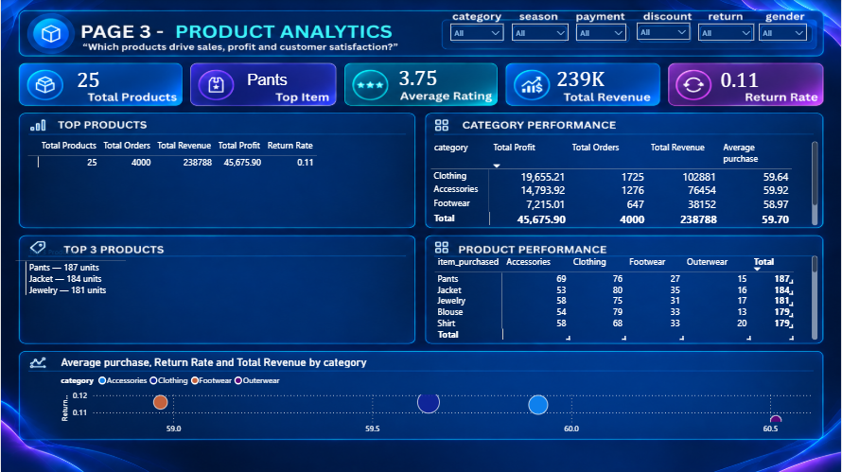

6.4 Page 4 — Sales & Returns Analytics
Business question: When do customers buy and what affects sales and returns?
Component | Recommended Content
Filters | Date | Season | Category | Discount | Promo | Return
KPIs | Revenue | Profit | Discount Usage % | Promo Usage % | Return Rate
Visual 1 | Monthly Sales — Revenue + Profit line chart
Visual 2 | Seasonal Analysis — column/bar chart
Visual 3 | Discount Analysis — Discount Yes vs No
Visual 4 | Return Analysis by Category
Bottom section | Discount / Purchase Behavior: Average Purchase | Revenue | Profit | Orders

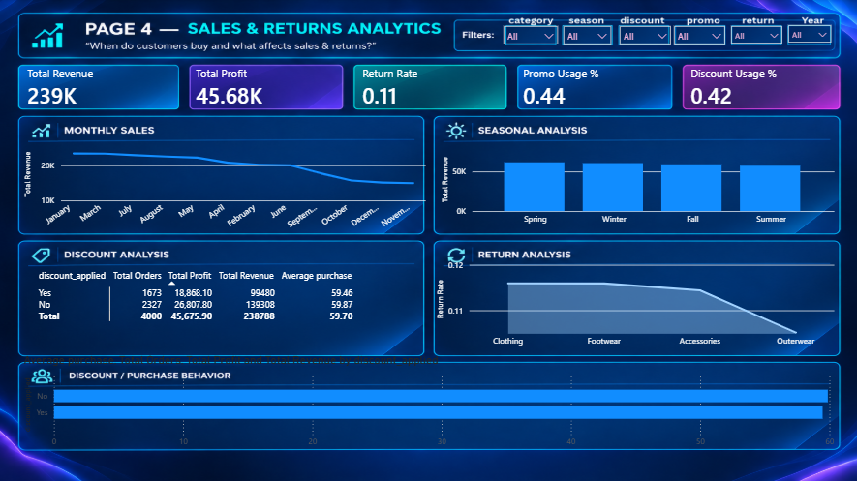

7. Power BI DAX Measures
The project uses the Power BI table name 'public customer'. The following measures were developed for the dashboard.

Total Orders
Total Orders =
COUNTROWS('public customer')

Total product
Total Products =
DISTINCTCOUNT('public customer'[item_purchased])

Total Customers
total customer = DISTINCTCOUNT('public customer'[customer_id])

Total Revenue
Total Revenue = SUM('public customer'[purchase_amount])

Total Profit
Total Profit =
SUM('public customer'[profit])

Average Purchase
Average purchase =
AVERAGE('public customer'[purchase_amount])

Return Rate
Return Rate =
DIVIDE(
CALCULATE(
COUNTROWS('public customer'),
'public customer'[return_status] = "Returned"
),
COUNTROWS('public customer'),
0
)

Repeat Customer %
Repeat Customer % =
DIVIDE(
CALCULATE(
DISTINCTCOUNT('public customer'[customer_id]),
'public customer'[previous_purchases]> 0
),
DISTINCTCOUNT('public customer'[customer_id]),
0
)

Subscription Rate
Subscription Rate =
DIVIDE(
CALCULATE(
DISTINCTCOUNT('public customer'[customer_id]),
'public customer'[subscription_status] = "Yes"
),
DISTINCTCOUNT('public customer'[customer_id]),
0
)

Purchase count
Purchase Count =
COUNTROWS('public customer')

Average Rating
Average Rating = AVERAGE('public customer'[review_rating])

Total Products
Total Products =
DISTINCTCOUNT('public customer'[item_purchased])

Discount Usage %
Discount Usage % =
DIVIDE(
CALCULATE(
COUNTROWS('public customer'),
'public customer'[discount_applied] = "Yes"
),
COUNTROWS('public customer'),
0
)

Promo Usage %
Promo Usage % =
DIVIDE(
CALCULATE(
COUNTROWS('public customer'),
'public customer'[promo_code_used] = "Yes"
),
COUNTROWS('public customer'),
0
)

Top Item
Top Item =
VAR TopProduct =
TOPN(
1,
SUMMARIZE(
'public customer',
'public customer'[item_purchased],
"PurchaseCount", COUNTROWS('public customer')
),
[PurchaseCount],
DESC
)
RETURN
MAXX(
TopProduct,
'public customer'[item_purchased]
)

Top 3 Products Text
Top 3 Products =
VAR TopProducts =
TOPN(
3,
ADDCOLUMNS(
ALL('public customer'[item_purchased]),
"UnitsSold", CALCULATE(COUNTROWS('public customer'))
),
[UnitsSold],
DESC
)
RETURN
CONCATENATEX(
TopProducts,
'public customer'[item_purchased]
& " — "
& [UnitsSold]
& " units",
UNICHAR(10),
[UnitsSold],
DESC
)

Key Business Insights

1. Customer Base
- The dataset contains 4,000 customer purchase records across 24 columns.
- The analysis covers 25 products, 4 categories, 50 locations, 4 seasons, and 3 customer segments.
- No missing values were identified during the data-quality analysis.

2. Customer Demographics
- The average customer age is approximately 44 years.
- The 51–65 age group represents the largest age-group segment in the dataset.
- Male customers account for the largest number of records in the analyzed dataset.

3. Purchasing Behavior
- The average purchase amount is approximately $59.70.
- Average purchase values are relatively similar across age groups, ranging from approximately $58.83 to $60.80.
- This indicates that purchase amount does not vary dramatically across the defined age groups in this dataset.

4. Customer Segmentation
- The Loyal customer segment represents the largest segment in the dataset.
- Customer segments can be compared using revenue, average purchase amount, order volume, and profit to understand their contribution to overall business performance.

5. Subscription Behavior
- Subscribers and non-subscribers show very similar average purchase amounts:
  - Subscribers: ~$59.54
  - Non-subscribers: ~$59.75
- This is a descriptive observation and should not be interpreted as evidence that subscription status causes higher or lower spending.

6. Seasonal Purchasing
Total purchase amount varies across seasons:
Season | Total Purchase
Spring | $61,655
Winter | $60,655
Fall | $59,137
Summer | $57,341
- Spring recorded the highest total purchase amount in the analyzed dataset.
- Summer recorded the lowest total purchase amount.

7. Product Performance
- The dataset contains 25 unique products across 4 categories.
- Product-level analysis can identify the most purchased products and products generating the highest total profit.
- The dashboard provides Top Product and Top 3 Products by Category analysis.

8. Profitability
- Average profit is approximately $11.42 per transaction.
- Profit analysis helps distinguish products or categories that generate high sales from those that generate high profitability.

9. Returns
- Return analysis compares returned and non-returned orders.
- Return rate can be analyzed by category, product, season, and customer segment to identify areas requiring further investigation.

10. Discounts & Promotions
- Discount Applied and Promo Code Used are treated as separate analytical dimensions.
- Their impact can be compared using revenue, average purchase, profit, and order volume rather than assuming that discounts and promotions have the same effect.

11. Previous Purchases & Subscription
- Customers are grouped into:
  - More than 5 previous purchases
  - 5 or fewer previous purchases
- Subscription rates are compared between these groups to understand the observed relationship between previous purchase history and subscription status.

12. Overall Analytical Takeaway
The analysis demonstrates how customer transaction data can be transformed into actionable business information through Python EDA, SQL analysis, DAX calculations, and Power BI visualization. The findings highlight customer demographics, purchasing behavior, product performance, seasonality, profitability, subscriptions, discounts, and returns.

Conclusion
This project demonstrates a complete end-to-end data analytics workflow, from raw data preparation and exploratory analysis to SQL-based business analysis and interactive Power BI visualization. The analysis provides a structured view of customer behavior, product performance, sales trends, profitability, subscriptions, discounts, and returns. The resulting dashboard and analytical report can support data-driven business analysis and provide a foundation for future predictive analytics and customer segmentation.

Business Suggestions & Recommendations

1. Focus on High-Performing Product Categories
- Identify categories generating the highest revenue and profit.
- Maintain sufficient inventory for consistently high-performing categories.
- Investigate lower-performing categories to understand whether pricing, demand, or product mix is affecting performance.

2. Use Seasonal Demand for Planning
- Spring has the highest total purchase amount in the analyzed dataset, while summer has the lowest.
- Businesses can use seasonal patterns to plan inventory, promotions, and marketing campaigns.
- Before making major decisions, compare the pattern across multiple periods to determine whether it is consistent.

3. Improve Customer Retention
- The dataset contains a large Loyal customer segment.
- Analyze loyal and repeat customers to understand their purchasing patterns.
- Consider loyalty programs, personalized offers, and targeted communication to encourage repeat purchases.

4. Analyze Subscription Customers
- Subscriber and non-subscriber average purchase values are very similar in this dataset.
- Instead of assuming subscriptions increase spending, analyze retention, purchase frequency, and lifetime value of subscribers.
- Test different subscription benefits and monitor their actual performance.

5. Optimize Discounts and Promotions
- Keep Discount Applied and Promo Code Used as separate dimensions.
- Compare discounted vs. non-discounted purchases using:
  - Revenue
  - Profit
  - Average purchase
  - Order volume
- Avoid evaluating promotions only by sales volume; also consider their effect on profitability.

6. Monitor Product Returns
- Track return rate by category and product.
- Products with unusually high return rates should be investigated further.
- Examine possible reasons such as product quality, sizing, descriptions, or customer expectations.

7. Focus on Profitable Products
- Revenue alone does not indicate business profitability.
- Compare sales volume, revenue, and profit together.
- Products with high revenue but relatively low profit should be reviewed for pricing, discounts, and costs.

8. Use Customer Segmentation for Targeted Marketing
Different customer segments can receive different marketing strategies.
For example:
Customer Type | Possible Strategy
Loyal Customers | Loyalty rewards
Frequent Buyers | Personalized offers
Low-Frequency Buyers | Re-engagement campaigns
Subscribers | Subscription benefits
High-Value Customers | Exclusive promotions
These strategies should be validated using actual customer response data.

9. Build a Data-Driven Monitoring System
The Power BI dashboard can be used to regularly monitor:
- Revenue
- Profit
- Orders
- Average Order Value
- Return Rate
- Subscription Rate
- Discount Usage
- Product Performance
This allows changes in business performance to be identified more quickly.

Recommended Business Tips
You can put these in a small "Actionable Recommendations" box in your report:
Tip 1: Focus on profitable products, not just high-selling products.
Tip 2: Use seasonal purchasing patterns to plan inventory and campaigns.
Tip 3: Monitor return rates by product and category to identify potential problems.
Tip 4: Evaluate discounts and promotions based on profitability, not only sales.
Tip 5: Use customer segmentation to personalize marketing strategies.
Tip 6: Track subscription customers using retention and purchase frequency, not only average spending.
Tip 7: Use the Power BI dashboard as a recurring performance-monitoring tool.

