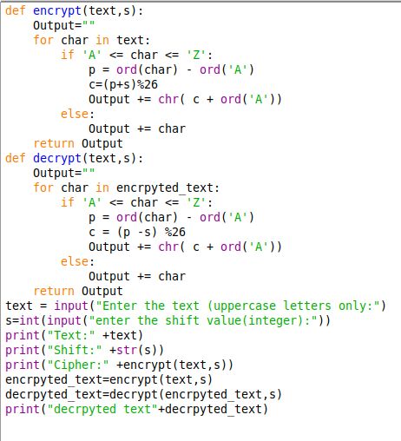

#position of character(0-25)
#caeser formula
#conv to char

#non-alphabetic char unchanged

#decrpytion

Output:

