Q. code for monoalphabetic cipher.

def monoencrpyt(): #encrpyt
alphabets="ABCDEFGHIJKLMNOPQRSTUVWXYZ" #reference table
cipher="ZXCVBNMLKJHGFDSAPOIUYTREWQ"
ENCRP="" #encrpyted data is stored here
msg=text.upper() #making the plain text to upper case
for i in msg:
if(i.isalpha()): #whether its alphabet or not
indexx=alphabets.index(i)
ENCRP+=cipher[indexx]
else:
ENCRP+=i
return ENCRP
def monodecrpyt(): #decrpyt
alphabets="ABCDEFGHIJKLMNOPQRSTUVWXYZ"
cipher="ZXCVBNMLKJHGFDSAPOIUYTREWQ"
DECRP=""
for i in encrpted_text:
if(i.isalpha()):
ind=cipher.index(i) #stores index of the letter in the cipher
DECRP+=alphabets[ind] #finds corresponding index letter in alphabet
else:
DECRP+=i
return DECRP
text=input("Enter plaintext here:")
encrpted_text=monoencrpyt()
print("encrpted_text:"+encrpted_text)
decrpted_text=monodecrpyt()
print("decrpted_text:"+decrpted_text)

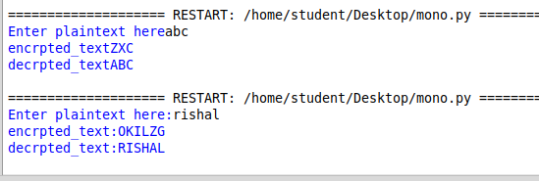
OUTPUT:

