

Bachelor of Computer Applications
Semester – V
Business Analytics
Experiment No.: 5
Title: Building a Customer Analysis Dashboard in Power BI for Sales, Revenue and Customer Insights

Submitted By:
Name: Risha Madhuri K
Reg. No.: 2411021240063
Date: 16-10-2026

Submitted To:
Faculty Name: Mr. Aman Kumar Sharma

Department of Computer Application
Alliance University
Chandapura - Anekal Main Road, Anekal
Bengaluru – 562106

Experiment No.: 5
Building a Customer Analysis Dashboard in Power BI for Sales, Revenue and Customer Insights
GITHUBLINK

Problem Statement
Problem Statement
A retail business stores its customer and order data in separate raw CSV files, which makes it difficult to see which product categories sell best, which payment methods customers prefer, how revenue changes from month to month, and which customers contribute the most; as the volume of customer and order records grows (1,000 customers and 5,000 orders), answering these questions manually is slow and error-prone, creating a need for an interactive Power BI dashboard that links the two datasets, calculates key sales and revenue metrics, and presents customer-wise, product-wise, payment-wise and time-wise insights to support faster, data-driven decisions.

Methodology / Steps Followed
Step 1: Data Collection

Customer analysis data provided for the assignment as two CSV files: customer_analysis_customers_1000.csv (customer details) and customer_analysis_orders_5000.csv (order transactions)

Customers table includes fields such as CustomerID, CustomerName, Age, Gender, City, State, CustomerSegment, IncomeBand, and SignupDate

Orders table includes fields such as OrderID, CustomerID, OrderDate, Product, ProductCategory, Quantity, SalesAmount, DiscountPercent, and PaymentMethod

Data selected to answer the five business questions: most popular product category, most used payment method, month-wise revenue trend, customers with the most purchases, and revenue concentration among customers

Step 2: Data Import
- Both CSV files (Customers and Orders) imported into Power BI using the "Get Data" → Text/CSV connector
- Tables loaded into Power BI Desktop's data model through Power Query
- Verified successful load of each table by checking row counts and column headers post-import
- Reviewed each table's preview in Power Query Editor before loading to catch any formatting issues early

Step 3: Data Cleaning and Transformation

Checked and corrected data types for each column (OrderDate and SignupDate as Date, SalesAmount and DiscountPercent as Decimal Number, Quantity and Age as Whole Number, IDs and names as Text)

Checked for duplicate rows and blank/null entries in the Orders and Customers datasets using Power Query

Kept column names consistent across tables (CustomerID in both tables) so the tables could be related

Verified that the key field (CustomerID) in the Orders table matches the Customers table before modeling the relationship

Step 4: Data Modeling

Built a data model connecting the customer_analysis_orders table (transactions) with the customer_analysis_customers table (customer details)

Created a relationship on CustomerID between the two tables to enable cross-filtering, so order data can be analysed by customer

Created measures/aggregations: Total Sales (Sum of SalesAmount), Total Orders (Count of OrderID), Total Customers (Count of CustomerID), and Total Quantity Sold (Sum of Quantity)

Validated the relationship by checking that filters applied on one table correctly cross-filtered the related table

Step 5: Dashboard Development
- Designed KPI cards for Sum of SalesAmount, Total Orders, Total Customers, and Total Quantity Sold
- Built visuals to answer each question: Sum of SalesAmount by ProductCategory (bar chart), Count of OrderID by PaymentMethod (pie chart), Sum of SalesAmount by Month (line chart), and Sum of SalesAmount / Count of OrderID by CustomerName (bar charts)
- Used bar charts for ranking categories and customers, a line chart for the monthly trend, and a pie chart for the payment method share
- Arranged all visuals on a single dashboard page for a consolidated, at-a-glance view of sales, revenue, and customer behaviour

Output
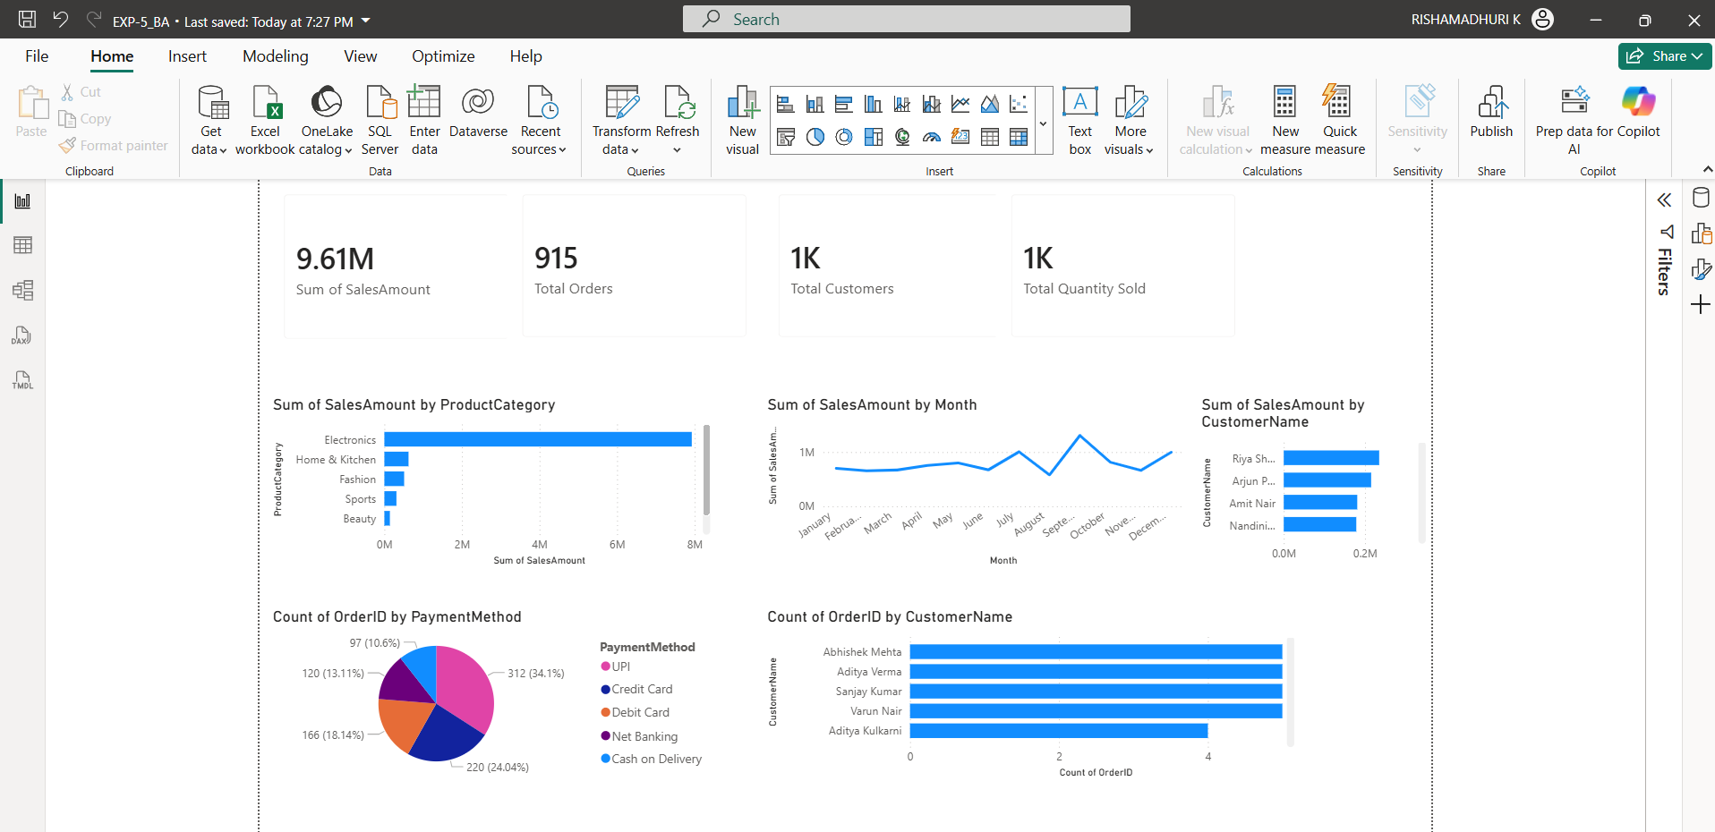

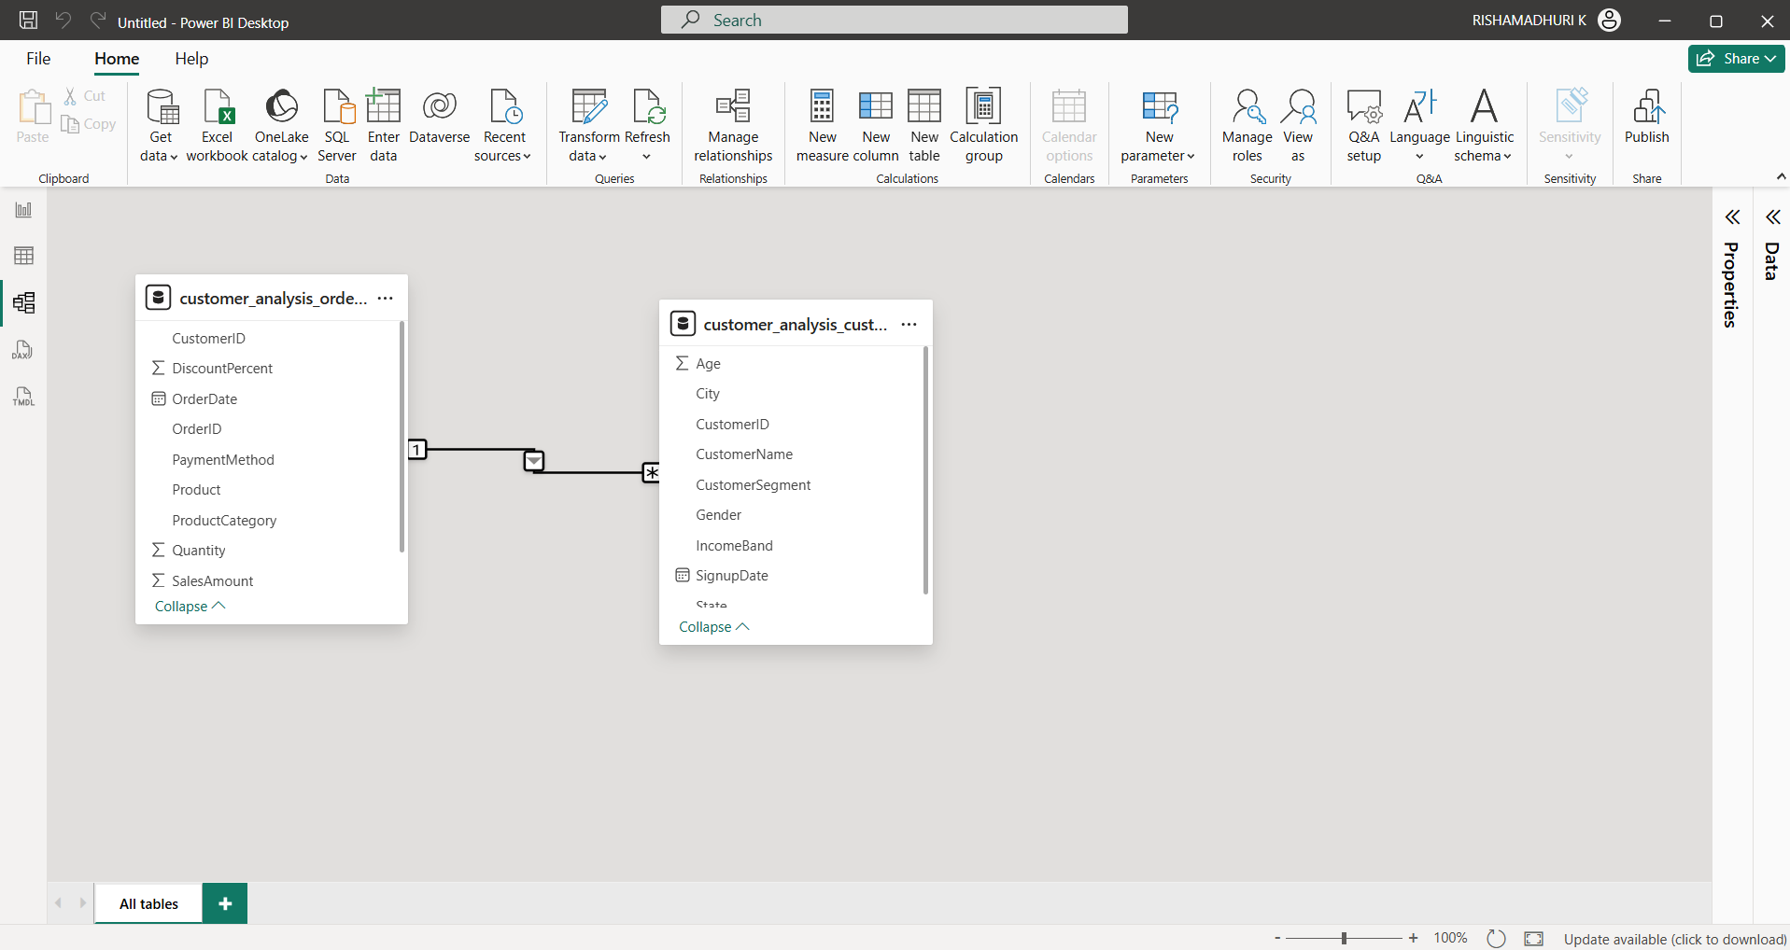

- A single-page interactive Power BI dashboard displaying Total Sales (9.61M), Total Orders (915), Total Customers (1K), and Total Quantity Sold (1K)
- Product category chart showing Electronics as the most popular category by sales, followed by Home & Kitchen, Fashion, Sports, and Beauty
- Payment method pie chart showing UPI as the most frequently used method with 312 orders (34.1%), followed by Credit Card (220, 24.04%), Debit Card (166, 18.14%), Net Banking (120, 13.11%), and Cash on Delivery (97, 10.6%)
- Monthly sales trend line showing how revenue changes month by month, with revenue staying around the 1M level and visible peaks and dips across the year
- Customer-wise charts showing the top customers by sales (e.g., Riya Sh., Arjun P., Amit Nair, Nandini) and by number of purchases (Abhishek Mehta, Aditya Verma, Sanjay Kumar, Varun Nair with 5 orders each)
- Data model view showing the Orders and Customers tables connected through CustomerID

Conclusion
This project successfully built an interactive Power BI customer analysis dashboard by importing the customer and order datasets, relating them through CustomerID, and visualising sales, revenue, and customer behaviour on a single page. The dashboard answers the five business questions—most popular product category, most frequently used payment method, month-wise revenue change, customers with the most purchases, and revenue concentration among customers—giving a clear, consolidated view that supports faster and better data-driven decisions.

Learning Outcomes
- Gained hands-on experience importing CSV datasets into Power BI and relating multiple tables using a common key (CustomerID)
- Learned to build a data model in Model view and use relationships to analyse transactions by customer attributes
- Developed practical skills in creating KPI cards and aggregations such as Total Sales, Total Orders, Total Customers, and Total Quantity Sold
- Learned to select appropriate visuals (bar chart, line chart, pie chart, KPI cards) for different business questions

Business Insights
- Electronics is by far the most popular category, contributing the large majority of total sales, so inventory and marketing focus should prioritise it while lower-selling categories (Sports, Beauty) need promotion
- UPI is the most frequently used payment method (about 34% of orders), and digital methods together account for roughly 89% of orders versus about 11% for Cash on Delivery, so payment gateway reliability and UPI offers are worth prioritising
- Monthly revenue stays fairly steady around the 1M level but shows seasonal peaks and dips, which can help with inventory planning and timing of campaigns
- The top customers each contribute only a small share of total revenue (roughly 0.2M each against 9.61M), indicating revenue is spread across many customers rather than concentrated in a few; repeat buyers with 4-5 orders are good targets for loyalty programmes

