

Bachelor of Computer Applications
Semester – V
Business Analytics
Experiment No.: 1
Title: Sales Performance Analysis Across Products, Categories, and Regions Using the Sample Superstore Dataset in Power BI

Submitted By:
Name: Risha Madhuri K
Reg. No.: 2411021240063
Date: 31-08-2026

Submitted To:
Faculty Name: Mr. Aman Kumar Sharma

Department of Computer Application
Alliance University
Chandapura - Anekal Main Road, Anekal
Bengaluru – 562106

Experiment No.: 1
Sales Performance Analysis Across Products, Categories, and Regions Using the Sample Superstore Dataset in Power BI
GITHUBLINK

Problem Statement
Management wants to quickly understand sales performance across products, categories, and regions to identify key business patterns. Task: import the Sample Superstore dataset into Power BI, build a clean data model, create DAX measures, and design visualizations to reveal sales, profit, and discount patterns across products, categories, sub-categories, regions, and time.

Methodology / Steps Followed
Step 1: Data Collection

Obtained the Sample Superstore dataset (CSV) from Kaggle — contains Order, Customer, Product, Region, Sales, Quantity, Discount, and Profit fields.

Reviewed structure: one row = one product line item within an order.

Step 2: Data Import
- Opened Power BI Desktop, used Get Data → Text/CSV to import the file (Sample_Superstore table).
- Opened in Power Query Editor (Transform Data) to inspect before loading.

Step 3: Data Cleaning and Transformation

Set correct data types (Text for Order ID/Product ID, Decimal for Sales/Profit/Discount).

Found Order Date and Ship Date had mixed date formats in the same column (some DD-MM-YYYY, some MM/DD/YYYY) — caused conversion errors when changing type directly.

Fixed using a Custom Column with conditional logic:

if Text.Contains([Order Date], "/") then

Date.FromText([Order Date], "en-US")

else

Date.FromText([Order Date], "en-GB")

Removed the old broken column, renamed the new one to Order Date. Repeated for Ship Date.

Step 4: Data Modeling

Created a separate DateTable using:

DateTable = CALENDAR(MIN(Sample_Superstore[Order Date]), MAX(Sample_Superstore[Order Date]))

Set Month Name → Sort by Column → Month Number (so months display Jan–Dec, not alphabetically).

Built a relationship: Sample_Superstore[Order Date] → DateTable[Date] (initially mistakenly linked to Month Name, which caused a "(Blank)" chart and a conversion error — corrected to link Date-to-Date).

Relationship: Many-to-one, Single cross-filter direction, active

Step 5: Dashboard Development
- KPI Cards: Total Sales, Total Profit, Profit Margin %, Total Orders.
- Clustered Column Chart: Total Sales by Category.
- Line Chart: Monthly Sales Trend (Month Name vs Total Sales).
- Clustered Bar Chart: Total Profit by Sub-Category, sorted ascending (surfaces loss-makers).
- Scatter Chart: Avg Discount (X) vs Total Profit (Y), legend = Category, with a zero reference line — shows discount's effect on profitability.
- Map: Total Sales by Region.
- Table: Product Name, Category, Total Sales, Total Profit, Profit Margin %, filtered to Top/Bottom products, conditional formatting on Total Profit (red = negative).
- Renamed visual titles to describe insights (e.g., "Discount Impact on Profit" instead of generic field names).
- Page named: "Sales & Profitability Overview"

Output

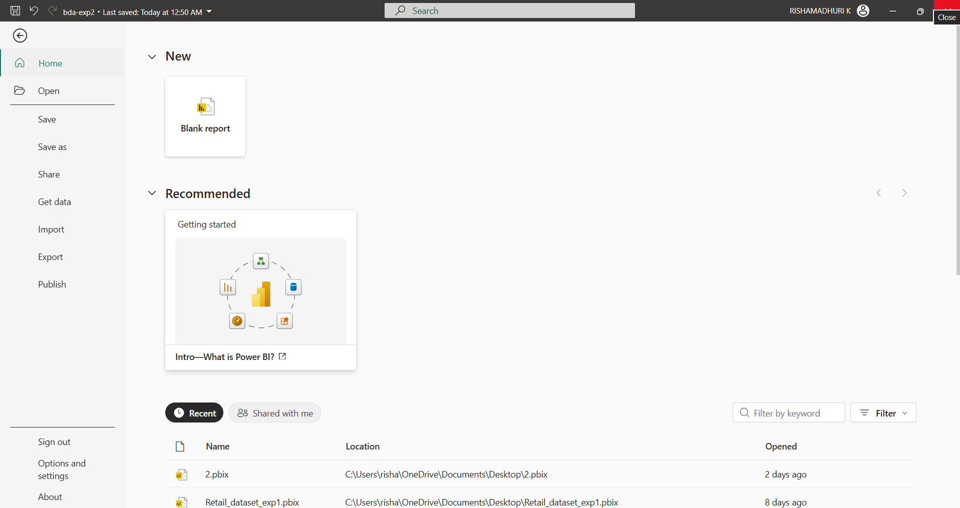
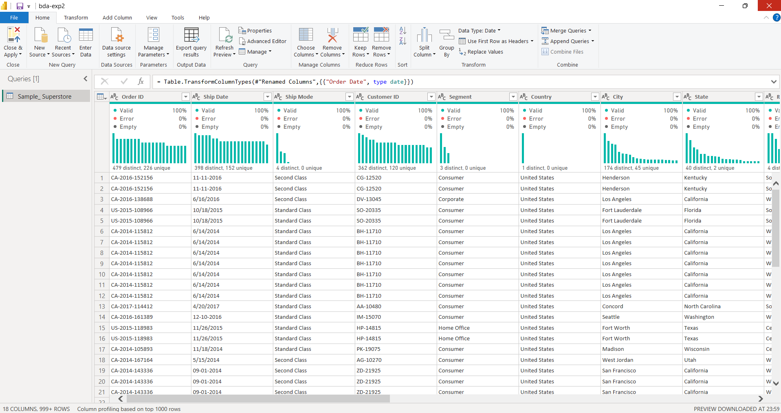

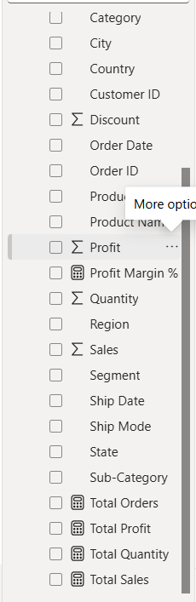

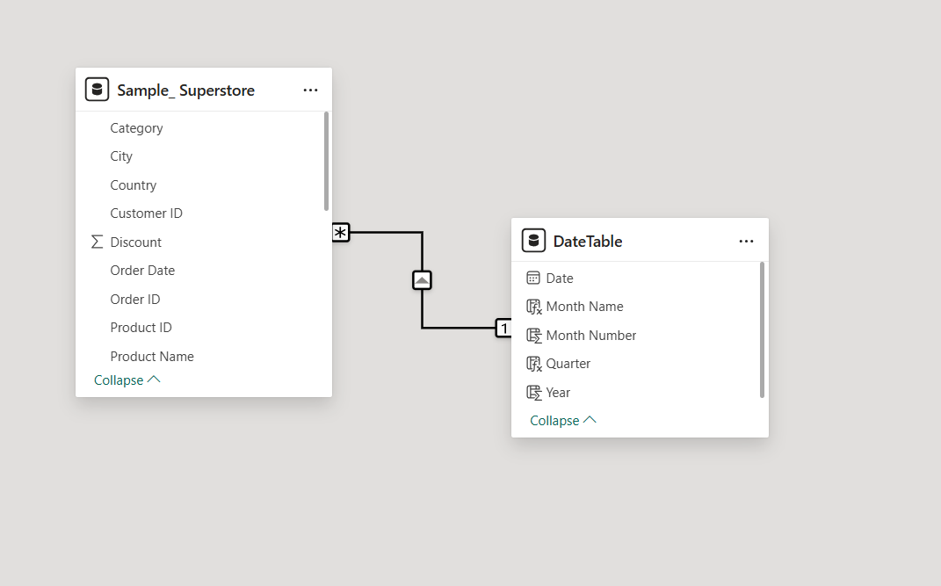

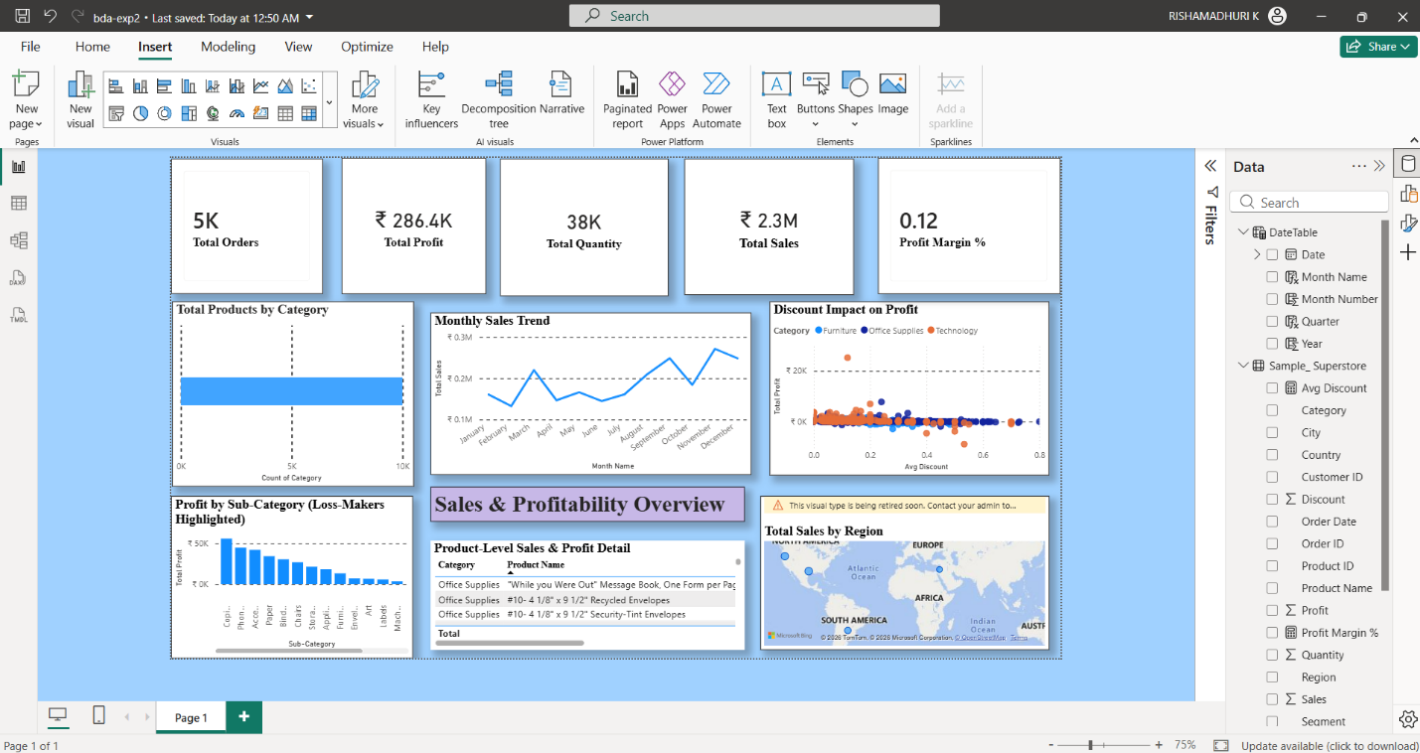

The final Power BI dashboard provides:
- Key metrics via KPI cards (Sales, Profit, Margin %, Orders).
- Category and sub-category sales/profit comparison.
- Monthly sales trend.
- Discount vs profitability relationship.
- Region-wise sales on a map.
- Product-level table highlighting most/least profitable items.

Conclusion
This project used Power BI to analyze the Sample Superstore dataset and build a dashboard for management to understand sales performance across products, categories, and regions. Power Query resolved inconsistent date formats; a dedicated date table enabled reliable time intelligence; DAX measures summarized key metrics. The resulting visuals — KPI cards, category/sub-category charts, a trend line, a discount-profit scatter chart, a regional map, and a product table — highlight where the business performs well and where discounting erodes profit.

Learning Outcomes
- How to identify and fix inconsistent date formats in Power Query using conditional custom columns.
- How to build and correctly relate a dedicated Date table for time intelligence.
- How to write DAX measures for core KPIs (Profit Margin %, Total Orders via DISTINCTCOUNT).
- How to choose the right visual type (bar, line, map, scatter, table) based on the business question.
- How to interpret a Discount vs Profit relationship to spot where discounting hurts profitability.
- How to design a management-facing dashboard with clear titles, formatted numbers, and conditional formatting.

Business Insights
- Technology and Office Supplies generally show better profit margins than Furniture, even with comparable or lower sales.
- Certain Furniture sub-categories (Tables, Bookcases) show low or negative profit due to heavy discounting.
- Profit tends to turn negative once discounts exceed roughly 30–40%, especially in Furniture.
- Sales show seasonal variation, typically rising toward later months of the year.
- Regional performance varies — some regions consistently outsell others

