INDUSTRY PROJECT: PROJECT REPORT
Industry Project title | Superstore Profit Analysis
Name of the Company | TCS
Name of the Institute | JNTUH College Of Engineering Manthani
Start Date | End Date | Total Effort(hrs) | Project Environment | Tools Used
Sep 28th 2025 | Nov 8th 2025 | 90 | Windows OS, Jupyter Notebook, MySQL, Power BI | Python (Pandas, Matplotlib, Seaborn), MySQL, Power BI, VS Code

Acknowledgements
I would like to express my heartfelt gratitude to my mentors at TCS, my faculty guide, and the management of JNTUH University College of Engineering Manthani for their continuous guidance and encouragement throughout this project. Their support helped me gain valuable knowledge in data analytics, Python programming, and dashboard design.

Objective and Scope
Objective:
To analyze the Superstore retail dataset to extract insights about sales, profit, customers, and product categories, and to visualize these insights through interactive dashboards that support data-driven business decisions.
Scope:
The project covers data collection, cleaning, transformation, database creation, SQL querying, visualization using Python libraries (Matplotlib, Seaborn), and dashboard development in Power BI. It demonstrates how integrated data analytics can identify sales trends, profitable regions, and customer behaviours.

Problem Statement

Retail organizations handle huge volumes of transactional data daily but struggle to extract meaningful insights. Manual analysis through spreadsheets is time-consuming, inconsistent, and lacks automation. As a result, businesses fail to identify regional sales performance, product trends, or profit opportunities effectively.
This project aims to solve this problem by developing an automated, data-driven analysis and visualization solution for retail performance monitoring.

Approaches
Traditionally, retail analysis is performed using manual spreadsheets or standalone software. These methods lack automation, integration, and real-time analysis capabilities. They also make it difficult to identify trends or relationships between product categories, customers, and regions.
The proposed project overcomes these limitations by combining Python-based pre-processing, SQL querying, and Power BI visualization for a unified, automated data analytics workflow.

Approach / Methodology - Tools and Technologies used

Phase 1: Data Preparation / Cleaning – Loaded superstore.csv into Python (Pandas), handled missing values, duplicates, and incorrect types, and saved the cleaned dataset.
Phase 2: Database Setup & Import – Designed relational schema with tables for Orders, Customers, Products, and Regions in MySQL and imported cleaned data.
Phase 3: SQL Analysis – Used queries to calculate sales, profit, and quantity per category, region, and customer segment.
Phase 4: Visualization – Imported SQL results into Python to create bar, pie, and line charts using Matplotlib and Seaborn.
Phase 5: Dashboard & Reporting – Developed an interactive Power BI dashboard with slicers for region, category, and time filters.

Workflow
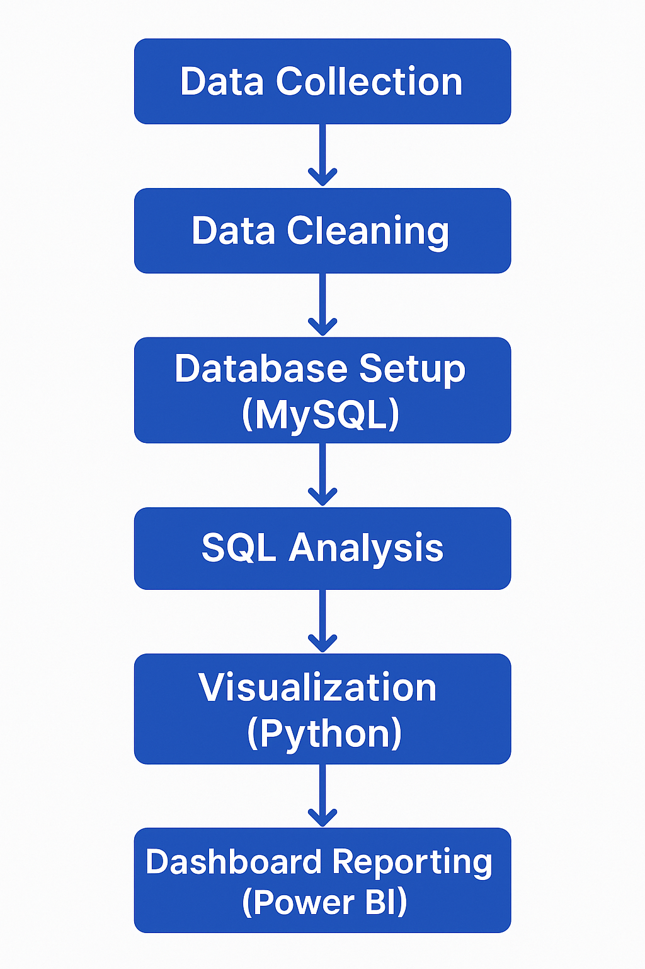

Implementation - Data collection, Processing Steps, Diagrams - Charts, Table
Data-Collection:
The Superstore dataset was obtained from Kaggle. It includes information on orders, products, customers, and profits across different regions.
Processing Steps:
- Cleaned data using Pandas (removed nulls, corrected data types).
- Imported the cleaned dataset into MySQL.
- Executed SQL queries to analyze sales and profit by category, region, and segment.
- Visualized results in Python and Power BI.

Visual Outputs:

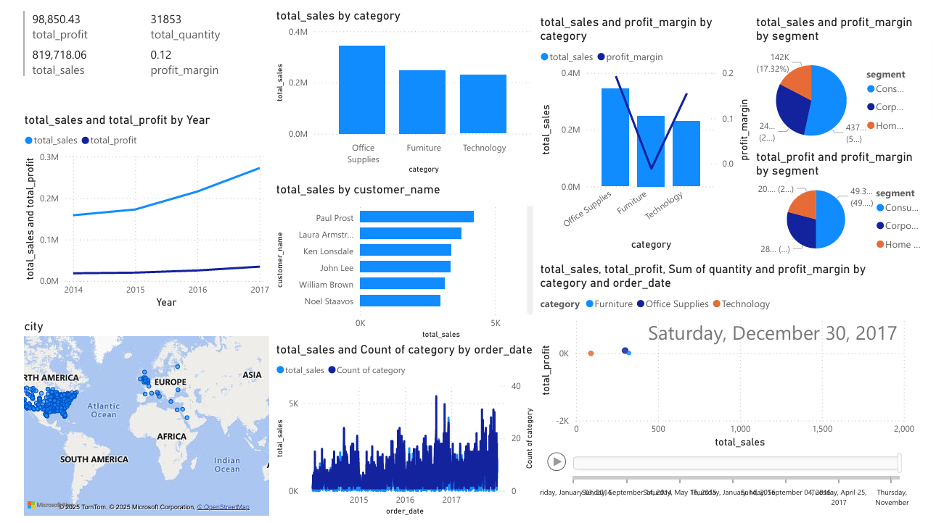

Solution Design

The Solution Design of the Superstore Data Analysis Project defines the system architecture, data flow, and tool integration that together convert raw data into actionable business insights. The design focuses on achieving data accuracy, automation, and interactive visualization through an integrated analytics workflow using Python, MySQL, SQL, and Power BI.

Challenges & Opportunities
Challenges:
- Handling missing and inconsistent data.
- Maintaining schema integrity during MySQL imports.
- Integrating MySQL outputs dynamically with Power BI.
Opportunities:
- Applying machine learning for predictive analysis.
- Expanding to real-time dashboards using live database connections.
- Automating data updates with APIs.

Business Recommendations
According to my project these are some concrete recommendations:-

Prioritize top-performing regions: the West region leads with the highest total sales (~$268K) and profit (~$34K), so allocate more marketing and inventory there and apply its winning strategies to underperforming markets.

Emphasize high-margin categories: Office Supplies (~19.3% profit margin) and Technology (~15.5%) outperform Furniture (−1.1%), so increase focus on these profitable lines while adjusting pricing or promotions for Furniture to address its losses.

Refine discount strategies for low-margin segments: Furniture shows negative profits in key markets, suggesting deep discounts may be eroding margins. Consider reducing aggressive discounts or using bundled offers to boost Furniture’s profitability.

Leverage customer segmentation: reward top customers , who drive the most sales with loyalty or upsell programs, and review terms for high-volume clients whose purchases yield low profit to improve overall ROI.

Conclusion
The Superstore Data Analysis project successfully extracted and visualized actionable insights from retail sales data.
Key Findings:
- West region contributed highest sales.
- Corporate customers showed the highest profit margin.
- Office Supplies category generated maximum revenue.
The final Power BI dashboard enabled users to explore data interactively, leading to faster and more accurate business decisions.

Link to code and executable file
GitHub Link: https://github.com/RISHI-glitch319/superstore-profit-analysis
References
1. Kaggle Superstore Dataset - (LINK)
2. Python Pandas Documentation - (LINK)
3. Matplotlib & Seaborn Libraries - (LINK)
4. Power BI Documentation - (LINK)
5. MySQL Reference Manual - (LINK)

