Attendance _System:

It is a software to store and manage student details, attendance and marks. It is built with Tkinter(Frontend), Python(Backend), Sqlite(Database).

Features:

* Easy and good looking User interface.
* Secure(has userid and password, to change password it is secured with otp)
* RememberMe option exists to ease out single user.
* Not need of installation.

Sample Screen Shots:

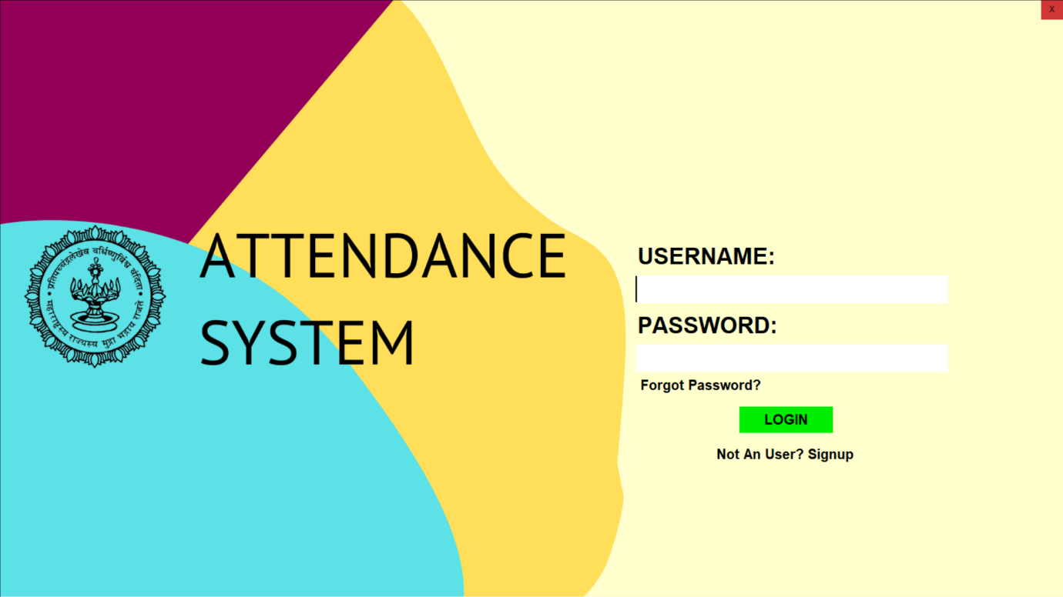

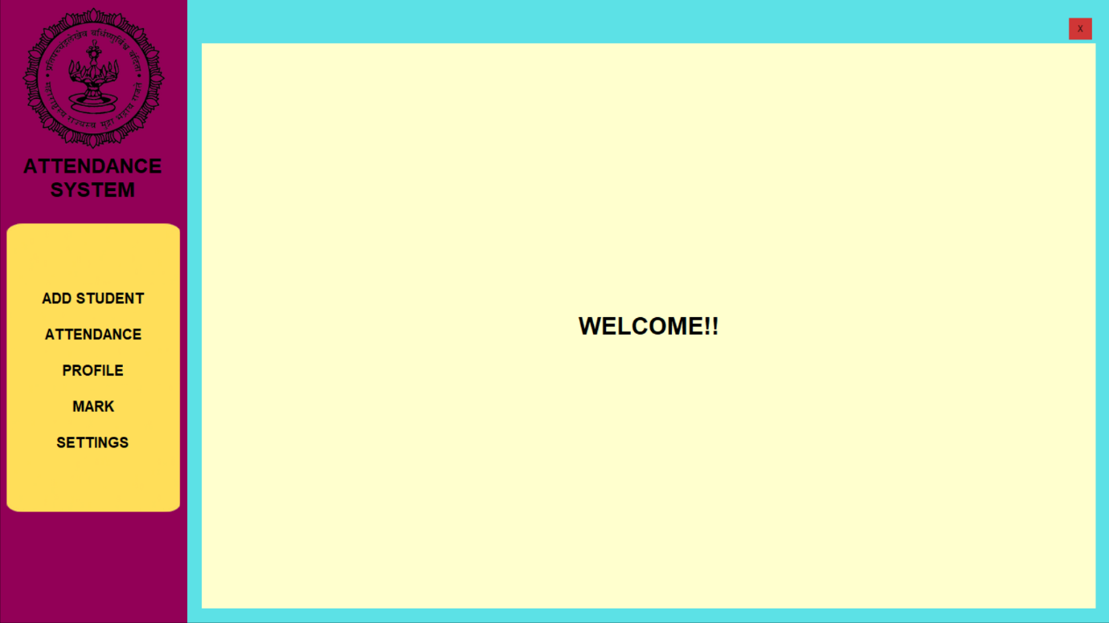

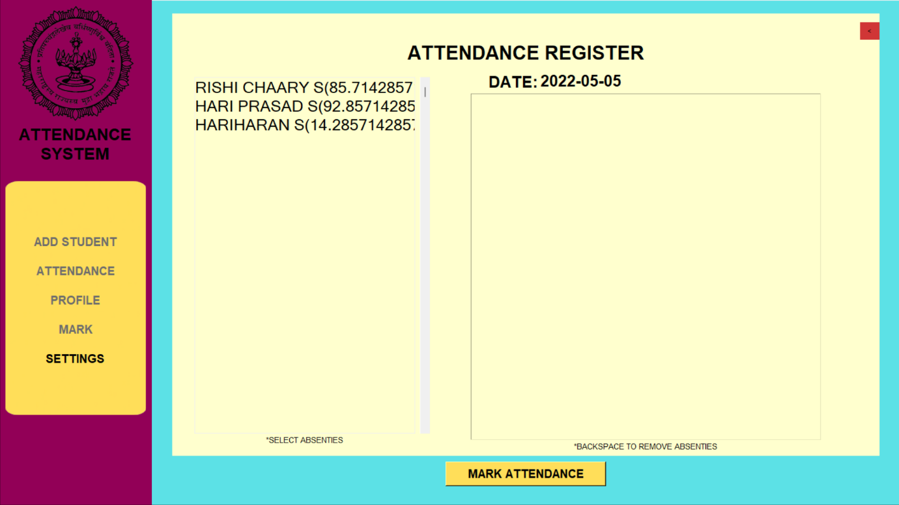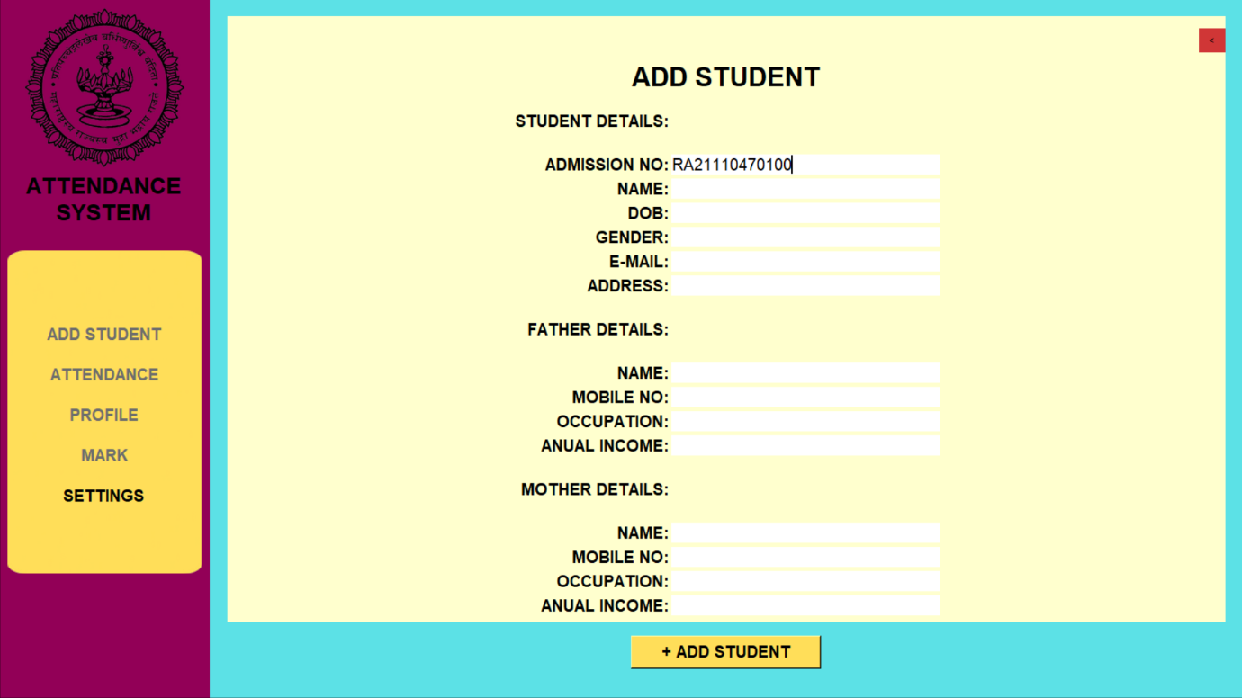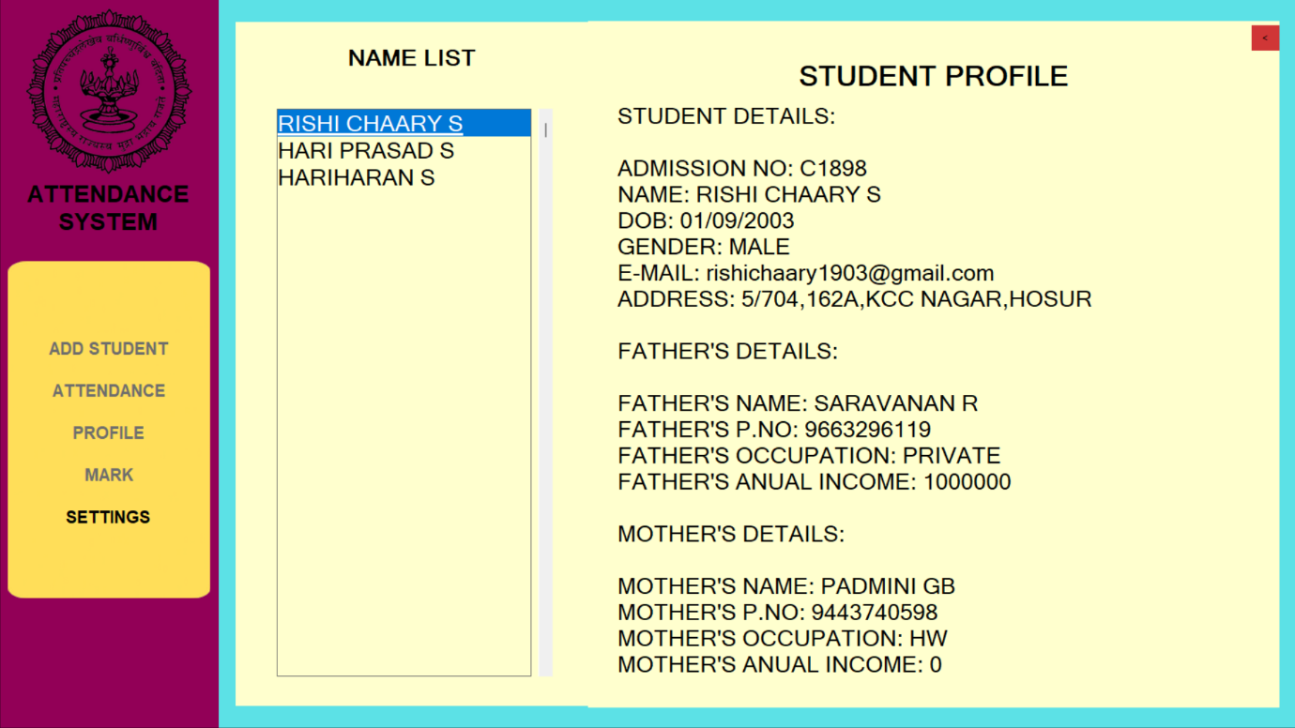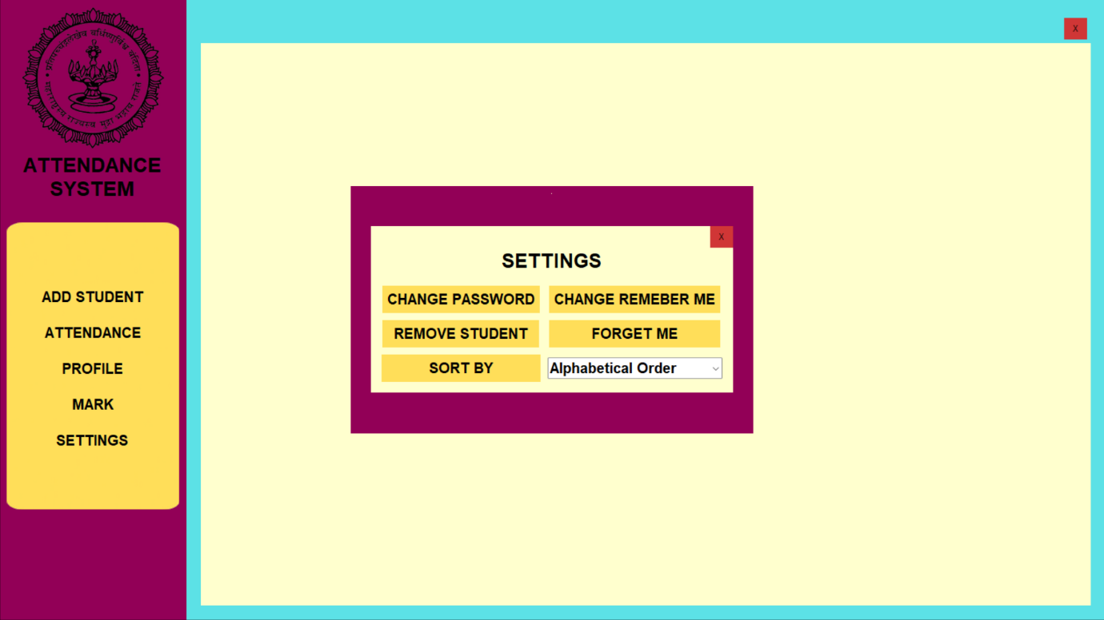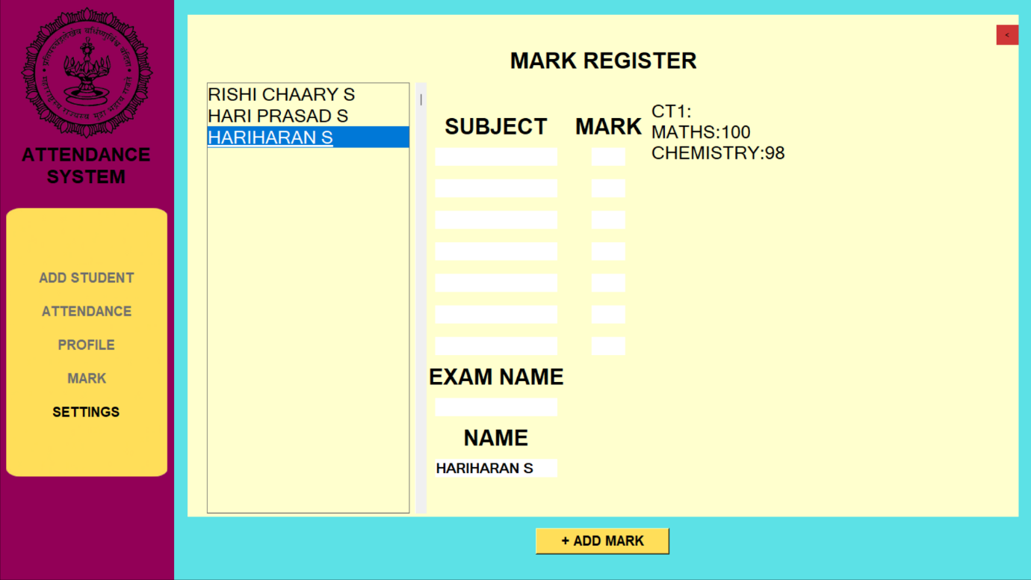

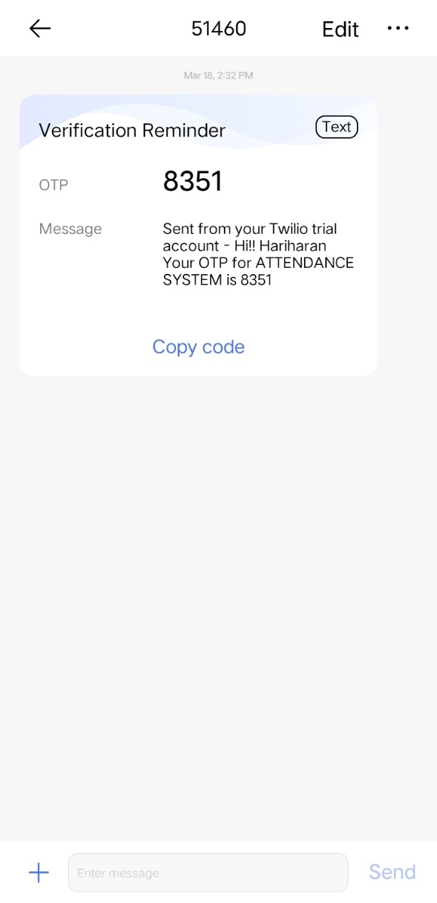

Library_Management_System(C):

A simple non-GUI library management system built with C language.

Sample Screen Shots:

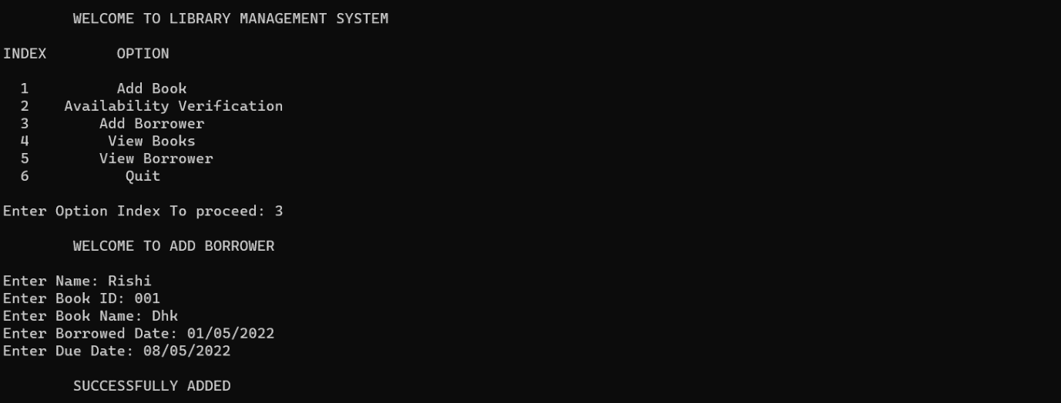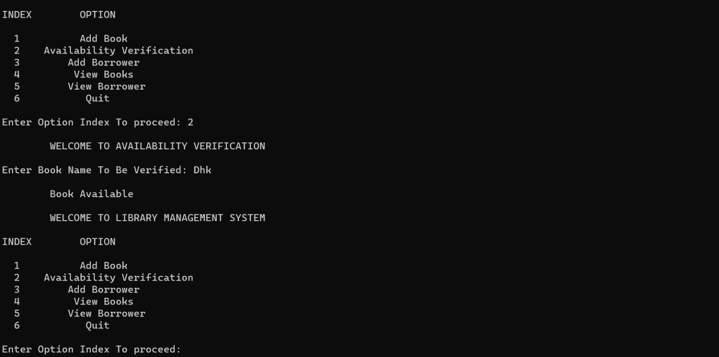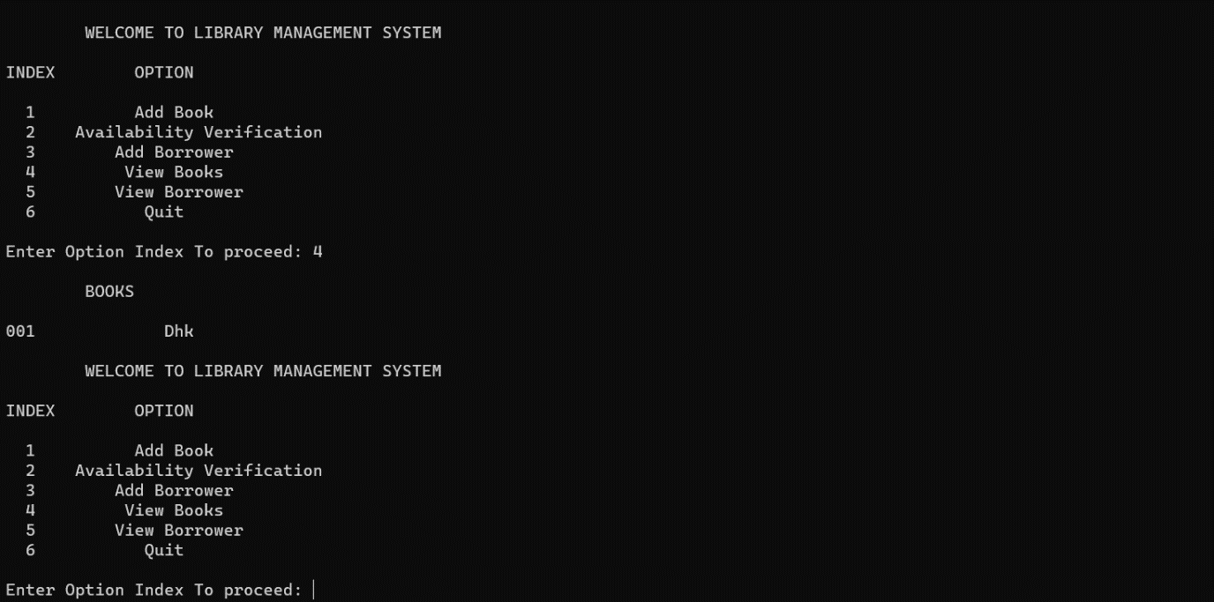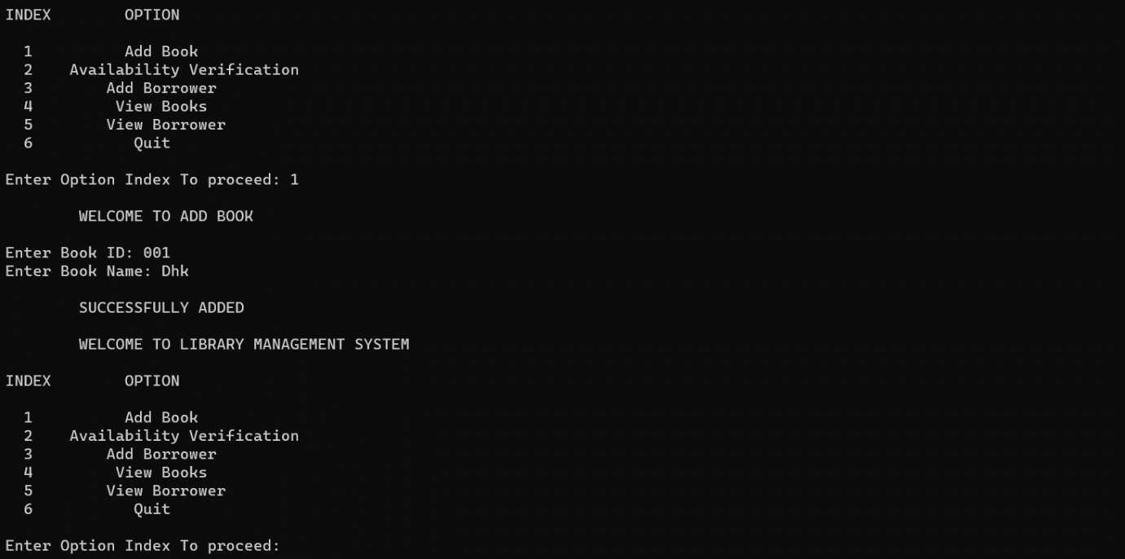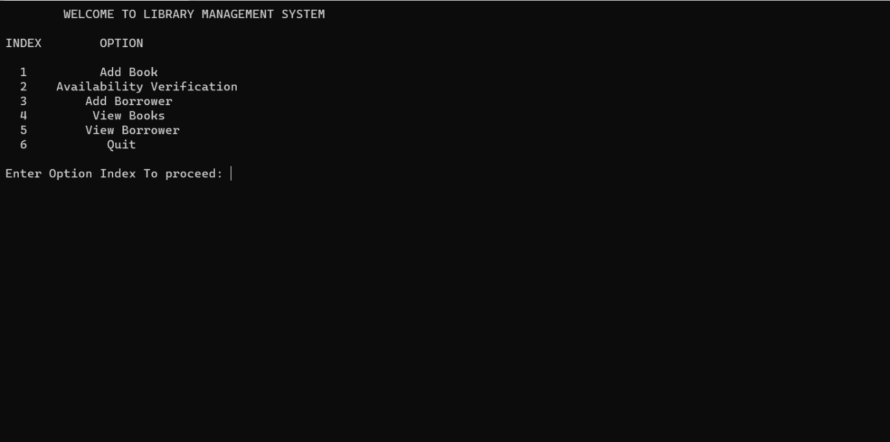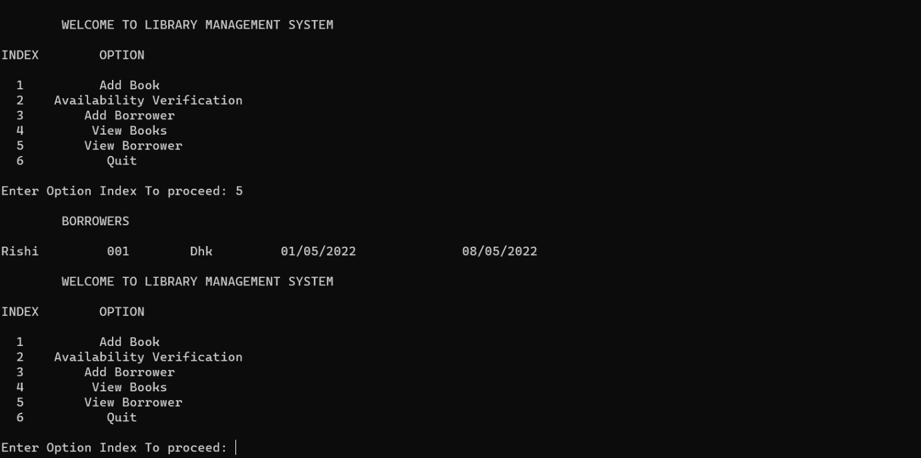

Library_Management_System(Python):

It a software to manage libraries in institutions. It is built with Tkinter(Frontend), Python(Backend), Sqlite(Database).

Features:

* Easy and Simple user interface.
* Secure with username and password.
* Wide range of divisions, grades and Staffs can be handled.
* RememberMe option exists to ease out single user.
* Factory reset to cleanup.
* Has dark and light mode.
* Shows due date alerts.
* No need of installation.

Sample Screen Shots:

