Question No 2

Date 30 -07- 2024

Read two numbers and interchange the values using three logics

Author : Rishijith Krishna

Roll No : 31

Semester : 1

Programme : BCA

Question : Read two numbers and interchange the values using three logics

LOGIC 1.

#include <stdio.h>

int main()

{

int a,b;

printf("Enter the first number");

scanf("%d",&a);

printf("Enter the second number ");

scanf("%d",&b);

a = a + b;

b = a - b;

a = a - b;

printf("The number interchanged are %d,%d",a,b);

return 0;

}

**OUTPUT**

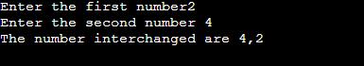

LOGIC 2.

#include <stdio.h>

int main()

{

int a,b,c;

printf("Enter the first number");

scanf("%d",&a);

printf("Enter the second number ");

scanf("%d",&b);

c=a;

a=b;

b=c;

printf("The number interchanged are %d,%d",a,b);

return 0;

}

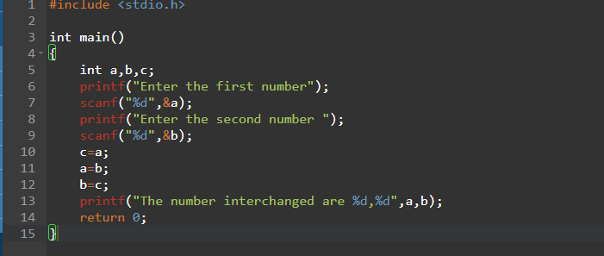

**OUTPUT**



LOGIC 3.

#include <stdio.h>

int main()

{

int a,b;

printf("Enter the first number");

scanf("%d",&a);

printf("Enter the second number ");

scanf("%d",&b);

a=a^b;

b=a^b;

a=a^b;

printf("The number interchanged are %d,%d",a,b);

return 0;

}

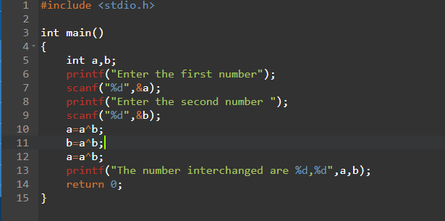

**OUTPUT**

