Question No 3

Date 30 -07- 2024

Write a C Program to compute the perimeter and area of a circle with a given radius

*******************************************************************************/

Author : Rishijith Krishna

Roll No : 31

Semester : 1

Programme : BCA

Question : Write a C Program to compute the perimeter and area of a circle with a given radius

*******************************************************************************/

.

#include <stdio.h>

int main()

{

float radius,perimeter,area,PI=3.14;

printf("Enter the radius");

scanf("%f",&radius);

area = PI*radius*radius;

perimeter = 2*PI*radius;

printf("Perimeter of a circle is %f and area of a circle is %f",area,perimeter);

return 0;

}

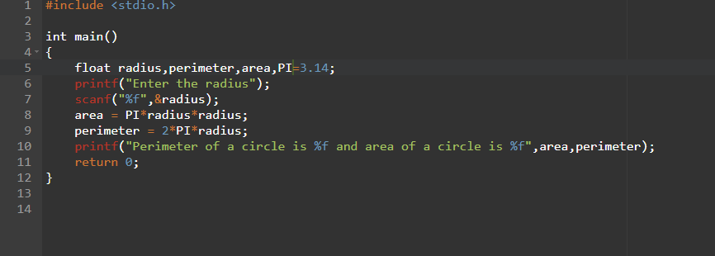

**OUTPUT**

