Question No 4

Date 30 -07- 2024

Write a C Program to compute the perimeter and area of a rectangle

*******************************************************************************/

Author : Rishijith Krishna

Roll No : 31

Semester : 1

Programme : BCA

Question : Write a C Program to compute the perimeter and area of a rectangle

*******************************************************************************/

#include <stdio.h>

int main()

{

float perimeter,area,lenght,width;

printf("Enter the value for lenght");

scanf("%f",&lenght);

printf("Enter the value for width");

scanf("%f",&width);

area = lenght*width;

perimeter = 2*(lenght+width);

printf("\n Area of rectangle is %f \n Perimeter of a rectangle is %f",area,perimeter);

return 0;

}

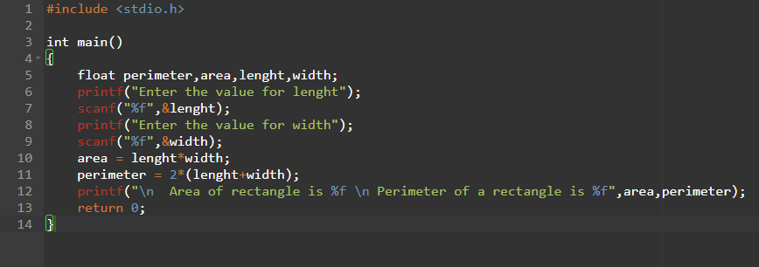

**OUTPUT**

