Question No 8

Date 30 -07- 2024

Write a program in c that takes minutes as input and display the total number of hours and minutes

*******************************************************************************/

Author : Rishijith Krishna

Roll No : 31

Semester : 1

Programme : BCA

Write a program in c that takes minutes as input and display the total number of hours and minutes

*******************************************************************************/

#include <stdio.h>

int main()

{

int min,hrs,total;

printf("Enter the no of minutes");

scanf("%d",&min);

hrs=min/60;

min=min%60;

printf("%d minutes is %d hours and %d minutes.\n",total,hrs,min);

return 0;

}

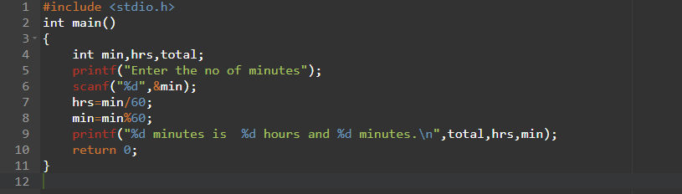

**OUTPUT**

