Question No 9

Date 30 -07- 2024

Write a C program to find the third angle of a triangle if two angles are given

*******************************************************************************/

Author : Rishijith Krishna

Roll No : 31

Semester : 1

Programme : BCA

Write a C program to find the third angle of a triangle if two angles are given

*******************************************************************************/

#include <stdio.h>

int main()

{

int a1,a2,a3;

printf("Enter the 1st angle ");

scanf("%d",&a1);

printf("Enter the 2nd angle ");

scanf("%d",&a2);

a3=180-a1-a2;

printf("The third angle of a triangle is %.2d\n",a3);

return 0;

}

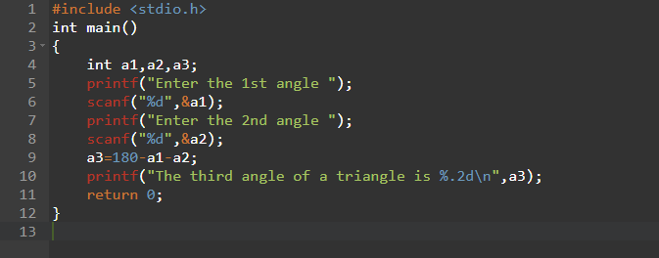

**OUTPUT**

