**Assignment - 6**

**I. What are the various elements of the Excel interface? Describe how**

**they're used.**

The Excel window

Many items you see on the Excel XP screen are standard in most other Microsoft software programs like Word, PowerPoint, and previous versions of Excel, while some elements are specific to Excel XP.

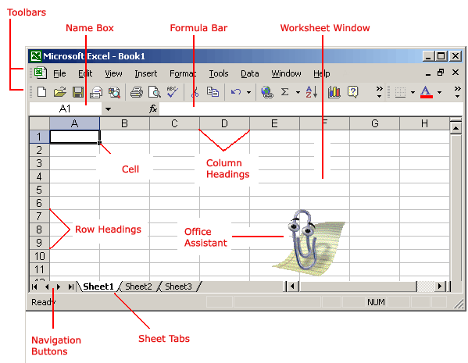

Workbook

Also called a spreadsheet, the workbook is a unique file created by Excel XP.

Title bar

The Excel XP Title Bar

The title bar displays both the name of the application and the name of the spreadsheet.

Menu bar

The Excel XP Menu Bar

The menu bar displays all of the menus available for use in Excel XP. The contents of any menu can be displayed by left-clicking the menu name.

Toolbar

Some commands in the menus have pictures or icons associated with them. These pictures may also appear as shortcuts in the toolbar.

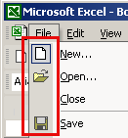

Column headings

The Excel XP Column Headings

Each Excel spreadsheet contains 256 columns. Each column is named by a letter or combination of letters.

Row headings

The Excel XP Row Headings

Each spreadsheet contains 65,536 rows. Each row is named by a number.

Name box

The Excel XP Name Box

This shows the address of the current selection or active cell.

Formula bar

The Excel XP Formula Bar

The formula bar isplays information entered—or being entered as you type—in the current or active cell. The contents of a cell can also be edited in the formula bar.

Cell

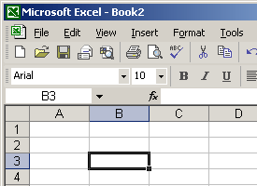

A cell is an intersection of a column and row. Each cell has a unique cell address. In the picture above, the cell address of the selected cell is B3. The heavy border around the selected cell is called the cell pointer.

Navigation buttons and sheet tabs

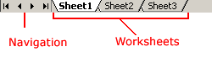

Navigation buttons allow you to move to another worksheet in an Excel workbook. They are used to display the first, previous, next, and last worksheets in the workbook.

Sheet tabs separate a workbook into specific worksheets. A workbook defaults to three worksheets. A workbook must contain at least one worksheet.

Workbooks and worksheets

A **workbook** automatically shows in the workspace when you open Microsoft Excel XP. Each workbook contains three **worksheets**. A worksheet is a grid of cells consisting of 65,536 rows by 256 columns. Spreadsheet information—text, numbers, or mathematical formulas—is entered into different cells.

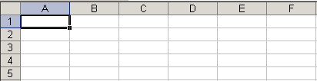

Column headings are referenced by alphabetic characters in the gray boxes that run across the Excel screen, beginning with column A and ending with column IV.

Rows are referenced by numbers that appear on the left and then run down the Excel screen. The first row is named row 1, while the last row is named 65536.

Important terms

* A **workbook** is made up of three worksheets.
* The worksheets are labeled **Sheet1, Sheet2**, and **Sheet3**.
* Each Excel worksheet is made up of columns and rows.
* In order to access a **worksheet**, click the tab that says **Sheet#**.

The cell

An Excel worksheet is made up of columns and rows. Where these columns and rows intersect, they form little boxes called **cells**. The active cell—or the cell that can be acted upon—reveals a dark border. All other cells reveal a light gray border. Each cell has a name. Its name is comprised of two parts: the column letter and the row number.

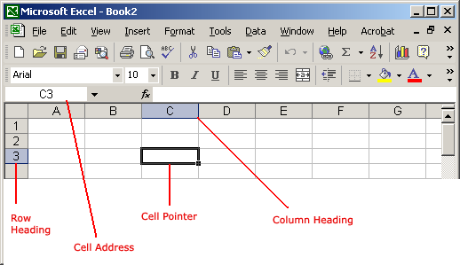

In the following picture, the cell C3—formed by the intersection of column C and row 3—contains the dark border. It is the active cell.

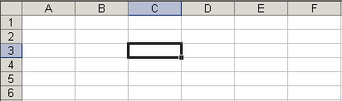

Important terms

* Each cell has a unique **cell address** composed of a cell's column and row.
* The **active cell** is the cell that receives the data or command you give it.
* A darkened border, called the **cell pointer**, identifies it.

Moving around the worksheet

You can move around the spreadsheet in several ways.

To move the cell pointer:

* To activate any cell, point to a cell with the mouse and click.
* To move the pointer one cell to the left, right, up, or down, use the keyboard **arrow keys**.

To scroll through the worksheet:

The **vertical scroll bar** located along the right edge of the screen is used to move up or down the spreadsheet. The **horizontal scroll bar** located at the bottom of the screen is used to move left or right across the spreadsheet.

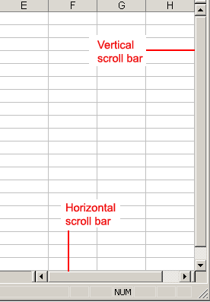

The **PageUp** and **PageDown** keys on the keyboard are used to move the cursor up or down one screen at a time. Other keys that move the active cell are **Home**, which moves to the first column on the current row, and **Ctrl+Home**, which moves the cursor to the top-left corner of the spreadsheet, or cell A1.

To move between worksheets:

As mentioned, each workbook defaults to three worksheets. These worksheets are represented by tabs—named Sheet1, Sheet2 and Sheet3—that appear at the bottom of the Excel window.

To move from one worksheet to another:

* Click the sheet tab—Sheet1, Sheet2 or Sheet 3—you want to display.  
    
  The Excel XP Sheet Tabs

**2. Write down the various applications of Excel in the industry.**

Data Entry and Storage.

Performing Calculations.

Data Analysis and Interpretation.

Reporting and Visualizations.

Accounting and Budgeting.

Collection and Verification of Business Data.

Calendars and Schedules.

Administrative and Managerial Duties.

3. On the ribbon, make a new tab. Add some different groups, insert

commands in the groups and name them according to their commands

added. Copy and paste the screenshot of the steps you followed.

**4. Make a list of different shortcut keys that are only connected to**

**formatting with their functions.**

**Shift + Del:**Cut selected item.

**Ctrl + C:**Copy selected item.

**Ctrl + Ins:**Copy selected item.

**Ctrl + V:**Paste selected item.

**Shift + Ins:**Paste.

**Home:**Goes to beginning of current line.

**Ctrl + Home:**Goes to beginning of document.

**End:**Goes to end of current line.

**Ctrl + End:**Goes to end of document.

**Shift + Home:**Highlights from current position to beginning of line.

**Shift + End:**Highlights from current position to end of line.

**Ctrl + Left arrow:**Moves one word to the left at a time.

**Ctrl + Right arrow:**Moves one word to the right at a time.

**5. What distinguishes Excel from other analytical tools?**

|  |  |  |
| --- | --- | --- |
| Parameters | Excel | Tableau |
| Definition | It is a spreadsheet application used to organize and format the data. | It is a visualization tool used for detailed analysis. |
| Usage | Suitable for storing data and statistical analysis. | Perfect for the quick and easy representation of data. |
| Security | The inbuilt security features are weak as compared to the tableau. | Several options to secure the data without scripting. |
| User Interface | To unleash the full potential of Excel, knowledge of VBA and basic scripting is required. | We can use tableau with no prior knowledge of coding. |
| Business Purpose | Quick on-off reports. | Best while working with big data. |
| Integration | Excel integrates with around 60 applications. | Tableau integrates with around 250 applications. |

**6. Create a table and add a custom header and footer to your table.**

On the Insert tab, in the Text group, click Header & Footer. Excel displays the Page Setup dialog box. Click Custom Header or Custom Footer. Use the buttons in the Header or Footer dialog box to insert specific header and footer elements.