Course Code: CSA1557

Course Name: Cloud Computing and Big Data Analytics

RISSHITH BS 192210021

1) Create a simple cloud software application for Library Reservation System using any Cloud Service Provider to demonstrate SaaS include the necessary fields such name ,journal,return and purchase date

AIM: To create a simple cloud software application for flight reservation system using any cloud service provider to demonstrate saas.

PROCEDURE:

Step1: Go to zoho.com.

Step 2: Log into the zoho.com.

Step 3: Select one application step.

Step4: Enter application name as flight reservation system.

Step 5: Created new application flight reservation system.

Step 6: Select one form

Step 7: The software has been created.

IMPLEMENTATION:

STEP1: GOTO ZOHO.COM

STEP 2: LOGINTOTHE ZOHO.COM

STEP 3: SELECT ONE APPLICATION

STEP 4: ENTER APPLICATION NAME

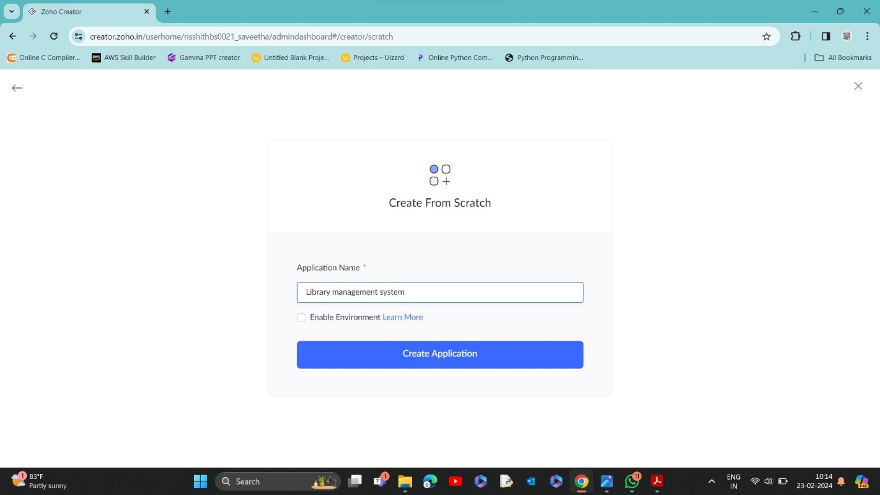

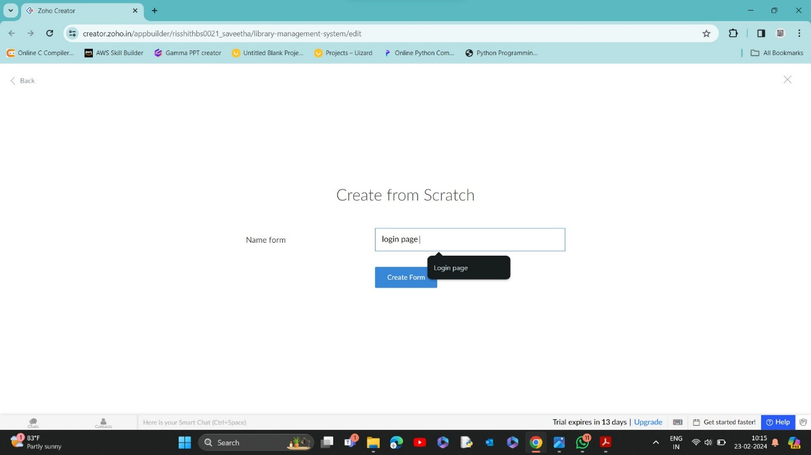

STEP 5: CREATED NEW APPLICATION

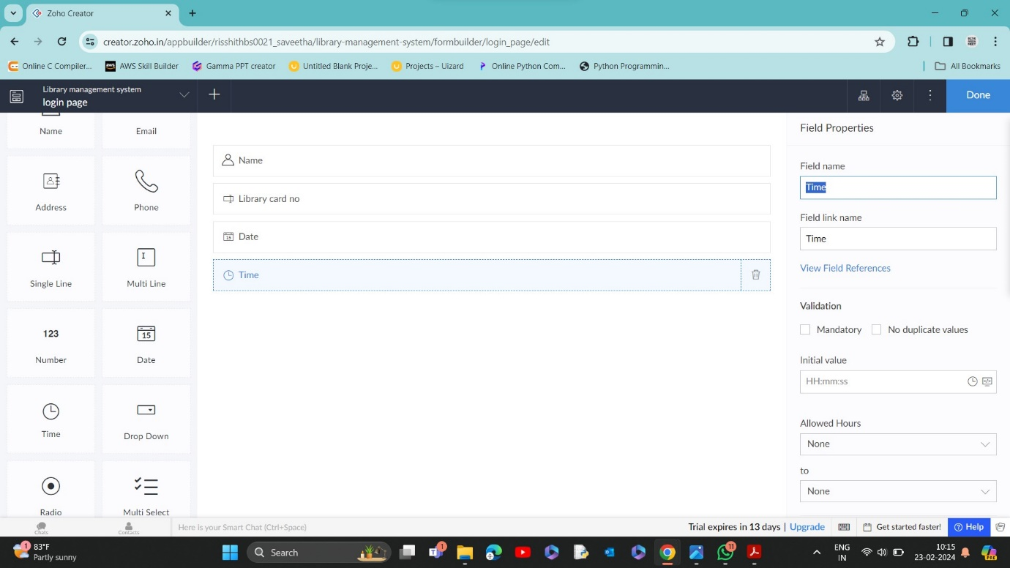

STEP 6: SELECT FROM STRATCH

STEP 8: THE FORM HAS BEEN CREATED AS LOGIN AND CHOOSE THE FIELDS IN LOGIN PAGE

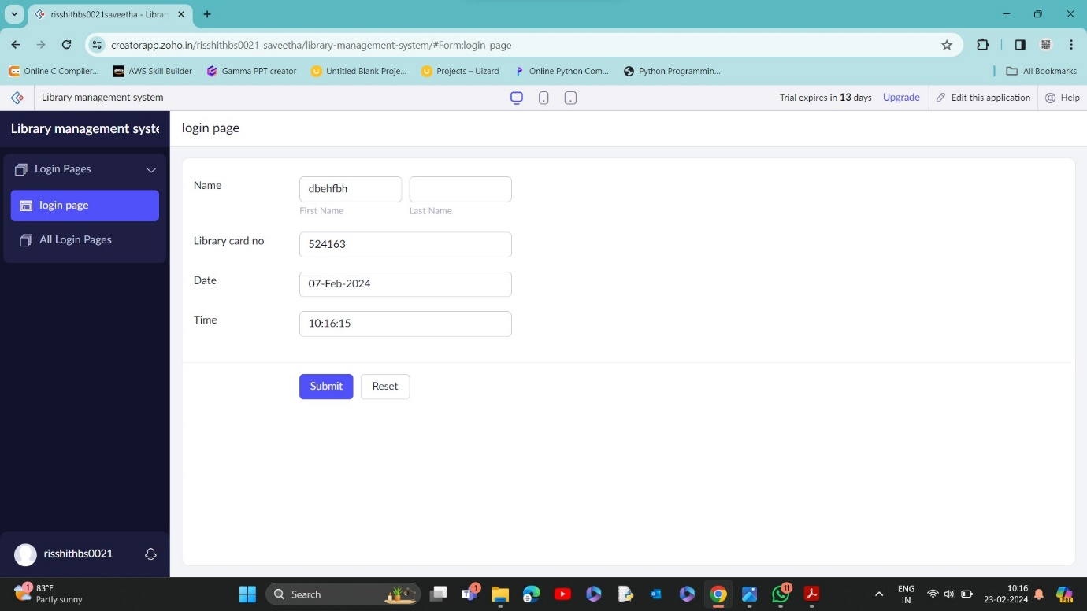

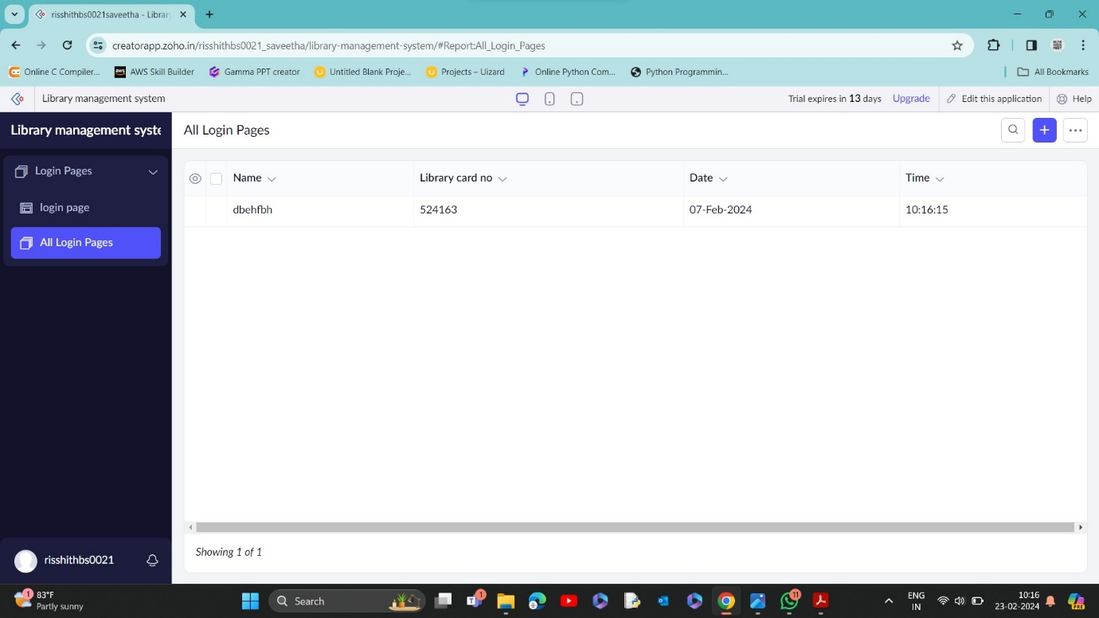

STEP 9: CLICK FROM SCRATCH

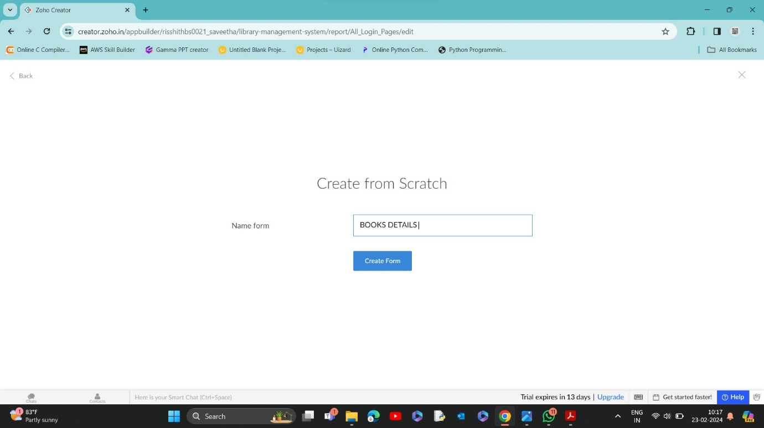

STEP 10: ENTER THE DETAILS TO LOGIN

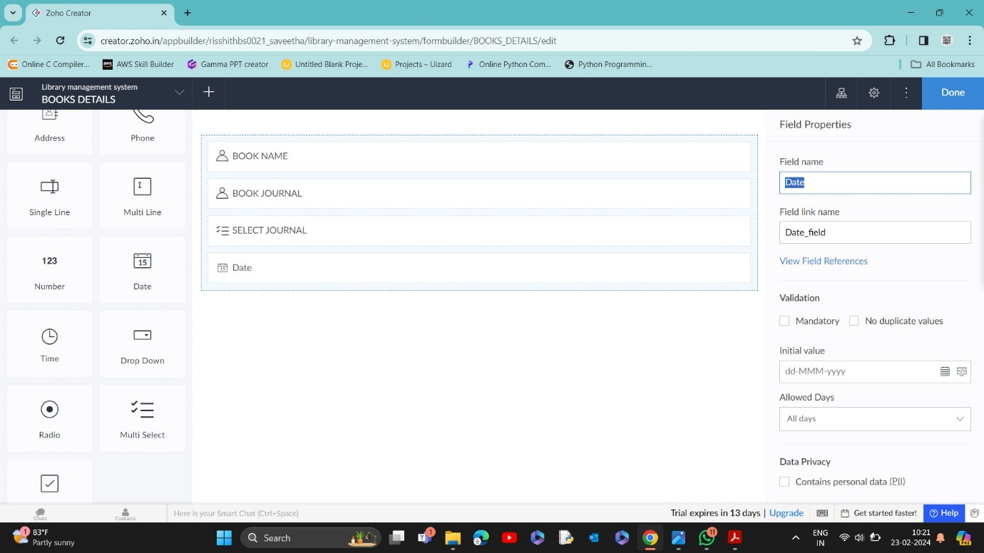

STEP 11:CLICK LOGIN REPORT ,THE REPORT HAS BEEN REGISTERED IN THE LOGIN REPORT.

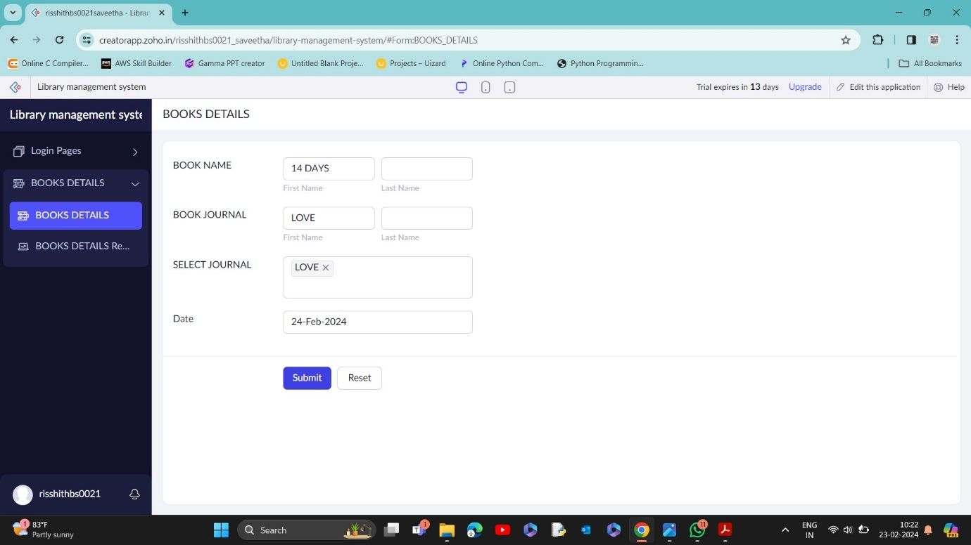

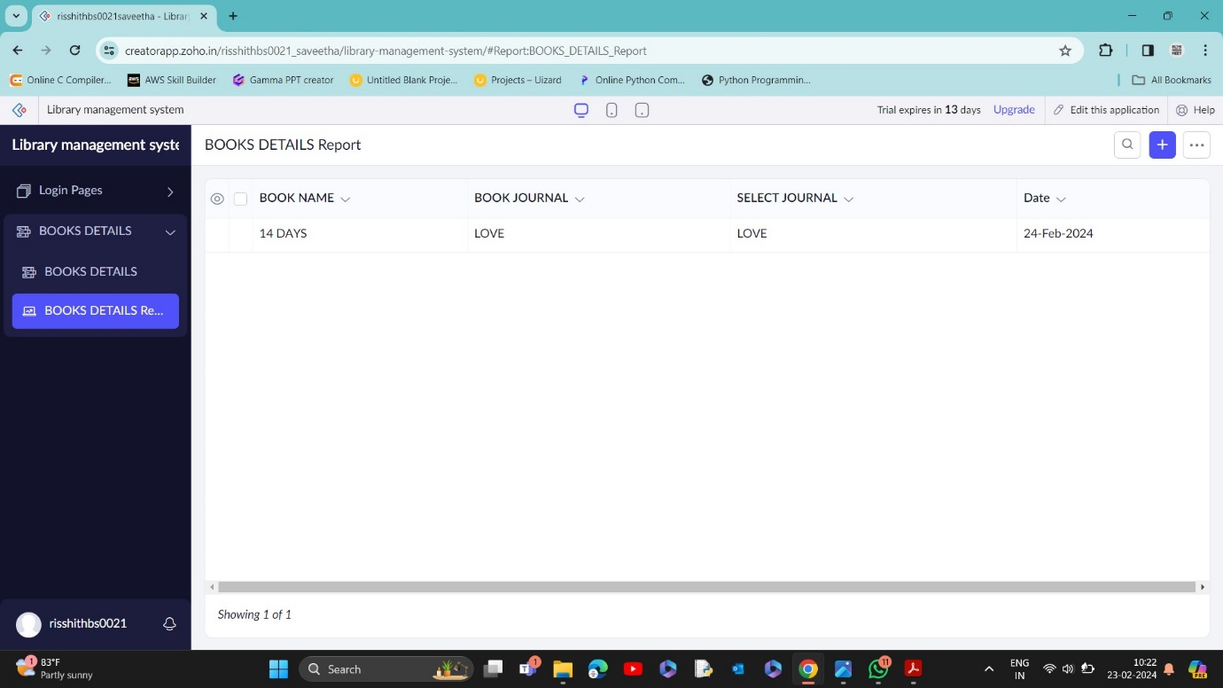

STEP 13: CLICK FROM SCRATCH

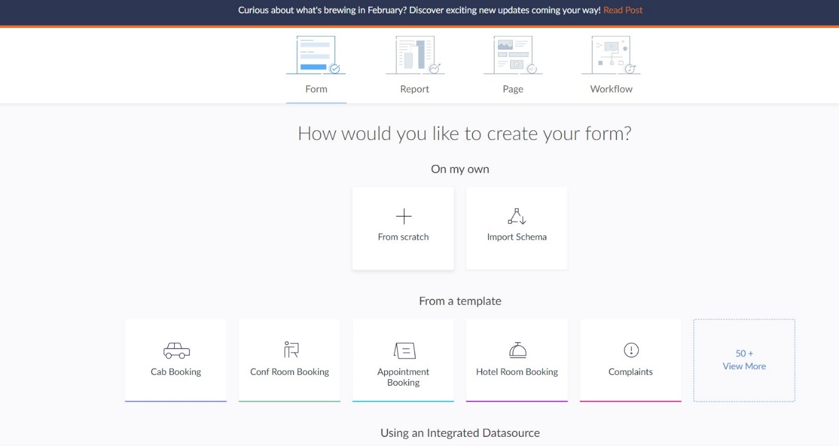

STEP 14: CREATE FORM AS Purchase details

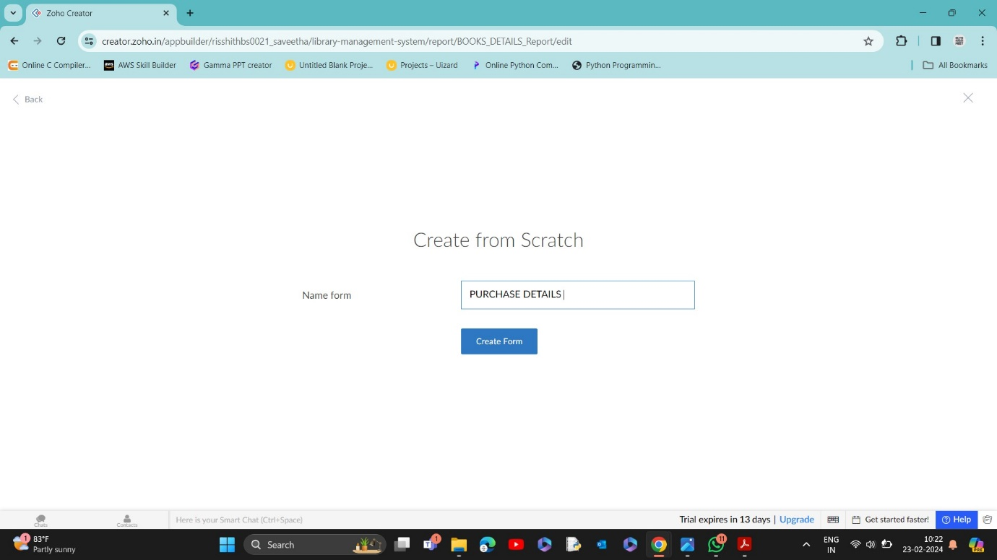

STEP 15: NEW FORM CREATED

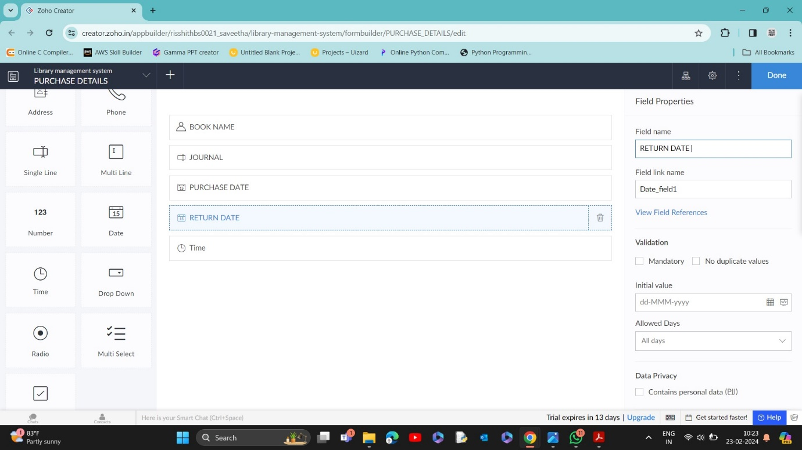

STEP 16: ENTER THE DETAILS

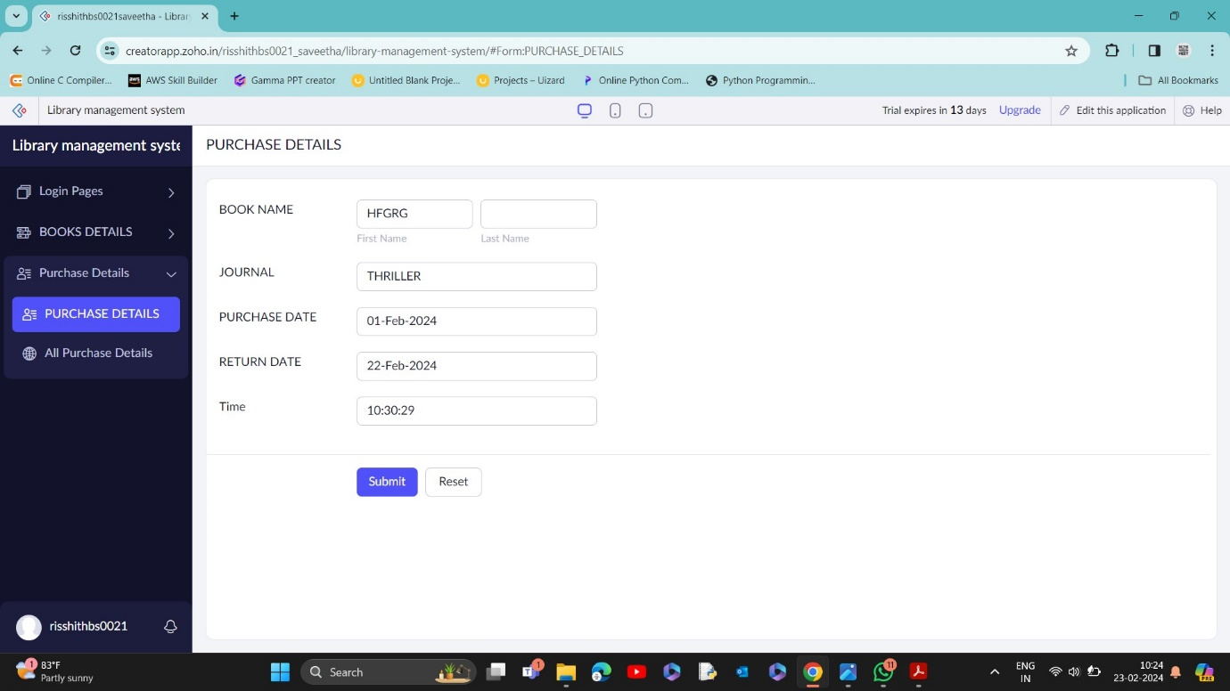

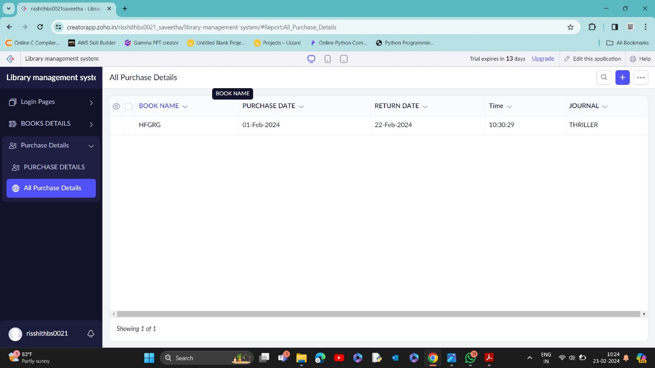

STEP 17:THE REPORT HAS BEEN REGISTERED.