**Synopsis *on***

**“Intelligence system for personality assessments from video interview”**

***Submitted in partial fulfillment of the requirements for Capstone Project Phase I***



**DEPARTMENT OF COMPUTER SCIENCE & INFORMATION TECHNOLOGY**

**K.E Society’s**

**RAJARAMBAPU INSTITUTE OF TECHNOLOGY**

**(An Autonomous Institute)**

**Rajaram Nagar, Sakharale - Village, Sangli - Dist, MH-415 414**

**2020-21**

***By***

|  |  |
| --- | --- |
| **Ms. Davari Sneha B.** | **1804022** |
| **Mr. Vakhariya Siddhant A.** | **1804032** |
| **Mr. Patil Akash D.** | **1804036** |
| **Mr. Chavan Shidhanath D.** | **1804039** |
|  |  |

**Under the Guidance of**

**Prof. Mrs. J. A. Patil**

**Introduction**

In today’s world, people spend and share most of their time and views on social media which becomes an integral part of their life. To recruit candidates, the HR began posting job advertisements on social media. But this creates a significantly huge number of applicants and hiring the perfect talent on time has become a challenge to HR. Not only that to screen and evaluate a large number of applications for single job post companies had to appoint a lot of recruiters which is very expensive, and also the effectiveness and efficiency of digital tools are very high in comparison with a human. Also, there always exists a chance of human cognitive biases. So, to overcome such challenges and make recruitment more efficient and timelier, recruitment companies need to use AI-powered digital and tools.

Inviting every job candidate to attend face-to-face interviews is not cost-effective. The asynchronous video interview (AVI) has been developed as an alternative, in which job candidates are asked to login to an interview platform and record their responses to predefined interview questions via webcam and microphone on their mobile device or computer, with their answers being analyzed by human raters at a later time. AVI allows candidates to record and answer questions at any place and time. Moreover, AVI accelerates the selection process because the interview video records can be shared and assessed independently at the human raters’ convenience without scheduling an interview.

Objectives

* To reduce the time to hire employee and save organization’s time and money.
* To speed up the screening process of hiring employee.
* To make unbiased standard assessments of the candidate.

Literature Survey

Artificial intelligence trained video interviewing technology analyzes facial features, moods, expressions, and intonations of the interviewees to select the most suitable candidates. Speech recognition, personality insights, tone analysis, the relevance of answers, emotional recognition, and psycholinguistics are used in this hiring process that uses technology automation. The best matches are shared with human recruiters along with AI’s own notes on individual candidates. To the extent that research on AI can help organizations find the right people, get them to apply, screen out the unqualified applicants, and differentiate between the more and less qualified candidates, it will have important implications for the world of practice.

Interpersonal communication skills and personality traits have been identified as critical success factors for job performance and organization effectiveness. Communication skills enable workplace members to effectively exchange, share, and feedback information to different stakeholders through verbal and nonverbal messages. Verbal messages are used to convey exact words, and nonverbal messages, such as gestures, facial expressions, posture, and tone of voice, are helpful for understanding underlying emotions, attitude, and feelings. Personality traits refer to individual patterns of thinking, feelings, and behaviors that can be used to predict whether an individual is a good fit for a specific job context or organizational environment. In this all the articles were searched from various sources like Google Scholar, Research Gate, and IEEE.

|  |  |  |  |  |
| --- | --- | --- | --- | --- |
| Research Paper No. | Problems Solved | Verbal | Non-Verbal | Methodology |
| [1] | Automatic prediction of hirability | - | Yes | Regression Methods |
| [2] | Automatic prediction of rating to interviewees | - | Yes | 16 Regression Models |
| [3] | Assessment of psychological and personality traits | Yes | Yes | CNN |
| [4] | Job analysis based on behavioural description | Yes | Yes | KSAO’s identification technique |
| [5] | Automated personality Assessment by  Video interview | Yes | Yes | Machine learning, Nomological network |
| [6] | Prediction of interpersonal communication skills | Yes | Yes | CNN |
| [7] | Knowing viability of AI in recruitment process | - | - | - |

Problem Statement

To assess the personality and skills of candidates during the online interview for respective job profile.

Problem Description

In today’s world, people spend and share most of their time and views on social media which becomes an integral part of their life. many organizations have focus on select best employee for their respective position. For selecting best employee from number of candidates is difficult task for organizations. For selecting best employee, organizations spend more time and also money for interviewers to take the interview of many candidates. Interviewers are higher authorized person. Employee hiring is long time process. For any drive organizations spend more money and time.

In pandemic situation like COVID-19 many organizations take Interviews in online mode and also there is new trend arise in many organizations to adopt online interview. So online interview is the new task for interviewees and also organizations. Every candidate face difficulty like suitable with new system, Eye contact. For preparing the online interview, interviewees required personality assessments of self-Interview in online mode.

System Architecture

To develop an automated video interview using artificial intelligence (AVI-AI) software that could be used to predict interpersonal communication skills and personality traits as perceived the human raters, we constructed a three-stage model, as illustrated in Fig. 1: video data processing, classifier training, and classifier validation.

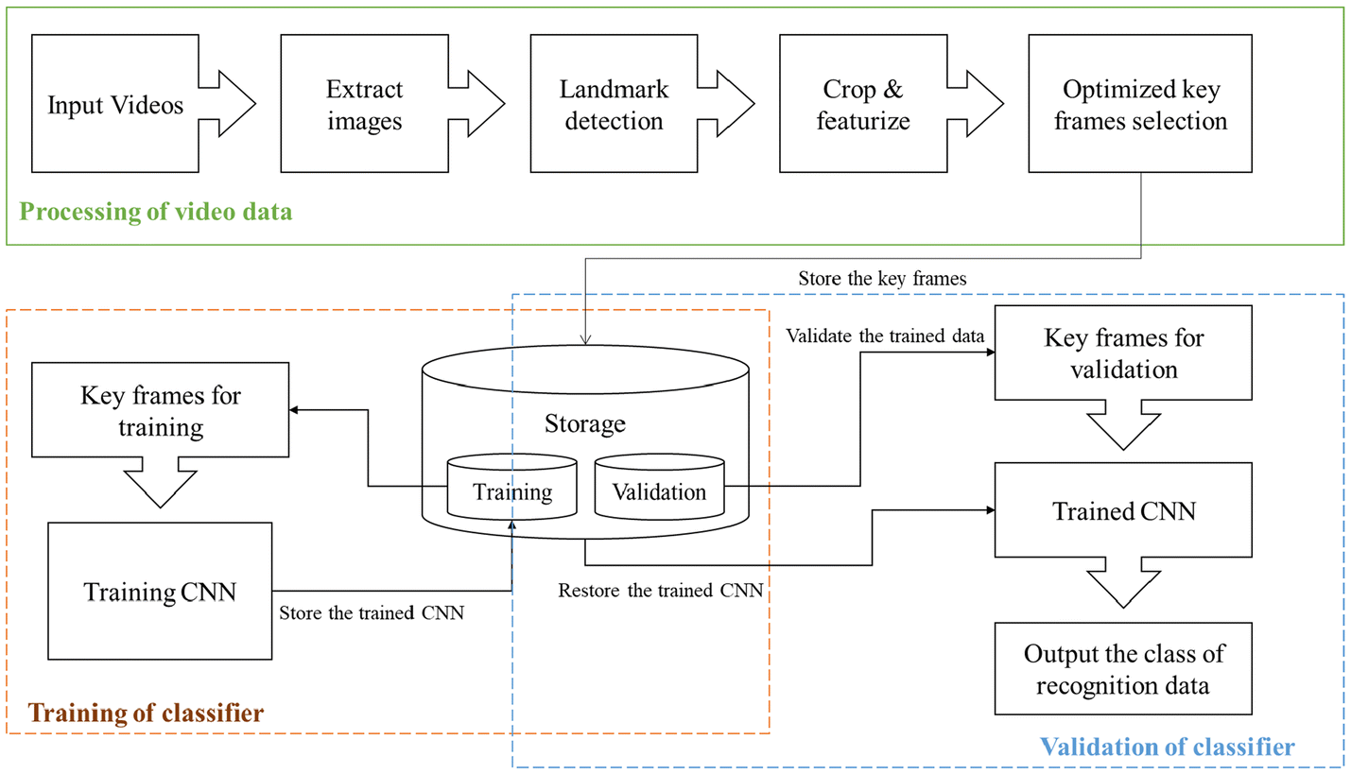

Fig. 1: System methodology Block diagram

Modules

1. Capturing module

We can capture video of candidate, generate interview scripts. The content of the video responses can then be used to conduct algorithmic analyses, including audio and visual data analyses of the video responses.

1. Video-Processing and Feature-Extraction Module

` In the video data processing stage, we will develop a system to extract facial expressions performed by the interviewees from each frame by using our own dataset. The facial features were detected using OpenCV and Dlib by tracking 86 facial landmark points per frame. Video analysis is also being used as an AI-powered tool where the system can be programmed to analyze the interviewee’s features like age, lighting, tone of voice, cadence, the keyword used, mood, behavior, eye contact, emotion, etc.

1. Classification Module

In the classifier training stage, we labeled data of the interviewees with their extracted features to train our prediction model for communication skills and big five personality traits. The model was a TensorFlow-based CNN model, measures the big five dimensions of personality traits: openness to new experiences (be creative and imaginative), conscientiousness (be organized and self-disciplined), extraversion (be assertive and sociable), agreeableness (be tolerant, honesty, and altruistic), and neuroticism (be vulnerable to frequent strong negative emotions).

1. Output Module

It shows that interpersonal communication skill and five personality traits of interviewees to the organization as well as candidates.

System Requirements

* **Hardware Requirement:-**
* i5 Processor Based Computer or higher
* Memory: 8 GB RAM
* Hard Drive: 256 GB
* SSD Up to 256GB
* Internet Connection
* Surveillance CCTV camera
* **Software Requirement:**
* Windows 7 or higher
* Anaconda
* Visual Studio 2019
* Graphic Processor
* Graphics Card 2GB

Project Outcome

* Make personality judgement of candidate during interview.
* Saves time and money of organization for recruitment process.
* Accelerate the screening process of recruitment.
* Organization can select best candidate as per their requirement

References

1. Nguyen, Laurent Son, Denise Frauendorfer, Marianne Schmid Mast, and Daniel Gatica-Perez. "Hire me: Computational inference of hirability in employment interviews based on nonverbal behavior." *IEEE transactions on multimedia* 16, no. 4 (2014): 1018-1031.
2. Naim, Iftekhar, M. Iftekhar Tanveer, Daniel Gildea, and Mohammed Ehsan Hoque. "Automated prediction and analysis of job interview performance: The role of what you say and how you say it." In *2015 11th IEEE international conference and workshops on automatic face and gesture recognition (FG)*, vol. 1, pp. 1-6. IEEE, 2015.
3. Suen, Hung-Yue, Kuo-En Hung, and Chien-Liang Lin. "TensorFlow-based automatic personality recognition used in asynchronous video interviews." *IEEE Access* 7 (2019): 61018-61023.
4. Kshatriya, Sunitha. "A case study of job analysis and its positive impact on behavioral structured interview." *International Journal of Research in Social Sciences* 7, no. 3 (2017): 643-671.
5. Hickman, Louis, Nigel Bosch, Vincent Ng, Rachel Saef, Louis Tay, and Sang Eun Woo. "Automated Video Interview Personality Assessments: Reliability, Validity, and Generalizability Investigations." (2021).
6. Suen, Hung-Yue, Kuo-En Hung, and Chien-Liang Lin. "Intelligent video interview agent used to predict communication skill and perceived personality traits." *Human-centric Computing and Information Sciences* 10, no. 1 (2020): 1-12.
7. Brishti, Juthika Kabir, and Ayesha Javed. "THE VIABILITY OF AI-BASED RECRUITMENT PROCESS: A systematic literature review." (2020).
8. Baur, Tobias, Ionut Damian, Florian Lingenfelter, Johannes Wagner, and Elisabeth André. "Nova: Automated analysis of nonverbal signals in social interactions." In *International Workshop on Human Behavior Understanding*, pp. 160-171. Springer, Cham, 2013.
9. Anderson, Kate T., and Jessica Holloway-Libell. "A Review of “Interviewing as Qualitative Research: A Guide for Researchers in Education and the Social Sciences” Seidman, I.(2013).. New York, NY: Teachers College Press. 178 pp." (2014): 428-428.
10. Horvath, Frank, J. P. Blair, and Joseph P. Buckley. "The behavioral analysis interview: clarifying the practice, theory and understanding of its use and effectiveness." *International Journal of Police Science & Management* 10, no. 1 (2008): 101-118.
11. [www.researchgate.com](http://www.researchgate.com)
12. https://spectrum.ieee.org/tech-talk/at-work/tech-careers/ai-tools-bias-hiring

**Sign of project guide Sign of project In-charge Sign of HOD**