**RAID**

RAID allows information to access several disks. RAID uses techniques such as *disk striping* (RAID Level 0), *disk mirroring* (RAID Level 1), and *disk striping with parity* (RAID Level 5) to achieve redundancy, lower latency, increased bandwidth, and maximized ability to recover from hard disk crashes.

RAID consistently distributes data across each drive in the array. RAID then breaks down the data into consistently-sized chunks (commonly 32K or 64k, although other values are acceptable). Each chunk is then written to a hard drive in the RAID array according to the RAID level employed. When the data is read, the process is reversed, giving the illusion that the multiple drives in the array are actually one large drive.

System Administrators and others who manage large amounts of data would benefit from using RAID technology. Primary reasons to deploy RAID include:

* Enhances speed
* Increases storage capacity using a single virtual disk
* Minimizes disk failure
* Hardware RAID versus Software RAID
* There are two possible RAID approaches: hardware RAID and software RAID.
* **Hardware RAID**
* The hardware-based array manages the RAID subsystem independently from the host. It presents a single disk per RAID array to the host.
* A hardware RAID device connects to the SCSI controller and presents the RAID arrays as a single SCSI drive. An external RAID system moves all RAID handling “intelligence” into a controller located in the external disk subsystem. The whole subsystem is connected to the host via a normal SCSI controller and appears to the host as a single disk.

RAID controller cards function like a SCSI controller to the operating system, and handle all the actual drive communications. The user plugs the drives into the RAID controller (just like a normal SCSI controller) and then adds them to the RAID controllers configuration, and the operating system won't know the difference.

**Software RAID**

Software RAID implements the various RAID levels in the kernel disk (block device) code. It offers the cheapest possible solution, as expensive disk controller cards or hot-swap chassis[[1]](https://access.redhat.com/documentation/en-us/red_hat_enterprise_linux/5/html/deployment_guide/ch-raid" \l "ftn.idm139734437280864) are not required. Software RAID also works with cheaper IDE disks as well as SCSI disks. With today's faster CPUs, software RAID outperforms hardware RAID.

The Linux kernel contains an MD driver that allows the RAID solution to be completely hardware independent. The performance of a software-based array depends on the server CPU performance and load.

To learn more about software RAID, here are the key features:

* Threaded rebuild process
* Kernel-based configuration
* Portability of arrays between Linux machines without reconstruction
* Backgrounded array reconstruction using idle system resources
* Hot-swappable drive support
* Automatic CPU detection to take advantage of certain CPU optimizations
* RAID Levels and Linear Support
* RAID supports various configurations, including levels 0, 1, 4, 5, and linear. These RAID types are defined as follows:
* **Level 0**
* RAID level 0, often called “striping”, is a performance-oriented striped data mapping technique. This means the data being written to the array is broken down into strips and written across the member disks of the array, allowing high I/O performance at low inherent cost but provides no redundancy. The storage capacity of a level 0 array is equal to the total capacity of the member disks in a hardware RAID or the total capacity of member partitions in a software RAID.
* **Level 1**
* RAID level 1, or “mirroring”, has been used longer than any other form of RAID. Level 1 provides redundancy by writing identical data to each member disk of the array, leaving a “mirrored” copy on each disk. Mirroring remains popular due to its simplicity and high level of data availability. Level 1 operates with two or more disks that may use parallel access for high data-transfer rates when reading but more commonly operate independently to provide high I/O transaction rates. Level 1 provides very good data reliability and improves performance for read-intensive applications but at a relatively high cost. The storage capacity of the level 1 array is equal to the capacity of one of the mirrored hard disks in a hardware RAID or one of the mirrored partitions in a software RAID.
* **Note**
* RAID level 1 comes at a high cost because you write the same information to all of the disks in the array, which wastes drive space. For example, if you have RAID level 1 set up so that your root (/) partition exists on two 40G drives, you have 80G total but are only able to access 40G of that 80G. The other 40G acts like a mirror of the first 40G.
* **Level 4**
* RAID level 4 uses parity[[2]](https://access.redhat.com/documentation/en-us/red_hat_enterprise_linux/5/html/deployment_guide/ch-raid" \l "ftn.idm139734530187952) concentrated on a single disk drive to protect data. It is better suited to transaction I/O rather than large file transfers. Because the dedicated parity disk represents an inherent bottleneck, level 4 is seldom used without accompanying technologies such as write-back caching. Although RAID level 4 is an option in some RAID partitioning schemes, it is not an option allowed in Red Hat Enterprise Linux RAID installations. The storage capacity of hardware RAID level 4 is equal to the capacity of member disks, minus the capacity of one member disk. The storage capacity of software RAID level 4 is equal to the capacity of the member partitions, minus the size of one of the partitions if they are of equal size.
* **Note**
* RAID level 4 takes up the same amount of space as RAID level 5, but level 5 has more advantages. For this reason, level 4 is not supported.
* **Level 5**
* RAID level 5 is the most common type of RAID. By distributing parity across some or all of an array's member disk drives, RAID level 5 eliminates the write bottleneck inherent in level 4. The only performance bottleneck is the parity calculation process. With modern CPUs and software RAID, that usually is not a very big problem. As with level 4, the result is asymmetrical performance, with reads substantially outperforming writes. Level 5 is often used with write-back caching to reduce the asymmetry. The storage capacity of hardware RAID level 5 is equal to the capacity of member disks, minus the capacity of one member disk. The storage capacity of software RAID level 5 is equal to the capacity of the member partitions, minus the size of one of the partitions if they are of equal size.
* **Linear RAID**
* Linear RAID is a simple grouping of drives to create a larger virtual drive. In linear RAID, the chunks are allocated sequentially from one member drive, going to the next drive only when the first is completely filled. This grouping provides no performance benefit, as it is unlikely that any I/O operations will be split between member drives. Linear RAID also offers no redundancy and, in fact, decreases reliability — if any one member drive fails, the entire array cannot be used. The capacity is the total of all member disks.
* [[1]](https://access.redhat.com/documentation/en-us/red_hat_enterprise_linux/5/html/deployment_guide/ch-raid#idm139734437280864)A hot-swap chassis allows you to remove a hard drive without having to power-down your system.
* [[2]](https://access.redhat.com/documentation/en-us/red_hat_enterprise_linux/5/html/deployment_guide/ch-raid#idm139734530187952)Parity information is calculated based on the contents of the rest of the member disks in the array. This information can then be used to reconstruct data when one disk in the array fails. The reconstructed data can then be used to satisfy I/O requests to the failed disk before it is replaced and to repopulate the failed disk after it has been replaced.

# CONFIGURING SOFTWARE RAID

Users can configure software RAID during the graphical installation process, the text-based installation process, or during a kickstart installation. This section discusses software RAID configuration during the installation process using the **Disk Druid** application, and covers the following steps:

1. Creating software RAID partitions on physical hard drives.
2. Creating RAID devices from the software RAID partitions.
3. (Optional) Configuring LVM from the RAID devices.
4. Creating file systems from the RAID devices.

To configure software RAID, select **Create custom layout** from the pulldown list on the **Disk Partitioning Setup** screen, click the **Next** button, and follow the instructions in the rest of this section. The example screenshots in this section use two 10 GB disk drives (/dev/hda and /dev/hdb) to illustrate the creation of simple RAID 1 and RAID 0 configurations, and detail how to create a simple RAID configuration by implementing multiple RAID devices.

### 6.2.1. Creating the RAID Partitions

In a typical situation, the disk drives are new or are formatted. Both drives are shown as raw devices with no partition configuration in [Figure 6.1, “Two Blank Drives, Ready For Configuration”](https://access.redhat.com/documentation/en-us/red_hat_enterprise_linux/5/html/deployment_guide/s1-raid-config#fig-raid-manual-free).

[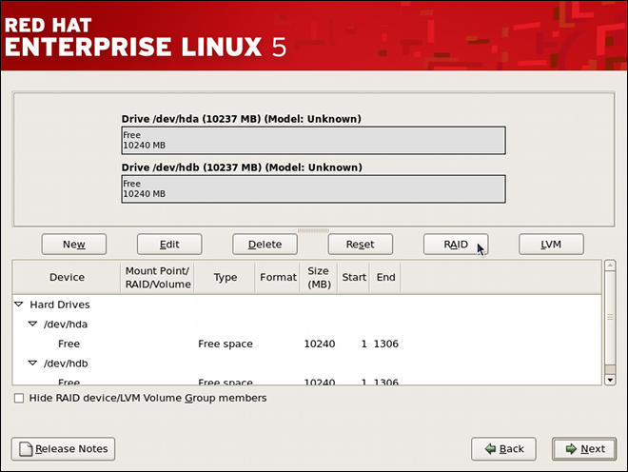](https://access.redhat.com/webassets/avalon/d/Red_Hat_Enterprise_Linux-5-Deployment_Guide-en-US/images/fd9da71041630631c47a06ddab11bbc9/raid-manual-free.png)

**Figure 6.1. Two Blank Drives, Ready For Configuration**

1. In **Disk Druid**, click the **RAID** button to enter the software RAID creation screen.
2. Choose **Create a software RAID partition** to create a RAID partition as shown in [Figure 6.2, “RAID Partition Options”](https://access.redhat.com/documentation/en-us/red_hat_enterprise_linux/5/html/deployment_guide/s1-raid-config#fig-raid-manual-part-opt). Note that no other RAID options (such as entering a mount point) are available until RAID partitions, as well as RAID devices, are created. Click **OK** to confirm the choice.

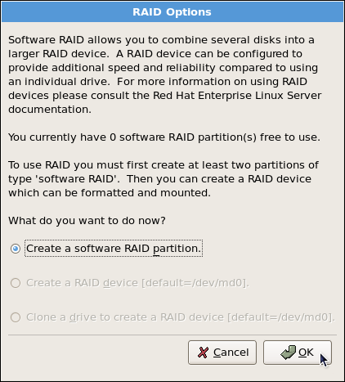

**Figure 6.2. RAID Partition Options**

1. A software RAID partition must be constrained to one drive. For **Allowable Drives**, select the drive to use for RAID. If you have multiple drives, by default all drives are selected and you must deselect the drives you do not want.

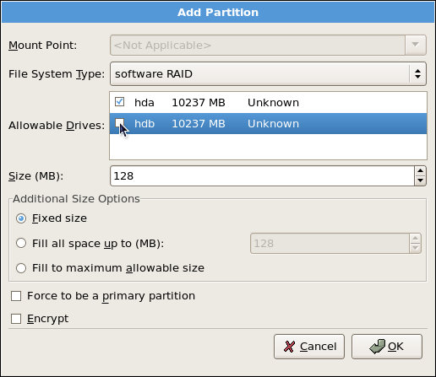

**Figure 6.3. Adding a RAID Partition**

1. Edit the **Size (MB)** field, and enter the size that you want the partition to be (in MB).
2. Select **Fixed Size** to specify partition size. Select **Fill all space up to (MB)** and enter a value (in MB) to specify partition size range. Select **Fill to maximum allowable size** to allow maximum available space of the hard disk. Note that if you make more than one space growable, they share the available free space on the disk.
3. Select **Force to be a primary partition** if you want the partition to be a primary partition. A primary partition is one of the first four partitions on the hard drive. If unselected, the partition is created as a logical partition. If other operating systems are already on the system, unselecting this option should be considered. For more information on primary versus logical/extended partitions, refer to the appendix section of the Red Hat Enterprise Linux Installation Guide.

Repeat these steps to create as many partitions as needed for your RAID setup. Notice that all the partitions do not have to be RAID partitions. For example, you can configure only the /boot partition as a software RAID device, leaving the root partition (/), /home, and swap as regular file systems. [Figure 6.4, “RAID 1 Partitions Ready, Pre-Device and Mount Point Creation”](https://access.redhat.com/documentation/en-us/red_hat_enterprise_linux/5/html/deployment_guide/s1-raid-config#fig-raid-manual-part-bootready-add) shows successfully allocated space for the RAID 1 configuration (for /boot), which is now ready for RAID device and mount point creation:

[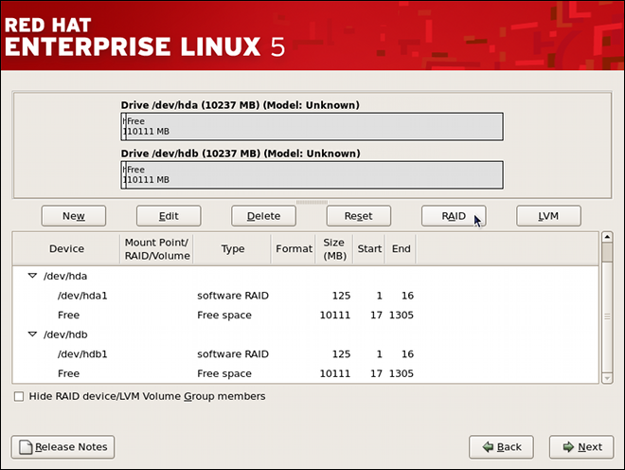](https://access.redhat.com/webassets/avalon/d/Red_Hat_Enterprise_Linux-5-Deployment_Guide-en-US/images/b5bd9cda195c205465245f8d02a53a53/raid-manual-part-bootready.png)

**Figure 6.4. RAID 1 Partitions Ready, Pre-Device and Mount Point Creation**

# CREATING THE RAID DEVICES AND MOUNT POINTS

Once you create all of your partitions as software RAID partitions, you must create the RAID device and mount point.

1. On the main partitioning screen, click the **RAID** button. The **RAID Options** dialog appears as shown in [Figure 6.5, “RAID Options”](https://access.redhat.com/documentation/en-us/red_hat_enterprise_linux/5/html/deployment_guide/s1-raid-diskdruid-manual-devmnt#fig-raid-manual-part-opt2).

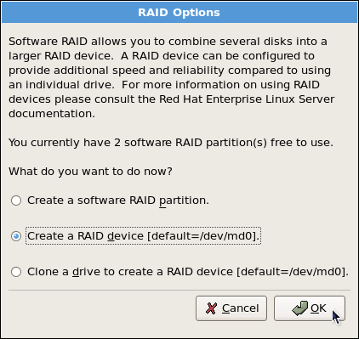

**Figure 6.5. RAID Options**

1. Select the **Create a RAID device** option, and click **OK**. As shown in [Figure 6.6, “Making a RAID Device and Assigning a Mount Point”](https://access.redhat.com/documentation/en-us/red_hat_enterprise_linux/5/html/deployment_guide/s1-raid-diskdruid-manual-devmnt#fig-raid-manual-mntpt), the **Make RAID Device** dialog appears, allowing you to make a RAID device and assign a mount point.

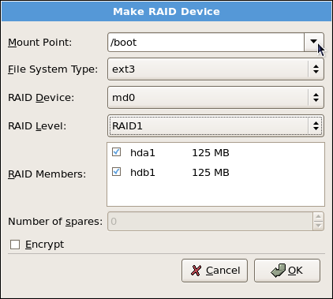

**Figure 6.6. Making a RAID Device and Assigning a Mount Point**

1. Select a mount point from the **Mount Point** pulldown list.
2. Choose the file system type for the partition from the **File System Type** pulldown list. At this point you can either configure a dynamic LVM file system or a traditional static ext2/ext3 file system. For more information on LVM and its configuration during the installation process, refer to [Chapter 11, LVM (Logical Volume Manager)](https://access.redhat.com/documentation/en-us/red_hat_enterprise_linux/5/html/deployment_guide/ch-lvm). If LVM is not required, continue on with the following instructions.
3. From the **RAID Device** pulldown list, select a device name such as **md0**.
4. From the **RAID Level**, choose the required RAID level.

**Note**

If you are making a RAID partition of /boot, you must choose RAID level 1, and it must use one of the first two drives (IDE first, SCSI second). If you are not creating a separate RAID partition of /boot, and you are making a RAID partition for the root file system (that is, /), it must be RAID level 1 and must use one of the first two drives (IDE first, SCSI second).

1. The RAID partitions created appear in the **RAID Members** list. Select which of these partitions should be used to create the RAID device.
2. If configuring RAID 1 or RAID 5, specify the number of spare partitions in the **Number of spares** field. If a software RAID partition fails, the spare is automatically used as a replacement. For each spare you want to specify, you must create an additional software RAID partition (in addition to the partitions for the RAID device). Select the partitions for the RAID device and the partition(s) for the spare(s).
3. Click **OK** to confirm the setup. The RAID device appears in the **Drive Summary** list.
4. Repeat this chapter's entire process for configuring additional partitions, devices, and mount points, such as the root partition (/), home partition (/home), or swap.

After completing the entire configuration, the figure as shown in [Figure 6.7, “Sample RAID Configuration”](https://access.redhat.com/documentation/en-us/red_hat_enterprise_linux/5/html/deployment_guide/s1-raid-diskdruid-manual-devmnt#fig-raid-manual-final) resembles the default configuration, except for the use of RAID.

[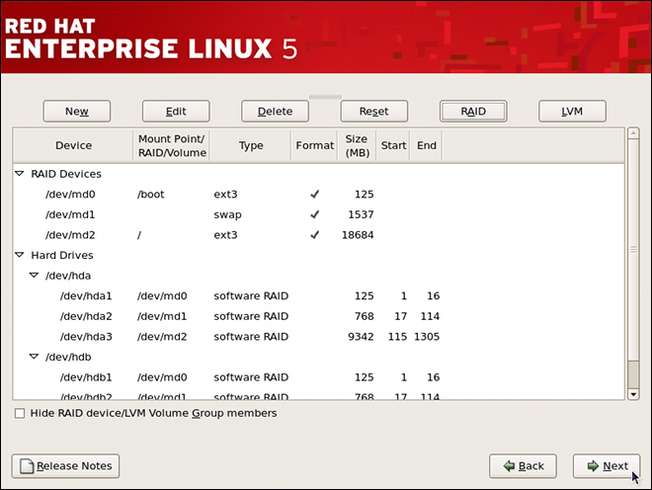](https://access.redhat.com/webassets/avalon/d/Red_Hat_Enterprise_Linux-5-Deployment_Guide-en-US/images/81a93c8ca49c6527a6312995cc9fd2e8/raid-manual-final.png)

**Figure 6.7. Sample RAID Configuration**

The figure as shown in [Figure 6.8, “Sample RAID With LVM Configuration”](https://access.redhat.com/documentation/en-us/red_hat_enterprise_linux/5/html/deployment_guide/s1-raid-diskdruid-manual-devmnt#fig-raid-manual-lvm-final) is an example of a RAID and LVM configuration.

[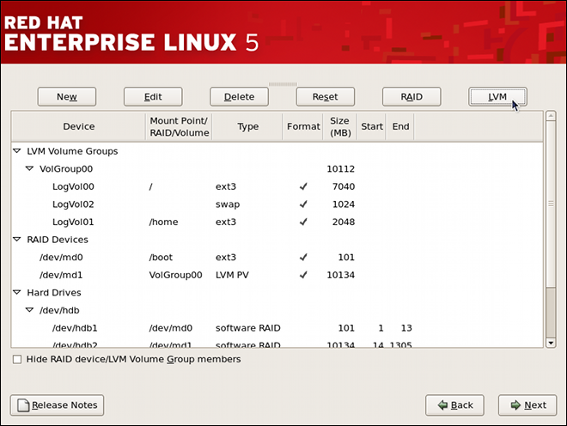](https://access.redhat.com/webassets/avalon/d/Red_Hat_Enterprise_Linux-5-Deployment_Guide-en-US/images/3b871e0d7929024700b3b1a64dcfed8b/raid-manual-lvm-final.png)

**Figure 6.8. Sample RAID With LVM Configuration**

You can proceed with your installation process by clicking **Next**. Refer to the Red Hat Enterprise Linux Installation Guide for further instructions.