GeminiDecode

Multilanguage Document Extraction by Gemini Pro

**Category**: Generative AI

**Project Overview**

**GeminiDecode: Multilanguage Document Extraction** is a Streamlit application designed to analyze and interpret document images in various languages. This app leverages Google's Gemini Pro language models to extract content from document images, translate it into English, and provide insights based on user queries. It is tailored for multilingual document processing, making it ideal for businesses operating across regions with diverse languages.

**Prior Knowledge**

* Generative AI Concepts
* Python Programming
* NLP: <https://www.tutorialspoint.com/natural_language_processing/index.htm>
* Generative AI: <https://en.wikipedia.org/wiki/Generative_artificial_intelligence>
* About Gemini: <https://deepmind.google/technologies/gemini/#introduction>
* Gemini API: <https://ai.google.dev/gemini-api/docs/get-started/python>
* Gemini Demo: <https://colab.research.google.com/github/google/generative-ai-docs/blob/main/site/en/gemini-api/docs/get-started/python.ipynb>
* Streamlit: <https://www.geeksforgeeks.org/a-beginners-guide-to-streamlit/>

**Technologies and Libraries Used**

* **Python**: Primary language for application logic.
* **Streamlit**: Front-end interface for an interactive user experience.
* **Google Generative AI (Gemini)**: API integration for document analysis and language translation.
* **Pillow (PIL)**: Image handling library.
* **dotenv**: Loads environment variables securely from .env files.

**Key Features** :

* **Multilanguage Document Extraction**: Extracts key data from business reports, code documentation, and technical manuals across multiple languages, offering real-time translation and summaries.
* **Customized Recommendations:** Provides tailored insights based on extracted content, suggesting relevant coding patterns, business strategies, or research findings from a global perspective.
* **Advanced Data Analytics**: Analyzes trends and patterns from extracted documents to offer insights, comparisons, and optimisations across coding projects, business strategies, and research endeavours.
* **Document Categorization**:  Automatically categorises documents based on content, such as business, coding, or research, enhancing searchability and accessibility.

**Use Cases:**

1. Coding Documentation
   * **User**: Emma, a 29-year-old software engineer.
   * **Objective**: Extract code snippets and best practices from multilingual coding repositories.
   * **Process**:
     1. Emma uploads coding documentation and repositories in various languages.
     2. **GeminiDecode** extracts relevant code snippets, programming patterns, and developer comments, translating and summarizing them.
     3. The app offers optimized coding practices based on similar patterns extracted from global repositories.
   * **Outcome**: Emma improves her code efficiency by utilizing extracted best practices from global coding communities.

1. Business Reports
   * **User**: Daniel, a 40-year-old business analyst.
   * **Objective**: Analyze business trends and strategies from multilingual market reports.
   * **Process**:
     1. Daniel uploads market reports and financial documents in different languages.
     2. **GeminiDecode** extracts key data points, strategies, and market insights from the    documents and provides translations.
     3. The app offers insights on market trends, business strategies, and financial performance based on global reports.
   * **Outcome**: Daniel gains a comprehensive understanding of market conditions and develops informed business strategies using global data.

3. Academic Research :

* + User: Dr. Liu, a 32-year-old data scientist.
  + Objective:  Extract insights from multilingual academic research papers for AI model development.
  + Process:
    1. Dr. Liu uploads AI and machine learning research papers in multiple languages.
    2. GeminiDecode extracts key research methodologies, model architectures, and findings from the documents.
       1. The app helps Dr. Liu compare research results from different regions, offering insights on model improvements.
  + Outcome: Dr. Liu accelerates her AI model development process by utilizing extracted global research methodologies.

4. Technological Stack:

* + **Python**: Core programming language used for document extraction, translation, and analysis algorithms.
  + **Deep Learning**:  Powers the natural language processing (**NLP**) and multilingual document extraction, ensuring accurate translations and insightful recommendations.
  + **Streamlit**: Creates an intuitive user interface for seamless document upload, extraction, and analysis.

Note: This project is currently capable of translating, analyzing, and extracting content from only 50 languages into English

Technical Architecture:

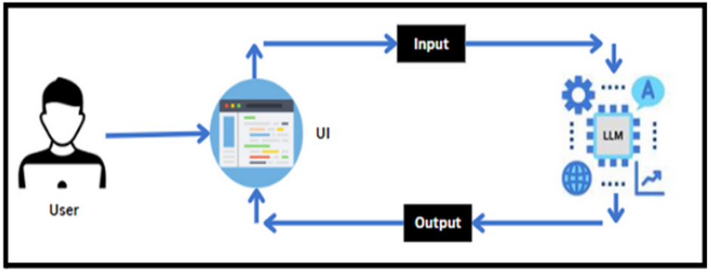

**GeminiDecode** provides a cutting-edge solution for researchers, developers, and business analysts by breaking language barriers and offering multilingual document extraction and analysis. It enhances workflows in coding, business, and academic research, providing global insights and data-driven decision-making support.

**Error Handling**

* **Missing API Key**: If the GOOGLE_API_KEY is not set in the .env file, the app will throw an error when attempting to access the Gemini API.
* **Invalid File Uploads**: If no file is uploaded or an unsupported file type is selected, the app shows an error message.
* **Model or API Errors**: If there’s a connection error with Gemini, the app displays a custom error message.

**Future Enhancements**

1. **Enhanced Error Handling**: Improve error messages to handle more API-specific errors.
2. **Support for Additional File Types**: Allow document files (like PDFs) in addition to images.
3. **Data Logging**: Log user interactions for data analysis and further model training.

**Conclusion**

**GeminiDecode** offers a robust and interactive solution for businesses needing fast and reliable multilingual document processing. This documentation outlines the application setup, feature details, and usage instructions, ensuring a straightforward setup and usage process.