Metrics
In this section we present some of the metrics for when we started to work on the project in the Fall quarter of 2010 until present, Winter of 2010. These metrics and their descriptions are provided by the Eclipse Metrics plugin available at http://eclipse-metrics.sourceforge.net/

Summary
The following tables summarize the overall work put into the iterations per quarter.
Delta = The difference in value between one quarter and the previous one.
TLOC = Total Lines Of Code

Before Fall 2010
Statistic | Value
# packages | 25
# classes | 142
TLOC | 9006
End of Fall 2010
Statistic | Value | Delta
# packages | 26 | 1
# classes | 153 | 11
TLOC | 9537 | 531
End of Winter 2010
Statistic | Value | Delta
# packages | 26 | 0
# classes | 163 | 10
TLOC | 9688 | 151
End of Spring 2010
Statistic | Value | Delta
# packages | 27 | 1
# classes | 196 | 33
TLOC | 10551 | 863

Number Of Levels
This metric is an indication of the maximum number of levels of nesting in a method. The idea of the metric is that a large Number Of Levels increases complexity and reduces comprehensibility. In addition, such methods generally (but not necessarily) operate at the lowest level of abstraction or at mixed levels of abstraction, both of which contribute to the confusion.
All methods that have a large Number Of Levels can be simplified by extracting private methods or by creating a Method Object. Both of these result in naming of the different parts of the original method, thus raising the level of abstraction.
Note that the Number Of Levels metric and the degree of indentation of the code are not necessarily the same. Consider the case of cascaded 'if/else if' statements. Each 'else if' is another level of nesting but this is not usually the way it is displayed in source listings.

Before Fall 2010
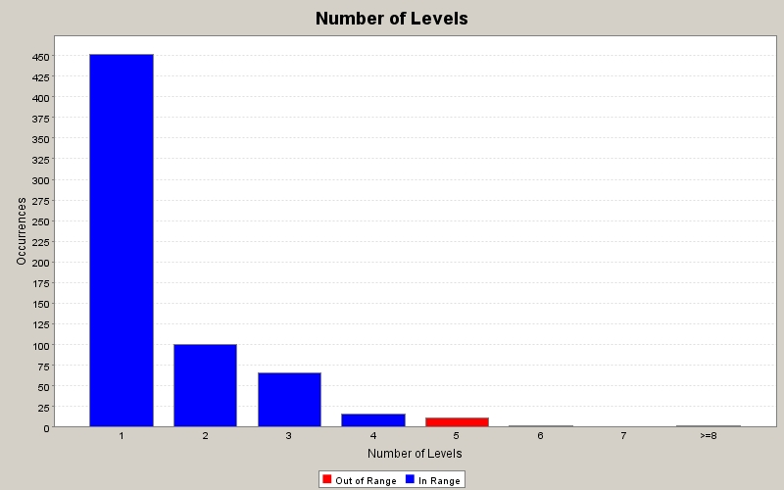
End of Fall 2010
There was an increase in the numbers of levels for the first, second and fifth groups. The maximum for the first group was 450, now it’s 475.
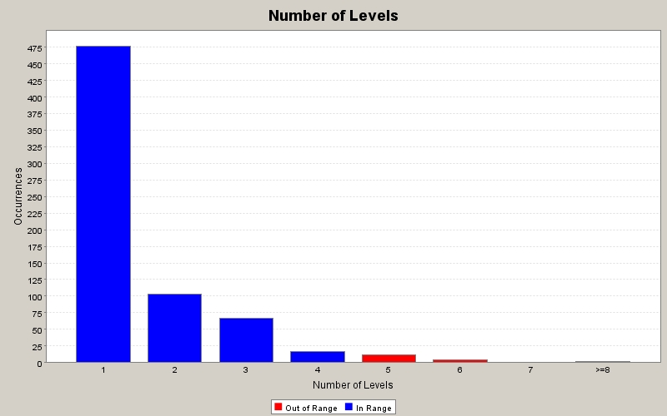
End of Winter 2010
There was an increase in the numbers of levels for the first, second, third and fourth groups. The maximum for the first group was 475, now it’s almost 525.
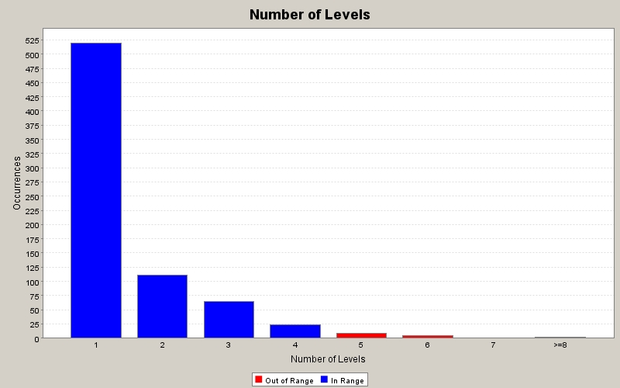

End of Spring 2010
The decomposition of the Joystick dialog into several classes helped in eliminating the “>=8” ocurrences. Also, due to refactoring and adding methods, the number of occurrences increased.
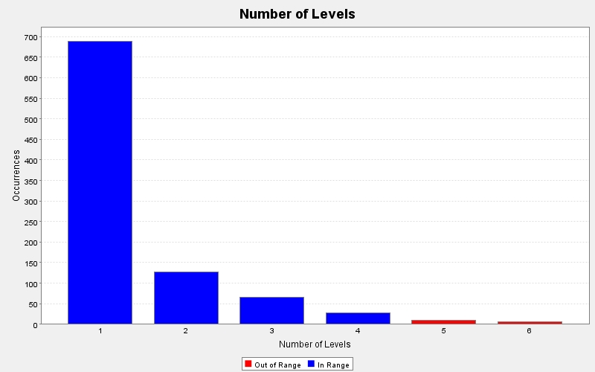

Comparison
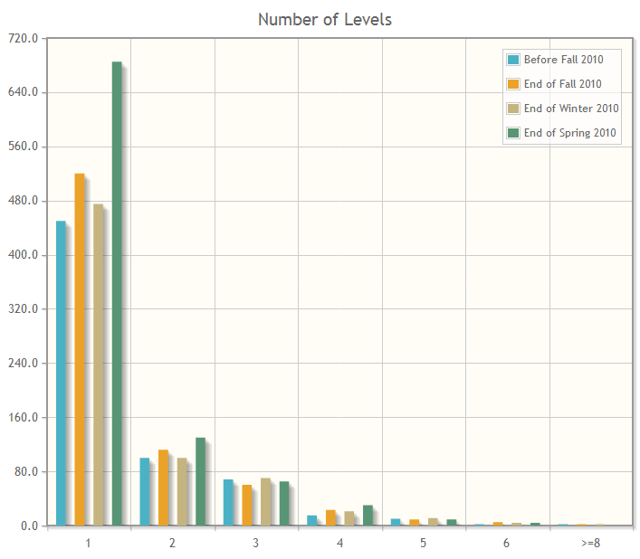
Number Of Parameters
This metric is a count of the number of parameters to a method. Methods with a large Number Of Parameters often indicate that classes are missing from the model.
Most methods that have a large Number Of Parameters can be simplified by grouping parameters into a number of related sets and making classes from those sets. It will often be the case that when this is done, those new classes attract behaviour that previously existed (uncomfortably) in other classes. The result will be the formation of semantically rich abstractions that encapsulate a coherent set of operations. This leads to an increase in maintainability.

Before Fall 2010
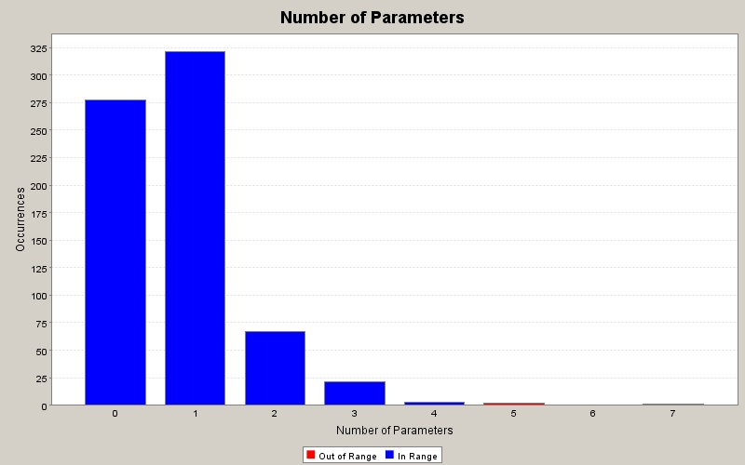
End of Fall 2010
Overall, there was an increase in the Number of Parameters passed because there was also an increase in the number of methods added. We can verify this by comparing the graphics for the methods that receive 0 parameters. Before this quarter, the number of methods with 0 parameters is close to 275, and at the end of this quarter, that number is closer to 300.
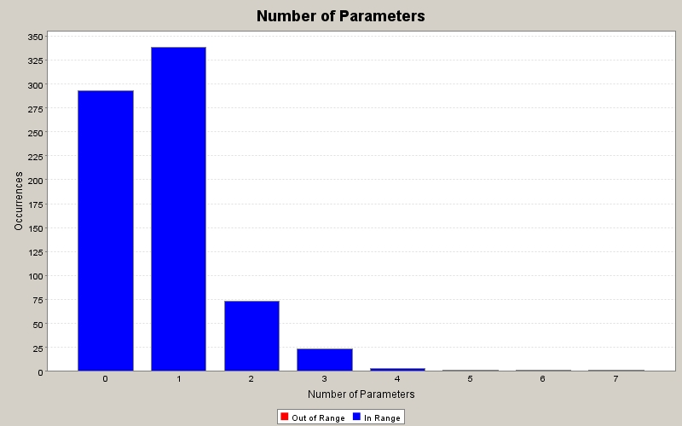
End of Winter 2010
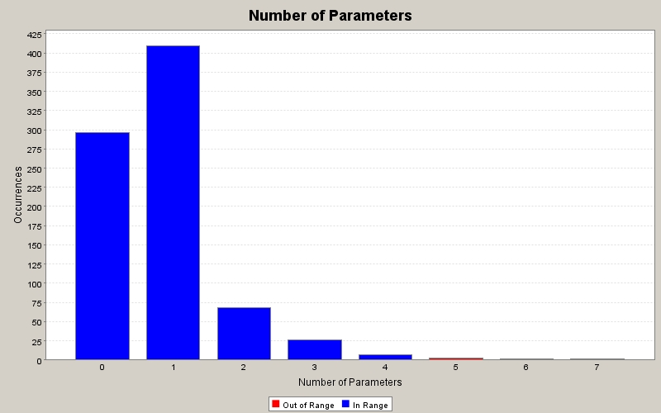

End of Spring 2010
Again, refactoring and adding methods can be translated into the increase in the occurrences for the number of parameters.
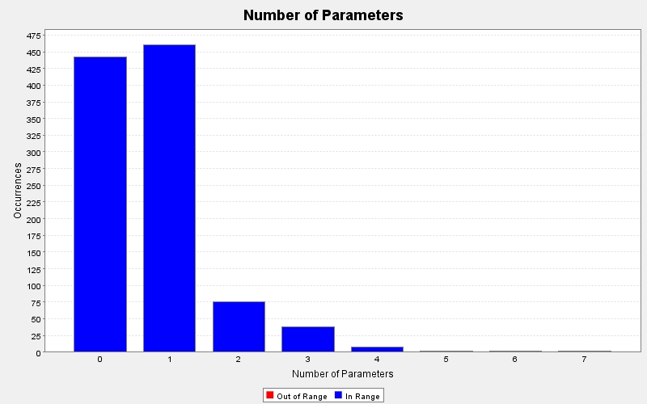

Comparison
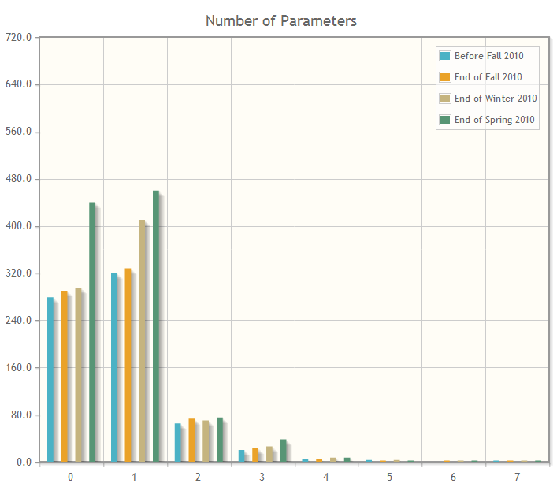

Feature Envy
Feature Envy occurs when a method is more interested in the features (methods and fields) of other classes than its own. The solution if it exists at all, is straightforward; move the method to the class that it is most envious of, passing any parameters the new method requires. If only part of the method demonstrates this envy, extract that part and then move the new method into the envied class. Sometimes this is not possible, since the envied class may be available only in a non-modifiable form.
Although conceptually straightforward, there are intricacies. For example:
- Features are normally accessed through instances, so if a method makes use of the features of one class through two different instances, how should the envy be calculated?
- A degree of envy is exhibited when a method makes use of more than one feature of another class, regardless of how many of its own features it uses. It is possible to eliminate any such envy, but this may result in a design that is more intricate and less clear than the alternative.
The approach we have taken is straightforward. Let:
m | be the method for which we want to calculate Feature Envy
F_{c} | be the set of features used by m that belong to type c
c_{m} | be the class in which m is defined

Then:
Feature Envy = max_{c ≠ cm}(|F_{c}|) - |F_{cm}|

Before Fall 2010
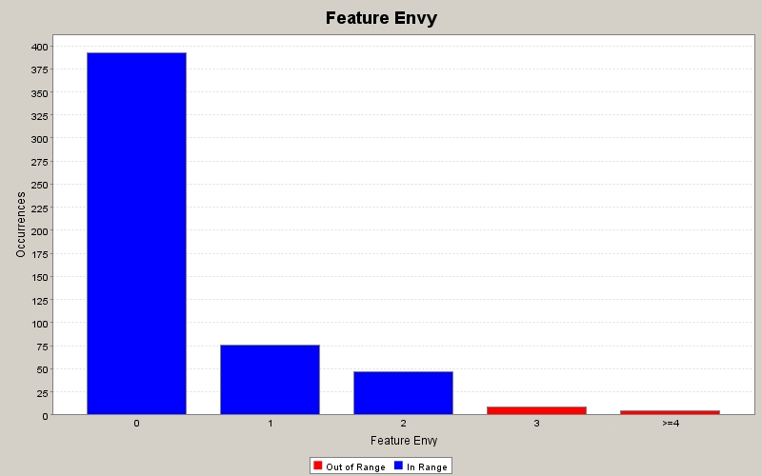
End of Fall 2010
Overall, the number of occurrences for Feature Envy is reduced. The only exception is the “>=4” group, which had a small increase in the number of occurrences.
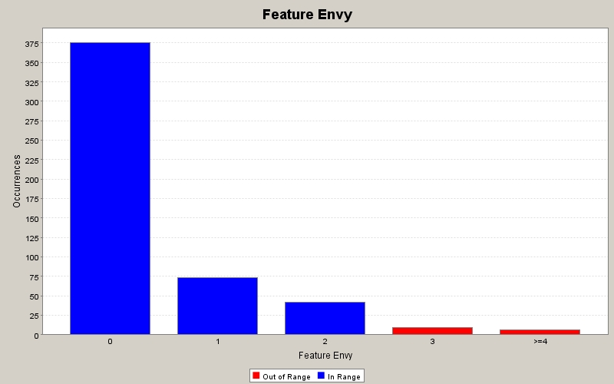
End of Winter 2010
The number of Feature Envy occurrences increased for all of the groups. The most noticeable is the “0” group, which jumped from 375 to more than 500 occurrences this quarter. We could attribute the increase in overall feature envy to the centralization of many features, instead of having the same code in several places.
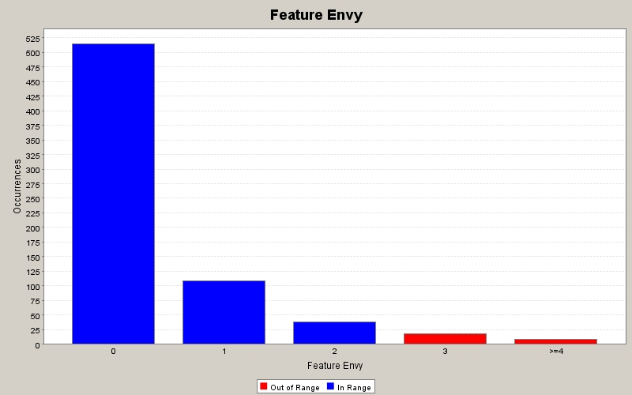
End of Spring 2010
Due to centralization, the number of occurrences for Feature Envy increased. This is the nature of refactoring while adding new methods.
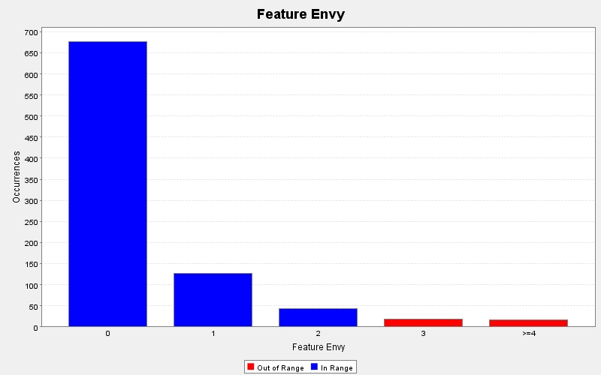

Comparison
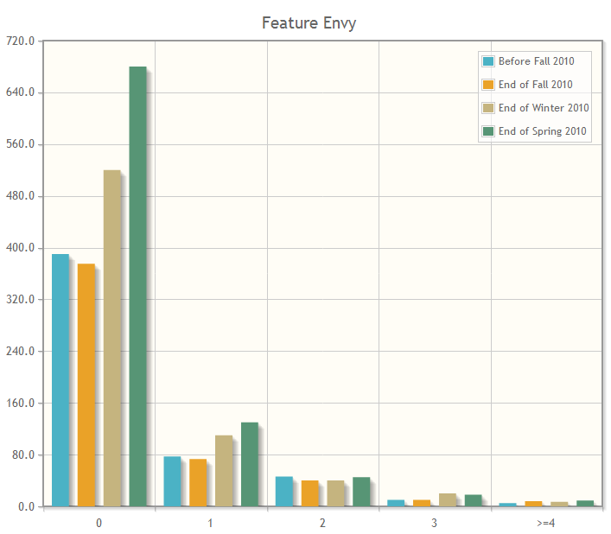
McCabe's Cyclomatic Complexity
This metric is an indication of the number of 'linear' segments in a method (i.e.sections of code with no branches) and therefore can be used to determine the number of tests required to obtain complete coverage. It can also be used to indicate the psychological complexity of a method.
A method with no branches has a Cyclomatic Complexity of 1 since there is 1 arc. This number is incremented whenever a branch is encountered. In this implementation, statements that represent branching are defined as: 'for', 'while', 'do', 'if', 'case' (optional), 'catch' (optional) and the ternary operator (optional). The sum of Cyclomatic Complexities for methods in local classes is also included in the total for a method.
Cyclomatic Complexity is a procedural rather than an OO metric. However, it still has meaning for OO programs at the method level.

Before Fall 2010
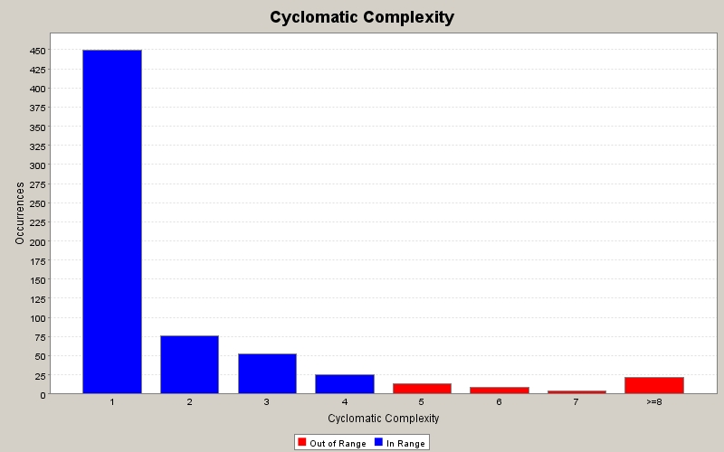
End of Fall 2010
There was an increase in the number of occurrences for Cyclomatic Complexity. We can assume that the increase in the first group is due to new methods being added because, according to the definition above, a method with no branches has a cyclomatic complexity of 1.
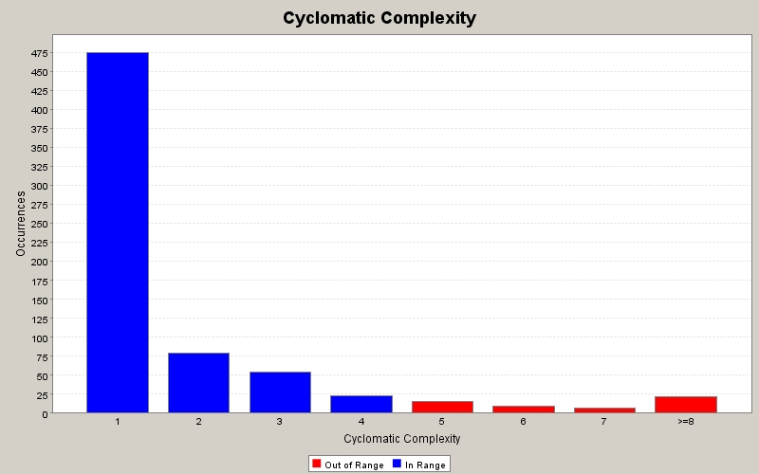
End of Winter 2010
Again, for this quarter the number of occurrences for Cyclomatic Complexity increased. It’s inevitable that as long as we add new methods, the Cyclomatic Complexity will increase, but we have to be aware of the fifth and sixth groups because for this quarter those values are almost the same.
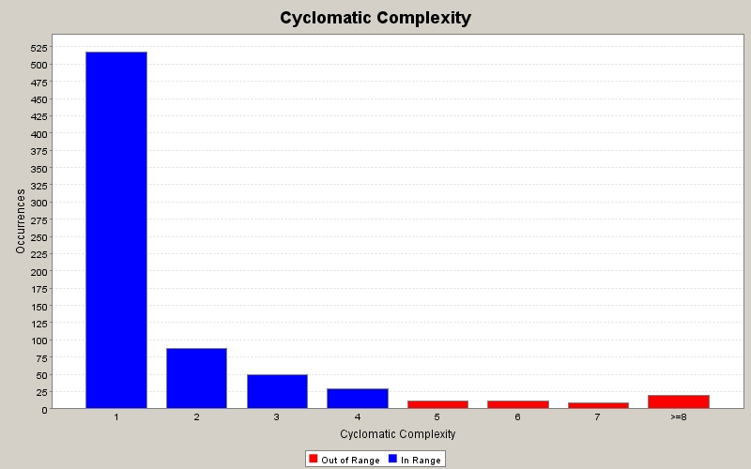
End of Spring 2010
For this quarter, the number of occurrences for the sixth group decreased in comparison to the other quarters. Refactoring is the culprit.
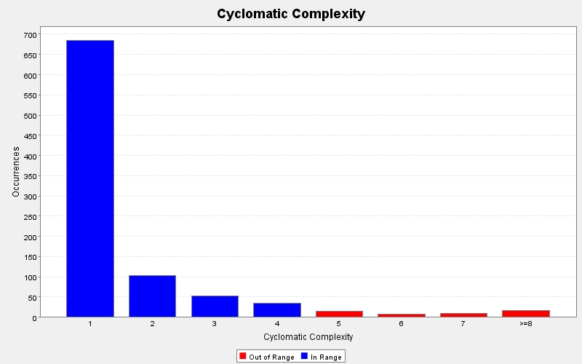
Comparison
